1. A CD player uses a laser that emits radiation of wavelength 790 nm. A student suggests setting up this laser to observe a two-slit interference pattern by shining it at a screen through a double slit.
Why would the student not be able to see any fringes? [1]
A laser that emits radiation of wavelength 790 nm is directed at a double slit with a suitable detector 1.2m from the slit. The slit spacing is 0.24 mm. How far apart are the fringes which correspond to maximum readings on the detector? [2]
How could you increase the fringe separation without changing the wavelength of the laser beam? [1]
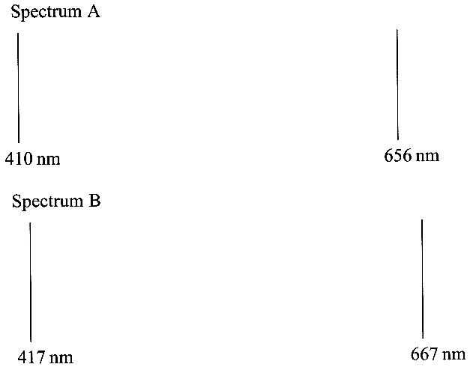
2. Spectrum A shows two emission lines of hydrogen obtained in a
laboratory; spectrum B shows the same lines as obtained from light
from a distant galaxy. Use these spectra to determine the velocity
of this galaxy. (The diagrams are not to scale.) [4]

Using a value for the Hubble constant of 1.8 x 10 ⁻¹⁸ s ⁻¹, estimate
the distance of this galaxy from Earth. [2]

3. Neutrons, like electrons, are often used to study crystal structure.
A suitable de Broglie wavelength for the neutrons would be
about 1 nm. Explain why the neutrons must have a de Broglie
wavelength of this order of magnitude. [2]
Given the mass of a neutron as 1.67 x 10 ⁻²⁷ kg, calculate the
kinetic energy of a neutron which has a de Broglie
wavelength of 1.20 nm. [3]
What is meant by wave-particle duality? Illustrate your answer with the example of neutrons.
You may be awarded a mark for the clarity of your answer. [4]
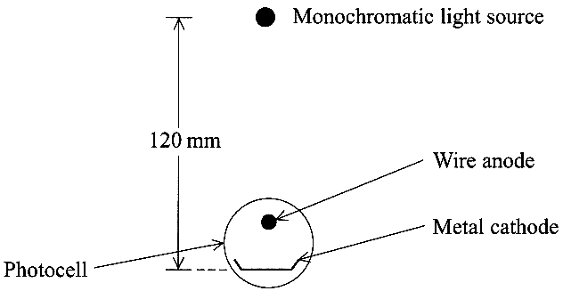
4. Describe, with the aid of a diagram, an experiment to demonstrate stationary
waves using microwaves. [4]
Using the idea of wave superposition, explain what is observed in
your experiment. [2]
Describe how you could use the experiment to measure the wavelength
of microwaves. [2]

5. A monochromatic light source is placed 120 mm above the
cathode of a photocell.
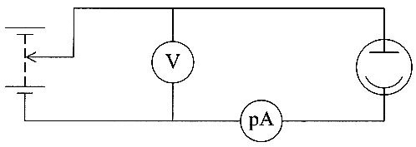
The light source consumes 6 W of power and is 15 % efficient.
Calculate the light intensity at the cathode.
State an assumption that you made. [3]

A potential difference is applied between the cathode and the
anode of the photocell and the sensitive ammeter detects the current.

The table below shows the currents which are obtained with this
apparatus for two different intensities and two different wavelengths of light, using two different cathode materials. Work function energies are given.

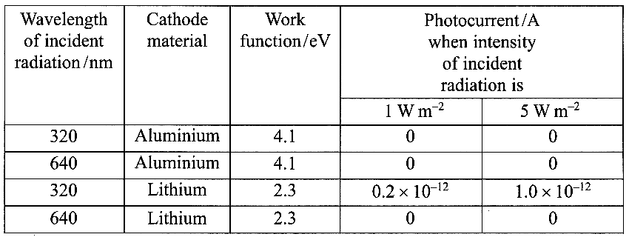

Show that the incident photons of λ = 320nm and λ = 640nm have energies of
approximately 4 eV and 2 eV respectively. [4]
Account for the photocurrent readings shown in the table. [3]
Calculate the stopping potential for the photoelectrons released by lithium when irradiated by light
of wavelength 320 nm. [2]

6. The graph opposite shows how the acceleration a
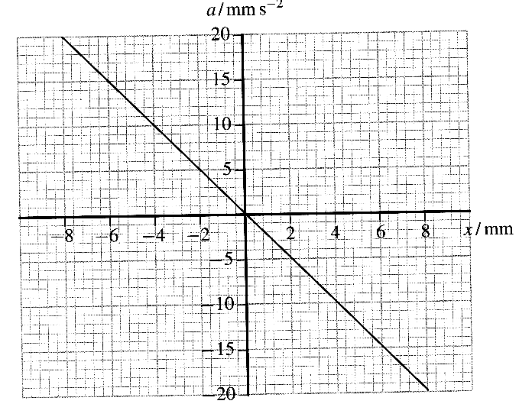
varies with displacement x for a particle undergoing
simple harmonic motion.
Calculate the gradient of this graph.
Use your value to deduce the frequency for this motion. [4]
Hence, write down the period of the motion. [1]

On a copy of the grid below sketch a graph of acceleration
against time for this motion. Assume that the displacement
is zero and the velocity is positive at t = 0.
Add suitable scales to the axes.
Draw at least two complete cycles. [3]
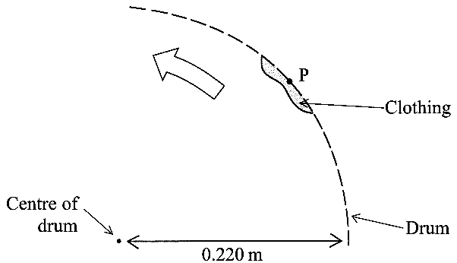
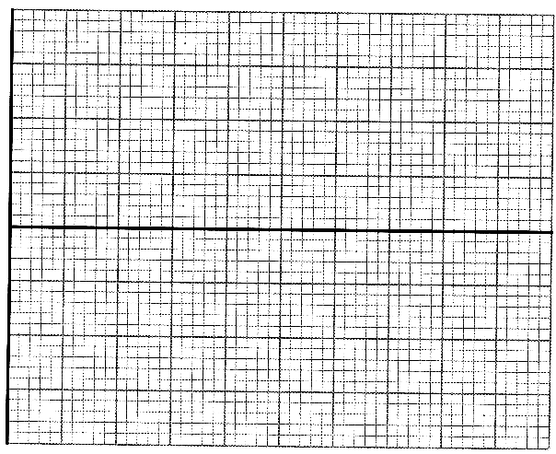

7. In a washing machine clothes are placed inside a metal
drum with small holes in it When the wet clothes are spun,
the drum rotates at high speed and water escapes through the holes.
The drum has a radius of 0.220 m and rotates at 800 revolutions per minute.
Show that the speed of the rim of the drum is approximately 18 ms⁻¹. [3]

The diagram above right shows a piece of clothing in the drum which is spinning anticlockwise.
Estimate the magnitude of the acceleration of this piece of clothing. [2]
Add an arrow to a copy of the diagram to show the direction of this acceleration. Label the arrow A.
Explain what force produces this acceleration. [2]
A drop of water becomes detached from the clothing at point P, which is next to one of the holes in the drum. Draw an arrow on your copy of the diagram to show the path which the drop of water now follows. Label this arrow B. [1]

8. Diagram (i) represents part of a stretched spring. Diagram (ii) represents the same section of the spring at one instant of time when a sinusoidal longitudinal wave is travelling along it.

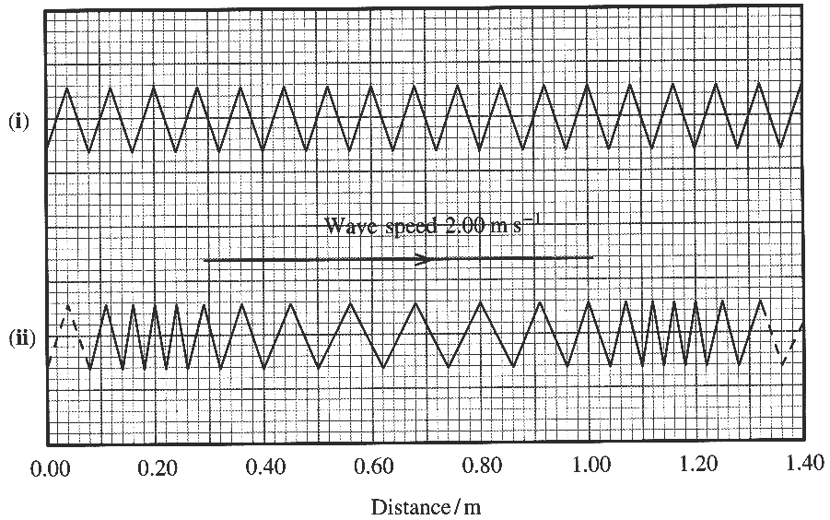
Use the diagram (ii) to determine the wavelength of the longitudinal wave. [1]
The wave speed is 2.00 m s⁻¹. Calculate the frequency of this wave. [1]
Describe qualitatively the motion of an individual coil of this spring as the longitudinal wave
travels along the spring. [3]

TOTAL FOR PAPER: 60 MARKS

