Topic D – Medical Physics

4. (a) Iodine-123 has a half-life of 13.3 hours. A sample of Iodine-123 has an initial activity of 8000 Bq.
How long will it take for the activity to fall to 1000 Bq? [2]
On a copy of the axes below sketch a graph to show how the activity of the sample varies with time over
a period of 80 hours. [3]

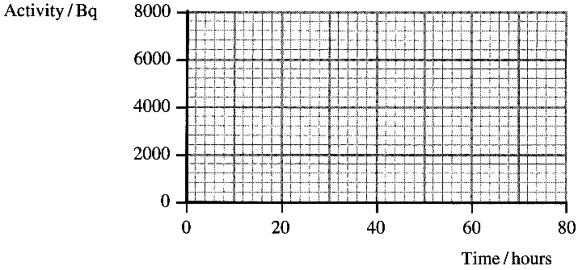
An identical sample is administered to a patient. Explain why the measured activity from the patient would not produce the same graph as you have sketched. [1]

(b) Technetium-99m (^{99m}₄₃Tc) is produced when molybdenum ⁹⁹₄₂Mo decays.
Write a nuclear equation for this decay. [1]
The diagram shows a generator for supplying ^{99m}₄₃Tc.

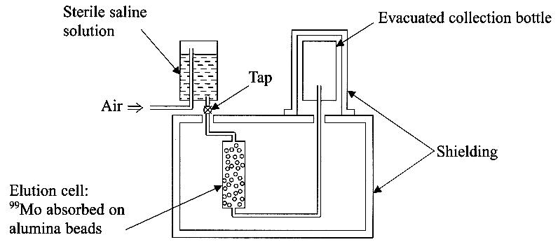

In which part of the generator is the ^{99m}₄₃Tc produced? [1]
Describe what happens when the tap is opened and air is forced into the space above the saline solution. [3]
Name a suitable material for the shielding. [1]
State one advantage of producing ^{99m}₄₃Tc in such a generator. [1]
⁹⁹₄₂Mo has a half-life of 67 hours.
Suggest two reasons why this half-life makes ⁹⁹₄₂Mo appropriate for use in this generator. [2]

(c) State the function of the following parts of an X-ray tube:
(i) the filament, (ii) the high voltage supply, (iii) the glass tube which encloses the anode and filament. [3]
State two ways in which the radiographer is protected from over-exposure to X-rays. [2]
On an X-ray photograph, bones show up as bright areas and air spaces such as the lungs produce very dark regions. Explain why. You may be awarded a mark for the clarity of your answer. [4]

(d) Ultrasound can be used to treat muscle injuries.
Why is a gel applied between the transducer and the patient's skin? [1]
State one way in which energy is lost from an ultrasound pulse as it passes through a material and state what happens to this energy. [2]
Beyond the layer of damaged muscle there is bone.
Calculate the reflection coefficient for ultrasound at the muscle-bone interface. [3]
Specific acoustic impedance of muscle = 1.7 x 10 ⁶ kg m ⁻² s ⁻¹
Specific acoustic impedance of bone = 7.8 x 10 ⁶ kg m ⁻² s ⁻¹
If energy loss in the muscle halves the intensity I of the ultrasound pulse, calculate how much of the intensity of the initial pulse actually enters the bone. [2]

Total 32 marks

