Topic C - Nuclear and Particle Physics

3. (a) Name the experiment which was used to find out about the structure of (i) the proton; (ii) the atom [2]
Show that the radius of a nucleus of calcium ⁴⁰Ca is approximately 4 x 10 ⁻¹⁵ m (r_{o} = 1.2 x 10 ⁻¹⁵ m ). [2]
Hence calculate the density of a calcium nucleus. (u = 1.66 x 10 ⁻²⁷ kg) [3]

(b) Part of the uranium decay series is shown below.
On a copy of this, write above each arrow the charged particle emitted during that decay. [2]

The stable end product of the complete uranium decay series is lead, ²⁰⁶₈₂Pb.
How many alpha particles are emitted between ²²⁶₈₈Ra and the end of the series? [1]

(c) On a copy of the axes below sketch a graph showing the energy spectrum of the β ⁻ particles
leaving a typical source. [2]

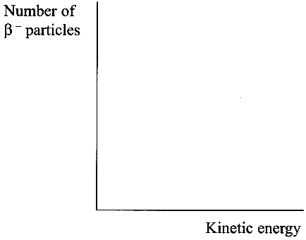
Explain how this energy spectrum led to the prediction of the existence of the antineutrino. You may be awarded a mark for the clarity of your answer. [4]

(d) Give one similarity and one difference between an antiparticle and its particle pair. [2]
What is the quark composition of an antiproton? [1]
State the baryon number of the antiproton. [1]

At CERN protons and antiprotons, each of energy 45 GeV, were collided when trying to create W and Z particles. The antiprotons had to be stored until enough of them were available to be accelerated to the required energy. Explain why it is difficult to store antiprotons. [2]
What is the maximum possible mass which can be created from such a collision? Give your answer in u. [3]
Give two reasons why the following interaction cannot take place.
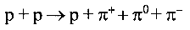

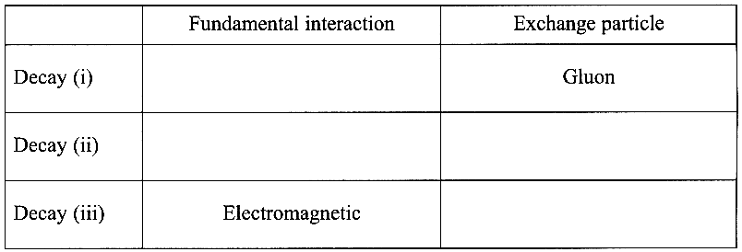
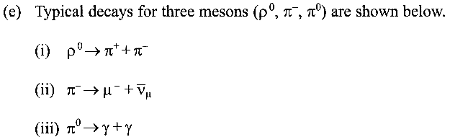

Complete a copy of the table opposite to show
the three different fundamental interactions and
exchange particles involved in these decays. [4]

State the fundamental interaction not given in
your table. [1]

Total 32 marks

