Topic B - Solid Materials

2. (a) The graph shows the stress-strain relationship for a material from which car seat belts can be made.
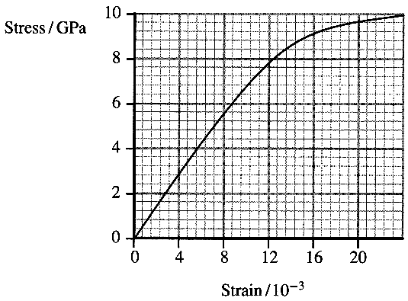
What physical quantity does the area under this graph represent? [1]

A car seat belt is 2 m long, 6 cm wide and 1.5 mm thick.
Show that the volume of the seat belt is approximately 2 x 10 ⁻⁴ m³. [1]
A passenger of mass 55 kg wears the seat belt when travelling in a car at a speed of 24 m s⁻¹.
Show that the kinetic energy of the passenger is about 16 kJ. [2]

Calculate the energy per unit volume which must be absorbed by the seat belt as it restrains the passenger when the car stops suddenly. Assume that all the passenger's kinetic energy is absorbed by the seat belt. [1]

Use the graph to show that a seat belt made from this material would be satisfactory for restraining the passenger in the situation described above. Assume the maximum strain in the belt is 20 x 10 ⁻³. [2]
In what way would the design of a seat belt, made from the same material, need to be changed to make it suitable for restraining the driver of a racing car when the car stops suddenly? Explain your answer. [2]
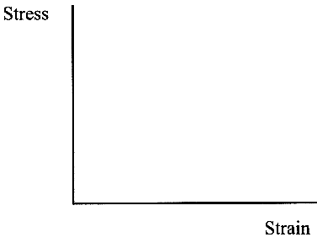
(b) On a copy of the axes opposite, sketch a stress-strain graph for rubber,
showing its behaviour for both increasing and decreasing stress. [2]
Use your graph to explain why a rubber band which is repeatedly stretched and
relaxed becomes noticeably warmer.
You may be awarded a mark for the clarity of your answer. [3]

(c) Metals sometimes suffer fatigue failure. Explain what is meant by fatigue
in this context. [1]
In 1950 two Comet aircraft crashed after only two years of flying as a result of fatigue failure.
The Comet was one of the first aircraft to have a pressurised cabin and had riveted panels close to square windows. Explain in terms of cracks and stress concentrations why these features may have caused the aircraft to suffer fatigue failure. [3]

(d) Chipboard and plywood are both composite materials. State what is meant by a composite material. [1]
Sketch labelled diagrams showing the structure of each of these materials and classify each as either a laminate, a fibre composite or a particle composite. [4]

(e) State the energy conversions which take place when a rock-climber falls and is then stopped by a climbing rope. [2]
From the list below select three properties that would be most desirable in a climbing rope: [2]
strength stiffness toughness elasticity brittleness

During a fall, a climber exerts a force of 6.0 kN on a rope. Use the rope data below to calculate the theoretical extension of the rope when this force is exerted assuming the elastic limit of the rope is not exceeded.
Effective Young modulus = 1.4 x 10 ⁹ Pa; Length = 45 m; Diameter = 11 mm [4]

Suggest one reason why a rope that has been involved in an extreme fall should be replaced as soon as possible. [1]

Total 32 marks

