Topic A – Astrophysics

1. (a) Charge coupled devices (CCDs) have a higher efficiency than photographic emulsion.
Explain what is meant by the term 'higher efficiency'.
State one advantage of this higher efficiency. [3]

(b) The satellite COBE was launched in 1989 to investigate the cosmic background radiation. COBE detected the peak in the spectrum of the background radiation at a wavelength of 1.1 x 10⁻³ m.
Use this value to calculate the temperature of space. [2]
To what part of the electromagnetic spectrum does radiation of wavelength 1.1 x 10⁻³ m belong? [1]

(c) State two ways in which a white dwarf star differs from a main sequence star. [2]
Describe what happens to a star after it has become a white dwarf. [2]
A Hertzsprung-Russell diagram showing the main sequence is drawn below. The luminosity of the Sun = L_{Θ}

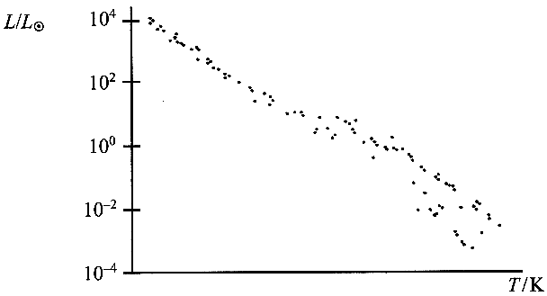

Add a scale to the temperature axis to a copy of the above. [2]
Identify one star on your diagram which has a luminosity very similar to that of the Sun. Label this star X. [1]
Shade in a region on your diagram where white dwarf stars are located. Label this region W. [1]
Label with an M the region on your diagram where the most massive main sequence stars are located. [1]
Explain why the most massive main sequence stars have the shortest lifetimes.
You may be awarded a mark for the clarity of your answer. [4]

(d) Two stars, Deneb and Vega, are similar in colour.
What can be deduced about the surface temperatures of the two stars? Explain your answer. [2]
The table gives some information about the two stars.
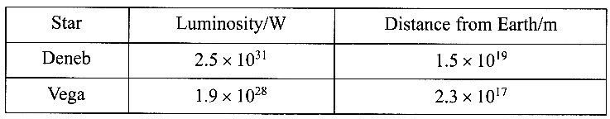
Which star has the greater surface area?
Justify your answer. [3]
Which star will have the higher intensity and therefore appear brighter as seen from the Earth?
Show all your working. [4]

(e) The Gemini telescope on Hawaii has a diameter of 8.0 m; the Hubble space telescope has a diameter of 2.4 m.
Show that Gemini has more than 10x the light gathering power of Hubble. [2]
Give one situation in which large light-gathering power is important. [1]
A telescope of diameter 100m could be sunk into the ground.
Suggest an operational disadvantage of having an extremely large telescope sunk into the ground. [1]

Total 32 marks

