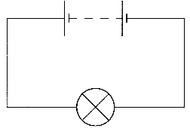
1. State the word equation that is used to define charge. (1)
Define potential difference. (1)
A 9.0V battery of negligible internal resistance is connected to a light bulb.
Calculate the energy transferred in the light bulb when 20 C of charge
flows through it. (2)

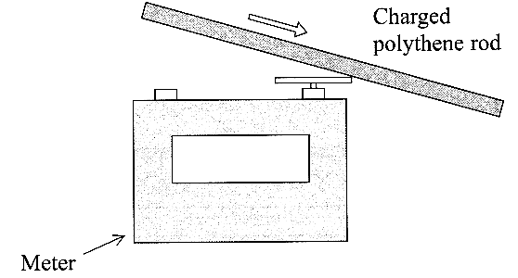
2. A polythene rod was negatively charged by rubbing it with a cloth.
The rod was then stroked several times across the metal cap of a meter
used for measuring charge. The initial reading on the meter was zero.
After 3.8 s the final reading was - 6.4 x 10⁻⁸ C.
Calculate the number of electrons that were transferred to the metal cap. (3)

Calculate the average rate in C s⁻¹ at which charge was transferred to the
metal cap. (2)
State the base unit for the rate of flow of charge. (1)

3. A heating coil is used to warm water that flows past it at
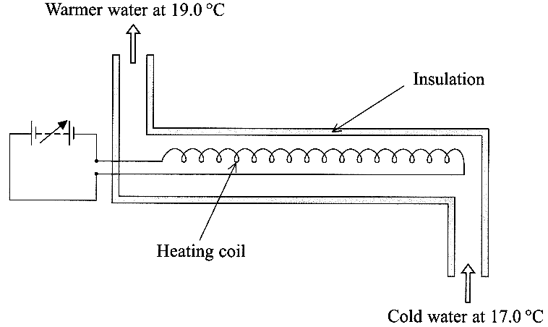
a steady rate of 0.24 kg s⁻¹.
The heating coil remains at a constant working
temperature of 350 °C.

The specific heat capacity of water is 4200 J kg⁻¹ K⁻¹.
Calculate the rate of absorption of energy by the cold
water assuming no energy is lost to the surroundings. (3)
The heating coil is operating at its normal working
temperature of 350 °C. The equation ΔU = ΔQ + ΔW
may be applied to the coil. State and explain the value
of each quantity for each second of operation. (6)

4. The increase in pressure Δp as you go down
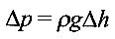
a distance Δh in a liquid of density p is given by the formula

where g has its usual meaning.
Show that this equation is homogeneous with respect to units. (3)
A diver at a depth of 30.0 m in the Dead Sea releases an air bubble of volume 2.00 cm³.
Calculate the volume of the bubble in cm³ when it reaches the surface of the sea, assuming the temperature of the air in the bubble remains constant.
Density of the water in the Dead Sea = 1170 kg m⁻³; Atmospheric pressure = 101 kPa. (4)
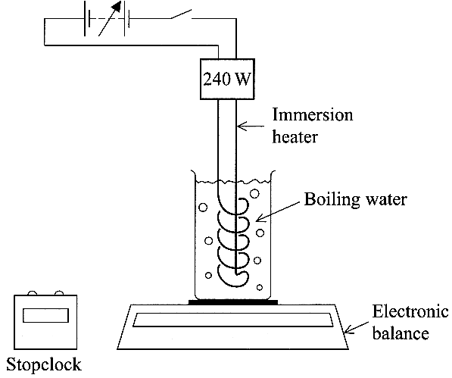
5. A student uses the apparatus shown to determine
a value for the specific latent heat of vaporisation of water l_{v}.
Define the term specific latent heat of vaporisation. (3)

The student uses an immersion heater to bring the water to a
vigorous boil and then takes readings to enable him to calculate
the mass of water that changes state in 285 s. He tabulates his results.
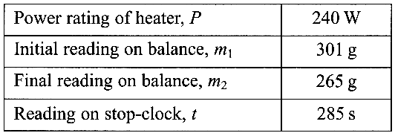

Calculate the energy provided by the immersion heater
during the 285 seconds. (2)
Hence show that his value for the specific latent
heat of vaporisation of water l_{v} is
approximately 2 x 10⁶ kg⁻¹. (2)
The student decides that he can improve his results by placing a lid partially over the beaker so that boiling water cannot spill but steam can still escape. Suggest and explain how this modification might affect his value for l_{v} .
You may be awarded a mark for the clarity of your answer. (4)
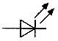
6. A light-emitting diode (LED) is a diode that emits light when it conducts. Its circuit symbol is
A student connects the first circuit shown below.
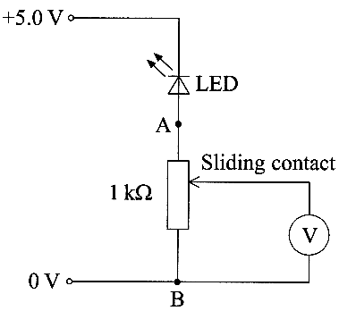
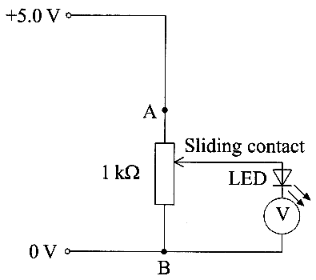

She notices that the reading on the high resistance voltmeter remains at 0 V as she slides the contact between terminals A and B. Explain this observation as fully as you can. (2)
The student then disconnects the LED and reconnects the second circuit shown above. She intends to vary the intensity of the light emitted by the LED by sliding the contact between terminals A and B.
The student cannot detect any light emitted by the LED. Briefly explain why the LED is so dim. (2)
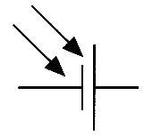
Draw the circuit that the student should have connected using this apparatus in order to vary the brightness of the LED and measure the potential difference across it. (3)

7. A solar cell is a device that generates a potential difference when certain
wavelengths of the electromagnetic spectrum are incident on it. The circuit symbol for a solar cell is

The solar cell is used in a circuit with a variable resistor, an ammeter and a voltmeter.
Readings of current I in the circuit and the terminal potential difference V across the solar cell are used to plot a graph of I against V. Draw a suitable circuit diagram. (2)

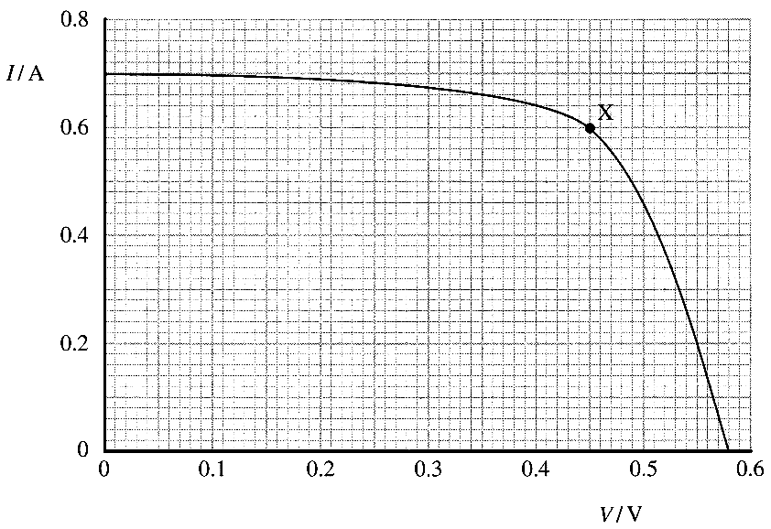
The graph shows a set of results obtained in this way. The intensity of the light incident on the cell remained constant while the readings were obtained.

Calculate the power output of the cell at the point marked X on the graph. (2)
Describe the variation of the power output of the cell as the current increases from zero to its maximum value. (3)
State the e.m.f. of the cell. (1)
Calculate the internal resistance of the cell when it is operating under the conditions represented by point X. (2)

8. State whether the following statements are true or false. In each case explain your reasoning.
Statement 1: When a battery is connected across a thick wire in series with a thin wire of the same material, the electrons move faster through the thick wire. (3)
Statement 2: When a battery is connected across a high resistance in parallel with a low resistance, more power is dissipated in the low resistance. (3)

TOTAL FOR PAPER: 60 MARKS

