Section I
1. Read the passage and then answer the questions at the end.

Light can exert a force
Energy is carried from the Sun to the Earth or from an open fire to a hand by electromagnetic waves. More surprising is the fact that electromagnetic waves also transport linear momentum This means that it is possible for electromagnetic waves to exert a force, and hence a radiation pressure, on an object, e.g. by shining light on it. Such forces must be small as we do not, after all, get pushed backwards when we raise a window blind and let in the sunlight. Radiation pressure is partly responsible for the way the tails of comets stream away from the Sun. Its use has even been proposed to propel space vehicles, by using reflecting sails that would open when the vehicle is going 'down wind'.
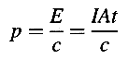
When a parallel beam of light, of intensity or energy flux I, falls perpendicularly on an absorbing surface of area A, the energy E incident in a time t is equal to I At. The momentum p transferred to the surface is given by

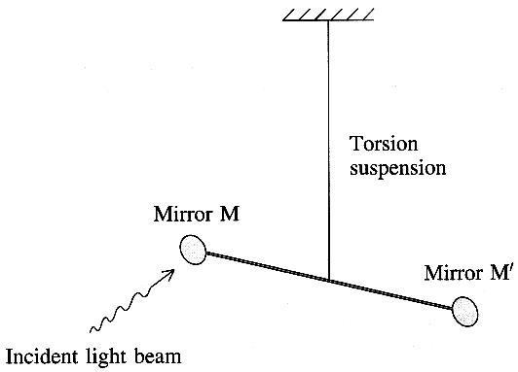
where c is the speed of light. When the light is entirely reflected from the surface the momentum
transfer will be twice this amount, just as a perfectly elastic ball transfers twice its initial
momentum when it bounces from the Earth.
The first measurement of radiation pressure was made more than
a hundred years ago by Nichols and Hull using a torsion balance
technique.
Incident light beam They allowed light to fall on mirror M in the
diagram, causing the balance arm MM' to turn through a measured
angle θ. By switching the beam on and off, they were able to find
the resonant frequency f₀ of the torsion balance. A knowledge
of θ and f₀. together with details of the suspended mirror system,
enabled them to calculate the force, and hence the radiation
pressure, exerted by the light. The intensity of their light beam
was measured by allowing it to fall on a blackened metal disc
and measuring the rise in temperature of the disc. Their experiments measured a radiation pressure of 7.01 μPa compared to the predicted value of 7.06 μPa.
[Adapted from D Halliday and R Resnick: Physics parts I and II Combined, third edition, 1978]

(a) Explain the meaning of the following phrases as used in the passage:
(i) radiation pressure (paragraph 1), (ii) down wind (paragraph 1), (iii) perfectly elastic (paragraph 2). (5)

(b) (i) Show that p = I At / c is homogeneous with respect to units.
(ii) Light of intensity 12Wcm⁻² falls for 30 minutes on a mirror of area 460 cm² which reflects 80 % of the incident light. Calculate the energy reflected from the mirror in this time. (7)
(c) Consider the following argument:
The momentum transferred to the surface = I A t / c (paragraph 2)
Hence the force exerted on the surface = I A / c (step 1)
Hence the pressure on the surface = I / c (step 2)
(i) State the physical principle used in step 1. State the physical principle used in step 2.
(ii) In sunlight the force on two sails, each of area 2 km², is of the order of 10 N each at a distance from the Sun equal to the Earth's orbital radius. Discuss the viability of using such sails to propel space vehicles, already in orbit, to reach the outer planets of the solar system. (5)

(d) Refer to the experiment performed by Nichols and Hull (paragraph 3).
(i) Describe how the balance arm was set into resonant oscillations and sketch a graph of the amplitude of oscillation against the forcing frequency. (ii) Suggest two ways of modifying the apparatus to increase the angle θ through which the balance arm MM' rotated when M was illuminated. (5)
(iii) State what data and what measurements, in addition to the rise in temperature of the disc, would be needed in order to establish the intensity of the light beam used. (iv) The calculated uncertainty in their measured value, 7.01 μPa, of the pressure of light was 1.5 %. Discuss briefly whether or not the result of their experiment confirms the theory of radiation pressure. (5)
(e) (i) Why is the fact that light can transport linear momentum surprising? (paragraph 1).
(ii) By considering the equation p = E / c , show that the momentum of a single photon of yellow light of energy E, for which λ = 560 nm, is about 10 ⁻²⁷ N s. (4)
(f) Draw a sketch to illustrate "the way the tails of comets stream away from the Sun" (paragraph 1). Your sketch should show the direction in which the comet is moving as well as the direction of the tail. (2)

TOTAL FOR SECTION I: 33 MARKS
Section II
Answer ALL questions

2. In 1932 Cockroft and Walton accelerated protons through a few hundred kilovolts and directed them at a lithium-7 target placed in a cloud chamber. The diagram illustrates the outcome of the experiment.
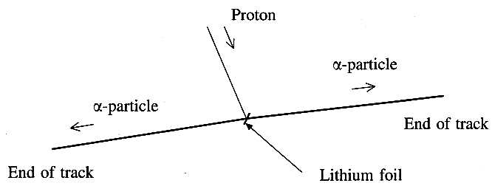

(a) (i) What evidence is there in the diagram that the two α-particles have the same initial energy?
(ii) Write a nuclear equation for this event. (4)
(iii) Calculate the kinetic energy of the pair of α -particles in joules, given
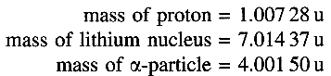
State any assumption you make. (4)

(b) Describe how the tracks of the protons and α -particles are produced in either a cloud chamber or a bubble chamber. You may be awarded a mark for the clarity of your answer. (4)

(c) As the proton approaches the lithium-7 nucleus, it is attracted gravitationally and repelled electrostatically.
Show that the ratio of the electrostatic force between these two particles to the gravitational force between them is independent of their distance r apart.
Hence show that this ratio is a very large number.
(You were expected to refer to the data on the data sheet provided at the end of the paper.) (4)

(Total 16 marks)

3. (a) A car is advertised as being able to accelerate from 0 to 60 miles per hour in 4.5 s.

(i) Given that 1 mile = 1.6 km, calculate the average acceleration of the car.
Express this acceleration as a fraction of the acceleration of a freely falling body close to the Earth's surface.

(ii) the diagram shows a free-body diagram for a front wheel drive car as the car accelerates from rest.
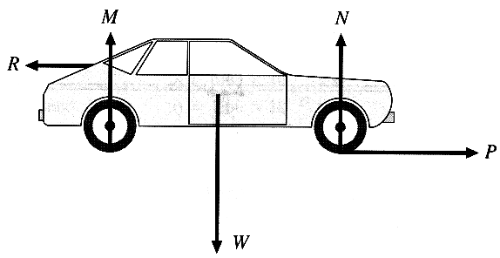

R is the backward push of the air on the car. Describe, in similar terms, each of the forces P and W. (5)

(iii) The car's power unit may be considered as a heat engine.
Draw a labelled energy flow diagram for this heat engine. (4)
(b) The car is later travelling at a constant velocity v of 29 m s ⁻¹. A speed trap measures this velocity using microwaves of frequency 1.1 x 10¹⁰ Hz.

(i) When the microwaves are reflected from the receding car, a Doppler shift is detected.
What is meant by a Doppler shift?

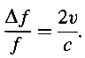
In this case

Calculate the Doppler shift in this case. (3)

(ii) The wavelength of the microwaves used can be measured in the laboratory. Describe how this could be done. (4)

(Total 16 marks)

4. The diagram shows a plan view of two horizontal parallel railway rails a distance d apart connected at one end by a conducting link WZ of resistance R. The rails have negligible electrical resistance.
An engineer rolls an axle XY, of resistance r, along the rails at a speed v.
The vertical component of the Earth's magnetic flux density B_{v} acts downwards as indicated.

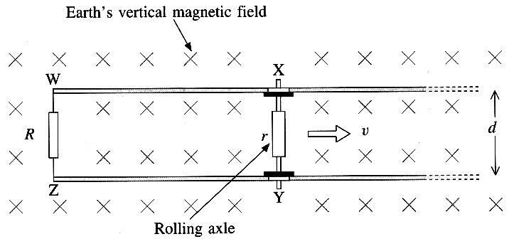

(a) As the axle moves along the rails an e.m.f. ε is induced in the circuit WXYZ.
(i) Explain the origin of this induced e.m.f.

(ii) The size of the e.m.f. is given by ε = B_{v} v d.
Suggest suitable values for d and v and hence estimate a value for ε. Take B_{v} to be 48 μT (5)

(iii) Show that the power P transferred to the conducting link of resistance R in the circuit WXYZ
can be expressed as
P = ε² R / ( R + r )². (3)

(b) (i) A small-scale model of this system is set up in a laboratory.
State what additional apparatus is needed, how it is used and what readings need to be taken to determine the power transferred to the resistor forming the conducting link in the model. (4)

(ii) It is suggested that in the laboratory the axle could be driven along the rails by replacing the conducting link WZ with a battery capable of delivering large currents.
Explain how the system would work.
Comment on the practicability of driving a train in this way. (3)

(Total 15 marks)

TOTAL FOR SECTION II: 47 MARKS

TOTAL FOR PAPER: 80 MARKS

