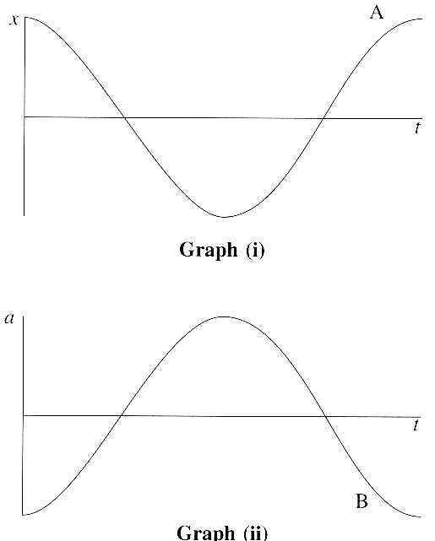
1. Define simple harmonic motion (s.h.m.). (2)
On graph (i), the curve labelled A shows how the
displacement x of a body executing simple harmonic
motion varies with time t.
On graph (ii), the curve labelled B shows how
the acceleration a of this body varies over the same
time interval.

Copy either graph and add to it a curve labelled C
showing how the velocity of this body varies over the
same time interval.
Which pair of curves illustrates the definition
of simple harmonic motion? (3)
A long simple pendulum has a natural frequency of
0.092 Hz. What is the length of this pendulum? (3)

2. A space station orbits the Earth once every 91 minutes.
Calculate the angular speed of the space station. (3)
The space station orbit is 210km above the surface
of the Earth, which has a radius of 6370km.
Find the acceleration of the space station. (3)
A box of mass 4.1 kg is located inside the space station.
What is the size and direction of the resultant force
acting on the box in the space station? (3)

3. Radio waves and sound waves are sometimes confused by the general public.
Complete a copy of the table below to give three ways in which they differ. (3)
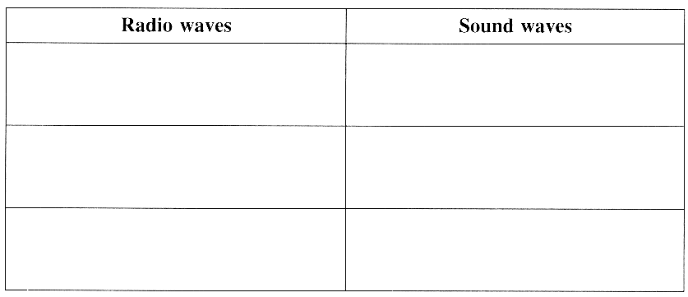

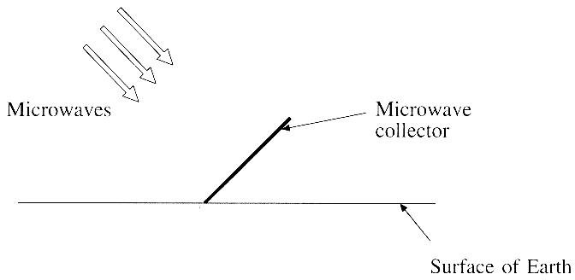
It is proposed to place a solar power station in
orbit around the Earth. The solar power station
will convert sunlight to microwave energy.
Microwave collectors on Earth will convert the
microwaves into electricity.
The solar power station orbits the Earth at a
constant distance from the surface of 36 000 km.
The total area of the collectors is equivalent to
a rectangle with dimensions of 120m by 250m.
The collectors are used to generate 600 kW of
power. Calculate the intensity of the microwaves
at the collectors. State any assumption that you make. (3)
Calculate the total power which the orbiting station would have to emit if it transmitted all directions.
State any assumption that you make. (3)
Suggest a more efficient method of transmitting the microwave energy to the collectors on Earth. (1)

4. The diagram opposite shows the lowest four energy levels of atomic
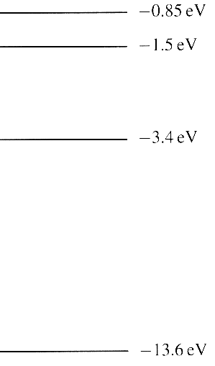
hydrogen. Calculate the ionisation energy in joules for atomic hydrogen. (2)
On a copy of the diagram above draw
(i) a transition marked with an R which shows a photon released with
the longest wavelength,
(ii) a transition marked with an A which shows a photon absorbed
with the shortest wavelength. (2)
Describe how you would produce and observe the emission spectrum
of hydrogen in the laboratory. What would such a spectrum look like? (3)
The 211 mm line of atomic hydrogen is often used in studying stars
or galaxies. To which region of the electromagnetic spectrum does this
line belong? (1)
A galaxy is observed with the 211mm line shifted to a wavelength
of 203mm. Calculate the speed of this galaxy.
What else can be deduced about the motion of this galaxy? (4)

5. The photoelectric effect supports a particle theory of light but not
a wave theory of light. State two features of the photoelectric effect
which support the particle theory of light but which do not support
the wave theory of light. For each feature explain why it supports
particle theory and not wave theory. (5)

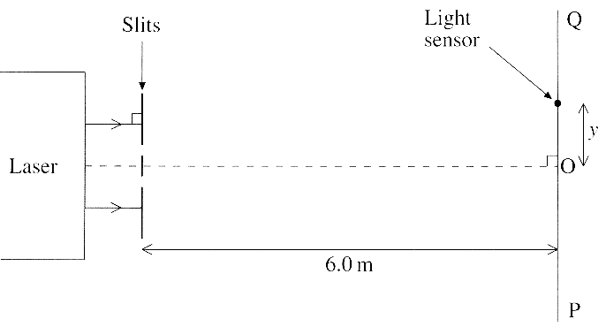
6. The diagram shows, not to scale, an experimental
arrangement for studying the transmission of light
by a double slit.
Monochromatic light from a laser falls normally
on two narrow, closely spaced parallel slits.
The intensity of light transmitted is studied by
moving a small light sensor along the line PQ,
at a perpendicular distance of 6.0 m from the slits.
The graph shows how the light intensity varies with
distance y from the mid-point 0.
Explain with the aid of a diagram why the two
light waves from the slits produce a minimum intensity at X. (2)
Point 0 is equidistant from the slits.
State, in terms of the wavelength λ, the path difference between the waves arriving at Y.
What is the phase difference, in radians, between the waves arriving at point Y? (2)
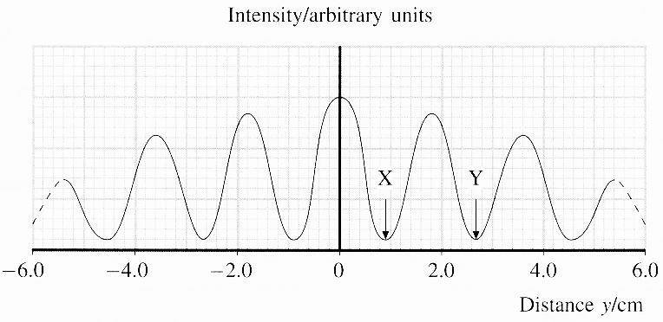

The spacing of the slits in the experiment was 0.20mm. Use this, together with information from the diagrams, to calculate the wavelength of the light. (3)
One of the two slits is now covered up and the experiment is repeated.
Add a line to a copy of the graph to show how you would expect the light intensity to vary with the distance y. (2)

7. Describe with the aid of a diagram how you could produce stationary waves on a string. (3)
Explain how you could use a stationary wave to determine the speed of travelling waves on the string.
You may be awarded a mark for the clarity of your answer. (4)

[TOTAL FOR PAPER: 60 MARKS]

