Topic D – Medical Physics

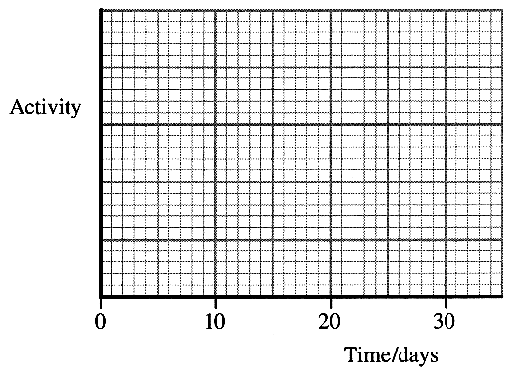
4. (a) An isotope of iodine ¹³¹I is produced when unstable
tellurium ¹³¹₅₂Te undergoes β ⁻ decay.
Write a nuclear equation for this decay. (2)

The unstable tellurium is produced when stable ¹³⁰₅₂Te is
bombarded with neutrons.
Where might such a reaction be carried out? (1)

State three factors which must be considered when
choosing a radionuclide for organ imaging. (3)

¹³¹I has a half-life of 8 days and a biological half-life of 21 days.
Calculate the effective half-life of ¹³¹I. (2)

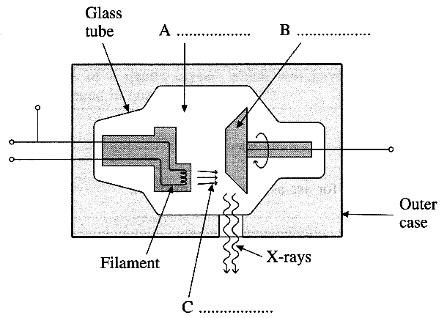
On a copy of the axes opposite and above sketch two curves, one
showing the activity of a sample of ¹³¹I kept in a laboratory
and the other showing the activity of a sample given to a patient.
Assume both samples have the same initial activity.
Label your curves L (laboratory) and P (patient). (3)

(b) The diagram below shows the main features of an X-ray tube.
Identify features A, B and C. (3)

An X-ray beam has an intensity of 20 MW m⁻² at a distance
of 0.10 m from a point source of X-rays.
What will be the intensity 1.0 m from the source? (2)

(c) Describe how it is possible to obtain information about the
depths of structures in a patient's body by using an ultrasonic A-scan.
You may be awarded a mark for the clarity of your answer. (5)

Explain why a coupling medium is essential between the body surface and the ultrasound probe. (2)
State a suitable substance for use as a coupling medium. (1)

(d) Read the short passage below and answer the questions about it.

The piezoelectric effect is a reversible relationship between mechanical stress and electric potential difference exhibited by certain crystals such as quartz. When a piezoelectric crystal is compressed, positive and negative charges appear on opposite crystal faces producing a potential difference across the crystal. Replacing the pressure by tension reverses this potential difference. If instead an electric potential difference is applied across the crystal then its thickness changes. A piezoelectric crystal placed in an alternating electric circuit will thus expand and contract. These effects are used in ultrasonic generators and detectors. The maximum transfer of energy occurs at a particular frequency called the resonant frequency. The wavelength of the ultrasound produced by a piezoelectric crystal at its resonant frequency is equal to twice the crystal thickness. [Adapted from Phaidon Concise Encyclopaedia of Science and Technology}
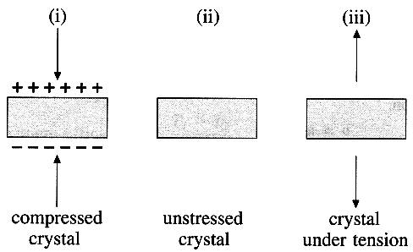
Explain what is meant by a reversible relationship. (2)

Diagram (i) shows the charge distribution on a compressed
piezoelectric crystal. Show the charge distribution on the
crystals on a copy of diagrams (ii) and (iii). (2)

Calculate the thickness of a quartz crystal which will have a
resonant frequency of 1.50 MHz..
( Speed of sound in quartz = 5740 ms⁻¹ ) (3)

What is the benefit of applying the alternating potential
difference at the resonant frequency of the quartz crystal? (1)

(Total 32 marks)

