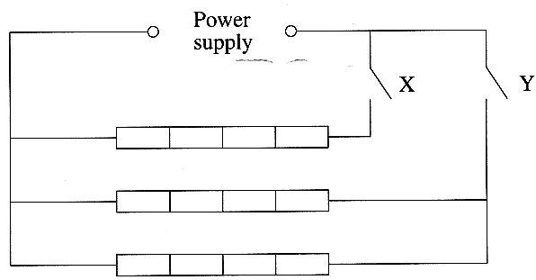
1. State the unit of the base quantity current. (1)
Determine the base units of potential difference. (3)

2. An electric room heater consists of three heating
elements connected in parallel across a power supply.

Each element is made from a metal wire of resistivity
5.5 x 10 ⁻ ⁵ Ω m at room temperature. The wire has a
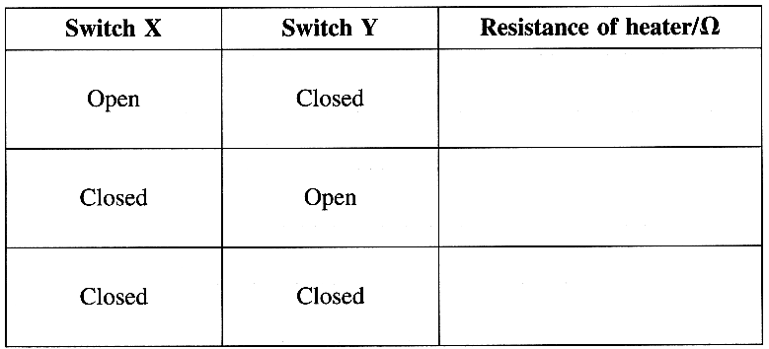
cross-sectional area 8.0 x 10 ⁻ ⁷ m² and length 0.65 m.
The heater is controlled by two switches, X and Y.
Show that the resistance of one heating element at
room temperature is approximately 45 Ω. (3)

Calculate the total resistance of the heater for the
combinations of switches, shown in the table,
at the moment the switches are closed. (3)

Calculate the maximum power output from the
heater immediately it is connected to a
230 V supply. (2)
After being connected to the supply for a few minutes the power output falls to a lower steady value.
Explain why this happens. (2)

3 A thick wire is connected in series with a thin wire of the same material and a battery. In which wire do the electrons have the greater drift velocity? Explain your answer. (3)
A battery is connected across a large resistor and a small resistor is connected in parallel. The currents through the resistors are different. Which resistor has the higher dissipation of power? Explain your answer. (3)

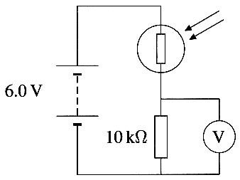
4. The circuit opposite can be used as a lightmeter.
The maximum value of resistance of the light-dependent resistor (LDR) is 950 k Ω.
What is the reading on the voltmeter for this resistance ?
The minimum value of resistance of the LDR is 1.0 k Ω. .
What is the reading on the voltmeter for this resistance? (3)
For this lightmeter the voltmeter is connected across the 10 k Ω resistor,
rather than the LDR. Explain how the readings on the voltmeter enable
this circuit to be used as a lightmeter. (2)

5. A student investigates how the current in a resistor varies as the potential difference across the resistor is varied. Draw a suitable circuit diagram for the investigation. (3)
The graphs show the variation of current with potential difference for a filament lamp and for an ohmic resistor.
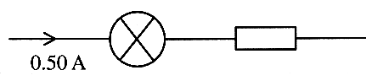
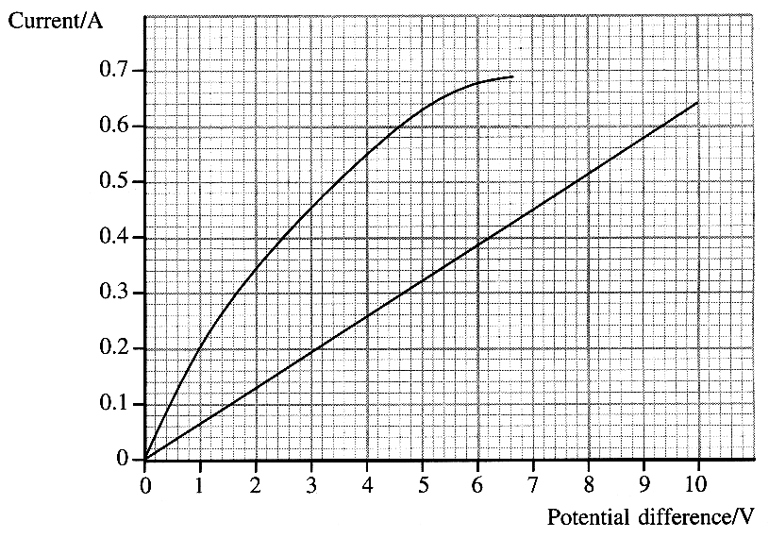
Identify which graph is for the lamp and which is for the resistor. (1)
The lamp and resistor are connected in series as shown. There is a current of 0.50 A.
Use the graph to find the total potential difference across the combination. (2)
What is the resistance of the lamp under these conditions? (2)

6. Define the term specific latent heat of fusion. (3)

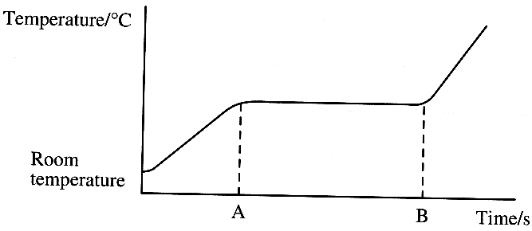
The graph shows how the temperature of a heated metal
sample varies with time.
During the time interval AB, the metal changes from a solid
to a liquid whilst still being heated. Explain, in molecular
terms, what is happening to the energy being supplied
during this time. (1)
Describe, in molecular terms, the main differences between
the solid and liquid states. You may illustrate your answer with simple diagrams. (2)
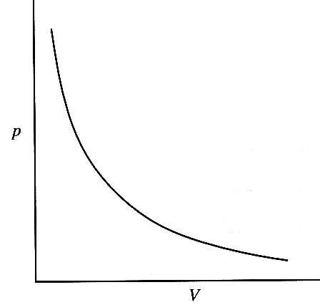
7. The graph shows the relationship between the pressure p and the volume V
of a fixed mass of dry air.
Write down the formula for this relationship. (1)

A uniform thin tube, sealed at one end, contains a thread of mercury which
traps a column of dry air. The other end of the tube is open to the atmosphere.
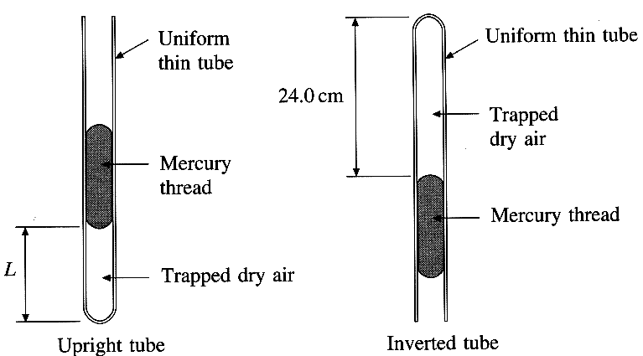

The length of the column of air changes when the tube is inverted. In each case the thread of mercury exerts a pressure of 0.20 x l0⁵ Pa and atmospheric pressure is 1.00 x l0⁵ Pa.
What is the pressure of the trapped dry air (i) when the tube is upright? (ii) when the tube is inverted? (2)
The final length of the column of air is 24.0 cm.
Calculate the initial length L in centimetres, when the tube is upright. (3)
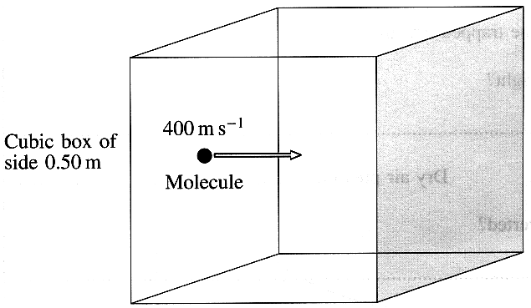
What assumption did you make about the dry air? (1)

8. A cubic box with sides of length 0.50 m contains a gas.
There are 1.5 x 10²⁴ molecules inside the box.
A molecule is moving at 400 m s ⁻¹ in a direction perpendicular
to the shaded face. The average rate of change of momentum for
this molecule at the shaded face is 1.6 x l0 ⁻ ²⁰ kg m s ⁻².
State the two assumptions that the kinetic theory makes about the
collisions of this molecule with the shaded face. (2)
One third of all the molecules strike the shaded face.
Calculate the average force exerted by these molecules if
their average speed is 400 m s ⁻ ¹. (3)
Hence calculate the gas pressure on the shaded face. (2)
The formula from kinetic theory for the pressure exerted by a gas is given by p = ¹/₃ ρ < c² >
State what the term < c² > represents. (1)
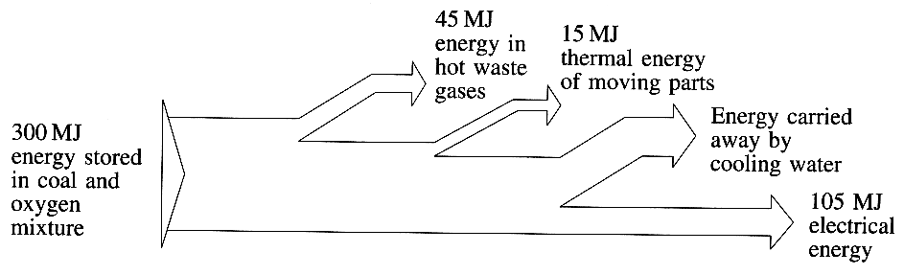
9. Outline the principle of operation of a
heat engine. You may be awarded a mark
for the clarity of your answer. (4)

The diagram shows the energy flow
for a typical coal-fired power station.
Calculate how much energy is carried
away by the cooling water. (1)
Calculate the efficiency of the power station. (1)

TOTAL FOR PAPER: 60 MARKS

