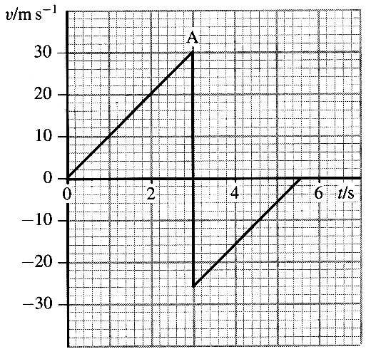
1. A ball is dropped from a high window onto a concrete floor.
The velocity-time graph for part of its motion is shown.

Calculate the gradient from the origin to A.
Comment on the significance of your answer. (3)

What happened to the ball at point A? (1)
Calculate the height of the window above the ground. (3)

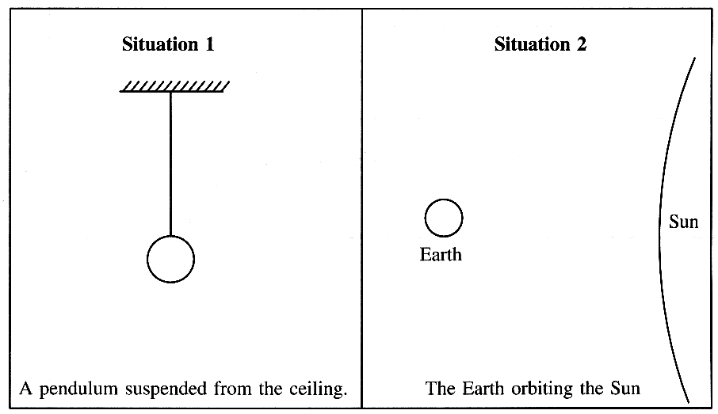

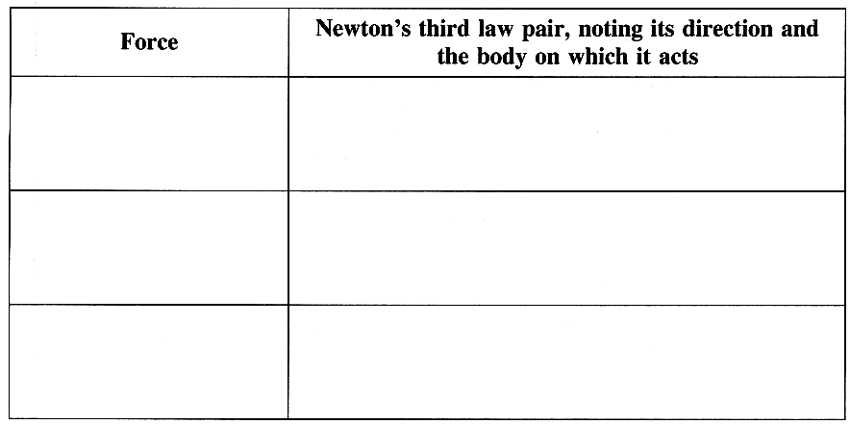

2. The diagrams above show two situations in which
forces act.
Complete labelled free-body force diagrams for
the pendulum bob in situation 1 and for the Earth in
situation 2. (3)

In a copy of the table opposite, write in the left-hand
column each of the forces you have shown.
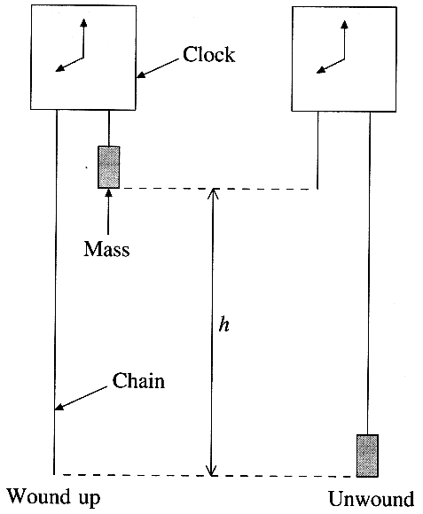
Then complete the right-hand column. (3)

3. A "grandfather" clock is a type of clock where the energy needed to
provide the movement of the hands comes from a falling mass.

To wind up the clock, the mass has to be raised a distance h.
In one such clock, the mass is a steel cylinder of diameter 0.060m
and height 0.17 m. Show that its mass is approximately 4 kg.
(The density of steel is 7.8 x 10³ kg m ⁻³.) (3)

The distance fallen by the mass is 1.l m.
Calculate the change in its gravitational potential energy. (2)
The clock has to be wound up once per week.
Calculate the average power output of the falling mass. (3)

4. In the context of the lever, Archimedes is recorded as saying
"Give me a long enough lever and I will move the Earth."
Explain in terms of the principle of moments the point
Archimedes was making. (2)
Comment on how practical Archimedes' suggestion really is. (2)

5. (a) State Newton's second law of motion. (2)
Describe how you could demonstrate experimentally that the acceleration of a trolley is proportional to the resultant force which acts on it. (5)

Turn over for the rest of Q5.
(b) Behind the windscreen of some cars there is a shelf, which is horizontal, but recessed to stop objects from falling off.
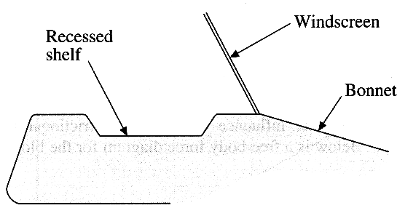
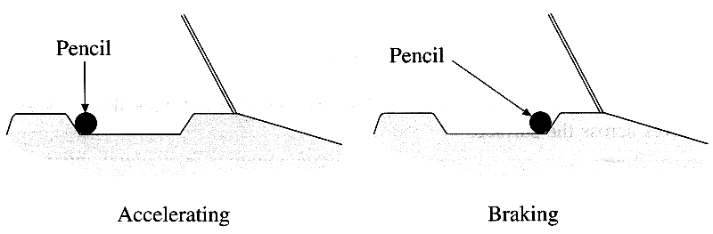

A pencil has been left on the shelf. Whenever the car accelerates forwards, the pencil is against the rear edge of the shelf. Whenever the car is braking the pencil is against the front edge.
Explain these observations. You may be awarded a mark for the clarity of your answer. (5)
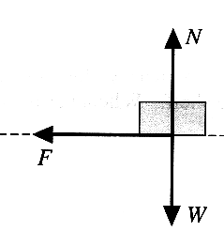
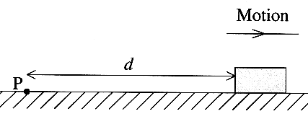
6. A block is projected from a point P across a rough,
horizontal surface.
The block slows down under the influence of a constant
frictional force F and eventually comes to rest.
On the right is a free-body force diagram for the
block whilst it is moving.
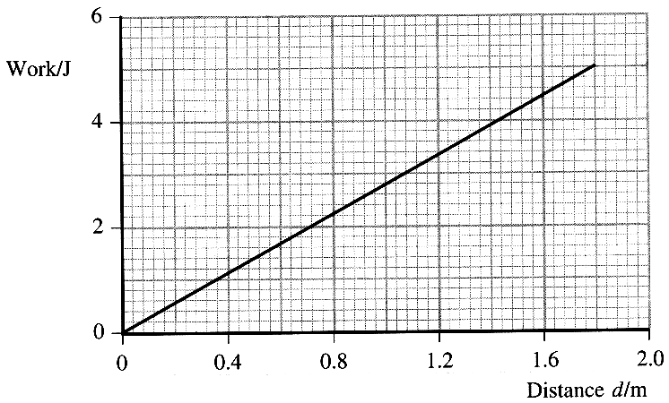
State, with a reason, the amount of work done by each
of the forces W and N as the block moves across the
surface. (2)

The sliding block does work against friction. The graph
shows how the total work varies with the distance d which
the block has travelled from the projection point P.
Use the graph to determine the force F. (2)

The block comes to rest 1.80 m from P. Add a line to a copy of
this graph above to show how the kinetic energy of the block
varied during the motion. (2)

The mass of the block was 0.820 kg. Calculate the speed with which it was projected from P. (2)

Suppose that, instead of a constant friction force, the block had been brought to rest by a drag force (air resistance) which depends on speed. Sketch a graph to show qualitatively how you would expect the total work done against air resistance to vary with the distance d. (1)
Explain the shape of your graph. (1)

7. How many neutrons does the nucleus of ¹⁴₆C contain?
Carbon-14 has a half-life of 5600 years. Calculate the decay constant of carbon-14. (3)
A sample of 14 g of carbon-14 contains 6.0 x 10²³ nuclei.
How many nuclei are there in 7.0 x 10 ⁻ ⁹ g of carbon-14 ?
Hence calculate the activity of 7.0 x 10 ⁻ ⁹ g of carbon-14. (3)
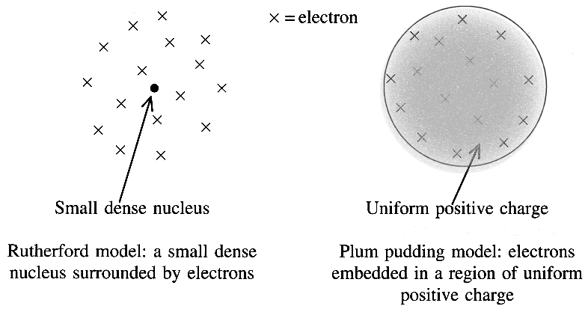
Carbon-14 is a beta-minus emitter and its decay product is a nucleus of nitrogen, N. Write down a nuclear equation demonstrating this decay. (2)

8. Two possible structures of the atom were proposed
in the early 1900s. They were the Rutherford and
"plum pudding" models, as shown.

Geiger and Marsden scattered alpha particles off gold
atoms. Outline the evidence from this experiment that
supported Rutherford's model. (3)
Suggest what Geiger and Marsden would have
observed if the "plum pudding" model had
been correct.
Explain your answer. (2)

TOTAL FOR PAPER: 60 MARKS

