1. The diagram shows a trolley moving down a gentle slope.
Add forces to a copy of the diagram below to produce
a free-body force diagram for the trolley. [3]

The trolley is photographed by a multiflash
technique. The result is shown opposite.
What evidence is there that the trolley is moving
with constant velocity? [1]
State the acceleration of the trolley down the slope. [1]
What does the value of the acceleration indicate about the forces acting on the trolley? [1]
2. The 'London Eye' is a large wheel which
rotates at a slow steady speed in a vertical plane
about a fixed horizontal axis. A total of 800
passengers can ride in 32 capsules equally
spaced around the rim. A simplified diagram
is shown opposite.
On the wheel, the passengers travel at a speed
of about 0.20 m s⁻¹ round a circle of radius
60 m. Calculate how long the wheel takes to
make one complete revolution. [2]
What is the change in the passenger's velocity
when he travels from point B to point D? [2]
When one particular passenger ascends from
point A to point C his gravitational potential
energy increases by 80 kJ.
Calculate his mass. [3]
Sketch a graph showing how the passenger's
gravitational potential energy would vary with
time as he ascended from A to C.
Add a scale to each axis. [3]
Discuss whether it is necessary for the motor driving the wheel to supply this gravitational potential energy. [2]

3. Define linear momentum. [1]
The principle of conservation of linear momentum is a consequence of Newton's laws of motion. An examination candidate is asked to explain this, using a collision between two trolleys as an example. He gives the following answer, which is correct but incomplete. The lines of his answer are numbered on the left for reference.
1. During the collision the trolleys push each other.
2. These forces are of the same size but in opposite directions.
3. As a result, the momentum of one trolley must increase at the same rate as the momentum of the other decreases.
4. Therefore the total momentum of the two trolleys must remain constant.
In which line of his argument is the candidate using Newton's second law? [1]
In which line is he using Newton's third law? [1]
The student is making one important assumption which he has not stated. State this assumption. Explain at what point it comes into the argument. [2]
Describe how you could check experimentally that momentum is conserved in a collision between two trolleys. [4]

4. State the number of protons and the number of neutrons in ¹⁴₆C. [2]
The mass of one nucleus of ¹⁴₆C = 2.34 x 10⁻²⁶ kg. The nucleus of carbon-14 has a radius of 2.70 x 10⁻¹⁵ m.
Show that the volume of a carbon-14 nucleus is about 8 x 10⁻⁴⁴ m³. [2]
Determine the density of this nucleus. [2]
How does your value compare with the densities of everyday materials? [1]
Carbon-14 is a radioisotope with a half-life of 5700 years. What is meant by the term half-life? [2]
Calculate the decay constant of carbon-14 in s⁻¹. [2]
5. A student performs an experiment to investigate how the forces exerted on a bridge by its supports vary as a vehicle
crosses the bridge. She models the bridge and vehicle using a metre rule and a suspended mass. Copy, complete and label the first diagram, below left, to show a way of supporting the ends of the rule so that the forces exerted on them can be measured. [2]

The second diagram is a free-body
force diagram for the rule.
P and Q are the forces exerted by the
supports; W and V are equal to the
weights of the rule and suspended
mass.
The graph shows how Q was found to
vary with the position of the mass.
State the principle of moments. [2]
Use this principle to explain, without
calculation, why force Q increases as
distance d increases. [2]
Using information from the graph,
calculate the value of W. [3]

6. A student has a sample of a
radioactive element which is thought to
be a pure beta emitter. The student has
only the following apparatus available:
• a thin window Geiger-Muller tube connected to a counter
• a piece of aluminium 3 mm thick, and
• a half-metre rule
How would the student determine the background radiation level in the laboratory? [2]
The student investigates how the count rate varies with distance from the source to the G-M tube and also the effect of inserting the aluminium absorber. From these experiments explain how the student could confirm that the sample was a pure beta emitter. You may be awarded a mark for the clarity of your answer. [5]

7. Copy and complete the following table which compares alpha particle scattering and deep inelastic scattering experiments. [2]
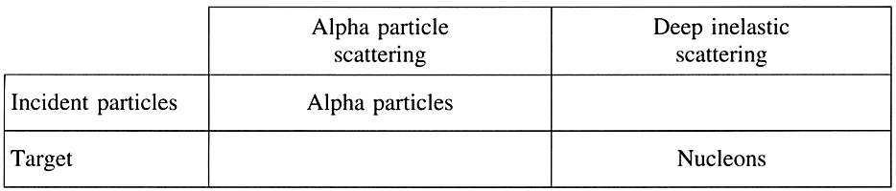
Write a short paragraph describing the conclusion from
(a) the alpha particle scattering and
(b) the deep inelastic scattering experiment. [4]

