1. A lambda particle enters a detection chamber, and decays, at point C, into a pion (which has charge -1) and a proton. The lambda particle itself leaves no visible track. A magnetic field acts at right angles to the plane of the diagram.

Explain how the diagram confirms that the pion is negatively charged.

(2)

State the charge carried by the lambda particle, explaining your reasoning.

(2)

Explain how you can deduce from the diagram that the proton has more momentum than the pion.

(2)

The angle between the proton and the pion tracks at point C is 49°. The momentum of the proton is 6.0 x 10⁻¹⁸kg m s ⁻¹, and the momentum of the pion is 5.0 x 10⁻¹⁸kg m s ⁻¹.
Use a scale drawing to find the magnitude of the momentum of the lambda particle.

(3)
The quark composition of two of the three particles is as follows:
_
pion ud lambda uds

Particles composed of quarks are classified as either baryons or mesons. Tick the correct classification for each of these two particles.

Baryon meson

pion ........... ...........

lambda ........... ...........
(2)
The charge of an up quark (u) is + 2/3 e.

Deduce the charge of a down quark (d).

(1)
(Total 12 marks)

2. A large current such as that in a power station or power line (e.g. 2000 A) is hard to measure using a conventional meter simply connected in series. The usual technique makes use of the fact that this current is alternating. A ring of iron is clamped round the wire whose current (l₁ in the diagram) is to be measured. A coil with 1000 turns is wound round the iron. An induced current flows in this coil; by measuring this current (l₂) with a conventional meter, it is possible to calculate the value of l₁.

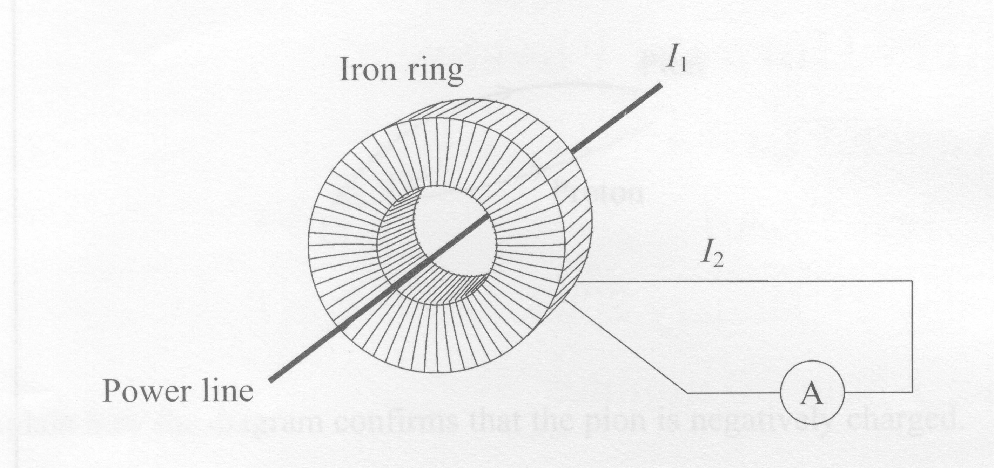

Suggest a reason why it is difficult to measure a large current with a conventional meter in series in the circuit.

(1)

Explain how the alternating current l₁ causes the current l₂.

(4)

Assume that the device functions as an ideal transformer. The power line is its primary coil, with one turn; its secondary is the coil round the iron ring, with 1000 turns.

What does ideal mean?

(1)

Calculate the value of l₂ if l₁ is 2000 A.

l₂= ________________________
(2)

(Total 8 marks)

3. The diagram shows part of a wind-direction indicator. A wind-vane is attached to the disc via an axle. The disc has four circular lines of slots cut in it as shown. A lamp illuminates the disc from above; below the disc are four photodiodes, one in line with each slot. As the wind direction changes, the disc rotates, and different slots allow light to fall on different combinations of photodiodes. The computer decodes the output frorn the photodiodes into a wind direction.

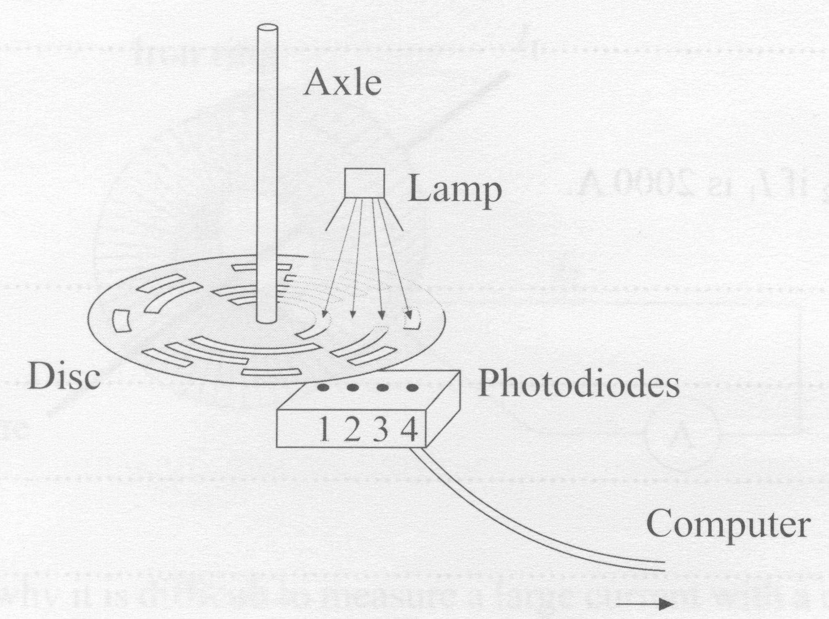

When the wind direction is from the North (as in the diagram below), the device encodes the output from the photodiodes as 1101.

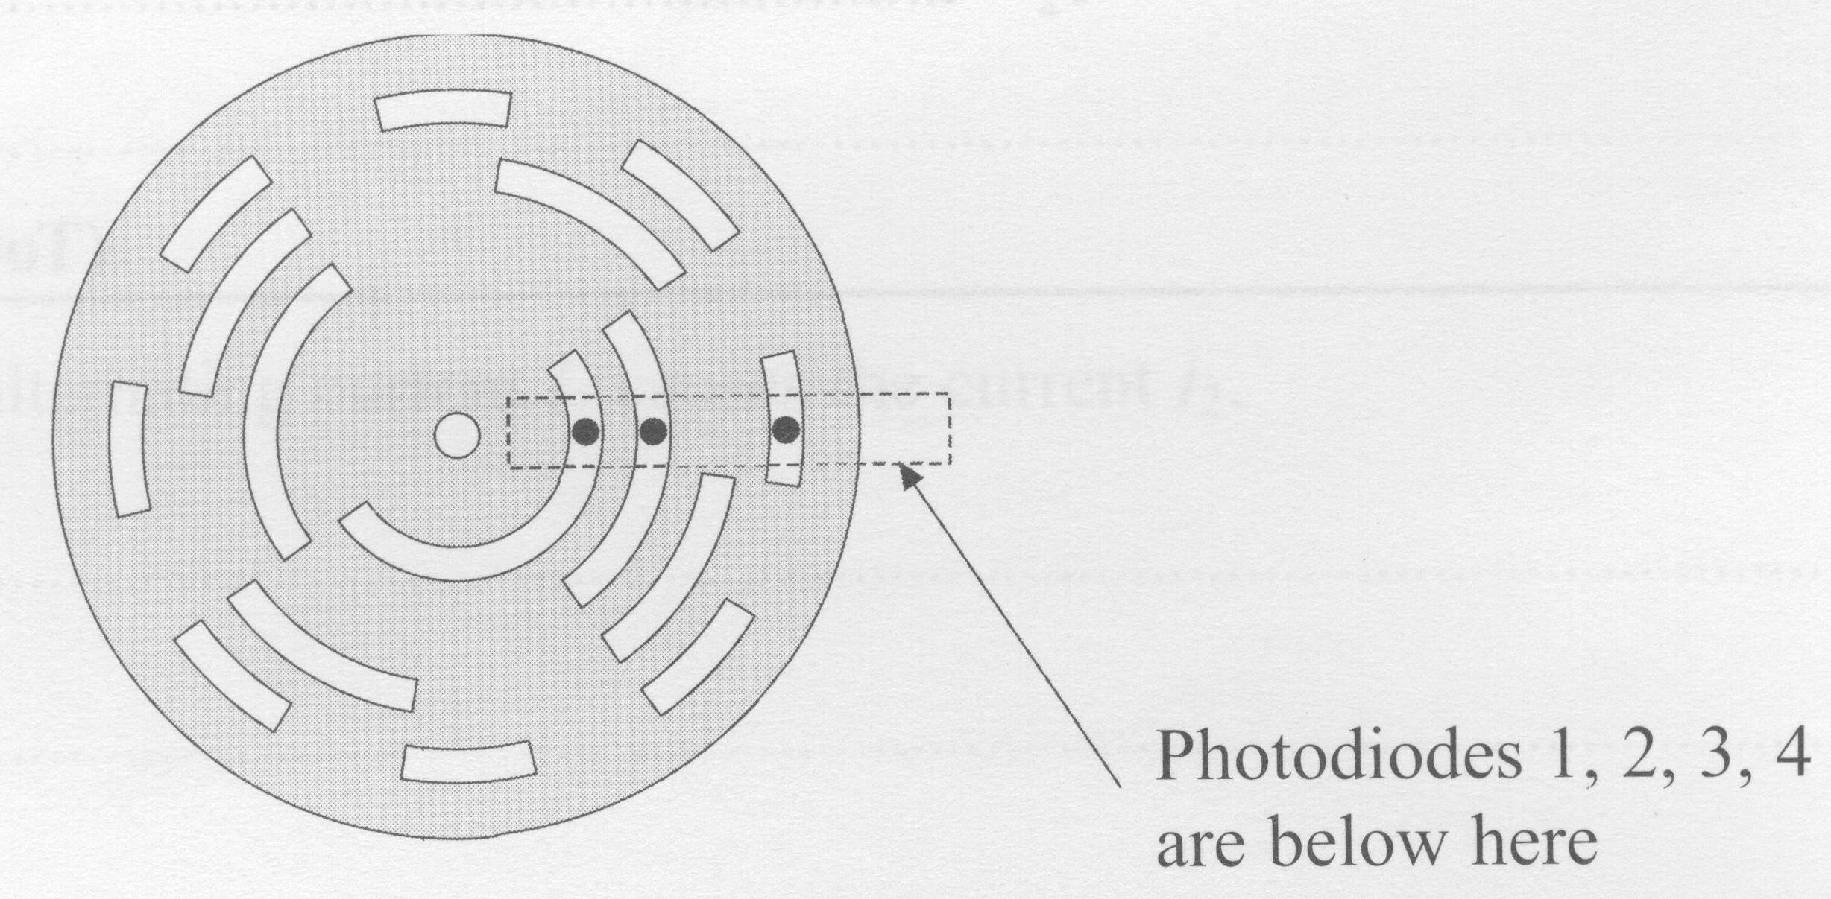

What code corresponds to a wind from the South`?

Code = ________________

(1)

Explain how such a device can detect and encode sixteen different wind directions using four photodiodes.

(3)

Through what angle can the wind change while the readout still shows the same wind direction?

Angle = _________________
(1)

(Total 5 marks)

4. In 1998 NASA launched the probe called Deep Space 1. Once in orbit, this probe was the first to use a solar powered ion drive to propel it on its mission.

The diagram shows the main features of the ion drive.

Atoms of xenon are ionised and then accelerated until they are ejected out of the rear of the probe, providing the means of propulsion.

Explain how the ions arc accelerated.

(2)

A xenon atom is ionised by the loss of a single electron. Show that its speed after being accelerated is about 4 x 10⁴ ms⁻¹.

Mass of xenon ion = 2.20 x 10⁻²⁵ kg.

(4)

The mass of xenon ejected in one second is 2.10 x 10⁻⁶ kg. Calculate the thrust on the space probe.

Thrust = ________________
(3)

Simply firing xenon ions into space would leave the probe negatively charged. Suggest a reason why this would lead to reduced thrust.

(1)

Chemical rockets eject their propellant at about a tenth of the velocity achieved by ion drives, but produce much greater thrust by ejecting more than a thousand kilograms per second.

Suggest why ion drives may be preferable for missions extending over long distances and periods of time.

(2)

(Total 12 marks)

5. A method has been developed to measure the amount of hydrogen in the space between a distant galaxy and Earth. Ultra-violet (UV) radiation from the galaxy is partially absorbed by the hydrogen as it travels towards Earth. Scientists can work out the intensity of the UV that would be observed at the top of the Earth's atmosphere if there were no absorption in space (from other information), and measure the actual intensity as the UV arrives at the top of the atmosphere. Then, if they know how UV is absorbed by hydrogen, they can calculate the amount of hydrogen between the galaxy and Earth.

The equation I = I₀ e ^{-μx} can be used to describe the exponential relationship between the above quantities.

What quantity in the paragraph about the experiment corresponds to I₀?

(1)

What quantity corresponds to I?

(1)

What is meant by exponential?

(1)

Deduce the unit of μ. Show your reasoning.

(2)

For a particular situation within this galaxy, the intensity of the radiation is reduced to 10% of its initial value after a distance of 3 x 10¹⁷m. Calculate the value of μ.

(3)

Below are some values of hydrogen density and the corresponding distance to reduce the intensity of the UV to 10% of its initial intensity.

Hydrogen  density/ 10³ atoms m⁻³ | Distance to reduce intensity of UV to 10% of initial intensity/ 10¹⁷m
3000 | 3
100 | 90

Show that these data suggest that μ is directly proportional to hydrogen density.

(2)

(Total 10 marks)

6. The following passage describing the inhabited part of the spaceship Discovery is adapted from 2001: A Space Odyssey by Arthur C. Clarke.

The space ship travelling through deep space contained a slowly rotating drum, ten metres in diameter. As it made one revolution every ten seconds, this produced an artificial gravity equal to that of the moon.

Diagram 1 below represents an astronaut standing on the surface of the moon.
Diagram 2 represents the astronaut standing inside the rotating drum as described in the passage.

Complete the diagrams by adding arrows to show any other forces acting on the astronaut.

(2)

Discuss the extent to which the astronaut in the rotating drum would experience an artificial gravity equivalent to the gravity of the moon.

Gravitational field strength on the moon = 1.6 N kg⁻¹.

(5)

(Total 7 marks)

7. A student has four identical lamps. She connects up circuit 1. Using 5 V the lamp flashes briefly when the switch is moved from left to right. She then connects up circuit 2. Using 10 V with this arrangement, each of the four lamps gives a similar flash to the lamp in circuit 1.

Discuss the physics of what the student has observed.

(Total 6 marks)

