Read the following passage carefully and then answer all the questions.

The MIR space station

The first sections of this space station were launched in 1986 by the Russian space agency. Extra sections were then added to the space station until its total mass was 1.1 x 10⁵ kg. Cosmonauts from a number of different countries used this space station for experiments but by the year 2000 the orbit of MIR round the Earth had dropped to a dangerously low height of 350 km. At this height the effects of the atmosphere began to reduce the height of the orbit even more rapidly.

A private company wanted to lease MIR, save it from plunging back to Earth, and then offer a unique type of package holiday. A number of physicists suggested the use of a rather unusual electric motor designed to reboost MIR back to a safe orbit height. This system was known as the METS: Mir Electrodynamic Tether System. Extracts from the proposal follow:

"The motor is unusual because some of its key parts are produced by the Earth itself: its magnetic field and ionosphere. The rest of the motor is a 5 km long aluminium wire which is connected at one end to the existing solar cell array normally used to provide electrical power on board MIR. The solar cell array produces an average power output of 1.5 kW.

The diagram below shows MIR in orbit above the Earth's surface. A small mass is attached to the other end of the wire to help stretch it out so that it hangs vertically.

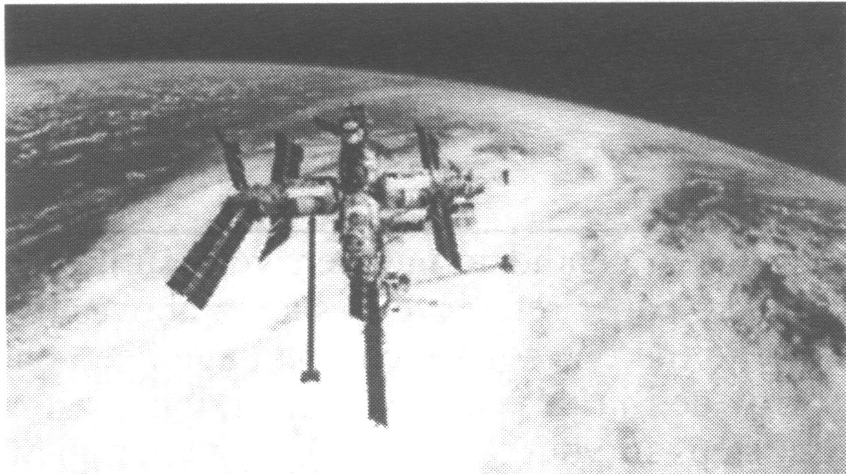

The combination of the current generated by an array of solar cells and the Earth's horizontal component of magnetic flux density (30 μT at this orbit height) produces a tiny force which can be used to boost MIR back to its original orbit.

At heights exceeding 80 km above the Earth's surface the atmosphere has such a low density that free electrons can exist for short periods of time before being captured by nearby ions. This region is known as the ionosphere. The ionosphere completes the circuit and allows a continuous flow of electrons through the wire.

The efficiency of the METS is about 80%. This is a much higher value than would be achieved using rockets to propel MIR back to a higher orbit."

The plan was eventually abandoned and MIR was directed into the Pacific Ocean in March 2001.

1. (a) Explain why the effects of Earth's atmosphere reduced the orbit height of MIR.

(2)
(b) The Earth's radius is 6700 km. Show that the magnitude of the gravitational field strength at a height of 350 km above the Earth's surface is about 9 N kg⁻¹.

(4)

(c) Show that the change in the gravitational potential energy of MIR is about 40 GJ if its height is increased by 40 km. You may assume that the change in g is negligible over the 40km.

(3)

(d) Calculate the average current in the tether if the terminal voltage of the solar cell array is 1000V.

Average current = ........................................... (2)

(e) Scientists predicted that MIR could be lifted by 40 km per year. Confirm that the efficiency of this system has approximately the value stated in the passage.

(3)

(f) The simplified diagram below shows MIR, its tether and Earth. Indicate and label a possible set of directions for the current, the magnetic flux density and resulting small force.

(2)

(g) Calculate the magnitude of the "small force" referred to in the passage.

Force = .............................................................
(2)

(h) Free electrons are produced in the atmosphere mainly by the interaction of UV sunlight and oxygen. Why do they remain free for an appreciable period of time only at a height exceeding 80km?

(2)

(Total 20 marks)

2. The current in the tether would be provided by a solar cell array on MIR. The graph below shows a set of current-voltage (I -V) curves for a particular solar cell for different light intensities. The cell was kept at 25 °C.

Draw a circuit diagram to show how a range of measurements of V and I could be taken for the solar cell at a given light intensity.

(3)
Show that the maximum power available for an intensity of 1000 W m⁻² is about 1.4 W.

(2)

It is suggested that maximum power is proportional to light intensity.
Without plotting any further graphs, analyse some of the data to comment on whether this suggestion is reasonable.

(3)
Data showing how the e.m.f., E of this cell depends on temperature t is provided in the table below.

E/ V t/ °C

0.62 12
0.59 25
0.54 50
0.51 63
0.48 75

Plot a graph off against t on the grid opposite.
(4)
Use the graph to determine a mathematical relationship between E and t.

(4)

The graph below shows the contribution of different wavelengths of light, arriving from the Sun, to the total intensity at a point just above the Earth's atmosphere.

This particular solar cell only produces current from light with a wavelength less than or equal to 1.1 x 10⁻⁶ m.

Use the graph to determine the light power from the sun that is available for conversion to electrical power in this satellite solar cell. The area of the solar cell is 4.0 cm².

(4)
(Total 20 marks)

3. The possibility of nuclear fusion experiments in your living room is getting closer! Lasers could be used to deliver a huge pulse of energy in a very short time to a small volume of deuterium (an isotope of hydrogen) to produce the conditions for fusion for just an instant.

A neodymium laser produces 40 J of coherent light of wavelength 1050 nm for a period of 400 fs (1 fs= 10⁻¹⁵ s).

Explain the meaning of the word coherent.

(1)
Calculate the power delivered by this laser.

Power =.............................................................
(2)

Calculate the energy level change taking place in atoms of neodymium when emitting light of the above wavelength.

(3)

The laser light is directed on to a small volume of deuterium fuel. This fuel is confined for a short time by its own inertia. The temperature increases considerably and fusion occurs for a brief instant converting deuterium into an isotope of helium.

Complete the nuclear equation for this fusion reaction by filling in the boxes.

(2)
The masses of the reacting nuclei are:

Nuclei Mass/u

²H 2.014 10
³He 3.016 03
¹n 1.008 67

1 u =1.66 x 10⁻²⁷ kg.

Show that the number of atoms of deuterium involved in the fusion process is about 10⁹ if the energy yield is only 10 millionths of the energy delivered by the laser (the efficiency is equal to 10⁻⁵).

(4)

Explain why the temperature must increase considerably in order for fusion to take place.

(2)
(Total 14 marks)

4. Today's telephone exchanges route telephone calls, which are electrical signals, using electronic switches. To route those telephone calls that are pulse code modulated on light beams in optic fibres might require tiny rotating mirrors. However, the design shown below is an optical switch without moving parts.

The channels labelled C act like optical fibres, carrying pulses of light. At each junction between two channels is a drop of fluid, F, with the same refractive index as the material in the channels. If a pulse of light needs re-routing along a different channel then a small voltage is applied to the fluid at that junction. The heating effect causes the fluid to form a bubble of vapour.

Explain pulse code modulation and the process by which light is redirected by this switch.

(Total 6 marks)

