PART 1

Answer ALL questions

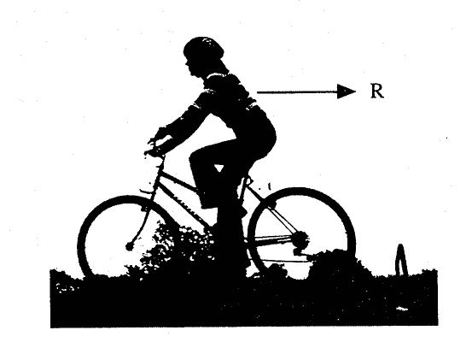
1. A cyclist is cycling with a constant velocity along a horizontal road as shown in the diagram below. The cyclist and bicycle should be regarded as a single object of total mass 70 kg throughout this question.

The arrow, labelled R, represents the direction of the resistive forces acting on the cyclist and bicycle. Draw labelled arrows, on the diagram above, to indicate the magnitude and directions of the other three forces acting on this object.
(2)
The cyclist is cycling along this horizontal road with a constant velocity of 3.6 ms⁻¹ producing a forward force of 4.0 N. Calculate the work done against the resistive forces each second .

(3)

An advertisement in a newspaper suggests than an electric power unit (which is easy to fit) will make sure that cycling can always be fun - even uphill. The unit is labelled 120 W. The advertisement claims that a cyclist can achieve a steady velocity of 3.6 ms⁻¹ up a hill of 1 in 12 with half the energy being provided by the unit. A hill of 1 in 12 means that for every 12 m along the road, the hill rises vertically 1.0 m.

Use suitable calculations to decide whether this claim is valid.

It is preferable for the airflow past the cyclist to be laminar. Explain the meaning of the word laminar and state why this is preferable .

(3)

2. Low-voltage sets of garden light bulbs are now available from most DIY stores. Most sets contain a transformer, cable and four outdoor light bulbs. The main advantage of using low voltage to power garden devices is safety.

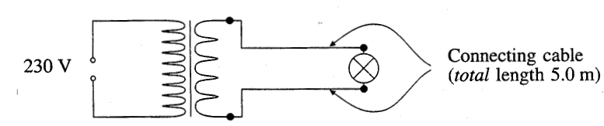
The diagram below shows a transformer and one of the light bulbs connected by cable of total length 5.0 m.

The transformer is labelled 230 V: 12 V, the cable has a resistance of 0.25 9 per metre and the bulb has a resistance of 2.5 S2.

Explain the operation of a transformer.

(4)
Calculate the voltage across the bulb in the arrangement illustrated in the diagram above. Assume the secondary coil provides an e.m.f. of 12 V and has zero internal resistance.

Voltage = ...........................................................
(3)

Calculate the current in the primary coil of the transformer. State any assumption made.

Current = ...........................................................
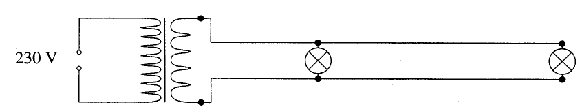
(3)
A further total length of 10 m of cable and a second bulb are added as shown below.

When the power is switched on the second bulb appears significantly dimmer than the first. Carefully explain this observation. (Full credit can be gained by a complete correct explanation in words or by calculation.)

(4)

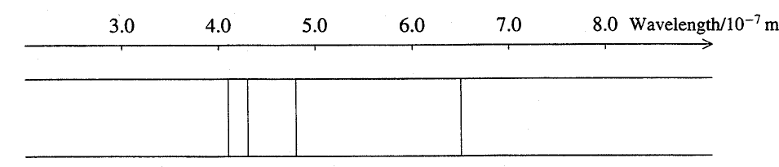
3. The following diagram illustrates a simplified emission line spectrum of the element hydrogen.
Outline the atomic processes leading to the formation of a line spectrum.

(5)

Beta Lyrae is part of a binary star system. Two stars revolve around a common centre of mass. The wavelength of an iron absorption line from Beta Lyrae is measured at intervals of time. The graph below shows how it varies.

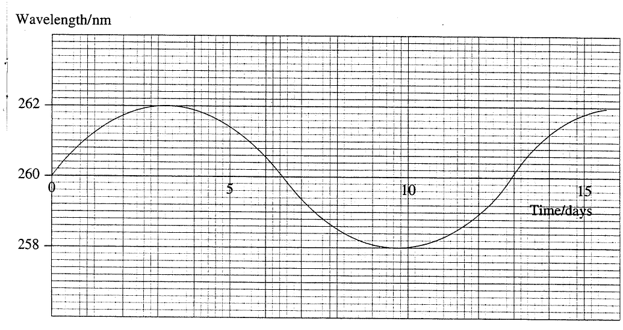
What type of force maintains each of these two stars in their orbit?

(1)
Explain why the wavelength of the light received from this star varies in this manner.

(2)
Calculate the orbital speed of this star.

Orbital speed = ..................................................
(2)
Calculate the radius of orbit of this star about the centre of mass.

Radius of orbit = ...............................................
(3)

PART II

Read the passage and then answer the questions that follow.

Liquid Crystals

Some substances possess properties of both liquids and solids within a certain temperature range. The substance can flow like an ordinary liquid and adopt the shape of its container. On the other hand it shows some order in its molecular arrangement like a crystal. These substances are known as liquid crystals.

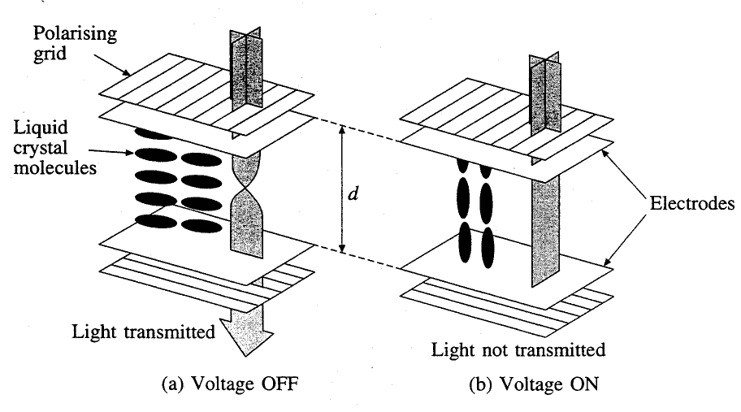
Liquid crystals show a long range order in a particular direction that will be referred to as the director. The refractive index, n, along the director is a different value to that at right angles to it. Typically n along the director is 1.65 and n at right angles to the director is 1.50.

The diagram above illustrates an arrangement in a simple prototype liquid crystal display. The light passes through a polarising grid and then through an electrode into the liquid crystal. The liquid crystal molecules then twist the light so that it can leave through a second electrode and another polarising grid, which is crossed at right angles to the first.

If the rotation of the plane of polarisation is 90° then the light is transmitted out of the bottom grid. This can be achieved using an appropriate thickness, d, of liquid crystal given by

d = 1.05 μm
Δn

where Δn is the difference between the two refractive indices within the liquid crystal.

If a small voltage is now placed across the two electrodes, the resulting electric field alters the orientation of the director such that the effective value of Δn decreases. The rotation of the plane of polarisation is significantly reduced and the light is no longer transmitted.

Liquid crystals are used in calculator, wristwatch and laptop computer displays. A display usually consists of several segments each controlled by an independent voltage. Light is allowed through the liquid crystal segment unless the voltage switches it off.

One of the problems with liquid crystal displays is their turn-on time, T_{on} This is the time it takes for the crystal to respond to the voltage. T_{on} is dependent on a number of factors and is proportional to the viscosity of the liquid crystal substance. If T_{on} is about 10 ms then for a display being scanned at 25 Hz, without multiplexing, only four parts of the display can be addressed in one complete scan.

4. (a) Briefly explain how scientists might investigate the order (or lack of it) in a liquid crystal. .

(2)
(b) Calculate the speed of light along the director of the liquid crystal.

Speed = .......................................................
(2)
(c) What is meant by plane polarised light?

(1)
(d) Describe an experiment that could be used to check whether the plane of polarisation had been rotated by a sugar solution.

(4)

(e) Calculate the thickness d of liquid crystal required for a 90° rotation of the plane of polarisation.

Thickness d = .............................................
(2)
(f) Calculate the electric field strength across the liquid crystal for a voltage of 1.5 V. State any assumption made.

Electric field strength = .............................
(3)
(g) Explain, with a suitable calculation, why, without multiplexing, only four parts of the display can be addressed within each scan.

(4)

(h) The problem discussed in (g) can be reduced by the use of multiplexing. Explain the meaning of the word multiplexing and describe one way in which multiplexing might be achieved.

(4)
(i) Liquid crystal displays only operate over narrow temperature ranges. Give two reasons why they will not operate outside this range.

(2)

5. It is suggested that the turn-on time, Ton, for a liquid crystal display is given by the equation

T_{on} = k η d²
V²

Where η is the viscosity,
V the voltage applied,
d the thickness of crystal, and
k is a constant.

Data showing how the turn-on time Ton depends on the voltage V is provided in the table below.

 | Turn-on time | Voltage
 | T_{on}/ms | V / V
 | 5 | 2.01
 | 10 | 1.42
 | 15 | 1.16
 | 20 | 1.00
 | 27 | 0.86

(a) On the grid opposite, plot a suitable graph to test the relationship suggested between T_{on} and V. Record the results of any calculations that you perform by adding to the table above.
(7)
(b) Discuss whether or not your graph confirms the suggested relationship between T_{on} and V.

(2)

(c) Use your graph to calculate a value of the constant k. The viscosity of the liquid crystal substance is 0.072 Pa s and its thickness is 6.0 μm.

(4)
(d) A second experiment is to be carried out to test the relationship between the turn on time T_{on} and the thickness d. Suggest a possible pair of axes to obtain a straight line graph from measurements of T_{on} and d.

List all the possible variables that would need to be kept constant.

(3)

