Physics Coursework

Identification of Purpose of Physics

Principles of Physics

. Conservation of energy is defined as a law of physics that states that energy cannot be created or destroyed, only converted from one form to another. It is important because energy is precious. It is mportant to know how much we have and how much we will need to do certain things, to be able to predict how much will be wasted and how we can improve efficiency, or sometimes make the efficiency worse.

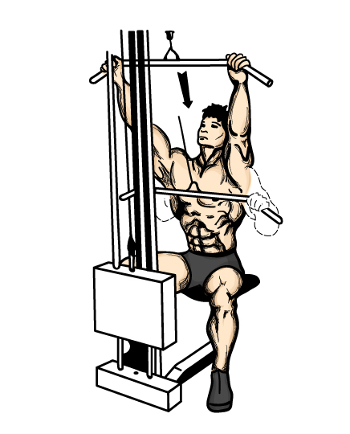
At the gymnasium there are many different exercises using weights, cardiovascular machines and sports. It is an important part of the gymnasium to have various types of physical exercise for people of all ages and abilities and so that different muscles can be exercised.

h

mg

Useful work = mgh

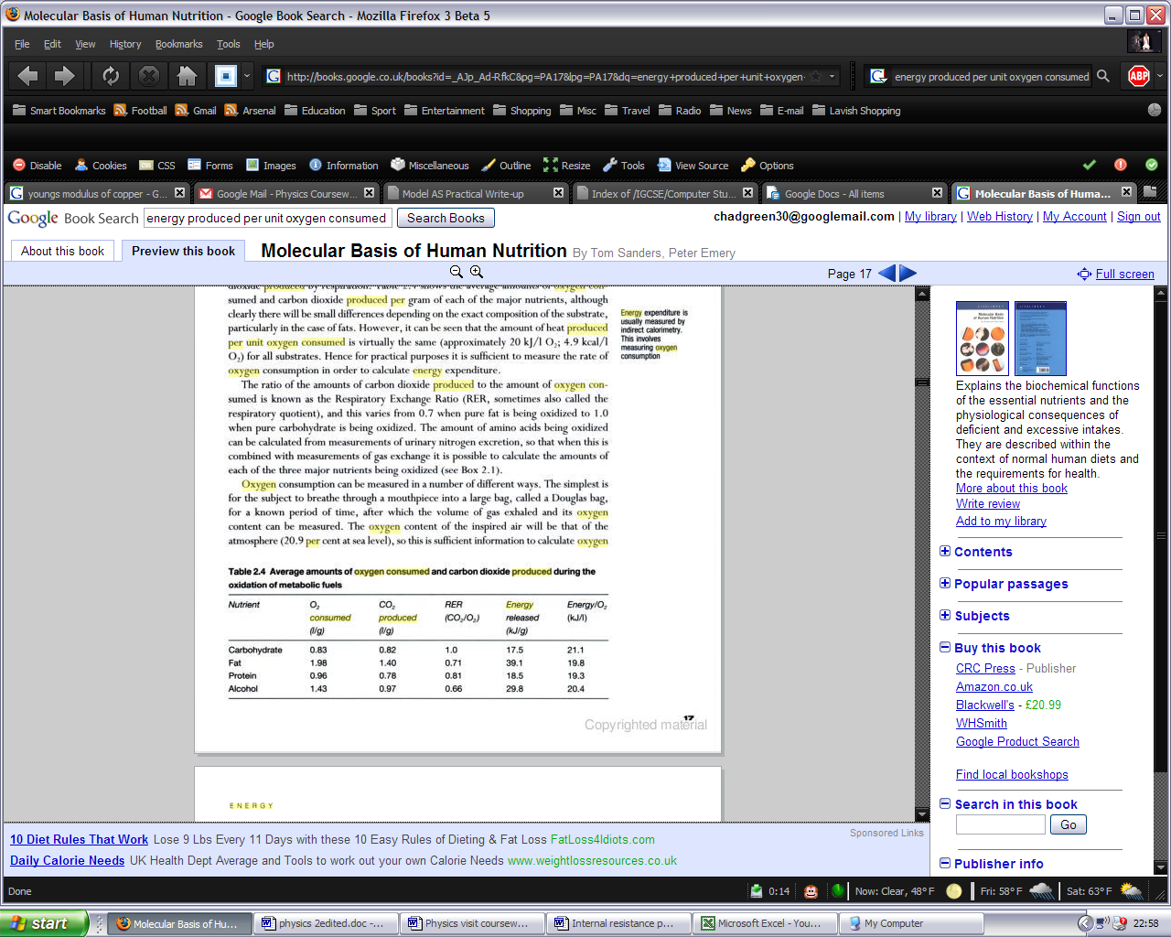

I am going to look at the conversation of energy in relation to certain exercises being performed in a gymnasium. During an exercise, energy from digested food is turned into kinetic energy for the exercise to be performed – after all, all exercise is movement. The energy is not created or destroyed during this process but is converted for it’s specific purpose. The energy is on tap: it is created only when it is needed, the mechanism being the metabolisation of glucose in it’s various forms, the body's fuel. This can happen in one of two ways – anaerobic or aerobic respiration. Aerobic respiration is more efficient than anaerobic respiration but if there is a shortage of oxygen or energy cannot be produced fast enough anaerobic respiration may of necessity take place. The human body can be treated just like a machine as far as it's efficiency is concerned. We can estimate the amount of energy consumed by measuring the oxygen intake, since for sustained exercise oxygen intake is directly related to energy produced.
To find energy produced we multiply the oxygen intake by a constant factor, which is a weighted average of all the values in the last column but most closely reflect the entry for carbohydrate, the being the energy source for sustained exercise, and the useful work done by measuring the potential energy gained by a weight or the distance a force is moved against a resistance. Such measurements indicate an efficiency of the order of 20%, though for running it can be of the order of 50% because the muscles can store some of the energy of each stride. Most of the energy produced during exercise is lost as friction, heat or exhaled or sweated away or lost in some other way and cannot be recovered. We can not measure this directly but only be comparing the useful work done with the energy produced which we infer from the oxygen intake. The easiest way to measure sustained energy production we do using a treadmill or static cycling machine, since these allow a steady rate of doing work which can be easily calculated. The athlete is walking or cycling against a resistance, and the useful work done is simply

Work done = Force x Distance moved

The athlete wears an oxygen mask so that their oxygen intake can be measured. Assuming that all the energy production is via aerobic respiration using the factor discussed above we can directly calculate their energy production or metabolic rate. Since people use energy even if they are not exercising we might expect our graph not to pass through the origin.

Energy Produced = K x Force x Distance Moved

Where k is not necessarily a constant. It is the efficiency.

The cycle machine was set to a resistance of 100 W. The load was increased at a rate of 5 W 30 s−1. In order to reach steady state, the load was kept constant for 3·5 minutes during the cycling session.

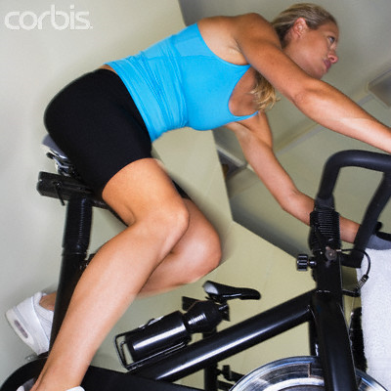

Useful Power | Power Produced | Efficiency %
100 | 280 | 35.7
105 | 300 | 35.3
110 | 322 | 34.2
115 | 371 | 33.1
120 | 369 | 32.5
125 | 391 | 32.0
130 | 419 | 31.0
135 | 435 | 31.0
140 | 467 | 30.0
145 | 483 | 30.0
150 | 521 | 28.8
155 | 564 | 27.9
160 | 588 | 27.2
165 | 635 | 26.0
170 | 664 | 25.6
175 | 700 | 25.0

All quantities in SI units

Conclusions
As the produced energy increases the human body becomes less efficient as a machine, going down from 36% to 25%.
During exercise the body produces a considerable amount of heat - obviously the more vigorous the exercise the more heat is produced. Since the human body is mostly water, and to heat 70kg of water by 1 degree Celsius uses 293300 J the falling efficiency seems probable. On top of this, we are designed in periods of vigorous exercise to dissipate heat energy by sweating and exhalation. The water evaporates from our skin using our own body heat as an energy source. It is surprising though from an intuitive sense, that the efficiency does not start to rise from a low level of activity. After all, when we are resting, and using maybe only 80W of power, our work efficiency is zero. If we then do a small amount of useful exercise our work efficiency rises rapidly. Maybe then we should have started our experiment from a resting metabolic rate, ie a work rate of zero, instead of a wrok rate of 100W.

