1996

Section A

1. (a) What do you understand by

(i) the mass,
(ii) the weight,

of a body?
[3]

(b) A toy rocket consists of a plastic bottle which is partially filled with water. The space above the water contains compressed air, as shown in Fig. 1.1.
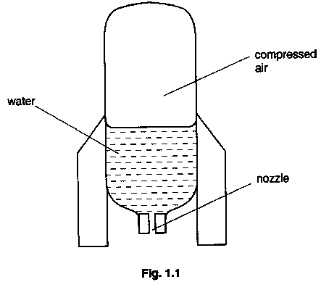

At one instant during the flight of the rocket, water of density ρ is forced through the nozzle of radius r at speed v relative to the nozzle. Determine, in terms of ρ, r and v

(i) the mass of water ejected per unit time from the nozzle,
(ii) the rate of change of momentum of the water.

Hence show that the accelerating force F acting on the rocket is given by the expression

$$F=π r^{2}ρ v^{2}−\text{mg}$$

where m is the mass of the rocket and its contents are at the instant considered. [6]

(c) The toy manufacturer recommends that the rocket should contain about 550 cm³ of water before take-off. If the initial air pressure is 1.6 x 10⁵, all of this water will be expelled and the pressure is just reduced to atmospheric pressure as the last of the water is expelled. However on one flight, the initial volume of water was 750 cm³ but the initial air pressure in the rocket was still 1.6 x ⁵ Pa. State, without calculation but with reason, the effect of this increased volume of water on

(i) the initial thrust,
(ii) the initial resultant accelerating force,
(iii) the initial acceleration,
(iv) the final mass of the rocket and its contents,
(v) the maximum height reached. [11]

2. (a) What is meant by a field force? [1]

(b) A particle has mass m and charge +q.

(i) State the magnitude and the direction of the force on this particle when it is at rest in
1. a gravitational field,
2. an electric field,
3. a magnetic field.

(ii) State the magnitude and the direction of the force on this particle when it is moving with velocity v in a direction normal to
1. a gravitational field,
2. an electric field,
3. a magnetic field. [9]

(c) The earth may be considered to be a uniform sphere of radius 6370 km, spinning on its axis with a period of 24.0 hours. The gravitational field at the Earth’s surface is identical with that of a point mass of 5.98 x 10²⁴ kg at the Earth’s center. For a 1.00 kg mass situated at the Equator,

(i) calculate, using Newton’s law of Gravitation, the gravitational force on the mass,
(ii) determine the force required to maintain the circular path of the mass,
(iii) deduce the reading on an accurate Newton-meter (spring balance) supporting the mass. [6]

(d) Using your answers to (c), state what would be the acceleration of the mass at the Earth’s surface due to

(i) the gravitational force alone,
(ii) the force as measured on the Newton-meter. [2]

(e) A student, situated at the Equator, releases a ball from rest in a vacuum and measures the acceleration towards the Earth’s surface. He then states that this acceleration is ‘the acceleration due to gravity’. Comment on his statement. [2]

3. (a) Both refraction and diffraction can involve change in direction of a wavefront. State the circumstances under which each of the following occurs:

(i) refraction,
(ii) diffraction [2]

(b) (i) A ray of light is incident on the boundary between two media. Draw a labelled ray diagram to illustrate what is meant by critical angle.
(ii) Monochromatic light is incident normally on one face AB of a right-angled glass prism ABC, as shown in Fig. 3.1.

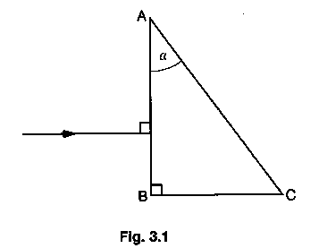

The prism is made of glass of refractive index 1.52.

1. Show that, if the angle α is greater than approximately 41º, no light emerges from face AC.
2. Copy Fig. 3.1, making angle α equal to 45^{o.} Complete the path of the ray through the prism.
3. Describe one application of prisms when used as in (ii)2. [10]

(c) An experiment is set up to demonstrate the behavior of water waves in a ripple tank.

(i) Draw diagrams, one in each case, to show the diffraction of water waves through
1. a narrow gap,
2. a wide gap.

(ii) Suggest why two-source interference of water waves, using a double-slit arrangement, may not be observed when the slits are wide but, when the slits are narrow with the same separation as previously, interference is observed. [8]

4. (a) Use energy considerations to distinguish between electromotive force (e.m.f.) and potential difference (p.d.). [3]

(b) A cell of e.m.f. E and internal resistance r is connected to a resistor of resistance R?, as shown in Fig. 4.1.

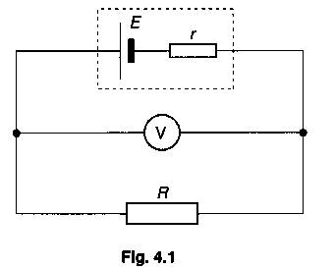
A voltmeter of infinite resistance is connected in parallel with the resistor.

(i) Copy Fig. 4.1 and include in the circuit a switch so that the voltmeter may be used to measure either the e.m.f. E of the cell or the terminal potential difference V.
(ii) State whether the switch should be open or closed when measuring
1. the e.m.f,
2. the terminal p.d.
(iii) Derive a relation between E, V, r and the current I in the circuit. [5]

(c) A student decided to build a temperature probe and set up the circuit shown in Fig. 4.2. The battery has e.m.f. 9.0 V and negligible internal resistance.

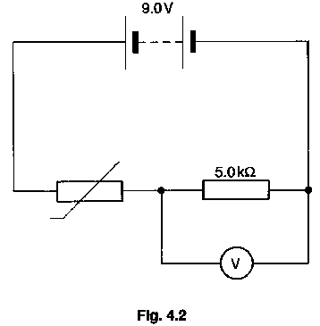

The voltmeter has infinite resistance. The calibration curve for the thermistor is shown in Fig. 4.3.
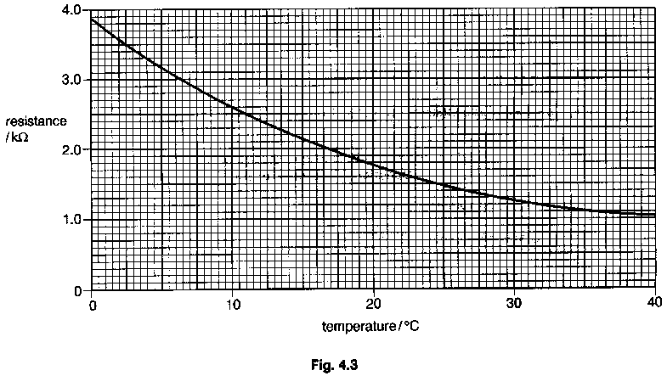

(i) Suggest why it is necessary to include a fixed resistor in the circuit of Fig. 4.2.
(ii) The probe is to be used to measure temperature in the range 0 ºC to 30 ºC.

1. Use Fig. 4.3 to find the resistance of the thermistor when the probe is at 30 ºC
2. Hence calculate the reading on the voltmeter for the temperature of 30 ºC.

(iii) When the temperature of the thermistor is 2.5 ºC, the voltmeter reads 5.30 V. The voltmeter has a range 0 - 10 V. Suggest one disadvantage of using this voltmeter in the circuit of Fig. 4.2 for temperature measurement. [7]

(d) During laboratory testing of the circuit in (c), the battery became ‘flat’. In order to proceed with his work, the student modified the circuit as shown in Fig. 4.4.

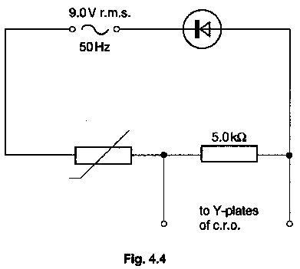
The screen of the c.r.o. was marked with a grid of squares of side 1.0 cm and the settings on the c.r.o. were as follows:

time base: 5.0 ms cm⁻¹
Y-plate sensitivity: 5.0 V cm⁻¹

By reference to (c)(iii), and assuming that the diode is ideal, draw to scale a sketch of the trace as seen on the screen of the c.r.o. when the temperature of the probe is 2.5 ºC. [5]

5. (a) (i) Distinguish between a solid and a liquid by reference to the spacing, ordering and motion of molecules.
(ii) By reference to your answers to (i), and to the first law of thermodynamics, give an explanation for latent heat of fusion. [7]

(b) (i) What is meant by an ideal gas?
(ii) The pressure P of an ideal gas of density ρ is given by the expression

P = 1/3 ρ <c²>

1. Identify the quantity < c²>.
2. Deduce an expression for the average translational kinetic energy of a gas molecule in terms of the thermodynamic temperature T. [5]

(c) The air cylinder for a diver has a volume of 9.00 x 10³ cm³ and when the cylinder is filled, the air has a pressure of 2.10 x 10⁷ Pa at 24 ºC. The diver is swimming in water of density 1.03 x 10³ kg m⁻³ and temperature 24 ºC at a depth of 15.0 m. When the diver breathes in, the pressure of the air delivered from the cylinder to the diver is always equal to the pressure of the surrounding water.

Atmospheric pressure is 1.01 x 10⁵ Pa.

Calculate, for the depth of 15.0 m,
(i) the total pressure on the diver,
(ii) the volume of air available at this pressure from the cylinder. [4]

(d) The supply of air in (c) is sufficient for the diver to remain at a depth of 15.0 m for 45 minutes. Assuming that the diver always breathes at the same rate (i.e. the same volume of air is required per minute, regardless of pressure), how long would the air in the cylinder last for the diver at a depth of 35.0 m and a water temperature of 20 ºC?
[4]

6. (a) Distinguish between the radioactive decay and the fission of a nucleus. [5]

(b) (i) A radioactive source of activity A emits γ-ray photons uniformly in all directions. A detector, of effective area of detection S, is situated a distance x from the source, as shown in Fig. 6.1.
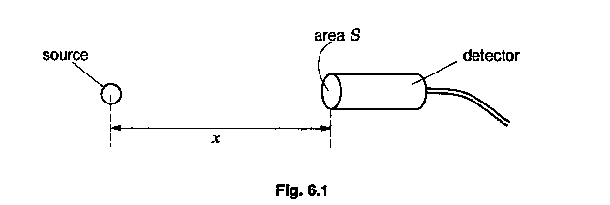

Show that the number N of photons entering the detector per unit time is given by

$$N=\frac{\text{SA}}{4{πx}^{2}}$$

State any assumption you make in your derivation.

(ii) A γ-ray source is to be transported in a sealed wooden box.

The source is placed in a lead container which is surrounded by expanded polystyrene, as shown in Fig. 6.2.
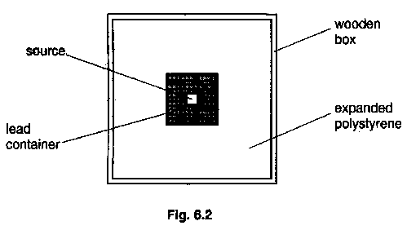

Suggest why, on health grounds,

1. the source is placed in a lead container,

2. the lead container is surrounded by polystyrene. [7]

(c) The isotope lron-59 is a β-emitter with a half-life of 45 days. In order to estimate engine wear, an engine component is manufactured from non-radioactive iron throughout which the isotope iron-59 has been uniformly distributed. The mass of the component is 2.4 kg and its initial activity is 8.5 x 10⁷ Bq.

The component is installed in the engine 60 days after manufacture of the component, and then the engine is tested for 30 days. During the testing period, any metal worn off the component is retained in the surrounding oil. Immediately after the test, the oil is found to have a total activity of 880 Bq. Calculate

(i) the decay constant for the isotope Iron-59,
(ii) the total activity of the component when it was installed,
(iii) the mass of iron worn off the component during the test. [8]

Section B
Answer two questions in this section.

One question is set on each of the seven optional topics, namely

Question 7: Option A, Astrophysics and Cosmology;
Question 8: Option C, The Physics of Materials:
Question 9: Option E, Electronics;
Question 10: Option F, The Physics of Fluids;
Question 11: Option M, Medical Physics;
Question 12: Option P, Environmental Physics;
Question 13: Option T, Telecommunications.

You may choose any two of the questions.

Option A
Astrophysics and Cosmology

7. (a) Distinguish between a planet and a comet. [2]

(b) The critical density ρ_{o} of matter in the Universe is given by the expression

$ρ_{o}=\frac{3H_{o^{2}}}{8πG}$.

(i) 1. Explain the significance of the constant H_{o}.

2. Discuss the possible fate of the Universe if the density ρ of matter in the Universe is
(α) greater than ρ_{o},
(β) less than ρ_{o}.

(ii) Fig. 7.1 shows possible curves for the variation with time of the size of the Universe.
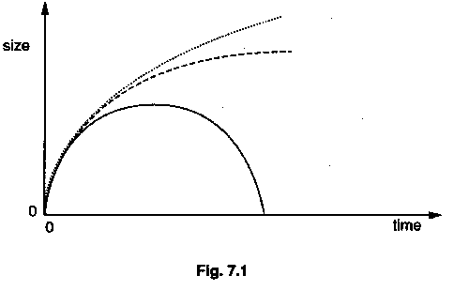

Copy Fig. 7.1 and on it

1. label the curve corresponding to ρ > ρ_{o},
2. label the curve corresponding to ρ < ρ_{o},
3. mark on the diagram a point to represent the Universe at the present time

(iii) Discuss your answer to (ii)3 with reference to the possible faith of the Universe.
[4]

Option C
The Physics of Materials

8. (a) (i) What do you understand by a Bravais lattice?
(ii) Fig. 8.1 represents a Bravais lattice.
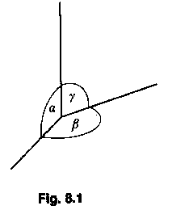

1. Draw a diagram of one cell of a hexagonal lattice.
2. Show on your diagram the Bravais lattice.
3. State the corresponding values of the angles α, β and γ. [6]

(b) (i) What is meant by a dislocation in a lattice structure?
(ii) Explain why work-hardening increases the strength of a material. [3]

(c) (i) Suggest, with reasons, a suitable shape for the hysteresis curve for the materials used in the wall of a car tyre.
(ii) Give one example of a situation where metal fatigue has been a problem and discuss how the difficulty was overcome. [6]

Option E
Electronics

9. (a) A student decided to build a device to monitor at a distance whether a door is open or closed. He lifted a switch in the door frame so that, when the door is closed, the switch is closed. This switch (S) was included in the circuit shown in Fig. 9.1.
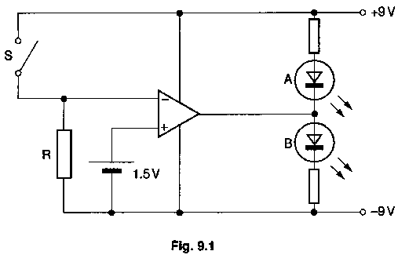

(i) What is the function of the resistor R?
(ii) Deduce the state of the light-emitting diodes A and B when S is closed.
(iii) What change, if any, occurs in the states of A and B when S is opened? [7]

(b) A second student designed a logic circuit using NAND gates in order to monitor the opening and closing of two doors. Logic 1 represents a closed door; logic 0 represents an open door. A logic 1 output is required when only one or the other of the doors is open.

(i) Write down the truth table for the circuit.
(ii) Draw the logic circuit which uses only NAND gates and a single LED to indicate logic 1 output. [4]

(c) Many items of equipment in the home are now controlled by microprocessors.

(i) Name an item found in the home which is controlled by a microprocessor.
(ii) State the function of the microprocessor in the item you have named in (I).
(iii) State two benefits resulting from the use of microprocessors. [4]

Option F
The Physics of Fluids

10. (a) A submerged marker-buoy is anchored to the sea-bed by a rope, as shown in Fig. 10.1.
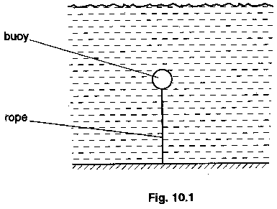

The buoy is spherical and has radius 0.12 m and mass 0.41 kg. The seawater may be assumed to be still and to have density 1.03 x 10⁻³ kg m⁻³.

(i) Calculate

1. the upthrust on the buoy,
2. the tension in the rope.

(ii) The rope breaks. Discuss whether the ascent of the buoy to the surface is likely to occur under streamline and/or turbulent conditions.
(Viscosity of seawater = 9.0 x 10⁻⁴ N s m⁻²; for a sphere, the Stokes' law formula is F = 6 π r η v and the Reynolds’ number R_{e} = ρ v r/η.) [7]

(b) (i) The Bernoulli equation may be expressed in the form

P₁ + ½ ρ v₁² = P₂ + ½ ρ v₂²

1. State the conditions under which the equation may be applied.

2. Give an explanation for the equation in terms of energy.

(ii) A passenger jet aircraft was cruising at an altitude of 8500m. The captain of the aircraft announced that, when some of the fuel had been used up, the aircraft would be able to fly at the same speed at a higher altitude, thus being more economical on fuel: Suggest reasons as to why

1. the aircraft could fly at a higher altitude when some fuel had been expended,

2. fuel economy would be improved. [8]

Option M

Medical Physics

11. (a) (i) Outline the use of magnetic resonance to obtain diagnostic information about internal structures of the human body.

(ii) Give two advantages of the use of magnetic resonance imaging (MRI) over the use of X-rays for diagnostic purposes. [7]

(b) (i) What is meant by the loudness of a sound?

(ii) Explain why loudness is more directly related to the intensity level, rather than the intensity, of a sound wave.

(iii) A small buzzer produces an intensity level of 65 dB at a distance of 2.0 m. Assuming that the buzzer emits sound uniformly in all directions, calculate the power of the sound produced by the buzzer. State one other assumption which you make. [8]

Option P
Environmental Physics

12. (a) The solar energy incident normally per unit time per unit area of the Earth's surface is 1100Wm⁻²

(i) Distinguish between a solar panel and a solar cell.

(ii) 1. State, in watts, the power output of a typical wind generator used for providing power to the Grid.

2. Estimate the effective surface area required for an array of solar cells so that it has the same power output as the wind generator. [6]

(b) Fig. 12.1 shows an idealized indicator diagram for a four-stroke internal combustion engine.
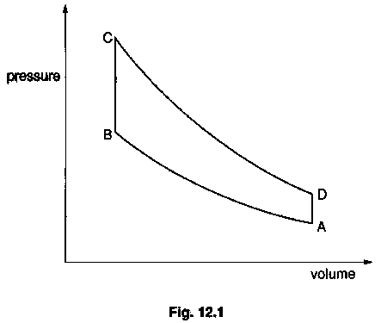

(i) Identify sections of the diagram which represent

1. adiabatic changes,
2. the combustion of fuel,
3. the opening of the exhaust valve.

(ii) The efficiency of a petrol engine is about 20%. Explain why it is not possible to construct a petrol engine which has an efficiency of 100%. [9]

Option T

Telecommunications

13. (a) Fig. 13.1 illustrates a block diagram of a system for the digital transmission, and subsequent reception, of an analogue signal.

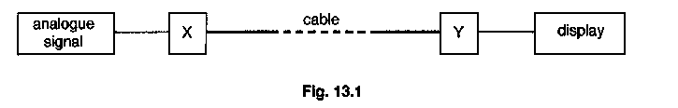

(i) What is the function of
1. block X,
2. block Y?

(ii) Fig. 13.2 illustrates the transmitted signal as seen on the display.
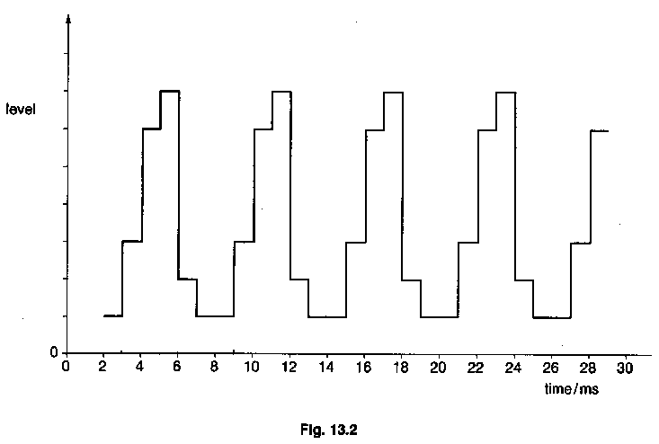
Calculate

1. the frequency at which the analogue signal is sampled,
2. the minimum number of bits which must be created at each sampling,
3. the frequency of the analogue signal.

(iii) State four advantages of fibre optic transmission over transmission using a metal cable. [11]

(b) (i) Copy and complete the table of Fig. 13.3.

frequency of  radiowaves/kHz | wavelength  /m | typical transmission  distance
2 x 10²
2 x 10⁵

Fig. 13.3

(ii) Give one reason why transmission between the Earth and a geostationary satellite could not be by means of long-wave radio waves. [4]

