1996

1. (a) Define acceleration. [1]

(b) Divers in Acapulco dive from a height of 36 m into the sea. Calculate, ignoring air resistance,
(i) the time they take to reach the water,
(ii) their speed of entry into the water. [4]

(c) One of the divers referred to in (b) had a mass of 61 kg. In a subsequent free-fall dive from an aircraft, before the parachute was opened, the diver reached a terminal speed of 90 m s⁻¹ . Calculate
(i) the weight of the diver,
(ii) the force of air resistance on the diver when at the terminal speed,
(iii) the magnitude and unit of the constant k in the expression
air resistance = k v²,
where v is the speed. [4]

(d) (i) Use the expression given in (c)(iii) to estimate the air resistance on a diver in (c) moving with a sped of 25 m s⁻¹ .
(ii) Hence comment on whether the instruction in (b) to ignore air resistance is justified. [3]

2. (a) An object undergoing simple harmonic motion has displacement from its equilibrium position. The displacement varies with time in the way shown in Fig.2.1(a).

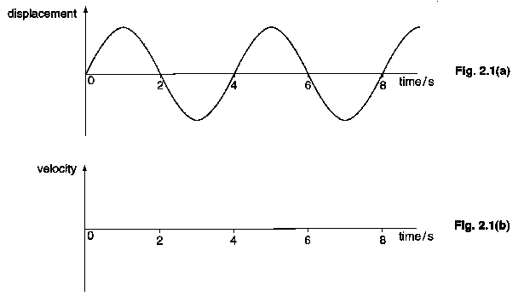

On Fig. 2.1 (b), sketch the variation with time of the velocity of the object. [2]

(b) For the object in (a), find
(i) the frequency f of the oscillation,
(ii) the angular frequency ω of the oscillation,
(iii) the phase difference between the displacement and the velocity. [4]

(c) The mass of an astronaut in an orbiting space station cannot be measured by using a normal balance. However, the mass can be measured by monitoring the oscillations of the astronaut when seated in a chair supported by a spring. The period of the oscillation T is given by the expression

$$T=2π\sqrt{\frac{M}{k}} ,$$
where M is the total mass of the chair and the astronaut, and k is the spring constant.

For a particular chair, of mass 6.3 kg, the spring to which it is attached has a spring constant of 1540 N m⁻¹.
(i) Calculate the period of oscillation when an astronaut of mass 73.2 kg sits in the chair.
(ii) Calculate the percentage change in the period of oscillation after the mass of the astronaut increased by 0.5 kg during a meal. [5]

3. (a) A capacitor is marked as having a capacitance of 100 μF. It is also marked 20 V.

(i) Explain what is meant by ‘a capacitance of 100 μF’.
(ii) How much charge is stored by the capacitor when a p.d. of 20 V is applied across it?
(iii) Write down the maximum charge which may safely be stored by the capacitor.
(iv) Calculate the energy stored by the capacitor when charged as in (ii) [5]

(b) Suggest why the maximum voltage to used is marked on the capacitor. [1]

(c) The circuit shown in Fig. 3.1 has a 6 V d.c. power supply and is set up with the switch open and the capacitor uncharged.
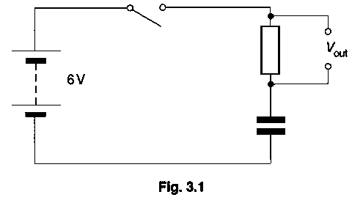

The switch is then closed. State what the output voltage V_{out} will be
(i) immediately the switch is closed,
(ii) after a long time [2]

4. (a) Describe the structure and principle of operation of an iron-cored transformer. [4]

(b) A graph of the power input to a transformer is shown in Fig. 4.1.

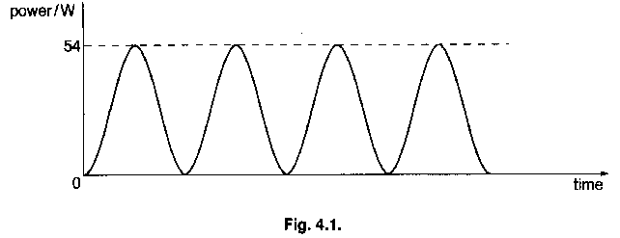

The transformer has a turns ration of N_{s}/N_{p} = 30 and the sinusoidal input voltage has a value of 6 V r.m.s. For the transformer, assumed to be ideal, calculate
(i) the r.m.s. value of the output voltage,
(ii) the mean power input (=the mean power output),
(iii) the r.m.s. value of the input current,
(iv) the r.m.s. value of the output current. [5]

5. (a) State two properties of glass which makes it a particularly suitable material to use in the construction of a mercury-in-glass thermometer. [2]

(b) Contrary to popular opinion, mercury expands only a small amount when it is heated; there are many liquids which expand a great deal more. State two reasons why mercury is still often used in thermometers. [2]

(c) Suggest how the following factors affect the operation of a mercury-in-glass thermometer.
(i) The fact that mercury freezes at 234 K
(ii) The amount of heat required to raise the temperature of the thermometer by 1 K
(iii) The diameter of the bore of the thermometer’s capillary tube
(iv) The volume of mercury used in the bulb of the thermometer [7]

6. (a) The results of 14 experiments to determine the charge on oil drops were as follows.

negative charge on oil drop/10⁻¹⁹ C
1.605  3.214 | 1.608  4.803 | 3.199  1.610 | 1.598  1.599 | 1.606  3.217 | 1.602  8.001 | 4.806  1.607

(i) Explain how these readings provide experimental evidence for the quantisation of charge.
(ii) Use these results to deduce a valued for the charge on the electron. [5]

(b) A stream of electrons with a variety of different speeds enters a region of uniform magnetic field, as shown in Fig. 6.1

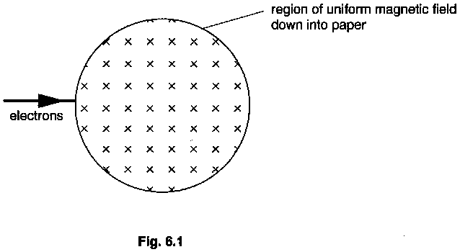

On Fig. 6.1, draw the path of a few of the electrons when in the field and after they leave the field. Label the path of the slowest and the fastest electron you have considered. [4]

7. Fig. 7.1 illustrates some of the electron energy levels in an isolated atom of lithium. The energies of the levels are given in electron-volts (eV).
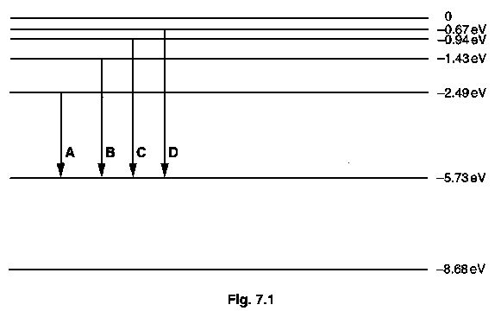

(a) The outer electron of a lithium atom is in the lowest energy level shown. How many joules of energy are required to remove this electron from the atom? [1]

(b) (i) Which of the transitions A, B, C or D would lead to the emission of radiation of the shortest wavelength?
(ii) Calculate the wavelength of this radiation.
(iii) State the region of the electromagnetic spectrum in which this radiation lies. [4]

(c) Sketch the appearance of the spectrum which these four transitions produce. [1]

(d) On Fig. 7.1 draw four transitions of greater energy change which give rise to another set of wavelengths. [2]

(e) The work function energy of lithium differs from the energy required to remove the outer electron from an isolated lithium atom. Suggest why this is so. [2]

8. The following paragraph is based on an article which was printed in the Sunday Times.

“The World Bank is considering the construction of a vast hydroelectric project to bring fresh water to Israel, Jordan and the Palestinians. The project could involve building a canal from the Mediterranean Sea to the Dead Sea, which lies 400 m below sea level. The canal would have hydroelectric plants to generate electricity for desalination plants at intervals along its length. The desalination plants could produce up to 100 million cubic metres of fresh water per year. At present, the Dead Sea is fed by the River Jordan, but there has been so much extraction of water for drinking and irrigation that, in summer, the flow of the river has been reduced to little more than a muddy trickle. The Dead Sea, which has a salinity that makes it the densest body of water on Earth is prone to rapid evaporation and, as more water has been tapped, the level has fallen by 3.0 metres in the last 35 years. The canal project would be a way of stopping this decline.”
© The Times Newspapers Ltd.

In carrying out detailed studies on the project, engineers have the following additional geographical and physical data.

surface area of the Dead Sea | 880 km²
specific latent heat of vaporisation of water | 2.26 x 10⁶ J kg⁻¹
mean power absorbed by a water surface from sunlight during daylight | 300 W m⁻²
the acceleration of free fall | 9.8 m s⁻²
density of sea water in Mediterranean sea | 1030 kg m⁻³

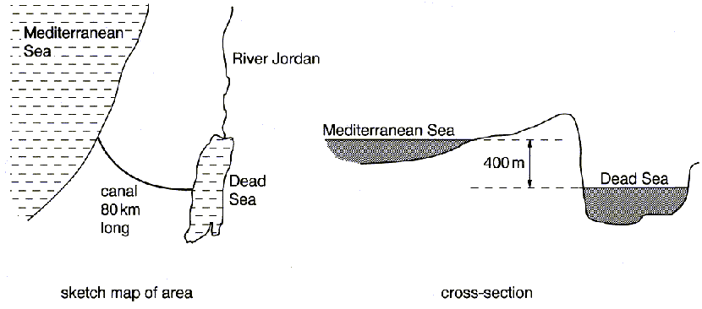

Answer the following questions about this project, using the data supplied.

(a) What does the passage suggest, is the reason for the Dead Sea being the ‘densest body of water on the Earth.’? [1]

(b) Calculate the mean power absorbed by the Dead Sea from the Sun during daylight.
[2]

(c) If 60 % of the power calculated in (b) is used to evaporated water form the Dead Sea, calculate the mass of water which evaporates in 12 hours of daylight. [3]

(d) Using the overall fall of the level of the Dead Sea, estimate the change during the last 35 years in the mass of water in the Dead Sea. [2]

(e) What form of energy is changed into electrical energy when water falls from the Mediterranean Sea into the Dead Sea? [1]

(f) Assume that the proposed project aims to refill the Dead Sea to its former level in the next 35 years. Estimate the mean power available from the water falling from the Mediterranean Sea into the Dead Sea. [3]

(g) A desalination plant operates on a cycle by evaporating water vapour from sea water and then condensing the water vapour back into fresh water. Explain why 2.26 x 10⁶ joules are not needed for each kilogram of fresh water produced in the cycle. [2]

(h) Using your answer from (f) and the figure given in the paragraph for the amount of fresh water which could be produced in a year, estimate the energy required to produce a kilogram of fresh water form sea water. [2]

(i) Describe briefly two physical problems which will make the scheme less efficient than any our calculations indicate. [2]

(j) Describe one change which could be made which would improve considerably the commercial viability of the scheme. What problems would result from this change? [2]

