1996

1. Which list of SI units contains only base units?
A kelvin, metre, mole, ampere, kilogram
B kilogram, metre, second, ohm, mole
C kilogram, newton, metre, ampere, ohm
D newton, kelvin, second, volt, mole

2. The dimensions of a cube are measured with vernier calipers

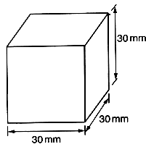

The measured length of each side is 30 mm. If the vernier calipers can be read with an uncertainty of ± 0.1 mm, what does this give for the approximate uncertainty in the value of its volume?

A $\frac{1}{\text{27}}$% B $\frac{3}{\text{10}}$% C $\frac{1}{3}$% D. 1%

3. A steel ball is held above a horizontal table and released so that it falls on to the table and
rebounds several times.
If the collisions are inelastic, which graph best represents the variation of acceleration a of the ball with time t?

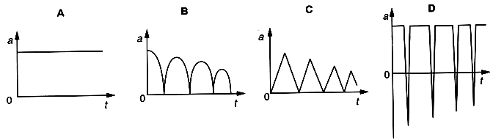

4. The rate of change of momentum of a body falling freely under gravity is equal to its
A impulse.
B kinetic energy.
C power.
D weight.

5. The diagram shows a diving-board held in position by two rods X and Y.
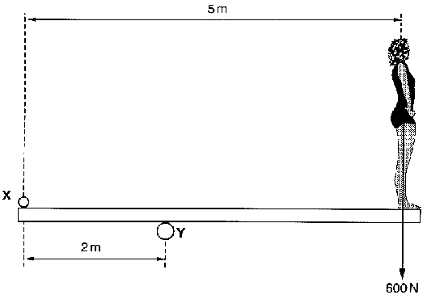
Which additional forces do these rods exert on the board when a diver of weight 600 N stands on the right-hand end?

 | At X (downwards) | at Y (upwards)
A  B  C  D | 400 N  600 N  900 N  900 N | 1000 N  1200 N  600 N  1500 N

6. The diagram shows an arrangement used to find the output power of an electric motor. The wheel attached to the motor's axle has a circumference of 0.5 m and the belt which passes over it is stationary when the weights have the values shown.
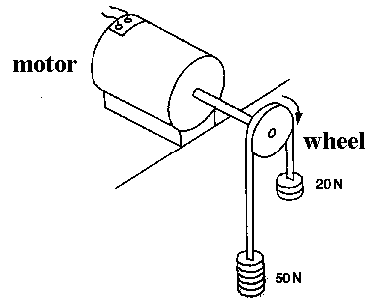
If the wheel is making 20 revolutions per second, what is the output power?

A 300 W B 500 W C 600 W D 700 W

7. For points outside a uniform sphere of mass M, the gravitational field is the same as that of a mass M at the centre of the sphere. The Earth may be taken to be a uniform sphere of radius r and density ρ.

How is the gravitational field strength g at its surface related to these quantities and to the gravitational constant G?

A $g=\frac{Gρ}{r^{2}}$ B $g=\frac{3G}{4πrρ}$ C $g=\frac{4π rρG}{3}$ D $g=\frac{4π r^{2} ρ G}{3}$

8. A satellite moves at constant speed in a circular orbit about the Earth.
Which statement about the momentum and kinetic energy of the satellite is correct?

momentum kinetic energy
A constant changing
B constant constant
C changing changing
D changing constant

9. Which graph shows the relationship between the acceleration a and the displacement x of a particle performing simple harmonic motion?

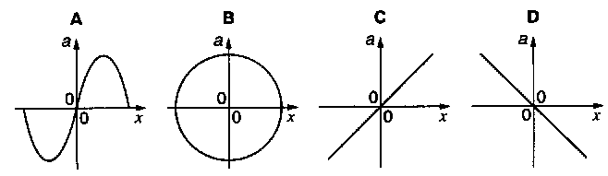

10. The graph shows the shape at a particular instant of part of a transverse wave travelling along a string.

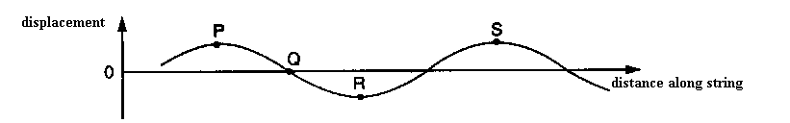

Which statement about the motion of elements of the string is correct?

A The speed of the element at P is a maximum.
B The displacement of the element at Q is always zero.
C The energy of the element at R is entirely kinetic.
D The acceleration of the element at S is a maximum.

11. A microwave transmitter emits waves which are reflected from a metal plate, as shown in the diagram. A detector responds to the stationary waves produced. R, S and T are three successive points at which the meter shows zero intensity.
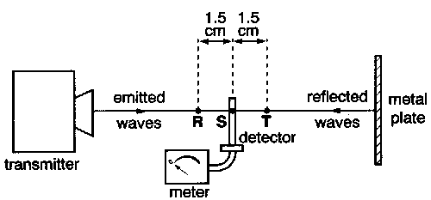
What is the frequency of the waves?
A 9.0 x 10⁶ Hz
B 1.0 x 10⁸ Hz
C 1.0 x 10¹⁰ Hz
D 2.0 x 10¹⁰ Hz

12. The table shows the wavelengths of electromagnetic waves in various parts of the spectrum. For which line in the table is X in the ultraviolet region and Y in the microwave region of the spectrum?

 | X | Y
A  B  C  D | 1 x 10⁻⁷ m  1 x 10⁻⁷ m  1 x 10⁻¹⁰ m  1 x 10⁻¹⁰ m | 1 x 10⁻² m  1 x 10⁻⁵ m  1 x 10⁻² m  1 x 10⁻⁵ m

13. A generator produces 100 kW of power at a potential difference of 10 kV. The power is transmitted through cables of total resistance 5 Ω.
How much power is dissipated in the cables?

A 50 W B 250 W C 500 W D 50 000 W

14. The diagram shows a rectangular block with dimensions x, 2x, and 3x.

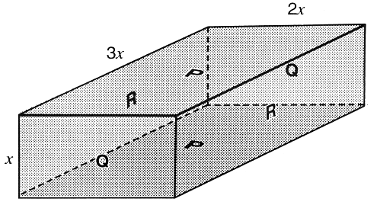
Electrical contact can be made to the block between opposite pairs of faces (for example, between the faces labelled P).
Between which two faces would the maximum electrical resistance be obtained?
A the faces labelled P
B the faces labelled Q
C the faces labelled R
D the resistance is the same, whichever pair of faces is used

15. A potential divider is used to give outputs of 2 V and 3 V from a 5 V source, as shown.

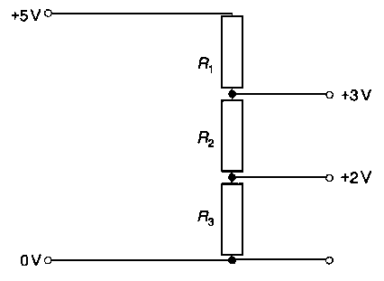
Which combination of resistance, R₁, R₂, R₃, gives the correct voltages?

 | R₁/kΩ | R₂/kΩ | R₃/kΩ
A  B  C  D | 1  2  3  3 | 1  1  2  2 | 2  2  2  3

16. The charge on the uranium nucleus is 1.5 x 10⁻¹⁷ C and the charge on the α-particle is 3.2 x 10⁻¹⁹ C.
What is the electrostatic force between a uranium and an α-particle when separated by a distance of 1.0 x 10⁻¹³ m?
A 4.3 x 10⁻²⁰ N
B 4.3 x 10⁻¹³ N
C 4.3 N
D 4.3 x 10¹⁰ N

17. The energy stored in capacitor of capacitance C, carrying charge Q with potential difference V between its plates, may be obtained by calculating the area under an appropriate graph.
Which graph shows the correct relationship between a pair of quantities C, Q and V, and in addition shows a shaded area which corresponds to the energy stored in the capacitor?

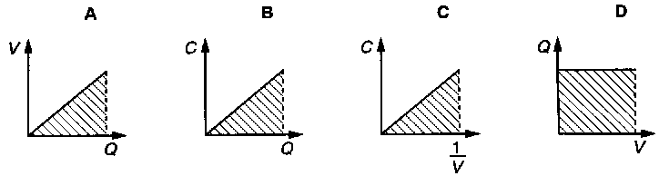

18. Four parallel conductors, carrying equal currents, pass vertically through the four corners of a square WXYZ. In two conductors, the current is directed into the page and, in the other two, it is directed out of the page.

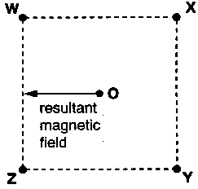
It is required to produce a resultant magnetic field at O in the direction shown.
What must be the directions of the currents?

into the page out of the page
A W and X Y and Z
B W and Z X and Y
C X and Z W and Y
D Y and Z W and X

19. The diagram shows two parallel wires P and Q in the plane of the paper. P is fixed; Q is free to move.
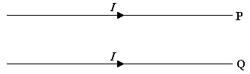
When the same current I passes through each wire in the same direction, Q moves

A away from P in the plane of the paper.
B downwards into the paper.
C towards P in the plane of the paper.
D upwards out of the paper.

20. A coil P is connected to a 50 Hz alternating supply of constant peak voltage. Coil P lies close to a separate coil Q which is connected to the Y-input terminals of an oscilloscope. A sinusoidal trace appears on the screen of the oscilloscope.

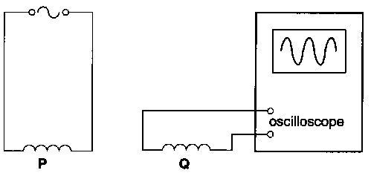

What would be the effect on the trace of linking the coils by a soft-iron core?

number of cycles
height of trace on screen
A increases increases
B increases stays the same
C stays the same increases
D stays the same stays the same

21. The circuit shows a bridge rectifier with a sinusoidal alternating voltage applied to it, the output terminals P and Q being joined together by a load resistor.
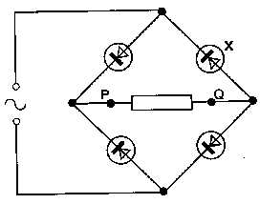
If the diode X were removed leaving a break in the circuit, which trace would be seen on a cathode-ray oscilloscope across PQ?

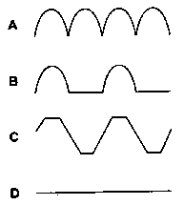

22. A suspended copper wire is gradually loaded until it is stretched just beyond the elastic limit, and it is then gradually unloaded. Which graph (with arrows indicating the sequence) best illustrates the variation of tensile stress σ with longitudinal strain ε?

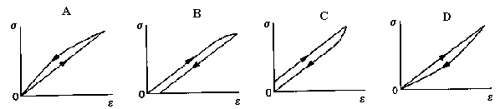

23. An iron wire and a brass wire, of equal lengths and equal cross-sectional areas, are joined at one end. A tensile force F is applied to the free ends, as shown.

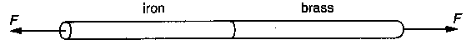

If the Young modulus of iron is twice that of brass, which statement is true?

A The extension of the brass wire is twice that of the iron wire.
B The extension of the iron wire is twice that of the brass wire.
C The tension in the brass wire is twice that in the iron wire.
D The tension in the iron wire is twice that in the brass wire.

24. A small quantity, mass m, of water at temperature θ (in ºC) is poured on to a large mass M of ice which is at its melting point.
If c is the specific heat capacity of water and L the specific latent heat of fusion of ice, then the mass of ice is given by

A $\frac{\text{ML}}{\text{mc}θ}$ B $\frac{\text{mc}θ}{\text{ML}}$ C $\frac{\text{Mc}θ}{L}$ D $\frac{\text{mc}θ}{L}$

25. Four gas molecules have the speeds shown.

speed / 10² m s⁻¹ | 1.0 | 3.0 | 5.0 | 7.0

What is their root-mean-square speed?

A 2.0 x 10² m s⁻¹ B 2.3 x 10² m s⁻¹ C 4.0 x 10² m s⁻¹ D 4.6 x 10² m s⁻¹

26. Thermal energy can be transferred by different processes, including

(i) transfer in a fluid by a process which is a consequence of a change in density of the fluid,
(ii) transfer in a non-metallic solid by the process of lattice vibrations.

Which terms are used for these processes?

process (i) process (ii)
A evaporation conduction
B evaporation radiation
C convection conduction
D convection radiation

27. The diagram shows part of a velocity selector.

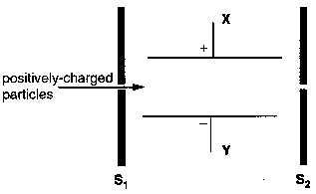
A beam of positively-charged particles, with a range of velocities, enters through the slit in S₁. An electric field is provided by two parallel plates X and Y with a p.d. between them of polarity as shown. The velocity selector is completed by the addition of an electromagnet to produce a magnetic field of a suitable strength and direction so that particles of only a particular velocity emerge from the slit in S₂.

What should be the direction of the magnetic field?

A from X to Y
B from Y to X
C perpendicular to and into the plane of the diagram
D perpendicular to and out of the plane of the diagram

28. Which graph shows how the energy E of a photon of light is related to its wavelength λ?

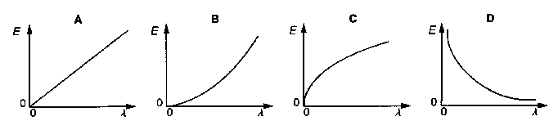

29. ${}_{\text{92}}^{\text{238}}{}U$decays through a series of transformations to a final stable nuclide. The particles emitted in the successive transformations are

α β β α α

Which nuclide is not produced during this series of transformations?

A ${}_{\text{88}}^{\text{228}}{}\text{Ra}$ B ${}_{\text{90}}^{\text{230}}{}\text{Th}$ C ${}_{\text{91}}^{\text{234}}{}\text{Pa}$ D ${}_{\text{92}}^{\text{234}}{}U$

30. In order to trace the line of a water-pipe buried 0.4 m below the surface of a field, an engineer wishes to add a radioactive isotope to the water.
Which sort of isotope should be chosen?

emitter half-life
A β a few hours
B β several years
C γ a few hours
D γ several years

