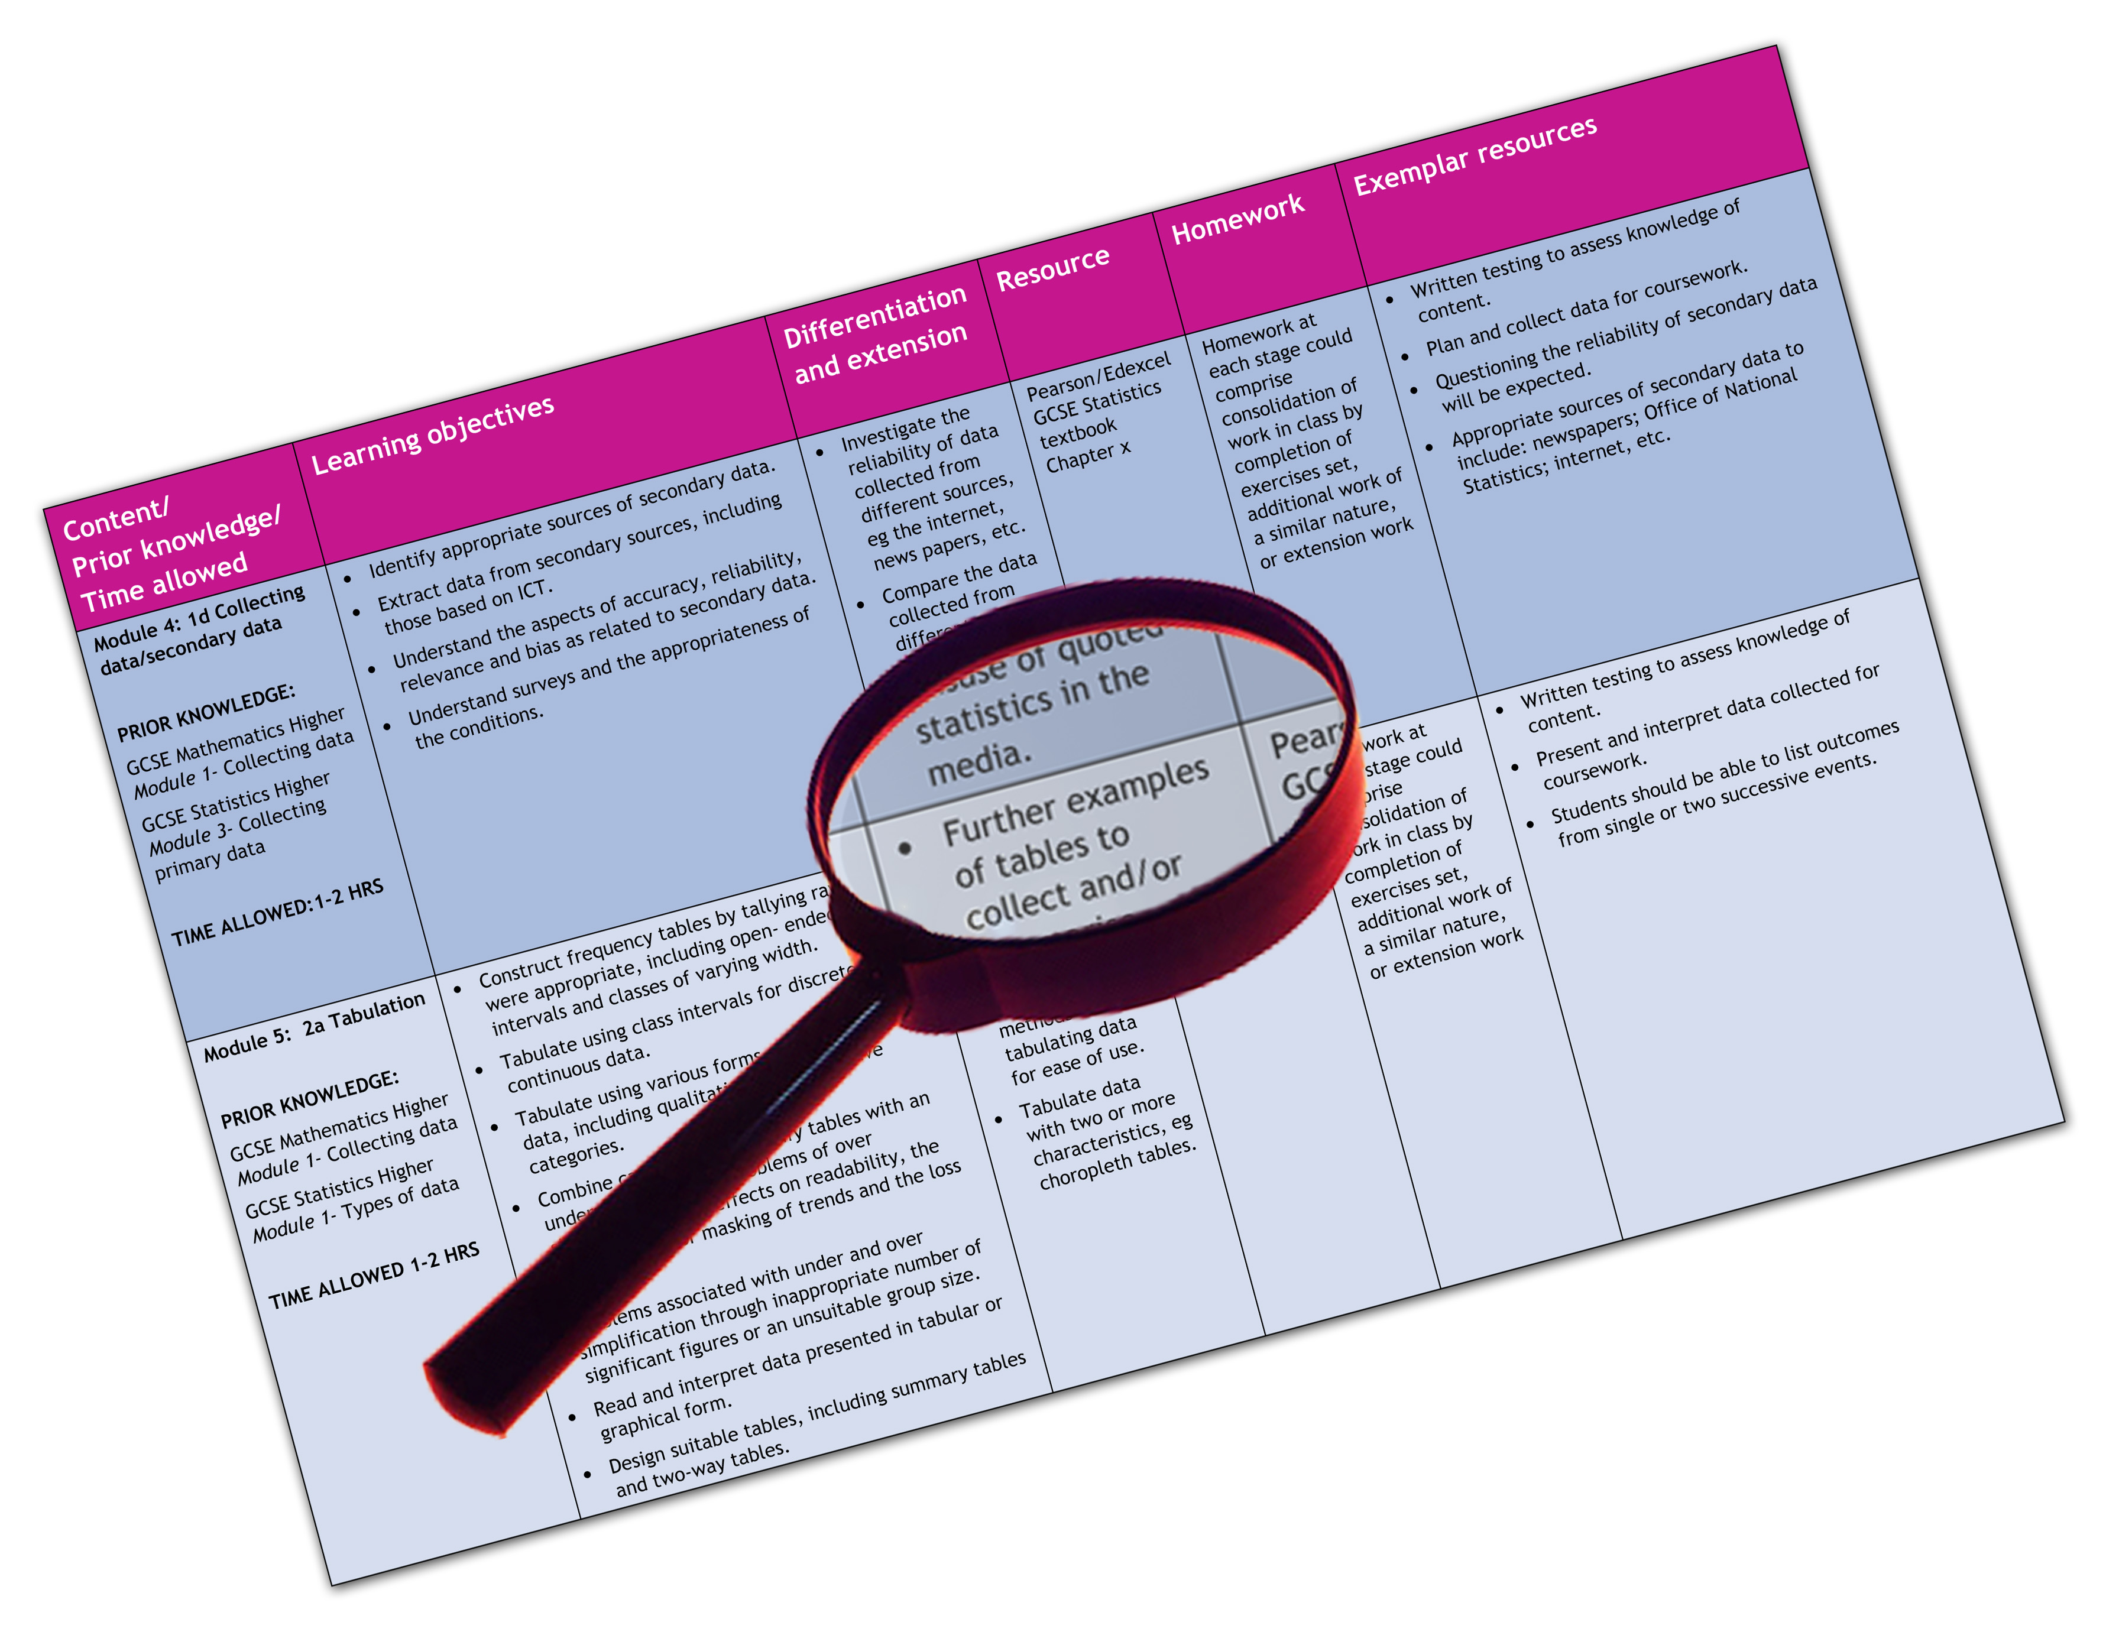


Edexcel GCE Physical Education
We are happy to provide this scheme of work for you to amend and adapt to suit your teaching purposes.

We hope you find this useful.
Editable scheme of work

Detailed help on resources

Week by week content coverage

Exemplar activities

Learning outcome

Unit 4

Unit 4 – The Critical Sports Performer
Specification content
See Chapter 8 in student book
4.1 Development Plan
This could be a unit of work to be introduced to suit the department’s planning of the course eg at the start of the course so that the students can start to develop their plan over the summer after the AS examination. See section 4.1 in student book.
 |  | Resources
Lesson 1 | Introduction to development plan – Review of strengths and weaknesses from task 2.4 | Student Book Chapter 10
Lesson 2 | Select plan aim – outline methodology | Student Book Chapter 10  Teachers Guide Worksheet 10.1
Lesson 3 | Undertake research  Develop a working time line to track plan | Student Book Chapter 10  Teachers Guide Worksheet 10.2  Teachers Guide Worksheet 10.3
Lesson 4 | Research session – literature/internet review of area to develop – application to chosen sporting activity and chosen role | Student Book Chapter 10
Lesson 5 | Draft 1 – Plan outline, methods on initial assessment and how progress will be monitored, resources required and set targets/goals for plan | Student Book Chapter 10
Lesson 6 | Complete draft 1 – planning and research section | Student Book Chapter 10
Lesson 7 | Submit plan for approval – revise content
Lesson 8 | Begin development plan – start monitoring and assessment | Student Book Chapter 10  Teachers Guide Worksheet 10.4
Lesson 9 -12 | Continue to assess and monitor plan – use lesson time to complete training diary/ formal reviews of progress and/or competition | Student Book Chapter 10  Teachers Guide Worksheet 10.5
Lesson 13 | Half way review – re test mid plan feedback
Lessons 14- 18 | Continue to assess and monitor plan – use lesson time to complete training diary/ formal reviews of progress and/or competition | Student Book Chapter 10
Lesson 19 | Complete plan – final test – feedback on progress

4.2 International Study

This could be a unit of work to be introduced to suit the department’s planning of the course eg it is suggested that this section is taught along side the international case studies in unit 3. See section 4.2 in student book.
 |  | Resources
Lesson 1 | Introduction to international study – concept and research pathways | Student Book Chapter 10  Teachers Guide Worksheet 10.7
Lesson 2 | Selection of study culture – submission to include initial research and justification for culture chosen | Student Book Chapter 10
Lesson 3 | Local structure of sport in chosen culture – grass roots organisation and sporting ethos of nation | Student Book Chapter 10
Lesson 4 | School structure of sport in chosen culture – PE and School sport programmes | Student Book Chapter 10  Teachers Guide Worksheet 10.8
Lesson 5 | Elite pathways/national provision/ global image of sport in chosen culture | Student Book Chapter 10
Lesson 6 | The chosen culture – sports issues/world standing/ global image
Lesson 7 | Complete 1st draft for submission
Lessons 8-10 | Revise draft for final submission/marking

4.3 Progressive Participation

Practical activity lessons to run alongside the theory lessons approximately 10/12 lessons for each activity — Lesson 1 | Assessing students current performance levels to ascertain standard and plan scheme of work to the correct level.  Issue the activity criteria for the students to decide their current level and set their goal for the activity.
Remainder of the lessons  4.3. Player/ Official/ leader | Based upon ability and potential.  Practices to improve skills in isolation and performance in the competitive situation.  Activities to stretch the students ability and understanding of the rules, regulations, strategies and tactics
Remainder of the lessons  4.3 Player/Official/ leader | Based upon ability and potential.  Develop the students’ skills so that they can be effective in competitive/competition situations as appropriate.  Develop the student’s leadership skills so that they can be effective and show knowledge and understanding in teaching/coaching situations

4.4 Life Plan

This could be a unit of work to be introduced to suit the department’s planning of the course eg it is suggested that this section is taught along side the international case studies in unit 3. See section 4.2 in student book.
 |  | Resources
Lesson 1 | Introduction to life plan– concept and research pathways | Student Book Chapter 10  Teachers Guide Worksheet 10.13
Lesson 2 | Playing pathway – creation of time line | Student Book Chapter 10  Teachers Guide Worksheet 10.4
Lesson 3 | Trends in chosen sport – participation levels, injury statistics | Student Book Chapter 10
Lesson 4 | Retirement phase | Student Book Chapter 10
Lesson 5 | Complete 1st draft for submission
Lesson 6-8 | Revise draft for final submission/marking

