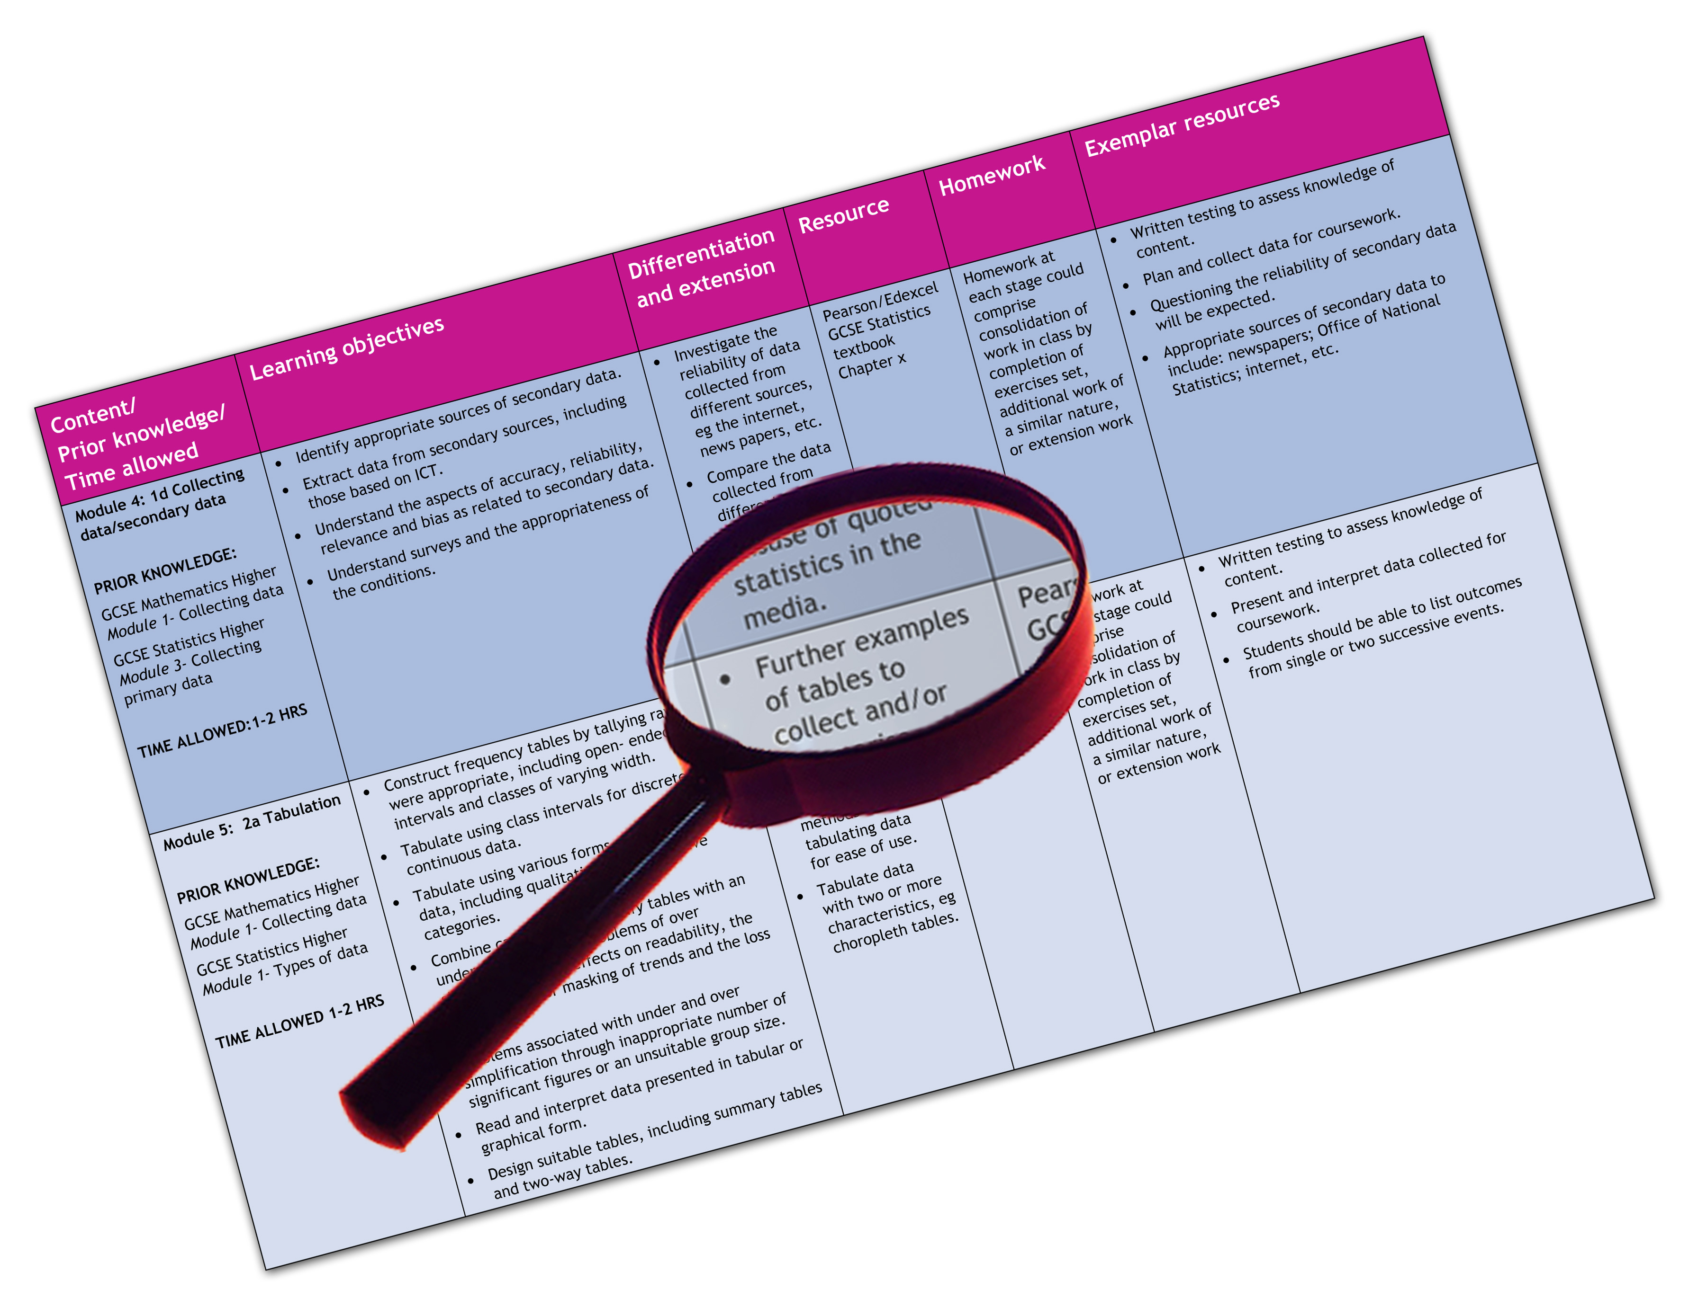


Edexcel GCE PE
We are happy to provide this scheme of work for you to amend and adapt to suit your teaching purposes.

We hope you find this useful.
Editable scheme of work

Detailed help on resources

Week by week content coverage

Exemplar activities

Learning outcome

Unit 2

Unit 2 – the Critical Sports Performer
Specification content
See Chapter 8 in student book
2.1.1  2.1.2 | Personal Performance role 1 (performer/ official/ leader)  Personal Performance role 2 (performer/ official/ leader)
Practical activity lessons to run alongside the theory lessons approximately 10/12 lessons for each activity — Lesson 1 | Assessing students current performance levels to ascertain standard and plan scheme of work to the correct level.  Issue the activity criteria for the students to decide their current level and set their goal for the activity.
Remainder of the lessons  2.1 Player/participant | Based upon ability and potential.  Practices to improve skills in isolation and performance in the competitive situation.  Activities to stretch the students ability and understanding of the rules, regulations, strategies and tactics
Remainder of the lessons  2.1.2 Official/ leader | Based upon ability and potential.  Develop the students’ skills so that they can be effective in competitive/competition situations as appropriate.  Develop the student’s leadership skills so that they can be effective and show knowledge and understanding in teaching/coaching situations

2.2 and 2.3 The local Study and the National Study

This could be a unit of work that can be delivered along side many of the topics in unit 1.2 opportunities and pathways and could be delivered and structured to suit the department’s planning of the course See section 2.2 and 2.3 in student book.
 |  | Resources
Lesson 1 | Introduction- local study – concept and research pathways  Explanation of primary and secondary research methods  Review of local media (e.g. local paper to identify research pathways)  Review of key terms such as first level elite | Student Book pp 159 -161  Student Book chapter 5
Lesson 2 | School structure of sport – organisation/fixtures/competition  Share experience – apply to chosen activity | Student Book chapter 6
Lesson 3 | Grass roots – local organisation/facilities opportunities  Develop local sports club case study  Active learning – visit to local sports centre/complex to research/collect evidence | Student Book chapter 7
Lesson 4 | Local schemes/funding/public sector provision  Active learning – visit/speaker – county sports organisation/ sports development officer | Student Book chapter 7
Lesson 5 | Private and voluntary sectors – review of national provision – comparison with local area  Active learning – use of Sports England’s active places interactive website to check out sports provision in local area | Student Book chapter 7  http://www.activeplacespower.com/
Lesson 6 | Complete first draft of cal study of chosen sports activity | Exemplar e portfolios – http://www.edexcel.com/quals/gce/gce08/pe/Pages/default.aspx  Student book pp184
Lesson 7 | Introduction to the national study – overview of assessment requirements. Review of terminology first level elite to international provisions Review of key organisations – application to chosen sports activity and role – eg who is the national governing body, is it a lottery funded sport, is it a UK sport target sport | Student Book pp161-162
Lesson 8 | Pathways – Area/County/Regional/National/International provision  Application to sports pyramid- active learning – can students identify case studies/performers at each level | Student Book chapter 6
Lesson 9 | National governing Body - role/function/provisions  Application to chosen activity | Student Book chapter 6  Teacher Resource Pack – Worksheet 8.5
Lesson 10 | Role of academies / United Kingdom Institutes of sport  World class and other elite sports pathways in the UK  Active learning - visit to sports academy/ High performance facility/ UKSI (link with Unit 1 .2) | Student Book chapter 6  Teacher Resource Pack – Worksheet 8.6
Lesson 11 | Funding and additional agencies. Review of lottery funding  Case studies – application to chosen role and activity | Student Book chapter 6
Lesson 12 | Complete 1st draft submission of national study | Exemplar e portfolios – http://www.edexcel.com/quals/gce/gce08/pe/Pages/default.aspx  Student book pp185
Lesson 13 | Final submission of local and national study | Exemplar e portfolios – http://www.edexcel.com/quals/gce/gce08/pe/Pages/default.aspx
2.4 Performance Analysis

This could be a unit of work to be introduced to suit the department’s planning of the course eg at the start of the course so that the students can get practice in analysing in all their activities so that they can offer the analysis in the activity they analyse best. Some activities are better suited to this than others. See section 2.4 in student book.
 |  | Resources
Lesson 1 | Introduction to analysis with examples good and bad  Oral — written – presentation  Demonstration of an analysis and/or show a video  Explain how the performance analysis section will be assessed through the e-portfolio  Explain how the controlled assessment will work  Issue the activity criteria – the 5 analysis exercises  Target Setting for each section of the AoP.  Students set their goals for the activity | Student book pp162  Internal assessment guide  Exemplar e portfolios – http://www.edexcel.com/quals/gce/gce08/pe/Pages/default.aspx
Lesson 2 | Learning to observe  Use a video to introduce ideas on Analysis of Performance  Viewing video to demonstrate how to perform an AoP | Student Book Chapter 8  Teacher Resource Pack – Worksheet 8.7
Lesson 3 | Analysis, experience and practice  Analysing skills  The experts  Practice observing and analysing | Student book chapter 8 – exercise 1
Lesson 4 | Practice analysing performance  Terminology qualitative analysis  The good points of the performance  The areas for improvement  Practice analysis — feeding back to the performer  Homework on the “Perfect  The technical Model” | Student book chapter 8 – exercise 1  Teacher Resource Pack – Worksheet 8.7  Teacher Resource Pack – Worksheet 8.8

 |  | Resources
Lesson 5 | The Perfect Model. Terminology Quantitative analysis or notational analysis Introduction to quantitative analysis. Students practice a quantitative analysis. Compare qualitative and quantitative analysis. Practice analysis — feeding back to the performer | Exemplar technical model – student book pp 186  Student book chapter 8 – Exercise 2
Lesson 6 | Analyse a performance using quantitative analysis. Analyse a performance using qualitative analysis. Know how to and have practised evaluating an analysis of performance  The Perfect Model | Student book chapter 8
Lesson 7 | Evaluating a notational analysis of a team game  Evaluation of a performance in an individual activity such as swimming. What will an evaluation of this analysis show? Evaluating skills | Student book chapter 8 – Exercise 3  Teacher Resource Pack – Worksheet 8.11
Lesson 8 | Analyse a performance using quantitative analysis. Analyse a performance using qualitative analysis Know how to and have practised evaluating an Analysis of Performance  Have practised feeding back on their analysis of performance. Have produced material suitable for use in writing, presenting and answering orally for their Analysis of Performance controlled assessment task. | Student book chapter 8
Lesson 9 | Training analysis  Identifying strengths and weaknesses. | Student book chapter 8 – Exercise 4  Teacher Resource Pack – Worksheet 8.12
Lesson 10 | Strengths and weaknesses. Comparative strength and weaknesses with elite performer in chosen activity and role. Evidence and submit strengths and weaknesses | Exemplar report – student book pp 187  Student book chapter 8 – Exercise 5  Teacher Resource Pack – Worksheet 8.15
Lesson 11 | Complete e portfolio

