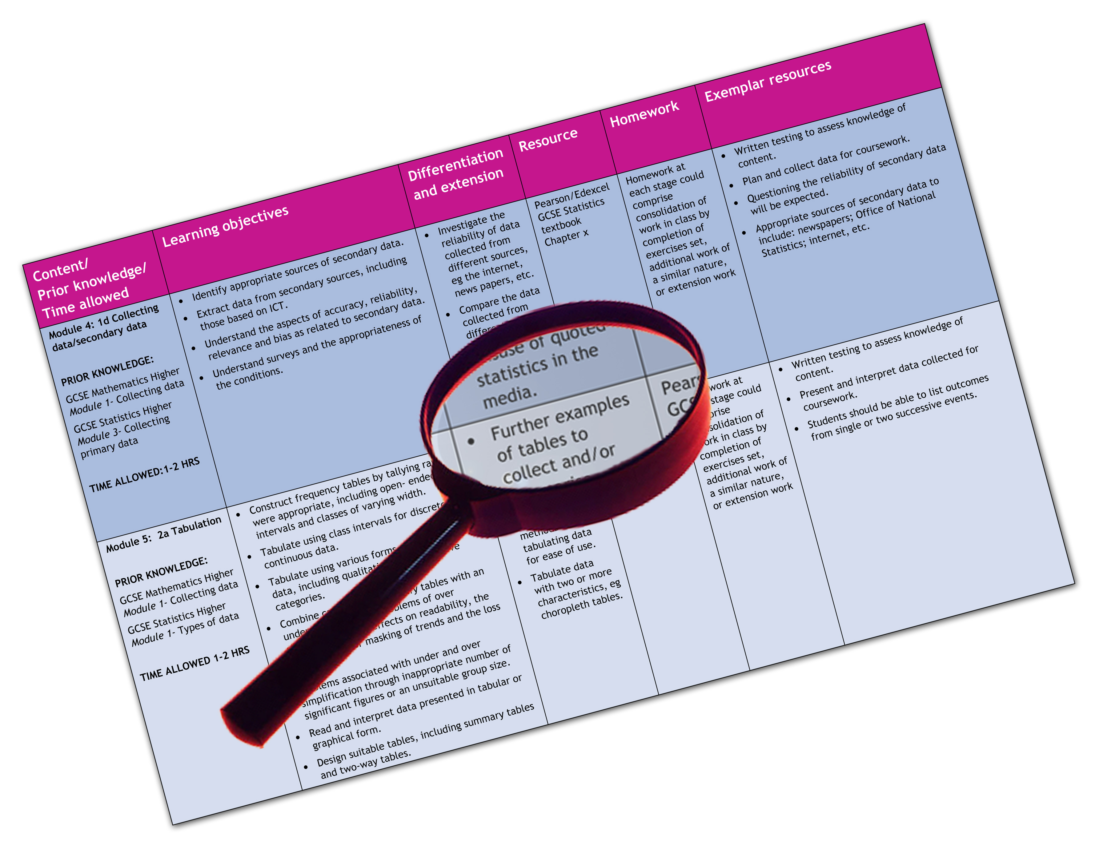


Edexcel GCE Physical Education
We are happy to provide this scheme of work for you to amend and adapt to suit your teaching purposes.

We hope you find this useful.
Editable scheme of work

Detailed help on resources

Week by week content coverage

Exemplar activities

Learning outcome

Unit 1

Specification content
Unit 1 — Participation in Sport and Recreation
Students will learn the theoretical parts of the course better if they are taught these topics through practical activity. This ‘hands-on’ approach to learning will help the candidates when they come to answer their written examination.

Section A — Healthy and Active lifestyles
Topic | Content | T and L guidance | Resources
Topic Area 1 | Requirements for participation:  Fitness, ability, resources, time.  Concepts of recreation and active leisure:  Philosophy of mass participation, sport for all.  Contemporary concerns:  Obesity, coronary heart disease, diabetes, high blood pressure, high cholesterol, metabolic syndrome, sedentary lifestyles, activity patterns, ageing population, access, stress. | Suggested one-two lessons to cover.  Part of induction.  Link to family and peers.  Press review and presentation.  Detail in area 2. | Student book Chapter 1.  Student book task page 5 .  Student book task page 12.  Teachers Resource Pack.  Worksheets 1.1, 1.2, 1.3 .
Topic Area 2  Health, fitness and exercise: | Differences, links, positive health benefits (physical and psychological).  Physical – (energy expenditure) reduction in body fat; increased resting metabolic rate and/or increased proportion of muscle mass; reduced rates of mortality, CHD, obesity, reduce risk of osteoporosis, and help type II diabetes management.  Current trends.  Comparative cultures, eg USA, Finland, Japan. | Suggested two lessons to cover.  Work on key terms – develop glossary.  Link to Active people survey – local stats.  Project work. | Student book Chapter 2.  Student book task page 22.  Student book tasks page 27.  Student book tasks page 37.  Student book tasks page 39.  Teachers Resource Pack.  Worksheet 2.1.

Topic | Content |  | T and L guidance | Resources
Topic Area 3  Nutrition and weight management: | Energy intake, food groups, hydration, balance diet, food pyramid, cholesterol, dietary requirements for exercise.  Balanced lifestyle:  Energy balance (energy intake vs energy expenditure), work–life balance, dealing with stress. | two lessons.  Food diary.  Comparison of different athletes diets – BBC Sports Academy. |  |  | Student book Chapter 2.  Student book task page 27.  Student book task page 28.  Student book tasks page 29.  Teachers Resource Pack.  Worksheet 2.1.  Worksheet 2.2.
Topic Area 4  Effects of ageing: | Physical maturation, decline in physical capability (cardiovascular fitness muscular strength, lung function, resting metabolic rate, osteoporosis, flexibility). | Suggested 1 lesson to cover.  Produce graph – visual time line.  Link to health Lifestyles – reformative.  Help the Aged = Ageing well/fit as a fiddle. |  |  | Student book – pp42-45.  Student book – take I t further task pp 44.  http://www.ageconcern.org.uk/AgeConcern/fit-as-a-fiddle.asp

Topic | Content |  | T and L guidance | Resources
Topic Area 5  Effects of exercise — responses and adaptations of the body systems  PART 1 | Muscular-skeletal system:  Responses (fibre recruitment, force production, metabolism).  Adaptations (increase fibre size, increase force production .  Increase metabolic energy supply).  Cardiovascular:  Responses (> SV, HR, Q, redistribution of blood flow to working muscle).  Adaptations (increase in size of heart, SV, Q and capillaries). | Suggested 10 lessons to cover both sections.  Active learning looking at short term responses of muscular skeletal system .  The major muscle groups — learning the muscles and their application in earlier lessons.  Increased fuel demands/lactic acid.  Isometric and isotonic contractions.  May need basic anatomy revision to underpin knowledge – how muscles work in pairs.  Active Learning — practical sessions demonstrating how exercise and fitness are linked to the cardiovascular system.  Practical application and information gathering.  Immediate and short term effects of exercise.  Blood pressure, heart rates and exercise how affected over sustained training.  Exercise and physical activity — the affects on the C/V system. |  |  | Student book chapter 3.  Student book task page 53.  Teachers Resource Pack.  Worksheet 3.1.  Worksheet 3.3.  Worksheet 3.4.  Student book chapter 3.  Student book task page 58.  Teachers Resource Pack.  Worksheet 3.5.

Topic | Content |  | T and L guidance | Resources
Topic Area 6  Effects of exercise — responses and adaptations of the body systems  PART 2 | Respiratory:  Responses (Increased rate and depth of breathing, increased gas exchange).  Adaptations (improvements in respiratory muscle performance.).  Neuro-muscular:  Responses (increased number of muscle fibres recruited, increase in rate of fibre recruitment) .  Adaptations (improved co-ordination, increases in force production and rate of force production, increase in speed). | Suggested 10 lessons to cover both sections.  Active lessons – use of information gathered during practical sessions.  Exercise and physical activity — the affects on the respiratory system.  Immediate and short term effects.  The effects of regular and long term participation.  Immediate and short term effects.  The effects of regular and long term participation. |  |  | Student book chapter 3.  Student book task page 62.  Teachers Resource Pack.  Worksheet 3.5.  Student book chapter 3.  Teachers Resource Pack.  Worksheet 3.5.
Topic Area 7  Fitness and training  PART 1 | Components of physical fitness:  Speed, strength, endurance (aerobic, muscular), flexibility, composition.  Components of skill fitness:  Coordination, balance, agility, reaction time, power, endurance (local muscle, cardiovascular, strength). | Suggested two lessons to cover.  Work on key terms – develop glossary.  Link to Unit 2 fitness types. |  |  | Student book chapter 4.  Student book task page 74.  Teachers Resource Pack.  Worksheet 4.1.  Worksheet 4.2.  Worksheet 4.3.

Topic | Content |  | T and L guidance | Resources
Topic Area 8  Fitness and training  PART 2 | Methods of fitness training:  Aerobic/anaerobic training, continuous, interval, power, circuit/weight/ resistance training, speed, fartlek, cross training, core stability, plyometrics, SAQ (speed, agility, quickness), stretching (static, ballistic, dynamic, proprioceptive neuromuscular facilitation — PNF).  Principles of training:  FITT, duration, recovery Application of fitness and training/overtraining.  Appropriateness of programmes to differing clients:  Young and old, trained and untrained, active and sedentary, healthy and unhealthy. | Suggested two lessons to cover.  Work on key terms – develop glossary.  Project work – linked to own sports activity – foundation for task 4.1.  Project based on developing fitness programmes for different members of students families – eg grandparents, sporty sibling, parent who wants to lose weight. |  |  | Student book chapter 4.  Student book task page 79.  Teachers Resource Pack.  Worksheet 4.3.  Worksheet 4.4 .

Topic | Content |  | T and L guidance | Resources
Topic Area 9  Fitness assessment | Rationale of assessment:  Maximal v sub-maximal tests, reasons for testing/use of tests for assessment of fitness, limitations, validity and reliability, using Technology to assess fitness.  Protocols of recognised fitness tests:  Application, understanding, Physical Activity Readiness Questionnaire.  (PARQ), tests for different components of fitness, eg strength, power, speed, flexibility, endurance, body composition. | Suggested two lessons to cover.  Work on key terms – develop glossary.  Active lessons — Healthy school week.  Staff MOT’s.  Fitness testing linked to strengths and weaknesses. |  |  | Student book chapter 4.  Exemplar PARQ – student book pp 90.  Student book task page 93.  Teachers Resource Pack.  Worksheet 4.5 .  Protocol of key fitness tests — http://www.topendsports.com/

Section B — Opportunities and pathways

Topic | Content | T and L guidance | Resources
Topic Area 1  The development of competitive sport | Festivals of sport:  Ancient, modern, popular recreations, the modern Olympic Games, international sports festivals.  Emergence of ‘rational sport’ as a product of the Industrial Revolution:  Codification (reason, need, process), development of national governing bodies, role of Oxbridge, export of the games ethic .  20th century:  Development of professional and international sport, ‘Spectatorism’, sport(s) as a business, rise of the ‘sports star’. | Suggested 8 lessons to cover.  Work on key terms – develop glossary.  Time line of key historical developments.  Own Sports study.  Local examples of sports historical development. | Student book chapter 5.  Exemplar time line – student book Fig 5.1.  Student book task page 100.  Student book task page 101.  Student book task page 104.  Teachers Resource Pack.  Worksheets 5.1,5.2, 5.3.  Overview of popular recreations- http://www.pe4u.co.uk

Topic | Content |  |  | T and L guidance |  | Resources
Topic Area 2  The development of competitive sport  Issues |  | 21st century:  Globalisation of sport, Olympic case study, increase in commercialism and media influence, sponsorship, advertisement and endorsement (eg problems of Montreal games followed by ‘Hamburger games’ of 1984), ‘Americanisation’, TV (influence of/on sport, impact of non-terrestrial networks).  Deviance in sport:  Sportsmanship, gamesmanship, performance enhancing drugs, role of WADA future developments. | Suggested 6 lessons to cover.  Mini Olympics review.  News reporting project on key issues – done in groups or as an individual.  Develop a scrap book of contemporary examples.  Regular review of press/media for related stories/examples. |  | Student book chapter 5.  Student book task page 110.  Student book task page 101.  British Olympic Association education resource area — http://www.olympics.org.uk/education.aspx
Topic Area 3  Performance pathways |  | Sporting pyramid:  Concept, how the base and peak interlink, difference between participation and performance Levels (foundation, participation, competition, elite), link to learning and development of skills as well as increasing training and support needs.  The roles of key UK agencies (Youth Sports Trust, UK Sport, Sport England etc), in managing the pyramid in the UK. | Suggested two lessons to cover.  Application to students own sporting activity.  Link to local and national study.  Application to own sports pyramid. |  | Student book chapter 6.  Student book task page 119.  Student book task page 121.  Teachers Resource Pack.  Worksheets 6.1, 6.2.

Topic | Content |  |  | T and L guidance |  | Resources
Topic Area 4  Performance pathways |  | Traditional pathways:  Role of schools, universities, clubs, sports colleges.  Current models:  National Framework for Sport, Game Plan, A Sporting Future for All, UKSI network, sports search programmes.  Talent Identification:  Concept, history of talent development in East Germany and Australia, UKSI and NGB talent identification schemes in the UK.  Talent Development:  Schools Games, World Class Programme TASS, AASE. | Suggested 3 lessons to cover.  Link to local and national study.  Visit to ‘local’ UKSI.  Group work into other nations elite sports systems and presentation to rest of group.  Plotting of local examples/case studies on development pathway – link to national study. |  | Student book chapter 6.  Teachers Resource Pack.  Worksheets 6.3, 6.4, 6.5.  Key websites.  www.sportsearch.org.uk  www.tass.gov.uk  www.sportsaid.org.uk

Topic | Content |  |  |  | T and L guidance |  | Resources
Topic Area 5  Lifelong involvement |  | Concepts (sport for all, mass participation, lifetime sports, leadership and volunteering programmes), Sport England’s participation segments benefits of increased participation .  Constraints on participation:  Opportunity, provision, esteem, cost, time, resources, geographical, pressure.  Target groups:  Definition, groups (gender, race, age, socio-economic background). | Suggested 3 lessons to cover.  Use Sport England – active people survey date to analyse participation in students locality.  Link to local and national study.  Develop marketing campaign for a target group – which identifies key constraints. |  |  | Student book chapter 7.  Student book task page 140.  Student book tasks page 142.  Teachers Resource Pack.  Worksheets 7.1.  Worksheet 7.2.  http://www.sportengland.org/research/active_people_survey.aspx
Topic Area 6  Reformative policies |  | Role of sports councils, eg Making England Active, multi-sport hubs, active places initiative, public service agreements.  Work of specialist agencies, eg Women’s Sports foundation, Federation of English Disability Sport, Kick It Out.  Concessions, programming, local schemes, school and county sports partnerships. |  | Suggested 3 lessons to cover.  Link to local and national study.  Disabled sport activity.  Local examples. |  | Student book chapter 7.  Student book tasks page 142.  Teachers Resource Pack.  Worksheets 7.3.

Topic | Content | T and L guidance | Resources
Topic Area 7  Technical developments and cultural trends: | Private gyms and health clubs, fashion and activity, role of media, technology linked to access, adrenaline and adventure sports, impact of 2012 Olympic Games. | Suggested two lessons to cover.  Link to local and national study.  Local examples. | Student book chapter 7.  Student book tasks page 146.
Topic Area 8  Long Term Athlete Development (LTAD) | Philosophy, models (eg elite, retention), reasons for LTAD review of current models, link to current sports models in the UK.  Early and Late Specialisation (‘FUNdamentals’, learning to train, training to train, training to compete, training to win, retirement and retainment. | Suggested two lessons to cover.  Link to local and national study.  Personal sports examples – apply to own sporting activity – foundation for task 4.4 in A2. | Student book chapter 7.

