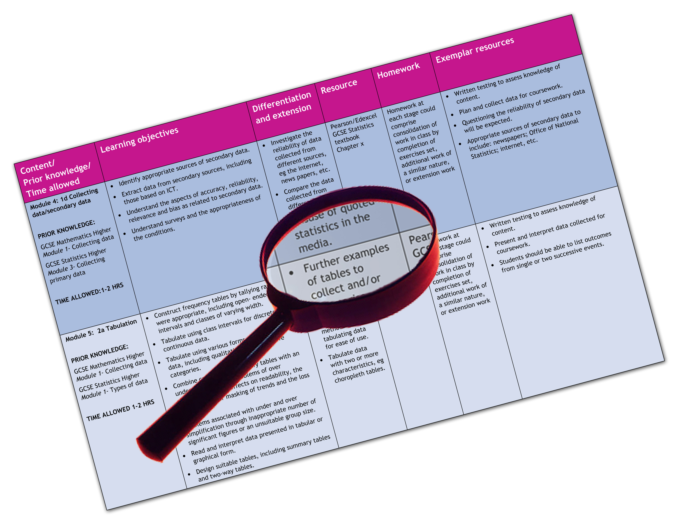


Edexcel GCE Music
We are happy to provide this scheme of work for you to amend and adapt to suit your teaching purposes.

We hope you find this useful.
Editable scheme of work

Detailed help on resources

Week by week content coverage

Exemplar activities

Learning outcome

Unit 4, 5 and 6

A2 Music
Edexcel scheme of work for GCE Music

Y13  Week | Content coverage/  key questions | Learning outcomes | Exemplar activities | Exemplar resources
1-3 | Introduction to A2 Music.  Outline of the three units of the course.  Planning for options in unit 5 – either two technical studies, two compositions or one of each.  Unit 4:Extended Performance Music  Overview of year. Planning a 12-15 performance (recital.  Aim in terms of content is to have a mock run through in the last week of this term ( in December) Performance recitals to be scheduled for February (after half term)  Unit 5: Composition and Technical Study  The composition briefs will be available form the second week of term, so pupils need to decide on options.  For those undertaking technical studies, the scheme plans a course of study up to the release date of the pieces on April 1st.  Unit 6: Further Musical Understanding  Two categories of works to be covered over the year as under the headings of Applied Music and Instrumental Music.  Applied Music: Study works  Stravinsky – Pulcinella Suite and Gabreli – Sonata pian’e forte  Associated Listening tests | To start to plan a programme for the performance in February in conjunction with instrumental music teacher  To start work on stylistic Bachian Harmony for the chorale question.  A starting point will be cadential progressions  Study of characteristics of Renaissance polychoral style as demonstrated by the Gabrieli work  Study of the twentieth century neo-classical style of Pulcinella (linking to work done last year of the Poulenc piece) | If possible, pupils should offer one performance by week 4 of the course.  Initial exercises in cadence completion (similar to AS task)  Looking at the different performance circumstances of these two contrasted pieces, as well as an analysis of the music. | Main resources for teaching the course:  Edexcel A2 Study Guide (pub. Rhinegold)  New Anthology of Music (pub. Edition Peters  A2 Harmony Workbook p.19 -32 (pub. Rhinegold)  Listening tests for students (Rhinegold)  A Student’s guide to Harmony – H Benham (Rhinegold)  Edexcel A2 Study Guide (pub. Rhinegold) has a section on this unit  Edexcel A2 Study Guide (pub. Rhinegold) has a section on this unit  A2 Harmony Workbook (pub. Rhinegold) has a section dedicated to Bach Chorales.  Edexcel A2 Study Guide (pub. Rhinegold) has a section on this unit  Edexcel A2 Study Guide (pub. Rhinegold)  New Anthology of Music (pub. Peters Edition)  Listening tests for students: A2 Music- published by Rhinegold/ January 2010)
4-6 | Unit 4: Extended Performance  Performance of one (or two) pieces (from the recital programme)  Unit 5: Composition and Technical Study  Working on Bach Chorale writing  Cadential progressions and approach chords  (or composition)  Unit 6: Further Musical Understanding  Work continues with a study of the two ground bass extracts from Dido and Aeneas  Applied Music:: Study works  Purcell – two extracts from ‘Dido and Aeneas’  Associated Listening tests | To gain confidence in performance in front of a live audience  To be able to use formulaic progressions correctly  To understand the hallmarks of the Baroque style and the workings of ground bass form | Class performances of a piece from each pupil.  Completion of exercises (form A2 Harmony Guide) | Edexcel A2 Study Guide (pub. Rhinegold)  New Anthology of Music (pub. Peters Edition)  Listening tests for students: A2 Music- published by Rhinegold/ January 2010)
7-9 | Unit 4: Extended Performance  On going preparation for recital  Unit 5: Composition and Technical Study  Working on writing strong bass lines/ high tenor parts and checking work for consecutives  (or composition)  Unit 6: Further Musical Understanding  Study of film music score  Applied Music:: Study works  Jerry Goldsmith – Planet of the Apes: The Hunt (opening)  Associated Listening tests | To further develop a facility for completing Bach Chorales  To understand the relationship between sound and picture and how composers produce film score music. | Completion of various exercises  (from A2 study Guide) | Edexcel A2 Study Guide (pub. Rhinegold)  New Anthology of Music (pub. Peters Edition)  Listening tests for students: A2 Music- published by Rhinegold/ January 2010)
10-13  End of Autumn Term | Unit 4: Extended Performance  Working towards a mock recital towards the end of this term.  Unit 5: Composition and Technical Study  Modulation procedures in Bach Chorales  Unit 6: Further Musical Understanding  Indonesian Gamelan Music – music for shadow puppet plays and ceremonies.  Applied Music:: Study work  Gong Kebyar de Sebatu (Bali) – Baris Melampahan  Associated Listening tests | To be able to identify and successfully completed modulations to related keys in Bach Chorales  A study of the characteristics of the oral tradition represented by this example of Indonesian gamelan Music | Completion of exercises (could be taken from A2 Harmony Guide)  Listneing and Analysis notes | Edexcel A2 Study Guide (pub. Rhinegold)  New Anthology of Music (pub. Peters Edition)  Listening tests for students: A2 Music- published by Rhinegold/ January 2010)
14-18  18-20 | Unit 4: Extended Performance  Preparation for recitals in weeks 20-22 (depending on individual arrangements)  Unit 5: Composition and Technical Study  Completion of Chorales and starting work on either the 32 bar song completion or figured bass.  (or composition)  Unit 6: Further Musical Understanding  Instrumental Music  Study of the Baroque and Classical works – Corelli Trio Sonata in D and Haydn String Quartet in E flat.  Associated Listening tests | To write idiomatic realisations of Bach Chorales  To understand the characteristics of the Baroque and Classical styles as exemplified by the two set works.  To achieve an understanding of the salient musical characteristics of Baroque Music and the Concerto principle  Knowledge of the Classical style and the principles of Sonata From  Study of the neo-classical style of Poulenc’s compositional style | Practice workings of sample questions  Listening/ Analysing activities  Individual Study  Analysis notes etc.  Set sample essays on each work, which ask the questions ‘ Describe how the musical features of Piano Sonata in Bb by Mozart show that this music was written in the Classical period’ and ‘Describe how the music of Sonata for Horn, Trumpet and Trombone shows that this piece is an example of twentieth century neo-classicism.’ | Edexcel A2 Study Guide (pub. Rhinegold)  New Anthology of Music (pub. Peters Edition)  Listening tests for students: A2 Music- published by Rhinegold/ January 2010)  Edexcel AS Study Guide p.76-79 (pub. Rhinegold)  Edexcel AS Music Listening 2nd edition Tests p.48-49 (pub. Rhinegold)  Edexcel AS Study Guide p.79-83 (pub. Rhinegold)  Edexcel AS Music Listening 2nd edition Tests p.60-61 and p.56-57 (pub. Rhinegold)
19-22 | Unit 4: Extended Performance  Preparation for recitals in weeks 20-22 (depending on individual arrangements)  Unit 5: Composition and Technical Study  32 bar song completion and /or figured bass  Unit 6: Further Musical Understanding  Instrumental Music  Study of the Romantic works of Beethoven ‘s Septet in Eb and Schumann’s Kinderscenen  Associated Listening tests | To understand the Romantic elements inherent in these two works. |  | Edexcel A2 Study Guide (pub. Rhinegold)  New Anthology of Music (pub. Peters Edition)  Listening tests for students: A2 Music- published by Rhinegold/ January 2010)
23-26 | Unit 4: Extended Performance  Completed  Unit 5: Composition and Technical Study  Technical Studies are released and 3 hours per study will need to be found on the timetable  Unit 6: Further Musical Understanding  Instrumental Music  Study of the two twentieth century works- Cage Sonatas and Interludes for Prepared Piano and Tippett Concerto for Double String Orchestra  Associated Listening tests | To understand the features of experimental music as exemplified by the John Cage work and the twentieth features in the Tippett concerto |  | Edexcel A2 Study Guide (pub. Rhinegold)  New Anthology of Music (pub. Peters Edition)  Listening tests for students: A2 Music- published by Rhinegold/ January 2010)
27-30 | Unit 6: Further Musical Understanding  Instrumental Music  Louis Armstrong and his Hot Five (West End Blues)  Associated Listening tests | To understand the principles in Jazz Music and the art of improvisation. |  | Edexcel A2 Study Guide (pub. Rhinegold)  New Anthology of Music (pub. Peters Edition)  Listening tests for students: A2 Music- published by Rhinegold/ January 2010)
30-34  End of Summer Term | EXAMINATION PERIOD | EXAMINATION PERIOD | EXAMINATION PERIOD

