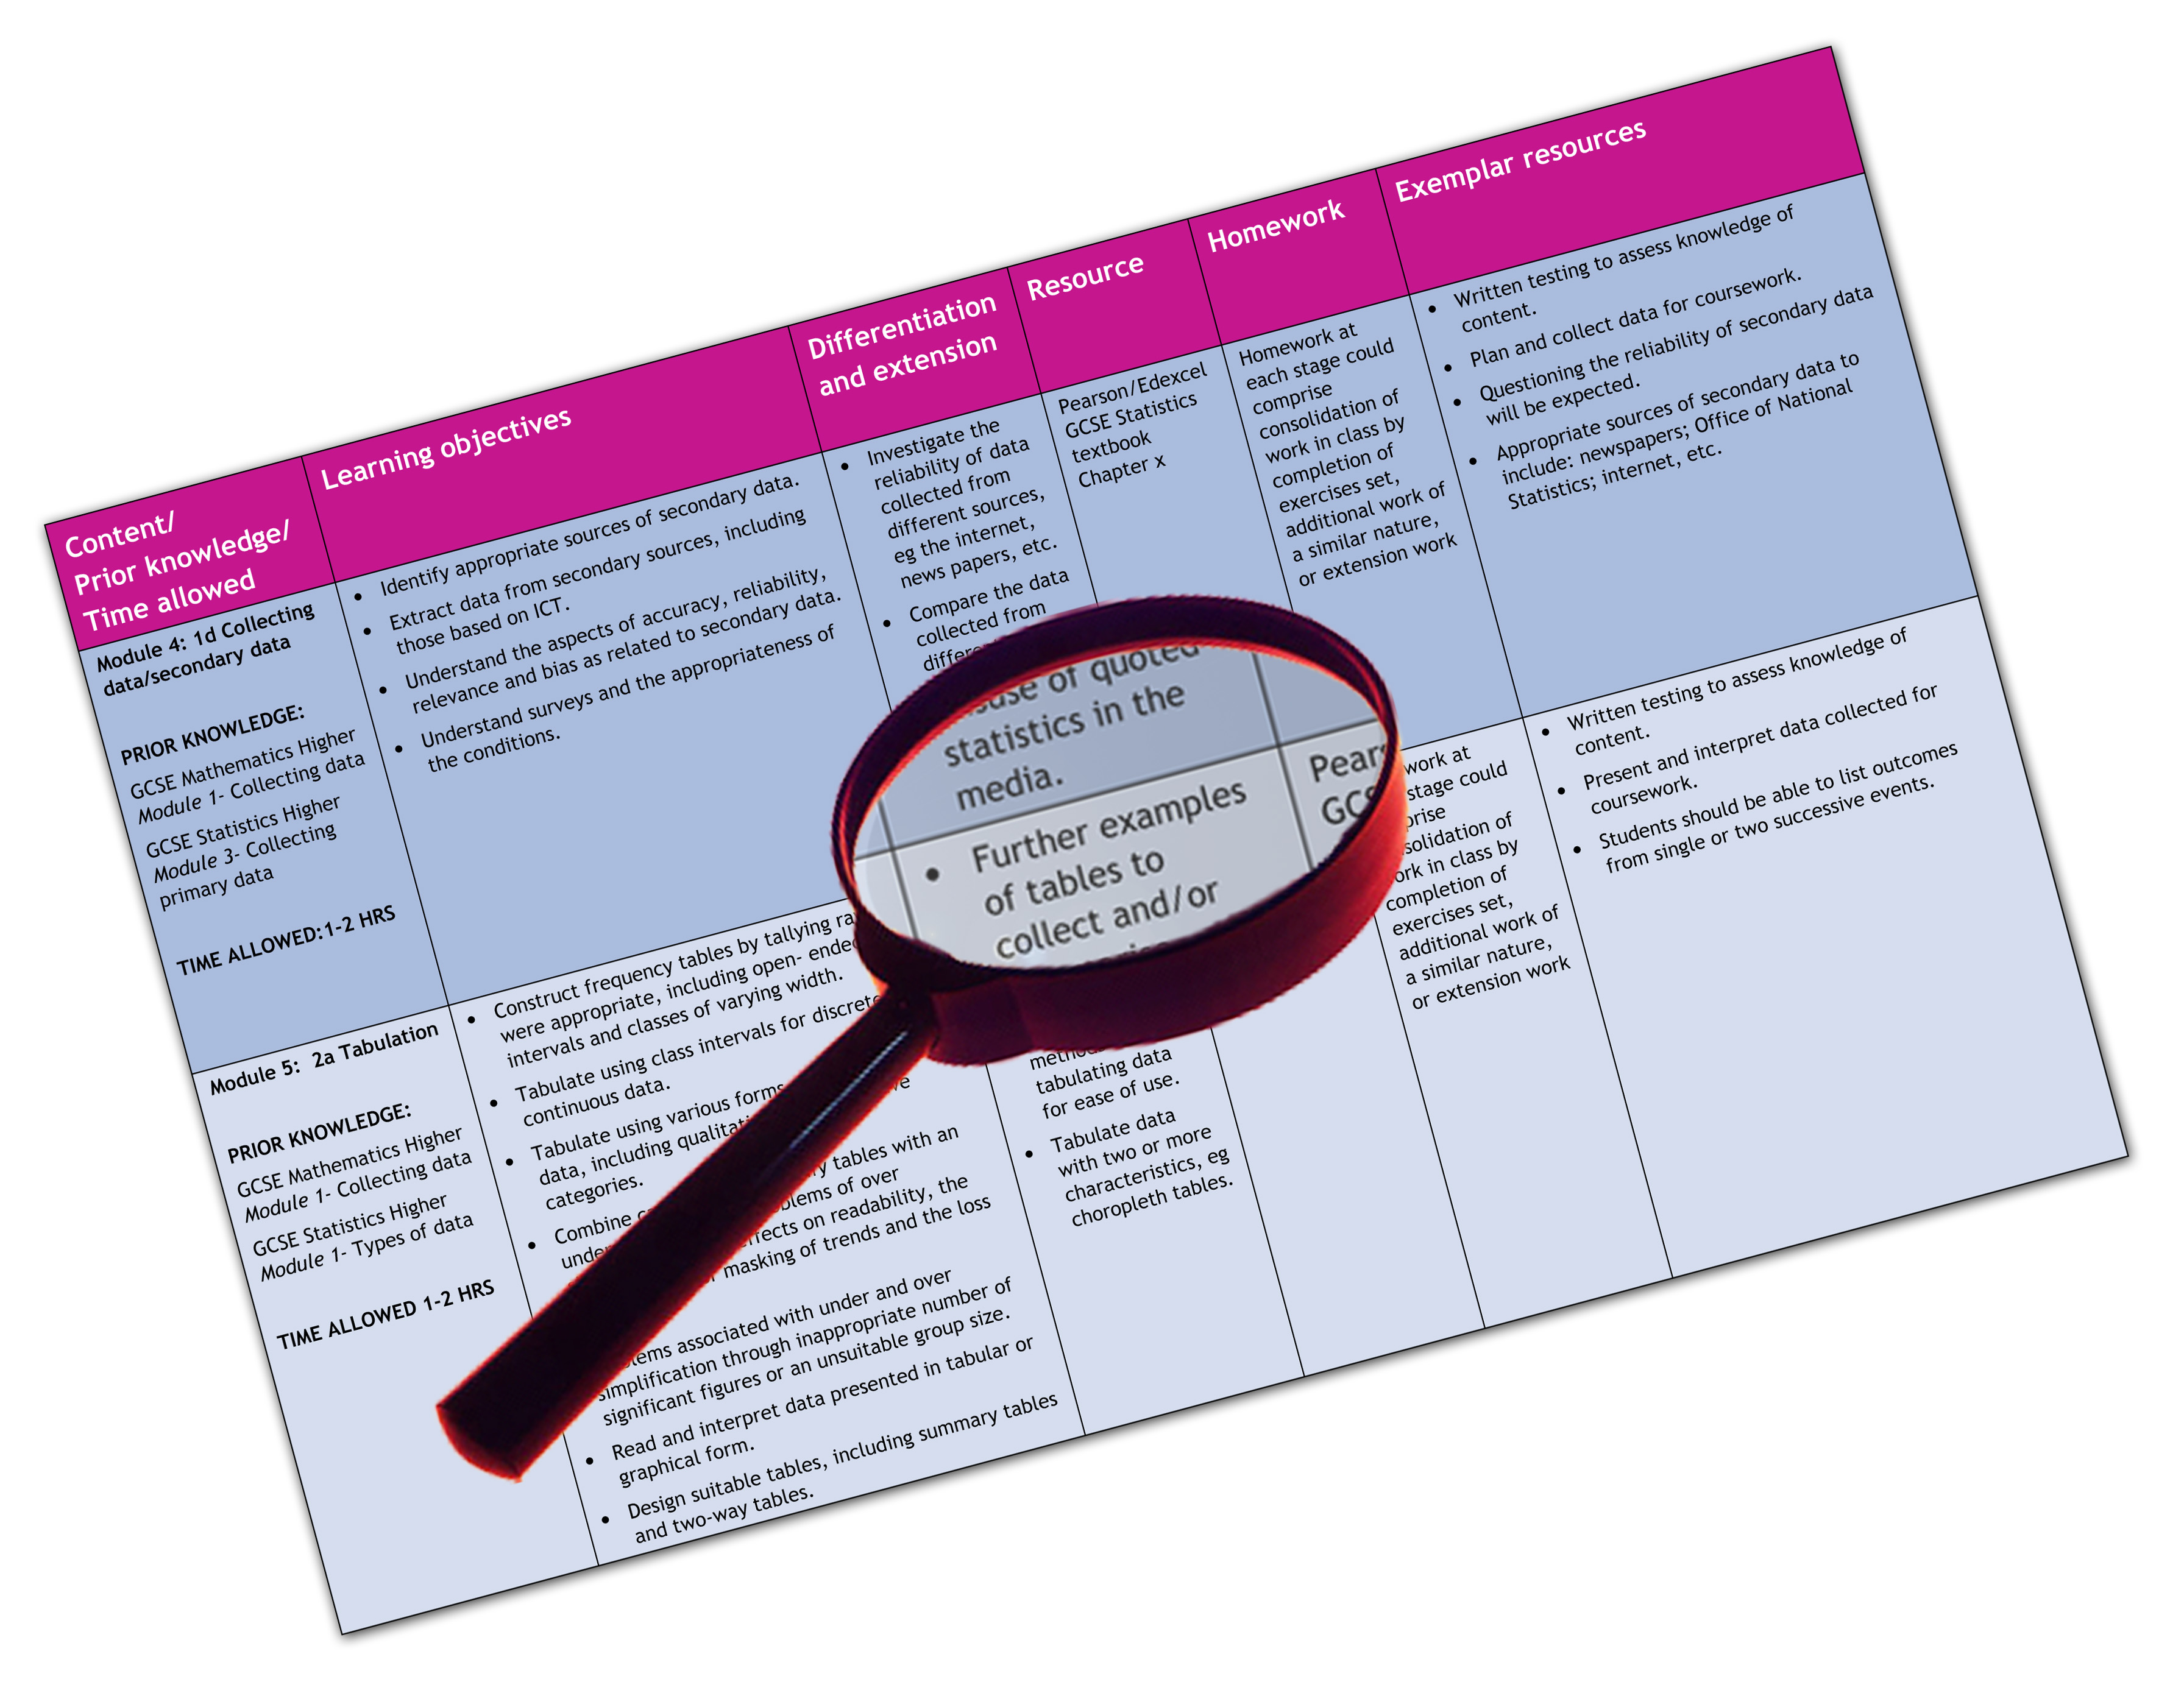


Edexcel GCE Music
We are happy to provide this scheme of work for you to amend and adapt to suit your teaching purposes.

We hope you find this useful.
Editable scheme of work

Detailed help on resources

Week by week content coverage

Exemplar activities

Learning outcome

Unit 1, 2, and 3

AS MUSIC
Edexcel scheme of work for GCE Music

Y12  Week | Content coverage/  key questions | Learning outcomes | Exemplar activities | Exemplar resources
1-3  1-3 cont. | Introduction to AS Music.  Outline of the three units of the course.  Unit 1: Performing Music  What makes a good performance?  This leads to a class performance of one piece in week 4.  Unit 2: Composing  What makes a good composition?  The composition briefs will be announced by week 4 of the course. In the first three weeks, consideration is given to the planning process and deciding which option to take from the four choices from Instrumental and Vocal options:  Instrumental  - Topic 1: Composing expressively  - Topic 2: Variation Structures  Vocal  - Topic 3: Words and music (Song composition)  - Topic 4: Text, context and texture (vocal ensemble composition)  Unit 3: Developing Musical Understanding  This term’s study will focus on the six vocal set works for 2010.  As a gentle introduction to this paper, start by looking at one of the set vocal pieces , Se quema la chumbamba (by Familia Valera Miranda).This has a simple structure, basic harmony and a straightforward transcribed score to follow.  Harmonic Analysis (Qu.4) and Harmony (Qu.5) | To explore performance following the long summer break and to set up a regular progress check of each pupil over the year.  To evaluate and compare each others performing skills highlighting strengths and weaknesses  To determine each pupils’ strengths in composition and for them to decide on the musical idiom or style for their piece.  To learn critical skills in evaluating creative compositions and to learn what makes a good composition.  To engage with one of the prescribed works and understand how the song works in terms of its key musical elements of melody, harmony, structure, rhythm, instrumentation etc.  To understand how a piece such as this is a fusion of musical styles and to be able to analyse the function of instruments/ voices in the music.  Exploration of common chords and their inversion | Pupils practice a piece for performance in week 4. This should give them time to organise themselves. This piece initially could be the same piece as recorded for GCSE as a starting point.  Pupils listen to examples from each of the four composition topics (these can be in any style/form). It might be a good idea to use the compositions done last year to initiate discussions.  It would be worthwhile to get each pupil to bring in a favourite piece (preferably with a score) so that some discussion can take place as to what makes a good composition? Is it the melody, harmony, structure, rhythms, and so on or is it a combination of different elements?  Pupils study the context of the music and how it is constructed and performed.  Analysis of the music in association with listening. Notes written onto score  Week 3:Pupils write an essay ‘Describe how the stylistic features of ‘Se quema la chumbamba’ show it is an example of Cuban son’  Sample exercises from study guide | Main resources for teaching the course:  Edexcel AS Study Guide (pub. Rhinegold)  New Anthology of Music (pub. Edition Peters  AS Harmony Workbook p.19 -32 (pub. Rhinegold)  Listening tests for students (Rhinegold)  A Student’s guide to Harmony – H Benham (Rhinegold)  Edexcel AS Study Guide p.98 (pub. Rhinegold)  New Anthology of Music page 534 (pub. Edition Peters)  AS Harmony Workbook p.19 -32 (pub. Rhinegold)
4-6 | Unit 1: Performing Music  Performances take place in week 4 as well as evaluations.  Pupils now select a piece for recording at the end of term to practice for the final recording in March 2010. The final piece could be that offered in December or a different piece. The assessment criteria (in the specification) should be discussed in order that pupils understand what is being assessed.  Unit 2: Composing  Discussion of the published composition briefs and selecting the chosen topic.  Discussion of research ideas, influences form composers, artists, pieces etc. Preparatory work for the Sleeve Note paper  Unit 3: Developing Musical Understanding  Analysis of two popular songs- ‘Waterloo Sunset‘ and ‘Tupelo Honey’  Harmonic Analysis (Qu.4) and Harmony (Qu.5)  Starting work on basic harmonic analysis | To learn about presenting a good musical performance with reference to the assessment criteria.  To understand what is needed in the next two months or so to present a confident and musical performance.  To chose the brief and decide on the style, idiom, genre of proposed composition.  To understand the need to keep notes/ research details etc. for the Sleeve Note examination paper  To analyse the structures and musical features in these two works. Comparison of the two pieces identifying similarities and differences.  To be able to recognise basic chords of I,II,IV,V and VI in root and first inversion | Group performances and evaluations by pupils in the class.  Pupils use the examination criteria to mark each performance as ‘pupil examiners’.  Use of Edexcel exemplar material form the website. This would be useful to carry out the same process with the podcast recordings and then compare marking and comments by Edexcel examiners.  Sleeve note questions written down into a personal file/ book to be added to as the composition evolves.  Writing up the key points for both works. This could be done in tabular format (with headings such as Melody, Rhythm, Harmony, Structure, Instrumentation, Musical Devices, Tonality etc|)  Use a simple chordal accompaniment, such as a hymn tune to identify chords in a key.  There are many structured examples in the AS Study Gide too. | Specification page 42 has the three Sleeve Note Questions  Edexcel AS Study Guide p.94-98 (pub. Rhinegold)  New Anthology of Music page 483 and 501 (pub. Edition Peters)  Edexcel AS Study Guide p.32-39(pub. Rhinegold)  AS Harmony Workbook (pub. Rhinegold)
7-9 | Unit 2: Composing  Preliminary steps to trying out ideas/ selecting text/ working out chords sequences/planning a structures (PREPARA|TION and RESEARCH time)  Note that these activities are not part of the 15 hours of controlled conditions (called WRITING time)  Unit 3: Developing Musical Understanding  Analysis of ‘Apres un reve’ by Faure and ‘Ohime, se tanto amate by Monteverdi.  Harmonic Analysis  Starting work on basic harmonic analysis. Cadences and formulaic progressions . | To achieve a plan for the composition to act as a template for the writing up process which starts in January.  To understand the features of Romantic music as represented by the set song ‘Apres un reve’ and then to look at the features of the Renaissance style of music as contained within the madrigal by Monteverdi.  To understand the four standard cadences and to be able to complete examples of each of these in an SATB score | These will be up to the individual but should include reference to sleeve note questions and pupils should keep a log of pieces that have influenced them (form the Anthology and beyond)  Activities will involve writing draft ideas, melodies/ chord patterns etc.  Listening to each piece and drawing up a comparative chart plotting features of each musical style under the headings of: MELODY, HARMONY, RHYTHM, TONALITY, WORD SETTING, TEXTURES.  To complete exercises featuring examples of each type of cadence | Edexcel AS Study Guide p.87-91 (pub. Rhinegold)  New Anthology of Music page 535 and 363 (pub. Edition Peters)  AS Harmony Workbook p. 33-50 (pub. Rhinegold)  Edexcel AS Study Guide p.40-43 (pub. Rhinegold)  Edexcel AS Music Listening 2nd edition Tests p.70-89 (pub. Rhinegold)
10-13  End of Autumn Term  14-17  18-20 | Unit 1: Performing Music  Performances will be in week 12, so time in these last three weeks of term to check on progress. In week 12, record performances and get the pupils to mark each other with the set criteria.  Some evaluations and feed back can be given In the last week of term.  Unit 2: Composing  Work continues on finding  ideas/ selecting text/ working out chords sequences/planning a structures (PREPARATION and RESEARCH time)  The writing up time will start next term.  Unit 3: Developing Musical Understanding  Summary of the works.  Sample essay writing (comparisons)  Some aural listening tests  Unit 1: Performing Music  As a follow up to last term’s performance, pupils now think about their piece(s) for the actual recording in March.  The three weeks should be set aside for pupils to discuss their repertoire with instrumental/ vocal tutors.  Piece(s) should be firmed up by week 17  Unit 2: Composing  This term’s lessons are set aside for controlled assessment time (15 hours) during which compositions will be written up.  The sleeve note should be completed in the final week of term.  Unit 3: Developing Musical Understanding  This term’s study will focus on the four instrumental set works for 2010.  Introduction to Instrumental Works and study of J.S Bach Brandenburg Concerto No. 4 in G (mov 1)  Practice aural question on the music (see resources)  Unit 1: Performing Music  Performance work continues  Unit 2: Composing  This term’s lessons are set aside for controlled assessment time (15 hours) during which compositions will be written up.  Unit 3: Developing Musical Understanding  Mozart: Piano Sonata in Bb and Sonata for Trumpet, Horn and Trombone by Poulenc are the two study works over this three week period.  Practice aural question on the music (see resources) | Sample solo performance recording 1 (these could be used for the real recordings in March)  To present a performance that demonstrates fluency, accuracy and a real sense if musical interpretation.  To start work on the creative process of original composition to a prescribed brief.  To achieve an understanding of the salient musical characteristics of Baroque Music and the Concerto principle  Knowledge of the Classical style and the principles of Sonata From  Study of the neo-classical style of Poulenc’s compositional style | Free choice of setting essays. Aim is to compare and contrast works looking at two musical elements from. MELODY, HARMONY, RHYTHM, TONALITY, TEXTURS, STRUCTURE.  Introduction of listening tests/ dictation exercises etc.  Class recording of performances  Working individually under ‘writing time’ for controlled assessment  Individual Study  Analysis notes etc.  Set sample essays on each work, which ask the questions ‘ Describe how the musical features of Piano Sonata in Bb by Mozart show that this music was written in the Classical period’ and ‘Describe how the music of Sonata for Horn, Trumpet and Trombone shows that this piece is an example of twentieth century neo-classicism.’ | Edexcel AS Music Listening 2nd edition Tests p.64-68 (pub. Rhinegold)  Edexcel AS Music Listening 2nd edition Tests p.32-63 (pub. Rhinegold)  Edexcel AS Study Guide p.76-79 (pub. Rhinegold)  Edexcel AS Music Listening 2nd edition Tests p.48-49 (pub. Rhinegold)  Edexcel AS Study Guide p.79-83 (pub. Rhinegold)  Edexcel AS Music Listening 2nd edition Tests p.60-61 and p.56-57 (pub. Rhinegold)
21-23  End of Spring Term | Unit 1: Performing Music  Arrange performance recording day during last 2 to 3 weeks of Spring Term  Unit 2: Composing  This term’s lessons are set aside for controlled assessment time (15 hours) during which compositions will be written up.  Arrange a 60 minute slot for the Sleeve note paper before the end of term  Unit 3: Developing Musical Understanding  Study of String Quartet no. 8 (1st mov) by Shostakovich  An in-depth study of the music and context of this work.  Practice aural question on the music (see resources) | To develop an understanding of this twentieth century musical idiom | 60 minute sleeve note paper (controlled conditions)  Written analysis on anthology  score  Essay on the stylistic aspects of the music | Edexcel AS Study Guide p.84-487(pub. Rhinegold)  Edexcel AS Music Listening 2nd edition Tests p.36-37 (pub. Rhinegold)
23-26 | Unit 1: Performing Music  If performances need to be re-done this can be scheduled into these first four weeks (submission deadline is May 15th  Unit 2: Composing  The fifteen hours (depending on lesson allocation time) will probably run into the first two/three weeks of this final AS term. Thereafter, recordings will need to be made (this needs to be scheduled in to the planning if not Sibelius recordings)  Unit 3: Developing Musical Understanding  In this final term running up to the examination at the end of May, there is time to revise key features of all prescribed works (instrumental and vocal)  During this period all coursework forms need to be completed and sent to the external Edexcel moderator. | To consolidate knowledge of the salient features in all the prescribed pieces | Setting of essays on Vocal and/or Instrumental Music comparing features (eg. melody, harmony, structure, rhythm etc.) between two of the pieces.
27-30 | Unit 1: Performing Music  Completed  Unit 2: Composing  Completed  Unit 3: Developing Musical Understanding  Revision for examination |  | Setting of essays on Vocal and/or Instrumental Music comparing features (eg. melody, harmony, structure, rhythm etc.) between two of the pieces.  Drawing up a tabular representation of the key features in each work to support revision for the essay questions
30-34  End of Summer Term | EXAMINATION PERIOD | EXAMINATION PERIOD | EXAMINATION PERIOD

