Probability

All probabilities must lie between 0 and 1 inclusive. The sum of the probabilities of all possible outcomes is 1

The sample space is the name given to all possible outcomes

The probability P(A) of an event A is the sum of the probabilities of the outcomes which make up A.

If A is an event, the A′ is the complement of A (‘not A’) and

P(A) + P(A′) = 1

If A₁, A₂, … A_{n} are n mutually exclusive events then

P(A₁ or A₂ or … or A_{n}) = P(A₁) + P(A₂) + … + P(A_{n})

If A and B are two events and P(A) > 0 then the conditional probability of B given A is
$P(B|A)=\frac{P(A\text{ and }B)}{P(A)}$ also $P(A|B)=\frac{P(A\text{ and }B)}{P(B)}$
Therefore $P(A\text{ and }B)=P(A)×P(B|A)=P(B)×P(A|B)$
This is the multiplicative law of probability. It is used in tree diagrams.

Two events are said to be independent if they have no effect on one another.
In that case $P(A|B)=P(A)$and $P(B|A)=P(B)$ so $P(A\text{ and }B)=P(A)×P(B)$

If A₁, A₂, … A_{n} are n independent events then

P(A₁ and A₂ and … and A_{n}) = P(A₁) × P(A₂) × … × P(A_{n})

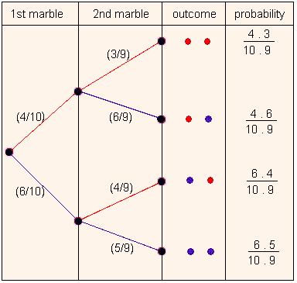
In probability questions the important skill is knowing when to add and when to multiply probabilities.

In a tree diagram you multiply as you go along branches (you are working out the probability of A and B and C), and you add when you combine vertically.

Example: We have 10 marbles; 4 red and 6 blue, and take two of them randomly. We define the events A {the 1st marble is red} and B {the 2nd marble is red }. What is the probability that at least one marble is red?

To find the probability of each of the 4 outcomes we multiply the two probabilities together.
Then we add the probabilities of the successful outcomes.

