Measures of Spread
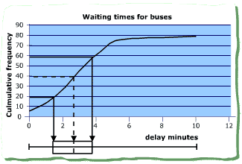
Range: Maximum value - minimum value

Interquartile range: Upper quartile - lower quartile

How to find the quartiles:
If lots of data use Cumulative Frequency Diagram
If little data - cheat!
- Find the median (2nd Quartile)
- Split data into top and bottom halves.
- (Remove median if odd number of data values)
- Find median of top half (Q3) and bottom half (Q1)

Use a box plot (Box and whisker diagram) to display quartiles.

Variance and Standard Deviation
The variance of a set of data x1, x2, … xn, whose mean is $\bar{x}=\frac{1}{n}\sum_{i=1}^{i=n}{x_{i}}$is given by

Variance = $\frac{1}{n}\sum_{i=1}^{i=n}{{\left(x_{i}−\bar{x}\right)}^{2}}$
This can also be written as $\frac{1}{n}\sum_{i=1}^{i=n}{x_{i^{2}}−{\bar{x}}^{2}}$

The standard deviation (σ) is the square root of the variance.

For a ‘Normal distribution’ of data, 70% of the values should be within one standard deviation of the mean and 95% of the values should be within 2 standard deviations.

The variance can also be calculated for data in a frequency table. In that case the formulae are:
Variance = $\frac{\sum_{i=1}^{i=n}{{\left(x_{i}−\bar{x}\right)}^{2}f_{i}}}{\sum_{i=1}^{i=n}{f_{i}}}$ or $\frac{\sum_{i=1}^{i=n}{x_{i^{2}}f_{i}}}{\sum_{i=1}^{i=n}{f_{i}}}−{\bar{x}}^{2}$

Simplifying calculations
As with the mean, when all the values are similar you can work out the variance by calculating the mean and then the variance relative to a non-zero value. No subsequent correction is required!

