LINEAR PROGRAMMING
(Read pp 133-139)

VARIABLES are the numbers of each of the things to be varied, usually represented by the letters x, y, z etc.
(e.g. the number of each type of bus hired, the number of teddy bears etc.)

CONSTRAINTS are the things that will prevent you making an infinite number of each of the variables.
(e.g. the quantity of coffee available, the time available, the fact that a negative quantity cannot be made etc.)
Each constraint will give rise to one inequality.

An OBJECTIVE is the aim you are trying to achieve.
(e.g. to maximise profit, to minimise cost etc.)
The objective function is the only equality/equation you write down using the variables.

To formulate a problem, you identify:
1) the variable 2) the constraints 3) the objective function
This is the “modelling” bit, you are translating the ‘real world’ problem into ‘mathematics’ so that you can (hopefully) solve it!

A FEASIBLE SOLUTION is any values of the variables which satisfy all the constraints.

A FEASIBLE REGION is a region which contains all feasible solutions.

An OPTIMAL SOLUTION is a feasible solution in which the objective is obtained.

There are two methods of solution:
Graphical Linear Programming
The Simplex Method (an Algebraic method)

Ex 6A pp 139-141
GRAPHICAL LINEAR PROGRAMMING

Example

Maximise the function

Draw the lines 2x + y =32 and x + y = 18
and shade out the unwanted regions

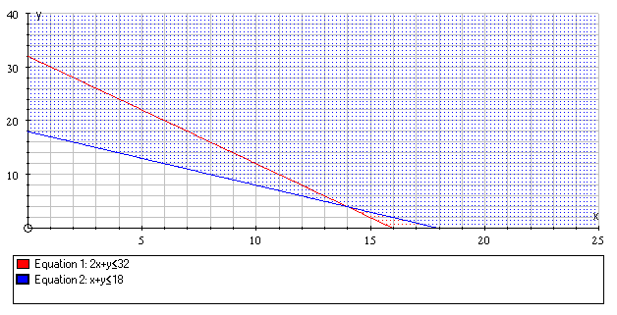
The feasible region is unshaded (it includes the edges in this case).

The objective function is f = 80x + 70y

The maximum(or minimum) value of the objective function occurs at one of the vertices of the feasible region.
Here, the vertices are at (0, 18), (14, 4) and (16, 0)
At (0, 18), f = 0 + 1260 = 1260
At (14, 4), f = 1120 + 280 = 1400
At (16, 0), f = 1280 + 0 = 1280
The maximum value of f is 1400 occurring when x = 14 & y = 4
(This is known as point testing using the vertex method)
When using the point testing method, you should obtain the vertices by solving simultaneous equations and not by reading off the graph (more accurate)

Another method to solve graphical linear programming problems involves the use of an ‘isoprofit’ line

Select a dummy value for the objective variable and draw a line of the form 80x + 70y = constant e.g 80x + 70y = 300

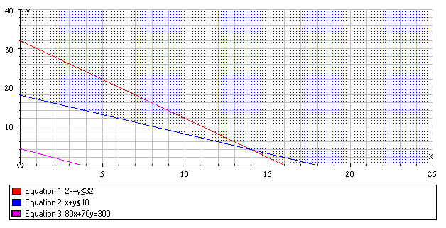

Any equation of the form 80x + 70y = constant will be parallel to this line.
Using a ruler (and set square!) parallel lines in the feasible region can be drawn.

If a maximal solution is required, it will the last point that lies on an ‘isoprofit’ line still within the feasible region and furthest away from the origin.

If a minimal solution is required, it will be the first point to lie on an ‘isoprofit’ line within the feasible region and nearest to the origin.

Once the optimal point is found, the values of the variables at that point give the solution.
In an exam, always draw one isoprofit line.
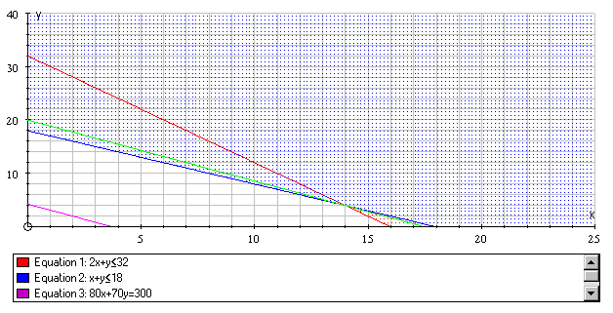

The optimal point is at (14, 4)

So, the maximum value of f is 1400 occurring when x = 14 and y = 4

(Read pp 146-154 including Examples 7-10)
Ex 6C pp 154-155
(Read pp 155-157)
Ex 6D p 157
(Read pp 157-161)
Ex 6E pp 161-163
ALGEBRAIC METHOD

This relies on the optimal solution being found by examining the value of the objective function at the vertices of the feasible region.

Consider the problem (as seen before):
Maximise the function

Introduce slack variables r and s such that

2x + y + r = 32
x + y + s = 18

This means that r ≥ 0 and s ≥ 0

They are called slack since they give the difference between the amount of resource available (32) and the amount used
(2x + y)

At a vertex of the feasible region, two of the variables x, y, r and s are zero

Number of variables = 4
Number of equations = 2
If you set the (number of variables − number of equations) of variables (i.e.2) to zero, you obtain a basic solution

The two variables set to zero are called non-basic variables
The variables solved for are called basic variables
A basic solution that is also feasible is called a basic feasible solution

x | y | r | s | Type | f = 80x + 70y | (x, y)
0 | 0 | 32 | 18 | basic feasible | 0 | (0, 0)
0 | 18 | 14 | 0 | basic feasible | 1260 | (0, 18)
0 | 32 | 0 | -14 | non-feasible | - | -
16 | 0 | 0 | 2 | basic feasible | 1280 | (16, 0)
18 | 0 | -4 | 0 | non-feasible | - | -
14 | 4 | 0 | 0 | basic feasible | 1400 | (14, 4)

Hence the maximum value of f is 1400 occurring when x = 14 and y = 4
THE SIMPLEX ALGORITHM

Developed by George Dantzig in 1947

Method

a) Since we are only interested in the boundary, we need to convert the inequalities into equalities by introducing slack variables, one for each inequality.

b) A Simplex tableau is created with one row for each constraint, plus one for the objective function, and one column for each variable (including the slack variables) and one extra for the values and another to explain the row operations used.

The equations are written (rewritten if necessary) so that all the variables are on the left-hand side and the right-hand side holds only the number term.

The constraints and objective function are entered into the tableau (the objective row should, at this point, contain some negative numbers)
Step 1

The objective row is scanned and the column containing the most negative term is selected (pivotal column) - indicate with an arrow

Step 2

Divide the value term in each row by the entry in the pivotal column (θ-values). The pivot (element) is that which yields the least (non-negative) result. Indicate the pivotal row with an arrow and circle the pivot.

Step 3

Divide the whole pivotal row by the pivot (this leaves the number 1 in place of the pivot) and change the basic variables.

Step 4

The aim now is to get zeros everywhere else in the selected column. This is done by adding to each row, multiples of the new pivotal row. The new rows form the next tableau.
(You should now have zeros in the pivotal column except for a one where the pivot was)

Step 5

Steps 1 to 4 are repeated until the objective row contains no negative elements.
At this point, the objective has been attained.

Step 6

To “decode” the information, read down the “basic variable” column, the number in the value column gives the value of that variable.
The value of all other variables not present in the final tableau is zero.
This is the optimal solution.
Example

Maximise the function

Introducing slack variables r and s, we get

2x + y + 1r + 0s = 32
x + y + 0r +1s = 18
f – 80x -70 y + 0r + 0s = 0

We enter these into the initial tableau

Steps 1 and 2

b.v. | x | y | r | s | value
r | 2 | 1 | 1 | 0 | 32 | 32/2 = 16
s | 1 | 1 | 0 | 1 | 18 | 18/1 = 18
f | −80 | −70 | 0 | 0 | 0

Step 3

b.v. | x | y | r | s | value
x | 1 | 1/2 | 1/2 | 0 | 16 | R1÷2
s | 1 | 1 | 0 | 1 | 18
f | −80 | −70 | 0 | 0 | 0

Step 4

b.v. | x | y | r | s | value
x | 1 | 1/2 | 1/2 | 0 | 16
s | 0 | 1/2 | −1/2 | 1 | 2 | R2-R1
f | 0 | −30 | 40 | 0 | 1280 | R3+80R1
Step 5 - Steps 1 and 2

b.v. | x | y | r | s | value
x | 1 | 1/2 | 1/2 | 0 | 16 | 16 ÷ ½ = 32
s | 0 | 1/2 | −1/2 | 1 | 2 | 2 ÷ ½ = 4
f | 0 | −30 | 40 | 0 | 1280

Step 5 - Step 3

b.v. | x | y | r | s | value
x | 1 | 1/2 | 1/2 | 0 | 16
y | 0 | 1 | −1 | 2 | 4 | R2 ÷ ½
f | 0 | −30 | 40 | 0 | 1280

Step 5 - Step 4

b.v. | x | y | r | s | value
x | 1 | 0 | 1 | −1 | 14 | R1-½R2
y | 0 | 1 | −1 | 2 | 4
f | 0 | 0 | 10 | 60 | 1400 | R3+30R2

The objective row contains no negative elements

Step 6

f = 1400 when x = 14 and y = 4
Example

Maximise P = 10x + 12y + 8z

Introducing slack variables r and s we get

2x + 2y + 0z + 1r + 0s = 5
5x + 3y + 4z + 0r + 1s = 15
P – 10x – 12y – 8z + 0r + 0s = 0

Initial tableau:

b.v | x | y | z | r | s | Value
r | 2 | 2 | 0 | 1 | 0 | 5 | 5/2=2.5
s | 5 | 3 | 4 | 0 | 1 | 15 | 15/3=5
P | −10 | −12 | −8 | 0 | 0 | 0

b.v | x | y | z | r | s | Value
x | 1 | 1 | 0 | 0.5 | 0 | 2.5 | R1 ÷ 2
s | 5 | 3 | 4 | 0 | 1 | 15
P | −10 | −12 | −8 | 0 | 0 | 0

b.v | x | y | z | r | s | Value
y | 1 | 1 | 0 | 0.5 | 0 | 2.5
s | 2 | 0 | 4 | −1.5 | 1 | 7.5 | R2-3R1
P | 2 | 0 | −8 | 6 | 0 | 30 | R3+12R1

b.v | x | y | z | r | s | Value
y | 1 | 1 | 0 | 0.5 | 0 | 2.5 | 2.5/0=∞
s | 2 | 0 | 4 | −1.5 | 1 | 7.5 | 7.5/4=1.875
P | 2 | 0 | −8 | 6 | 0 | 30

b.v | x | y | z | r | s | Value
y | 1 | 1 | 0 | 0.5 | 0 | 2.5
z | 0.5 | 0 | 1 | −0.375 | 0.25 | 1.875 | R2÷4
P | 2 | 0 | −8 | 6 | 0 | 30

b.v | x | y | z | r | s | Value
y | 1 | 1 | 0 | 0.5 | 0 | 2.5 | Stet
z | 0.5 | 0 | 1 | −0.375 | 0.25 | 1.875 | R2÷4
P | 6 | 0 | 0 | 3 | 2 | 45 | R3+8R2

Hence, P = 45 when y = 2.5, z = 1.875, x = 0
(Also r = s = 0)
(No algebra, no words, efficient setting out - that’s simplex!)

The OPTIMALITY CONDITION states:

If the objective row of a tableau has zero entries in the columns labelled by the basic variables and no negative entries in the columns labelled by the non-basic variables then the solution represented by the tableau is optimal.

(Read Examples 14 and 15 on pp 171-175)
Ex 6F on pp 175-176

