Co-ordinates, points and lines

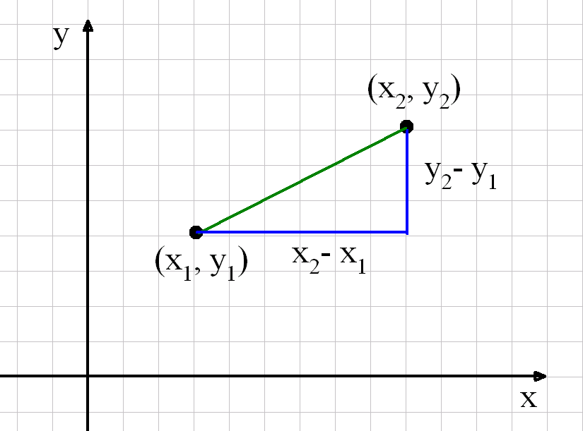

The distance between the points (x₁, y₁) and (x₂, y₂), which is also the length of the line segment joining them, is $\sqrt{{\left(x_{2}−x_{1}\right)}^{2}+{\left(y_{2}−y_{1}\right)}^{2}}$

The mid-point of the line segment has co-ordinates $\left(\frac{x_{1}+x_{2}}{2},\frac{y_{1}+y_{2}}{2}\right)$
The gradient of the line joining the points is $\frac{y_{2}−y_{1}}{x_{2}−x_{1}}$

The equation of the line with gradient m through the point (0,c) is y = mx + c

The equation of the line with gradient m through the point (x₁, y₁) is y - y₁ = m(x – x₁)

To find the y-intercept of a straight line, put x = 0 and solve for y.

To find the x-intercept of a straight line, put y = 0 and solve for x.

Another equation for a straight line is ax + by + c = 0, where a, b and c are integers. Note that this c is not the y-intercept!

If a line has gradient m, the gradient of the line perpendicular to it is $−\frac{1}{m}$

Two lines with gradients m₁ and m₂ are perpendicular if (and only if) m₁m₂ = -1

