Practice Spring half-term test – C2

1. (a) Using the factor theorem, show that (x+3) is a factor of
x³−6x²−7x+60
(b) Factorise x³−6x²−7x+60 completely.

2. f(x)=15x³+px²+qx+6.
Given that f(x)is exactly divisable by (5x−1), and also that when f(x) is divided by (x−1) the remainder is −40,
(a) find the value of p and the value of q.
(b) Hence factorise f(x) completely.

3. The expansion of (3+px)⁵ in ascending powers of x, as far as the term in x² is 243+Ax+480x². Given that p>0, find the value of p and the value of A.
4. Solve each equation for θ in the interval 0 ≤ θ ≤ 360° giving your answers to 1 decimal place.
a) sin θ = 0.8
b) cos 3 θ = 0.2

5
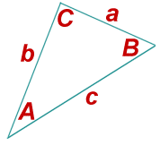
In the triangle ABC, a=7cm,b=7cm, and c=4cm.
(a) Show that cosA=2/7,
(b) Hence or otherwise find the exact value of sinA.
(c) Find the area of the triangle

6
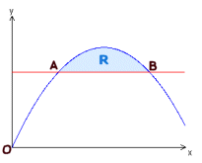
The diagram shows the shaded region R which is bounded by the curve
y=3x − x²and the line y=2. The points A and B are the points of intersection of the line and the curve.
(a) Find the x-coordinates of the points A and B.
(b) Find the area of R.

7
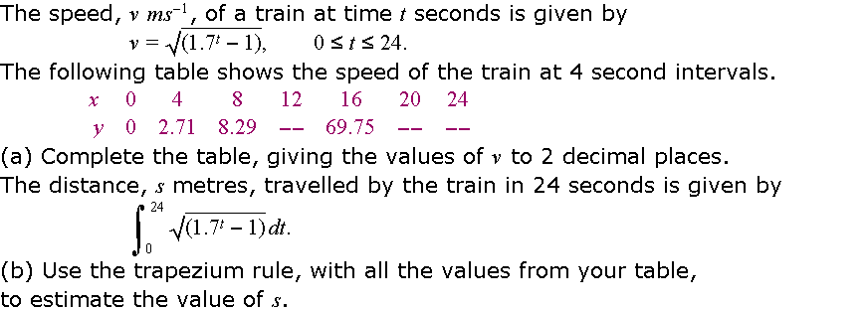

8 For the curve y = cos 2x for 0≤x≤360
- Write down Any co-ordinates where the curve intersects the co-ordinate axes
- Write down the co-ordinates of any turning points of the curve

Answers can be found at www.realmaths.com

