Paper Reference(s)
6674/6667
Edexcel GCE
Pure Mathematics P4
Further Pure Mathematics FP1
Advanced Level
Wednesday 19 January 2005 − Morning
Time: 1 hour 30 minutes

Materials required for examination Items included with question papers
Mathematical Formulae Nil

Candidates may use any calculator EXCEPT those with the facility for symbolic algebra, differentiation and/or integration. Thus candidates may NOT use calculators such as the Texas Instruments TI 89, TI 92, Casio CFX 9970G, Hewlett Packard HP 48G.

Instructions to Candidates
In the boxes on the answer book, write the name of the examining body (Edexcel), your centre number, candidate number, the unit title (Pure Mathematics P4 or Further Pure Mathematics FP1), the paper reference (6674 or 6667), your surname, other name and signature.
When a calculator is used, the answer should be given to an appropriate degree of accuracy.

Information for Candidates
A booklet ‘Mathematical Formulae and Statistical Tables’ is provided.
Full marks may be obtained for answers to ALL questions.
This paper has eight questions.
The total mark for this paper is 75.

Advice to Candidates
You must ensure that your answers to parts of questions are clearly labelled.
You must show sufficient working to make your methods clear to the Examiner. Answers
without working may gain no credit.
1. (a) Sketch the graph of y = ⏐x – 2a⏐, given that a > 0.
(2)
(b) Solve ⏐x – 2a⏐ > 2x + a, where a > 0.
(3)

2. Given that 3 + i is a root of the equation f(x) = 0, where

f(x) = 2x³ + ax² + bx – 10, a, b ∈ ℝ,

(a) find the other two roots of the equation f(x) = 0,
(4)
(b) find the value of a and the value of b.
(3)

3. Find the general solution of the differential equation

$\frac{dy}{dx}$ + 2y cot 2x = sin x, 0 < x < $\frac{π}{2}$,

giving your answer in the form y = f(x).
(7)

4. Figure 1
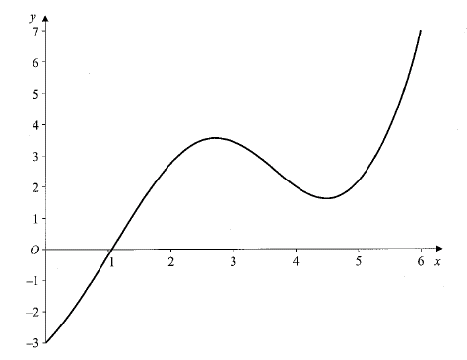

Figure 1 shows part of the graph of y = f(x), where

f(x) = x sin x + 2x – 3.

The equation f(x) = 0 has a single root α.

(a) Taking x₁ = 1 as a first approximation to α, apply the Newton-Raphson procedure once to f(x) to find a second approximation to α, to 3 significant figures.
(5)
(b) Given instead that x₁ = 5 is taken as a first approximation to α in the Newton-Raphson procedure,

(i) use Figure 1 to produce a rough sketch of y = f(x) for 3 ≤ x ≤ 6,

and by drawing suitable tangents, and without further calculation,

(ii) show the approximate positions of x₂ and x₃, the second and third approximations to α.
(2)

5. (a) Express $\frac{1}{r(r+2)}$ in partial fractions.
(2)
(b) Hence prove, by the method of differences, that

$\sum_{r = 1}^{n}{ \frac{4}{r(r+2)}}$ = $\frac{n(3n+5)}{(n+1)(n+2)}$.
(5)
(c) Find the value of $\sum_{r = \text{50}}^{\text{100}}{ \frac{4}{r(r+2)}}$, to 4 decimal places.
(3)

6. (a) Show that the transformation y = xv transforms the equation

x²$\frac{d^{2}y}{{dx}^{2}}$– 2x$\frac{dy}{dx}$ + (2 + 9x²)y = x⁵, I
into the equation
$\frac{d^{2}v}{{dx}^{2}}$ + 9v = x². II
(5)
(b) Solve the differential equation II to find v as a function of x.
(6)
(c) Hence state the general solution of the differential equation I.
(1)

7. The curve C has polar equation r = 6 cos θ , –$\frac{π}{2}$ ≤ θ < $\frac{π}{2}$,
and the line D has polar equation r = 3 sec $\left(\frac{π}{3}−θ\right)$, –$\frac{π}{6}$ ≤ θ < $\frac{5π}{6}$.

(a) Find a cartesian equation of C and a cartesian equation of D.
(5)
(b) Sketch on the same diagram the graphs of C and D, indicating where each cuts the initial line.
(3)

The graphs of C and D intersect at the points P and Q.

(c) Find the polar coordinates of P and Q.
(5)

8. Given that z = 4$\left(\text{cos}\frac{3π}{4}+i\text{sin}\frac{3π}{4}\right)$ and w = 1 – i√3, find

(a) $\left|\frac{z}{w}\right|$,
(3)
(b) arg $\left(\frac{z}{w}\right)$, in radians as a multiple of π.
(3)
(c) On an Argand diagram, plot points A, B, C and D representing the complex numbers z, w, $\left(\frac{z}{w}\right)$ and 4, respectively.
(3)
(d) Show that ∠ AOC = ∠ DOB.
(2)
(e) Find the area of triangle AOC.
(2)

TOTAL FOR PAPER: 75 MARKS
END

