Question number | Scheme Marks
1 (a)  (b)  (c) | B1,B1,B1  (3)  ,  attempt at one calculation, 146, 266 M1A1A1  269 is an outlier 269 A1dep  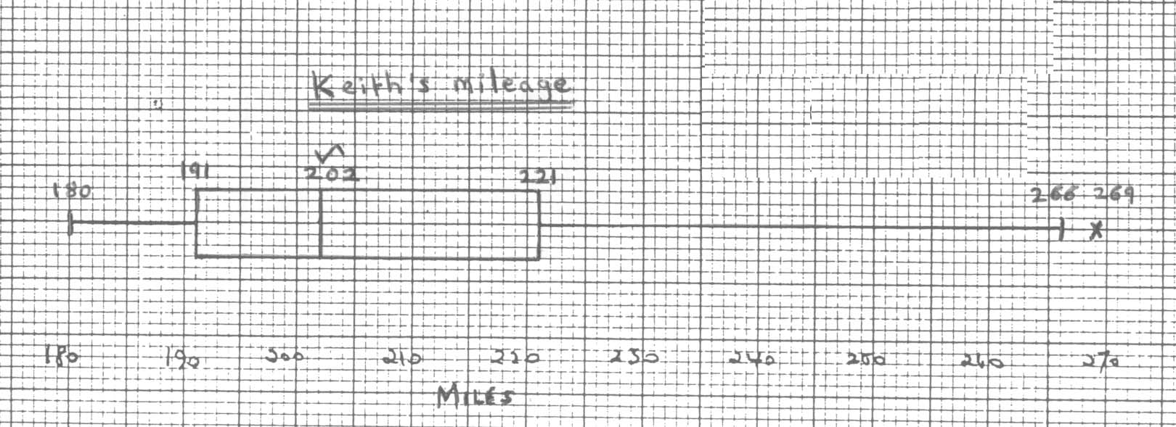  Scale and ‘miles’ B1  Box with two whiskers M1  191, their median, 221 A1∫  180,266 or 263,269 A1  (8)  Keith: positive skew one calc,+ve skew M1,A1  Asif: almost symm or slight –ve skew A1  (3)  (Total 14 marks)

Question number | Scheme Marks
81  2(a)  (b)  3 (a)  (b)  (i)  (ii)  (c) | awrt0.79 B1  awrt 0.16 B1  or equivalent B1∫  OR just answer B1 ONLY (3)  awrt 35.7 B1  (1)  (Total 4 marks)  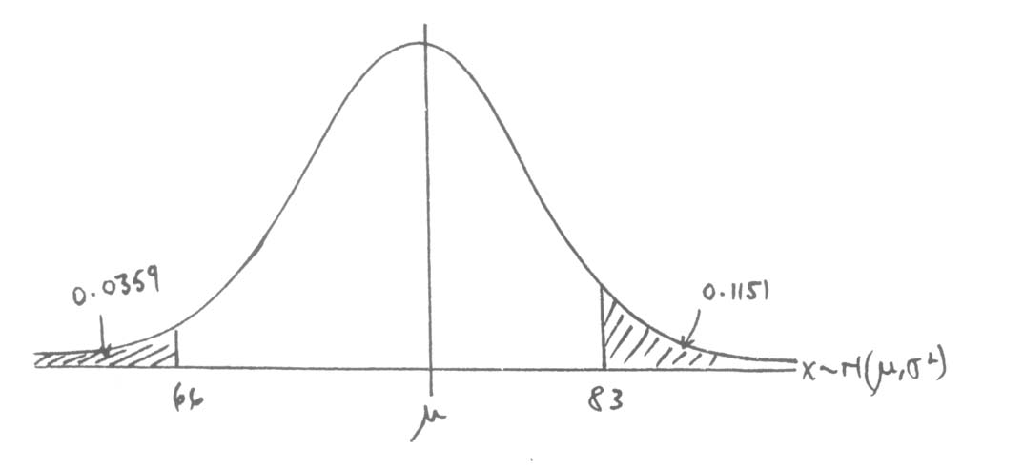  Bell shaped curve & 4 values B1  (1)  -1.80 B1 seen  Clear attempt including standardization either way, or equivalent M1,A1  1.20, or equivalent B1A1  Subtracting **given answer*  Clear attempt to solve, cso M1A1  75 B1  (8)  standardize both either way M1  -1.20, 1.60 A1 seen  4 dp A1  (3)  (Total 12 marks)

Question number | Scheme Marks
4  (a)  (b)  (c)  (d)  (e)  (f) | -3 –2 –1 0 1 2  0.2 0.2 0.1 0.1  linear function of =1, 0.2 M1A1  (2)  B1  (1)  B1  (1)  , -0.9 M1A1  M1  A1  (4)  , 3.3 M1A1  , 2.49 M1A1  (4)  M1  A1  (2)  (Total 14 marks)

Question number | Scheme Marks
S  A B  5 (a)  (b)  (c) | 2 intersecting closed curves in a box M1  B1,B1  B1∫  (4)  0.583 or or B1∫  (1)  or 0.375 their fractions divided, cao M1,A1  (2)  (Total 7 marks)

Question number | Scheme Marks
6 (a)  (b)  (c)  (d)  (e)  (f) | Any one method, cao M1,A1  cao A1  cao A1  (Or 114.5,83 & 42.75)  (4)  formula, all correct (),0.439 M1A1∫A1  (3)  Slight / weak evidence, B1  students perform similarly in pressups and situps context for +ve B1  (2)  M1A1  method includes , awrt 10.7 M1A1  OR divisor (n-1) awrt 11.4  (4)  (or 22.4 divisor (n-1)) 1.96 B1  ,21.0 or 22.4 M1A1  (3)  Pressups discrete, Normal continuous B1  Not a very good assumption B1 dep  (2)  (Total 18 marks)

Question number | Scheme Marks
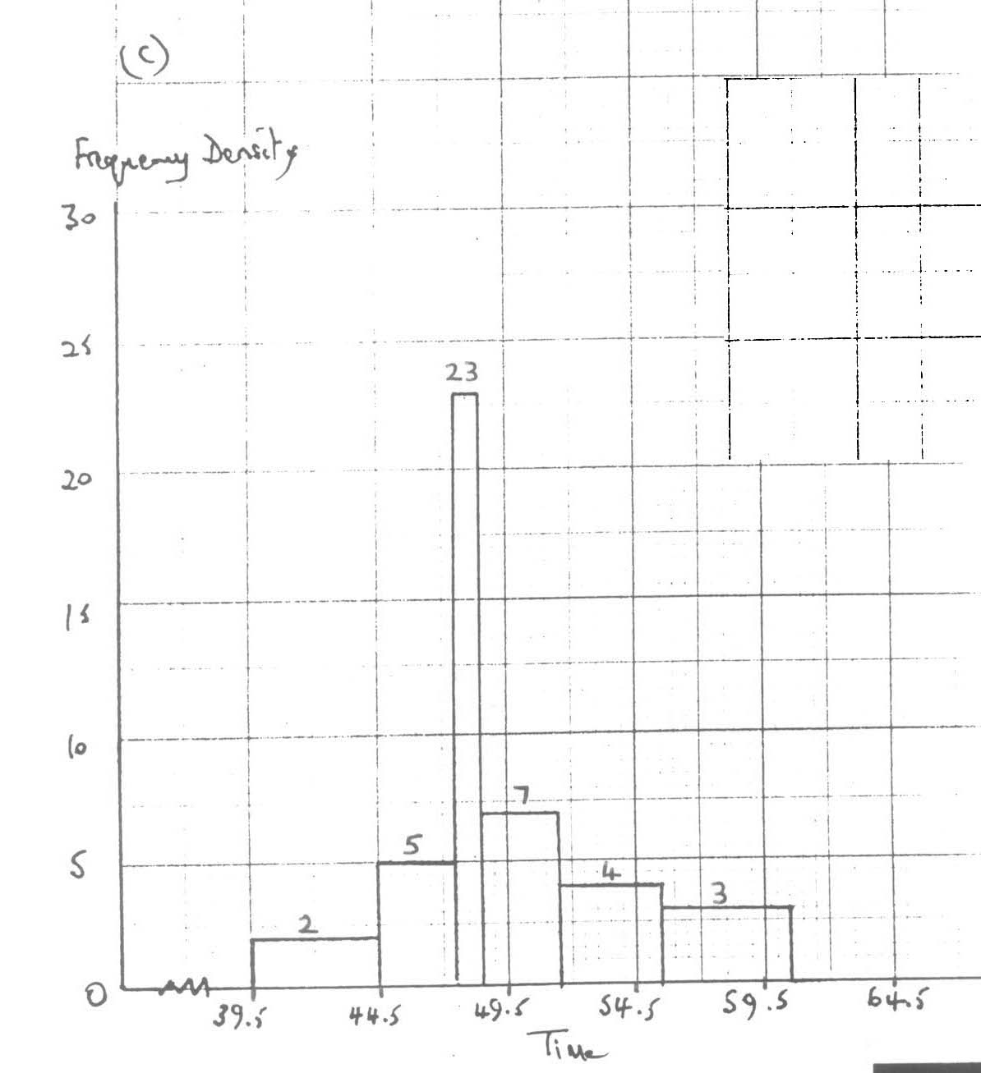  Freq / class width (implied) M1  Scales and labels B1  Histogram, no gaps & their fdM1  All correct A1  7(a)  (b)  (c) | Time data is a continuous variable B1  (1)  39.5, 44.5 both B1  (1)  (4)  (Total 6 marks)  6 mark

