Paper Reference(s)
6675

Edexcel GCE
Pure Mathematics P5
Advanced/Advanced Subsidiary
Monday 21 June 2004 − Morning
Time: 1 hour 30 minutes

Materials required for examination Items included with question papers
Answer Book (AB16) Nil
Graph Paper (ASG2)
Mathematical Formulae (Lilac)

Candidates may use any calculator EXCEPT those with the facility for symbolic algebra, differentiation and/or integration. Thus candidates may NOT use calculators such as the Texas Instruments TI 89, TI 92, Casio CFX 9970G, Hewlett Packard HP 48G.

Instructions to Candidates
In the boxes on the answer book, write the name of the examining body (Edexcel), your centre number, candidate number, the unit title (Pure Mathematics P5), the paper reference (6675), your surname, other name and signature.
When a calculator is used, the answer should be given to an appropriate degree of accuracy.

Information for Candidates
A booklet ‘Mathematical Formulae and Statistical Tables’ is provided.
Full marks may be obtained for answers to ALL questions.
This paper has eight questions.

Advice to Candidates
You must ensure that your answers to parts of questions are clearly labelled.
You must show sufficient working to make your methods clear to the Examiner. Answers
without working may gain no credit.

1. Using the definitions of cosh x and sinh x in terms of exponentials,

(a) prove that cosh² x − sinh² x = 1,
(3)
(b) solve cosech x − 2 coth x = 2,

giving your answer in the form k ln a, where k and a are integers.
(4)

2. 4x² + 4x + 17 ≡ (ax + b)² + c, a > 0.

(a) Find the values of a, b and c.
(3)
(b) Find the exact value of

$\int{\frac{1}{4x^{2}+4x+\text{17}}}$ dx.
(4)

3. An ellipse, with equation $\frac{x^{2}}{9} + \frac{y^{2}}{4}$ = 1, has foci S and S′.

(a) Find the coordinates of the foci of the ellipse.
(4)

(b) Using the focus-directrix property of the ellipse, show that, for any point P on the ellipse,

SP + S′P = 6.
(3)

4. The curve C has parametric equations

x = cosh t − t, y = cosh t + t.

Find the exact value of the radius of curvature of C at the point where t = ln 3.
(9)

5. Given that y = sinh^{n − 1} x cosh x,

(a) show that $\frac{dy}{dx}$ = (n − 1) sinh^{n − 2} x + n sinh^{n} x.
(3)
The integral I_{n} is defined by I_{n} = sinh^{n} x dx, n ≥ 0.

(b) Using the result in part (a), or otherwise, show that

nI_{n} = √2 − (n − 1)I_{n − 2}, n ≥ 2
(2)
(c) Hence find the value of I₄.
(4)

6. A curve has intrinsic equation s = a sec³ψ − a, where a is a non-zero constant. Given that
x = 0 and y = 0 at ψ = 0,

(a) show that y = a tan³ ψ,
(4)
(b) find a similar expression for x in terms of ψ.
(4)
(c) Hence show that a cartesian equation of the curve is

ay² = $\frac{8}{\text{27}}$x³.
(2)

7. Figure 1
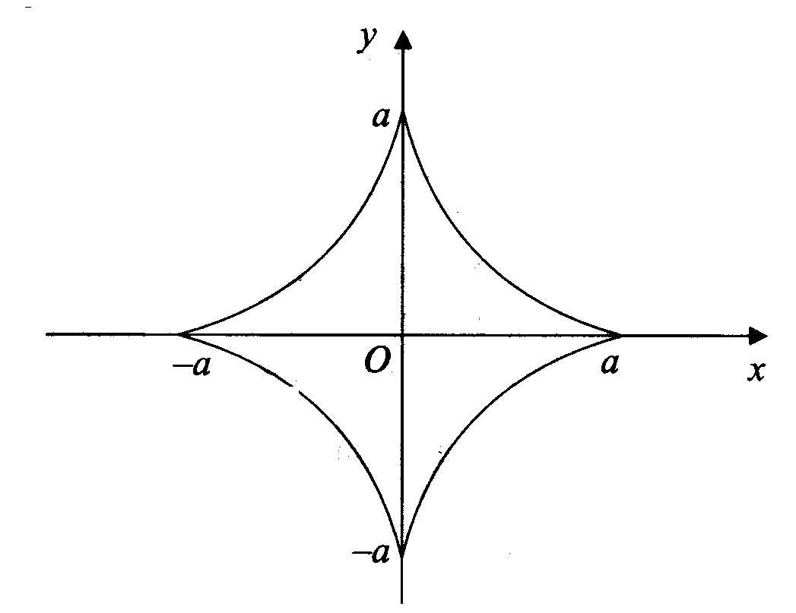
Figure 1 shows the curve with parametric equations

x = a cos³ θ, y = a sin³ θ, 0 ≤ θ < 2π.

(a) Find the total length of this curve.
(7)

The curve is rotated through π radians about the x-axis.

(b) Find the area of the surface generated.
(5)
8. (a) Show that the normal to the rectangular hyperbola xy = c², at the point P$\left(\text{ct}, \frac{c}{t}\right)$, t ≠ 0 has equation
y = t²x + $\frac{c}{t}$ − ct³.
(5)
The normal to the hyperbola at P meets the hyperbola again at the point Q.

(b) Find, in terms of t, the coordinates of the point Q.
(5)

Given that the mid-point of PQ is (X, Y) and that t ≠ ±1,
(c) show that $\frac{X}{Y} = − \frac{1}{t^{2}}$,
(2)
(d) show that, as t varies, the locus of the mid-point of PQ is given by the equation
4xy + c²${\left(\frac{y}{x} − \frac{x}{y} \right)}^{2}$ = 0.
(2)

END

