Question number | Scheme | Marks
1. (a)  (b) | Expand brackets and attempt to use appropriate formulae.  =  =∗  Use S(40) – S(9) =  = 26660 | M1  A1  M1  A1  (4)  M1  A1  (2)
2. (a)  (b) | f(1) = -1 and f(2) = 2  Attempts  Uses Newton Raphson  any correct answer | B1  B1  (2)  M1  A1  dM1  A1  (4)

Question number | Scheme | Marks
3. (a)  (b) | Equating imaginary parts 2ab = 30 and thus ab = 15 ∗  Also  Attempt to solve by valid method involving elimination of unknown  or | M1  A1  (2)  B1  M1  A1 A1  (4)
4. | Solves by valid method  Obtains or equivalent (may only obtain relevant root if graph is used)  Solves  Obtains  Rejects two of these roots and obtains (or uses graph and obtains)  Special case:  Squares both sides to obtain quadratic in and solve to obtain  Obtains or  Last three marks as before. | M1  A1  M1  A1  dM1  A1, A1  (7)  M1 A1  M1A1  dM1A1A1  (7)

Question number | Scheme | Marks
f.t. w  in quadrant other than first  Re  Im  A  B  5. (a)  (b)  (c)  (d)  (e) | i  arg w = or adds two args e.g.  = or 1.83 radians  (=20), then square root  AB =  Or w – z =  = | M1  A1, A1  (3)  M1  A1  (2)  M1 A1  (2)  B1  B1  (2)  M1  A1  (2)  M1  A1c.a.o  (2)

Question number | Scheme | Marks
Min point and passing through (0,1)  shape  6. (a)  (b)  (c) | Integrating Factor =  =  and  When  at minimum point.  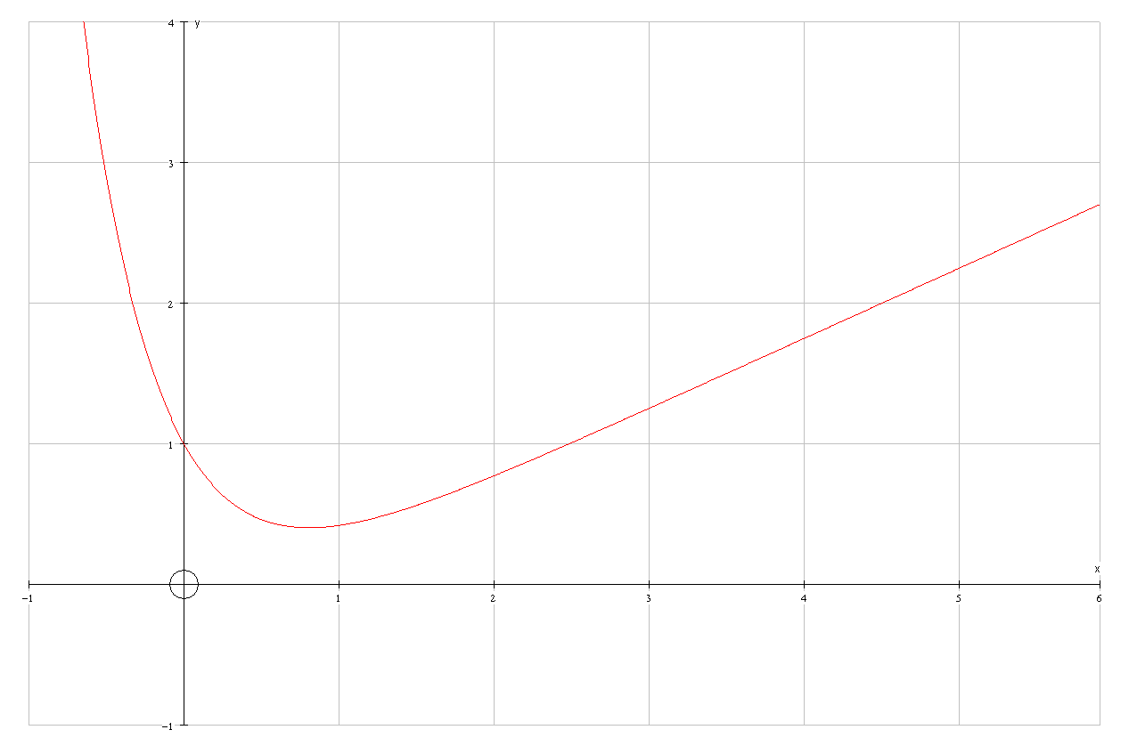 | B1  M1  M1  A1  A1  (5)  M1  M1  M1  A1  (4)  B1  B1  (2)

Question number | Scheme | Marks
7. (a)  (b) | Auxiliary equation:  Complementary Function is  Particular Integral is  Puts 1 = A+2 and solves to obtain A = -1  Puts 1 = B – A – 2 and uses value for A to obtain B  B=2 | M1  M1A1  M1  A1  B1  (6)  M1,  M1 A1ft  M1  A1cso  A1cso  (6)

Question number | Scheme | Marks
8. (a)  (b)  (c)  (d) | [Co-ordinates of points are and ]  Area =  =  =  =  = k[…  …..  Uses limits and -correctly or uses twice smaller area and uses limits and 0 correctly.(Need not see 0 substituted)  or or 3.022  ∴Area = | M1  M1  A1 A1  (4)  M1A1  (2)  M1 M1  A1  B1  B1  M1  A1  (7)  B1  M1, A1  (3)

