Paper Reference(s)
6674
Edexcel GCE
Pure Mathematics P4

Advanced/Advanced Subsidiary
Thursday 20 June 2002 − Morning
Time: 1 hour 30 minutes

Materials required for examination Items included with question papers
Answer Book (AB16) Nil
Graph Paper (ASG2)
Mathematical Formulae (Lilac)

Candidates may use any calculator EXCEPT those with the facility for symbolic algebra, differentiation and/or integration. Thus candidates may NOT use calculators such as the Texas Instruments TI 89, TI 92, Casio CFX 9970G, Hewlett Packard HP 48G

Instructions to Candidates
In the boxes on the answer book, write the name of the examining body (Edexcel), your centre number, candidate number, the unit title (Pure Mathematics P4), the paper reference (6674), your surname, other name and signature.
When a calculator is used, the answer should be given to an appropriate degree of accuracy.

Information for Candidates
A booklet ‘Mathematical Formulae and Statistical Tables’ is provided.
Full marks may be obtained for answers to ALL questions.
This paper has eight questions.

Advice to Candidates
You must ensure that your answers to parts of questions are clearly labelled.
You must show sufficient working to make your methods clear to the Examiner. Answers
without working may gain no credit.

1. Prove that
$\sum_{r=1}^{n}{6(r^{2}−1)}$ ≡ (n − 1)n(2n + 5).
(4)

2. f(x) = e ^{2x} – 15x – 2.

The equation f(x) = 0 has exactly one root α between 1.5 and 1.7.

(a) Taking 1.6 as a first approximation to α, apply the Newton-Raphson procedure once to f(x) to find a second approximation to α, giving your answer to 3 significant figures.
(5)
(b) Show that your answer is the value of α correct to 3 significant figures.
(2)

3. f(x) = x⁴ – 6x³ + 17x² – 24x + 52.
(a) Show that 2i is a root of the equation f(x) = 0.
(1)
(b) Hence solve f(x) = 0 completely.
(6)

4. Using algebra, find the set of values of x for which
2x – 5 > $\frac{3}{x}$.
(7)

5. Given that z = 3 + 4i and w = −1 + 7i,

(a) find ⏐w⏐.
(1)
The complex numbers z and w are represented by the points A and B on an Argand diagram.

(b) Show points A and B on an Argand diagram.
(1)
(c) Prove that △OAB is an isosceles right-angled triangle.
(5)
(d) Find the exact value of arg $\left(\frac{z}{w}\right)$.
(3)

6. (a) Find the general solution of the differential equation
cos x $\frac{dy}{dx}$ + (sin x)y = cos³ x.
(6)
(b) Show that, for 0 ≤ x ≤ 2π, there are two points on the x-axis through which all the solution curves for this differential equation pass.
(2)
(c) Sketch the graph, for 0 ≤ x ≤ 2π, of the particular solution for which y = 0 at x = 0.
(3)

7. (a) Find the general solution of the differential equation
2$\frac{d^{2}y}{{dt}^{2}}+7\frac{dy}{dt}+3y$= 3t² + 11t.
(8)
(b) Find the particular solution of this differential equation for which y = 1 and $\frac{dy}{dt}$ = 1 when t = 0.
(5)
(c) For this particular solution, calculate the value of y when t = 1.
(1)

8. Figure 1

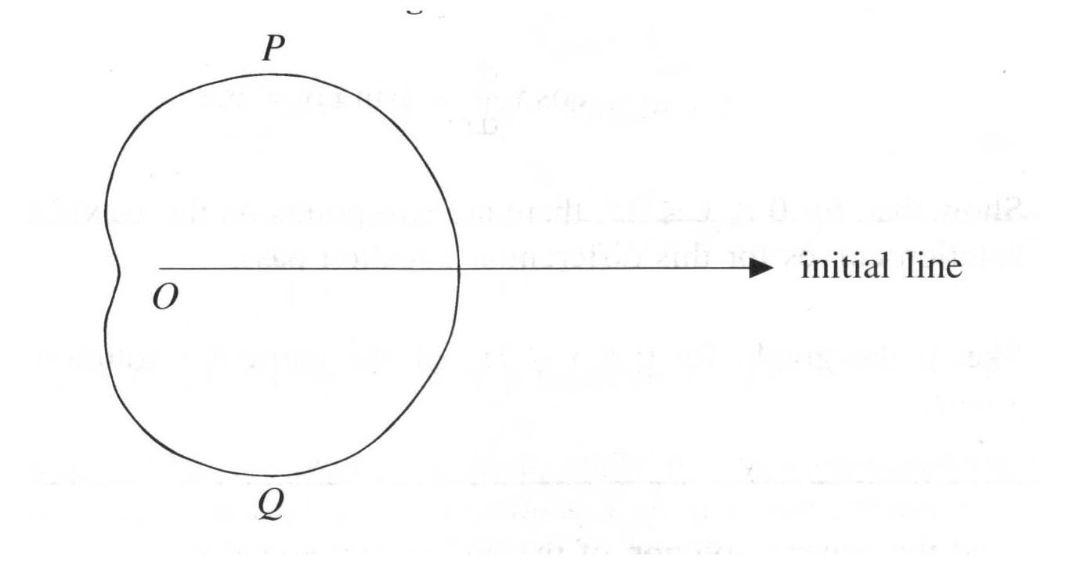

The curve C shown in Fig. 1 has polar equation
r = a(3 + √5 cos θ ), −π ≤ θ < π.

(a) Find the polar coordinates of the points P and Q where the tangents to C are parallel to the initial line.
(6)
The curve C represents the perimeter of the surface of a swimming pool. The direct distance from P to Q is 20 m.

(b) Calculate the value of a.
(3)
(c) Find the area of the surface of the pool.
(6)

END

