**Unit 4 exemplar report**

**OPTION 1: Tectonic Activity and Hazards**

**Note:** *These exemplar reports are based on the work of candidates under examination conditions, during the June 2010 examination series. The reports were originally hand written but have been typed up, with diagrams redrawn. Errors, including QWC errors, have in most cases been kept. The aim of these exemplar reports is to highlight good practice and areas of potential improvement. The marking levels and examiners comments given are indicative and should be used as a basis for discussion in the classroom, rather than indicating a specific grade.*

**Pre-release research focus**

* **Explore** the range of tectonic event profiles and how these and other factors affect the responses of people and governments.
* **Research** contrasting locations and hazard events to draw out the range of tectonic activity and the different responses generated.

**Report title:**

‘Tectonic hazard profiles determine the way in which people and governments respond to hazards’. Discuss

**Student’s plan:**

Intro – definitions

Park model

THP factors

Magnitude – Lincolnshire, Iripinia

Speed onset - Popocatepetl, Kashmir

Areal Extent – tsunami

Other factors - economic development

Scientific understanding

Location

Conclusion - why chose case studies

Nevado del Ruiz

Loma Prieta

Introduction

Tectonic hazards pose significant challenges to humans. Earthquakes alone have claimed over 1 million lives in the last 100 years. A tectonic hazard can be defined as an event occurring due to movement or deformation of the earth’s crust with the potential to cause damage to property and loss of life. Examples include earthquakes, volcanic hazards and tsunami.

‘Response’ refers to the actions taken to minimise or prevent economic damage, injury and loss of life. Responses occur prior to, during and post disaster. Responses can be seen to follow a three pronged approach which includes modify the cause/ event, modify the vulnerability and modify the loss. These different response approaches can be related to the Park Model below (Figure 1).

Figure 1: Park’s response model

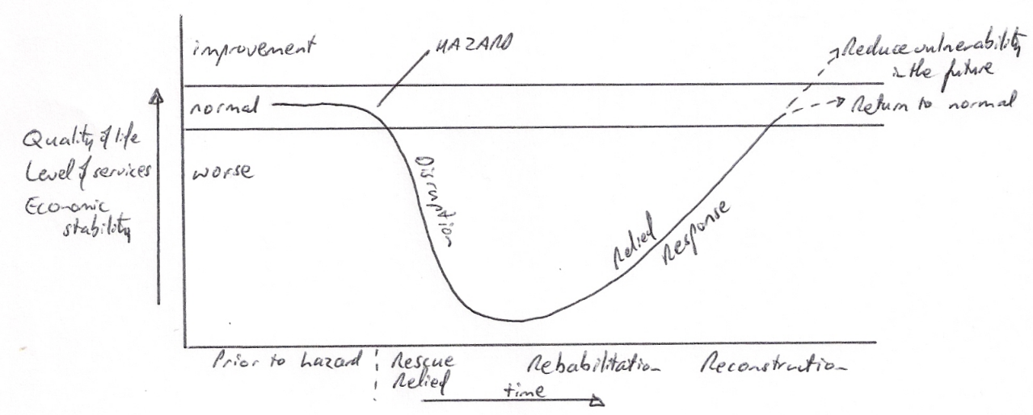

(Source: Hazards and Responses , V Bishop, 2001)

The responses shown by the Park model do vary. This can be due to a range of physical factors which are related to the nature of the hazard. Hazard profiles show the nature of different tectonic hazards. The profiles illustrate factors such as magnitude and areal extent (Figure 2). The nature of tectonic hazards varies greatly. A typical earthquake profile and volcanic profile (for a destructive plate margin) are very different especially in terms of frequency and spatial predictability, as is shown in Figure 2.

Figure 2: Tectonic hazard profile

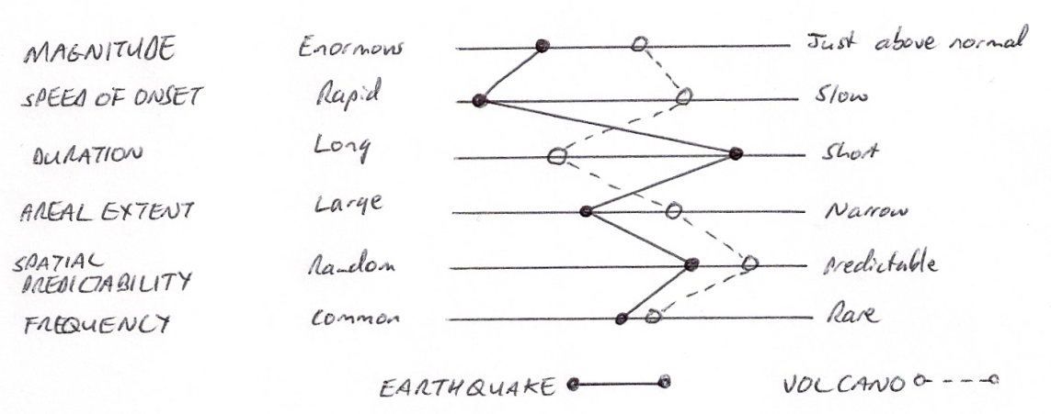

However, there are also human factors such as economic development and level of preparation which can influence the nature of hazard response. This report will examine both the physical factors of hazard profiles and human factors in greater detail. This will be done using a range of examples and case studies which focus on countries at different levels of development as well as different tectonic hazards. Using a range of examples by place and type of hazard is important because focussing on one hazard e.g. earthquakes in one location type e.g. the developing world would produce a narrow report. **[Reference to Methodology i.e. explaining broad approach and need for range]**

Magnitude and response

Magnitude, which is a key part of a hazard profile, can have a marked effect on the response to a tectonic hazard. The Lincolnshire earthquake in the UK in February 2008 measured only 5.2 on the Richter magnitude scale. The hazard caused an estimated £30 million in damages (Source: Risk Management Solutions website) mostly due to damage to buildings. The response was small, and concentrated mostly of reconstruction and repair rather than rescue. This is because the earthquake was large enough to damage structures, but not large enough to cause collapse.

The Iripinia earthquake occurred in 1980 in Italy, and MEDC similar to the UK. This earthquake was magnitude 6.9 and killed 2900 people with a further 300,000 made homeless. Because of this a major international response happened with the USA pledging $70 million in aid. The response placed greater emphasis on rescue and relief compared to Lincolnshire because of the devastation to buildings and the number of trapped people.

The contrasting Park models of the two earthquakes (Figure 3) show how the energy released by each earthquake had a direct impact on the response required. In Iripinia the focus was on rescue and relief whereas in Lincolnshire response moved almost immediately to rebuilding. Also, different players were involved as there was no need for NGOs and International aid in Lincolnshire. In Iripinia more emphasis needs to be placed on modifying vulnerability before the next earthquake e.g. by rebuilding buildings to resist earthquake shaking because of the possibility of a similar magnitude quake in the future.

Figure 3: Iripinia and Lincolnshire compared

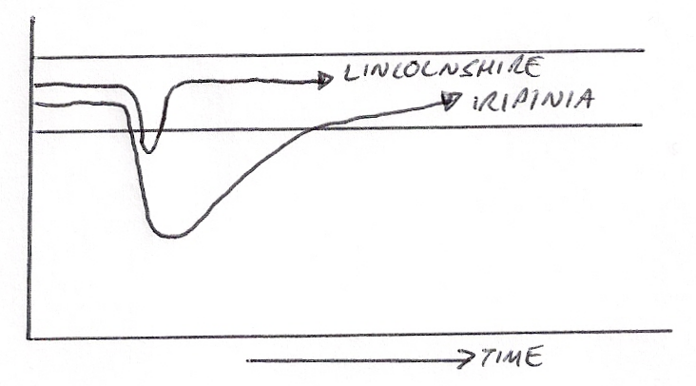

Magnitude does effect response, because the larger an earthquake generally the more need there is for rescue and relief. At a certain magnitude, response often needs to involve national government and even international NGOs because local groups cannot cope.

Speed of Onset

A further factor from the tectonic event profile in Figure 2 is speed of onset and this also influences the response. A slow onset hazard allows greater time to initiate evacuation procedures or take other steps to modify the vulnerability of the population.

Volcanic eruptions, unlike earthquakes, can often be predicted. The eruption of Popocatepetl in 2000 was predicted by volcanologists to occur on 18th December 2000. Prior to this the local authorities evacuated over 30,000 people from the danger zone. As a result, when the eruption did occur there was no loss of life. With the relatively slow speed of onset of an eruption, usually indicated by small earthquakes and the emission of more gases from vents, warning and evacuation are possible.

However, the speed of onset for an earthquake is much more rapid and no effective warnings can be made. Despite continued scientific investigation into prediction most responses to earthquakes have to focus on modifying vulnerability through the use of live-safe building design and land-use zoning.

Overall, speed on onset is an important physical factor. Slow onset makes warning and evacuation a possibility. This is even possible with tsunami, as in many locations warnings of several hours can be given. Rapid onset forces governments to either plan very long term before an event to reduce vulnerability, or focus on swift emergency relief and response after disaster strikes. However, the success of Popocatepetl could equally be said to be due to scientific understanding in that without scientists understanding and recognising (and measuring and monitoring technology) eruption warning signs successful evacuation would not occur.

Development level

The previous sections of this report have focussed on some of the physical factors of event profiles, but human factors also influence hazard response such as development level and infrastructure.

High economic development not only allows extensive investment in pre-hazard responses intended to modify the vulnerability or event, but combined with developed infrastructure allows efficient and rapid response in the stages shown on Figure 1 post-hazard.

The Loma Prieta earthquake in California in 1989 measured a significant 6.9 on the Richter scale, but only caused 63 deaths (USGS website – this website is generally seen as being reliable as it is written and updated by world renowned scientists) [**Methodology – justification of use of this website**]. This low mortality figure can be partly attributed to the USA’s ability to respond prior to hazards by reducing vulnerability. Strict building regulation exist and were enforced and land-se zoning meant that some of the most vulnerable areas e.g. to liquefaction, were not extensively built on. There is a very good emergency response system in the USA with professional fire and rescue services. In addition people in California receive education about earthquake risk and what to do when a hazard strikes. The USA is relatively self-sufficient in terms of immediate response meaning people and materials are close at hand and can be deployed quickly.

This is in sharp contrast to the Haiti earthquake of January 2010. This was a magnitude 7.0 quake, very similar to Loma Prieta, but it caused up to 250,000 deaths and widespread devastation with up to 50% of structures in Port au Prince levelled. There are many reasons for the different impacts to similar magnitude earthquakes. In Haiti:

* It is the poorest nation in the western hemisphere, so individuals often have no resources of safety net.
* Building regulations, if they exist, were not enforced and many people lived in vulnerable shanty structures.
* Infrastructure was poor and quickly destroyed, and there was only one runway at the airport which meant international aid was slow to arrive
* There was ineffective governance and no one to organise immediate response.

Physical factors such as the nature of the land also had a role. The port area of the capital city suffered extensive liquefaction destroying facilities that could have been used to bring in aid. As a result, the steps taken to modify the loss immediately after the earthquake had a minimal impact as relief failed to reach the vulnerable population. (BBC online news article, 2010, ‘Why did so many die in Haiti’ and BBC online Earthquakes in depth).

These contrasting examples show that in fact, human factors related to wealth and development are just as important in explaining response as the physical factors of the hazard profile. Loma Prieta and Haiti were physically quiet similar events, which is why they were chosen as examples even-though Loma Prieta is little dated. There has not been a significant earthquake in California since that date.

**[Methodology - Reference to example choice and justification of using an ‘old’ example]**

Location

On some occasions the actual location of a hazard can be the most crucial factor. The 7.6 magnitude 2005 Kashmir earthquake in Pakistan occurred in the foothills of the Himalayas. This is a harsh, isolated and mountainous region. The earthquake led to numerous landslides which accounted for up to 1/3 of all deaths. Landslides blocked roads into the area. The isolation, lack of road transport and bad weather made immediate response especially difficult. Combined with the low level of economic development in Kashmir, the isolation and unusual number of landslides have to be taken together in order to understand the 80,000+ death toll. The region was un-prepared for the hazard, despite being in an area of high earthquake risk. Part of the explanation for the lack of preparation was that community knowledge of the risk had lapsed as the area had not experienced a major quake for over 100 years.

Preparation

Some tectonic hazards can be prepared for. One of these is tsunami. Scientists understand that when sub-sea earthquakes generate tsunami, they spread out across oceans in fairly predictable ways. Since 1946 the Pacific Ocean Warning System has been in operation (PTWS website). It has 23 member nations and the PTWS detects seismic activity in the Pacific above a magnitude of 7.0 and issues warnings of potential tsunami within 1 hour. This allows people on vulnerable coasts to be warned and evacuated. Equally good is the USA’s THRUST programme which generates warnings for tsunami caused by earthquakes within 100km of a coast.

However, at the time of the 2004 Boxing Day tsunami such a warning system was not in operation in the Indian Ocean. Had it been, it could have saved 10,000s of lives so long as evacuation was also possible. However, some have argued that on a cost-benefit basis a warning system would not have been feasible, as 90% of tsunami are generated in the Pacific Ocean (BBC Horizon TV programme ‘Asian Tsunami. 2005) . In the Indian Ocean the risk might not be seen as great enough to warrant investment as Figure 4 shows.

Figure 4: Cost –benefit analysis

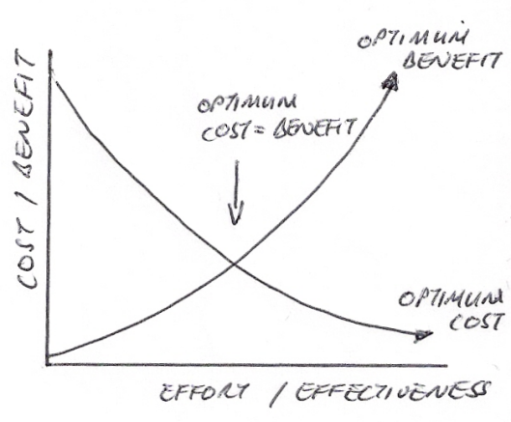

These examples show that preparation and warning systems are a response that can reduce vulnerability but that they are expensive. In addition, even in locations which believe themselves to be prepared the reality can still be dreadful. The 1995 Kobe earthquake in Japan led to over 6000 deaths despite Japan believing itself to be the best prepared country in the world with regard to earthquakes. Event the so called ‘earthquake proof’ Hanshin Expressway collapsed.

Conclusion

This report has shown that there are a variety of factors, both physical from the Tectonic Event Profile and human factors that influence the responses of people and governments. No one factor seems to stand out as bearing the greatest influence on response. It is more the interaction of many factors that determine response. Physical factors such as magnitude are important, because on a basic level the larger the event the greater the immediate response will need to be (e.g. Lincolnshire versus Iripinia) – in the worst cases e.g. Haiti it needs to be international.

However, for similar magnitude quakes an MEDC may be able to respond internally whereas LEDCs such as Haiti and Pakistan will require an international response. This is related to level of development and the state of governance. Speed of onset is important, and this is related to hazard type as earthquakes are instantaneous and come without warming whereas volcanoes and tsunami can often be predicted allowing warning and evacuation e.g. Popacateptel.

Human factors are very important. Level of development seems to combine with physical aspects of a hazard to either lead to a decent response of leave an area unprepared both before a hazard and for its aftermath. With 600 million people expected to live in areas vulnerable to tectonic hazards by 2025, the response to tectonic hazards seems set to grow more crucial.

Examiner comments:

|  |  |
| --- | --- |
| ***Overall comments*** | **How this could be improved** |
| ***Comments on Plan***  This students plan is logical; the flow of the report is clear and some key areas of discussion are identified, plus some relevant examples / case studies. | It could be developed further, and the 2 examples following ‘conclusion’ appear to be ‘new’ and therefore it is not clear where they fit in. It is wise to jot down a few conclusion ideas within the plan. |
| ***Comments on introduction, defining and focusing on the question***  The report has a good focus on hazards and response, with detailed definitions of natural hazards, plus response (related to the Park Model); hazard profiles are defined and a focus is developed which incorporates examining physical factors shown on the hazard profile as well as other, human, factors. | The introduction does lack a focus on ‘people and governments’ which is an important aspect of the question. There is some reference to people and governments in the report but the introduction should have been more focussed on this aspect of the title. The candidate could have given the report more direction in the introductory section. |
| ***Comments on researching and methodology***  Some reference to methodology and selection of evidence is made, embedded in the report at certain points (a perfectly acceptable approach).  A wide range of examples is used, both in terms of location, hazard type and level of development. Most data is accurate, and most examples reasonably up to date. Some concepts i.e. Park’s model are included and integrated well. | The Iripinia example is very dated, and no explanation is given for choosing a 30 year old example. Further comments on the use of some sources and examples could be given i.e. explaining their inclusion or commenting on data reliability. |
| ***Comments on analysis, application and understanding***  The analysis is generally very good. Examples are related to responses carefully, rather than just described. There are on-going links back to the question so application is good. There is a clear supported argument that goes beyond hazard profiles and explores other factors; the complex nature of response is addressed. Diagram are used very effectively and always referred to. | Occasionally, more reference could be made back to models from the introduction. Figure 2 is rather generic.  The ‘people and governments’ aspect of the report title is often an after-thought.  Only 2 aspects of the hazard profile are discussed in detail (other are mentioned) |
| ***Comments on conclusion and evaluation***  There is good ongoing evaluation, often in the form of a summative paragraph comparing / contrasting examples or drawing out differences. The final conclusion is clear, and refers back to the title question as well as recalling the salient points of many of the examples used; the complex nature of the question is discussed. | Recall is good, although some key examples are not referred back to. |
| ***Comments on quality of written communication and sourcing***  Very good overall, with high standards of QWC, good use of terminology, an organised report-style structure and good use of diagrammatic material. | Referencing / sourcing does appear but it could be a little more developed in places e.g. website URLs and dates / authors from some sources. |

**Summary of marking levels awarded:**

|  |  |  |  |  |
| --- | --- | --- | --- | --- |
| **D**  **Introducing, defining and focussing on the question** | **R**  **Researching and methodology** | **A**  **Analysis, Application and understanding** | **C**  **Conclusions and evaluation** | **Q**  **Quality of written communication and sourcing** |
| (10) | (15) | (20) | (15) | (10) |
| Level 3  (6-8 marks) | Level 4  (12-15 marks) | Level 4  (17-20 marks) | Level 4  (12-15 marks) | Level 3  (6-8 marks) |