Unit 4 exemplar report

OPTION 5: Pollution and Human Health at Risk

Note: These exemplar reports are based on the work of candidates under examination conditions, during the June 2010 examination series. The reports were originally hand written but have been typed up, with diagrams redrawn. Errors, including QWC errors, have in most cases been kept. The aim of these exemplar reports is to highlight good practice and areas of potential improvement. The marking levels and examiners comments given are indicative and should be used as a basis for discussion in the classroom, rather than indicating a specific grade.

Pre-release research focus
Explore the varied causes of health risks, and the degree to which pollution strategies have played a significant part in reducing them.
Research health risks in contrasting locations and the contribution of pollution control in their management.
Report title:

To what extent is pollution control a key strategy in reducing health risks?

---------------------------------------------------------------------------------------------------------------------------------------
Plan
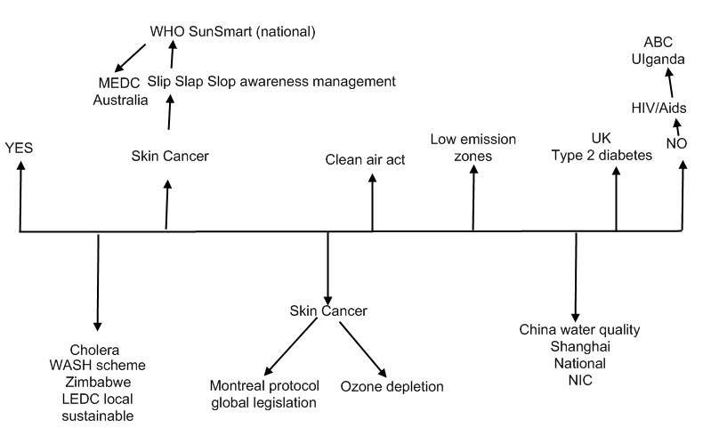

Introduction 1.1
This report will be focussing on the extent to which pollution control is a key strategy in reducing health risks. The World Health Organisation has estimated that over 25% of deaths in the developing world are caused by pollution. Pollution has been defined as ‘substances, usually toxic chemicals or conditions in the environment, especially in the air and water which pose a major health risks to humans and their well being(online medical health dictionary)
Health risks have been defined by:
Vulnerability X exposure to disease - management

Figure 1.1(see plan) conveys that this report will examine and explore a range of different case studies at differing levels of economic development as well as contrasting MEDC and LEDCs in order to answer this complex question. It also shows that pollution is not the only source of health risk.
References will also be made throughout to where the information has been sourced, this can be found in the Methodology table Figure 1.4reference will be made to models including the Environment transition Model (Fig 1.2) and the Kuznet Curve (Fig 3)

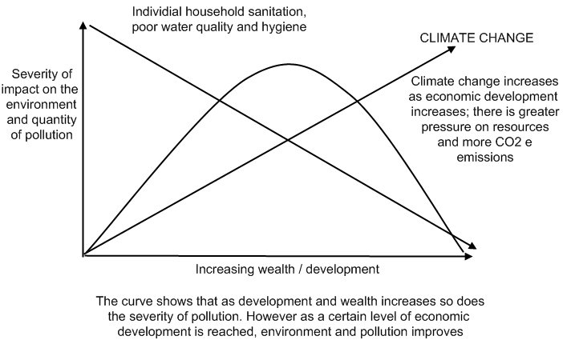

Case studies have been placed on the models to highlight where they are in levels of development
The curve shows that as development and wealth increases, so does the severity of pollution on the environment. However once a certain level of economic development is reached, environmental pollution improves because of specific strategies to either reduce pollution at the source or sink.
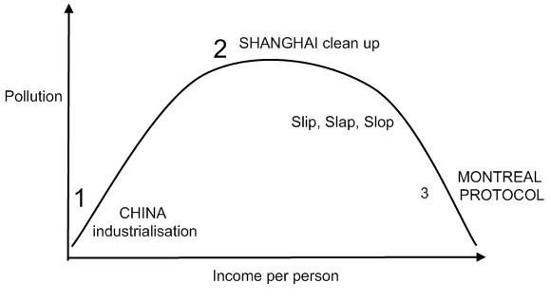

Methodology table
Source | Reliability | Date
WHO  (internet) | Reliable source of information; non-bias; provided by the UN; information collected around the world regularly | Up to date
BBC World health  (internet) | Reliable range of articles on different health issues; may be bias due to the stakeholders involved. | Up to date
Guardian  (newspaper) | Articles from issues around the world. Their website contains information on issues from old articles; useful for comparison. | Past and current
Avert.org  (internet) | Avert NGO information about HIV, up to date information from the UN. | Current
EPA  (internet) | Official website slightly biased. Range of examples on pollution control strategies. | Current
Dunn et al, 2009  (Edexcel Geog textbook) | Written by geographers and examiners; non-biased and useful information | Up to date
Sunsmart.org | NGO; awareness about skin cancer supported by WHO. | Up to date
UN Aid Wash scheme  (YouTube video) | Video about the scheme which is slightly biased as it is trying to promote it. | Out of date but highly relevant
Radio 4 | Part of the BBC, discussions on current affairs and news; different stakeholders involved. | Up to date

Skin Cancer 2.1
With increasing populations and economic development, there are now an increasing number of health issues being posed to both individuals and managers. Skin cancers are the most common type of cancer in white populations, both in the UK and worldwide(BBC) There has been a major increase in this risk, highly related to rapid economic development and increased CO2 causing ozone depletion
Ozone depletion 2.2
It has been estimated that the ozone layer has been declining by 4% every decade, rapidly increasing the amount of UV rays passing through the atmosphere .Linking back to Figure 1.2 it clearly shows that with increases in economic development so does climate change which poses threats to health and well being of people. The reason for this rapid depletion in the ozone layer is due to ozone depleting CFCs, used in aerosol cans and refrigerators. There have been numerous pollution control strategies such as the Montreal Protocol to help reduce this health risk(Dunn et al 2008)
Montreal Protocol 2.3 ---International Legislation
This was a successful strategy starting in 1987.It involved banning manmade CFC production .It was estimated by the Environmental Protection Agency that over the past 20 years this protocol has helped phase out 95% of CFC production between 1990-2010 delaying global warming by up to 12 years (EPA.ORG, 2010) The Protocol also is supported by a Multilateral Fund which provides resources to developing nations to promote the transition to ozone-safe technologies
Counter Argument 2.1
However, this management scheme has increased the use of other ozone depleting gasses such as HFCs, also potent global warming gases especially in poorer countries deperate to increase manufacturing. A recent news report on BBC Radio 4 stated that NOAA scientists have found that there is an increase in CO2 concentrations in the atmosphere from increased HFCs"HFCs are good for protecting the ozone layer, but they are not climate friendly’. HFCs currently have a climate change contribution that is only about 1 % in comparison to the contribution of CO₂ emissions but by 2050 the HFCs contribution could rise to 7 to 12 % of what CO₂ contributes
Sub conclusion
So this conveyed that even though international , indeed global legislation of CFCs to help reduce health risks such as skin cancer to vulnerable counties like Australia positioned under one of the areas of the depleted ozone layer, this in turn has created the longer term issue of HFCs affecting the whole climate

National Pollution Management
Implementation of global strategies has to be done at a national level to be effective. Fig 1.3 suggests that at a certain level of national wealth, pollution management becomes a government priority, hence the formation of environmental protection Agencies, watchdogs and legislation on emissions. However, there is also the management of preventing the exposure to the health risk, such as The World Health Organisation has teamed up with a NGO called ‘SunSmart’ working in Australia to raise awareness on melanoma. Their recent campaign ’Slip Slap Slop’ has had some success by making individuals aware of the health risks on the radio and TV .Their campaign is called ‘Healthy Skin’ and targets 18-25year olds, encouraging self awareness and regular check ups with a GP. Nationally there has been a decrease of 25% of skin cancer cases.( SunSmart.Org and Guardian newspaper)
Subconclusion
This section suggests that pollution management must go together with health risk management , and must be appropriate for the level of technology and education of any area. Australia has enough money and investment and infrastructure to ensure a reduction of health risk

3. The case of Cholera management at a global and local scale
Cholera is a dangerous contagious bacterial disease found in contaminated water systems, and still a major issue in developing nations, particularly densely populated slum dwellings such as in Mumbai or Lagos, or a threat in with water after say a disaster like Hurricane Katrina in New Orleans. Successful pollution controls have been set up locally in places like Zimbabwe, which has a very high incidence.
UNAID has been trying to help control water quality and the spread of the disease through a strategy called ‘WASH’ (Water Aid Sanitation & Hygiene’). Before the 2008-0 outbreak in Zimbabwe when 4000 died and 10,000 cases were reported UNAID workers visited many rural areas such as Bulawayo. Their WASH strategy involved teaching and bringing self awareness about hygiene and what to do in an outbreak. Soap and Dehydration tablets were issued. New sewage systems were established and help given on maintenance using appropriate local materials During the outbreak it was estimated a 32% decrease in the number of cholera cases where the WASH scheme operated, Bulawayo included.
Sub conclusion
This case study illustrates the importance of bottom up, low cost and appropriate strategies for vulnerable people in poorer countries especially, aided by the international community. The UN has sufficient funds to ensure continuity and hence sustainability is achieved. Both pollution control(sewage scheme) and health risk reduction( education) created a sustainable solution- needed in a country where the President has actually denied any outbreaks of the disease and national government is ineffective (UNAID.ORG 2009).

4. Lifestyle diseases rather than pollution
There are still numerous diseases which pollution control cannot manage, mainly those created by lifestyle and behavioural factors, such as HIV/AIDs and many sorts of cancer and heart disease. Type 2 Diabetes is linked especially to rapid economic growth and a consumer, sedentary life style. Fig 1.2 suggests that as economic development increases so does income, and more affluence causes these lifestyle changes.

4.2 Type 2 Diabetes
This is linked to poor eating habits and obesity, and is becoming a massive problem not just in MEDCS like the UK and USA but in transition economies of the BRIC. The NHS estimate £1m is spent every hour on this health risk, and is an increasing health burden on society and managers. However, what Fig 1.3 shows is that once a certain level of national income is reached, management controls are implemented and health risks decrease. In the UK as an example, the health authority in the London Borough of Hounslow is implementing schemes such as ‘active and healthy’: 12 week courses aimed at teenagers and young adults to help improve their lifestyles and help prevent Type 2 diabetes developing.

4.3 HIV/AIDs –ABC approach in Uganda
HIV/AIDs is another disease affected by lifestyle and behaviour and hence its management will not focus on pollution. It is transmitted through unprotected intercourse, contaminated drug users and breast milk. The WHO has estimated 38.8million people are living with the virus currently, 2/3 of which are in sub-Saharan Africa. This is putting a major pressure on employment, economic growth and hence indirectly health care generally.
However there are a few developing countries such as Uganda which have actually reduced the prevalence of HIV/AIDs through an approach backed by the government known as ABC: Abstinence before marriage, Be faithful to your partner and use Condoms. This education/cultural target is alongside free ARV treatment and condom distribution has reduced by 32% HIV/AIDs

Conclusion
So to what extent is pollution a key strategy in reducing health risk? This report has focussed on a range of contrasting examples at different levels of economic development to help combat health risks. It has shown that many of today’s risks are a result of pollution- and indeed anyone living with diseases like HIV/AIDs in a polluted environment may pick up secondary infections easier with a lower immune system tolerance.
The report has conveyed that global control strategies such as the Montreal Protocol do show significant reduction in tackling pollution at the source. Unfortunately as with many technological fixes, substitute CFCs such as HFCs are now increasing the threat to health from increased global warming.
Management of health risk is often most effective at local levels, as shown in individuals participation in Slip Slap Slop, WASH and ABC campaigns, funded internationally or nationally which has helped ensure that the control is effective and appropriate across the spectrum
Overall what this report has concluded that in order for pollution control to help reduce health risks is that both international and national organisations need to work alongside local strategies (especially in vulnerable developing countries). Pollution is increasingly transboundary, especially air(as seen in climate change)
The models used in this report have clearly highlighted that health risks are going to rapidly increase unless climate change and exploitation is dealt with. Rather than these developing counties managing the environment and pollution after industrialisation, it needs to be implemented throughout to ensure people’s health and well being are not put at risk. This is where technology transfer is important.
The key to pollution control strategies is SUSTAINABILITY! Organisations need to work together now to reduce health risks but also to ensure that these strategies don’t impact future generations.

Examiner comments:
Overall comments | How this could be improved
Comments on Plan  This students plan is logical; and some key areas of discussion are identified , although one case study is introduced but not then used(Shanghai). Diagrams like this do tend to sort out a framework effectively | A few conclusion ideas.
Comments on introduction, defining and focusing on the question
Clear reference to title, ie focus. There is a justified relevant framework with clear definitions. It is pleasing to see not just the use of simplistic Brandt North-- South Divide but a more complex global division economically.
Comments on researching and methodology  A wide range of case studies selected both for pollution related and other health risks. Supported by accurate facts and stats. Excellent use of diagrams/models .One section is a little misleading(2.2, it is specifically CFCs not global warming causing ozone depletion and in fact melanoma most caused by culture: exposure to sun through recreational tanning. This is more indirectly linked to economic development because of increased leisure time and disposable income. | A table is simple but effective, if a little time consuming. A simple paragraph might be a faster technique to use.  Global warming is linked to the health risks of increased vector borne diseases, effects of extremes of heat, flooding etc
Comments on analysis, application and understanding
Every section is related clearly back to the title- ie high conceptual content and cogent argument. Diagrams are used very effectively and always referred to. There was some good use of vocabulary and concepts from Unit 3 in Section 3 on Cholera.
Comments on conclusion and evaluation
Obvious, detailed sub conclusions and extensive end conclusion related directly to previously selected case studies, thoroughly recalled.
Comments on quality of written communication and sourcing  Coherent structure and sequencing with excellent standards of grammar, vocabulary and strong ongoing referencing for most material. | Care must be taken that not too extreme a report style is adopted with only a basic paragraph comprising a section

Summary of marking levels awarded:

D  Introducing, defining and focussing on the question | R  Researching and methodology | A  Analysis, Application and understanding | C  Conclusions and evaluation | Q  Quality of written communication and sourcing
(10) | (15) | (20) | (15) | (10)
Level 4  (9-10 marks) | Level 4  (12-15 marks) | Level 4  (17-20 marks) | Level 4  (12-15 marks) | Level 4  (9-10 marks)

