Evidence A

Binge drinking over New Year's Eve could cost NHS £23m

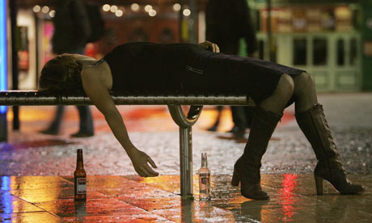
A think-tank has proposed that severely intoxicated people admitted to hospital should pay the price of their short-term treatment. Excessive New Year's Eve revelry could inflict a £23m hangover on the NHS as it deals with the consequences of binge drinking, it is claimed today. Other research showed that those who drink at home consume dangerously large measures; one think-tank has proposed that severely intoxicated people admitted to hospital should pay the price – £532 – of their short-term treatment as an alcohol awareness lesson.
A multitude of health warnings have been issued ahead of what is traditionally the busiest period for alcohol-related hospital admissions. Policy Exchange, a centre-right think-tank, produced its figure of £23m for the NHS bill based on estimates of visits to A&E departments, ambulance callouts and inpatient services on 31st December and 1st January.
"The costs of being admitted to hospital to sleep off alcoholic excess should be met by individuals, not the NHS," it suggests. "Those admitted to hospital for less than 24 hours with acute alcohol intoxication should be charged the NHS tariff cost for their admission of £532."
The Department of Health also releases research today showing that people drinking spirits at home in England give themselves more than double what they would get in a pub if they ordered a single shot. Experiments with drinkers in London, North Shields and Liverpool found that average "home barmen" pour 57ml when they drink a spirit such as vodka, gin or whisky – 32ml more than a standard single 25ml measure.
"If that average English drinker knocked back eight spirits drinks over a week at home, they would be drinking nearly half a litre (456ml) of vodka, gin or whisky," the study found, "compared to 200ml if they'd ordered the same number of single measures in a pub or bar. "People aged 31 to 50 were shown to be the most generous decanters while men poured out larger measures than women. Larger wine glasses also encouraged drinkers to overestimate what constitutes a single unit of alcohol.
Professor Ian Gilmore, president of the Royal College of Physicians, who chairs the Alcohol Health Alliance, said: "It is worrying that people have little appreciation of how much they are drinking when serving themselves, especially given the rise in home drinking fuelled by cheap alcohol from supermarkets. Part of this lack of awareness comes from ever larger glass sizes and drinks such as wine and beer increasing in strength."
(Source: adapted from www.guardian.co.uk by Owen Bowcott, 31 December 2009)
Evidence B

Bring in 50p minimum price for alcohol, MPs urge
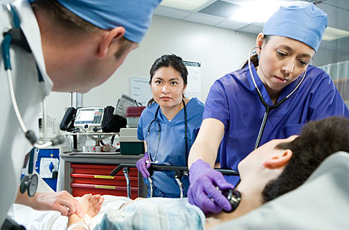
Costs of dealing with alcohol abuse 'overwhelming the NHS' say experts. The government was under mounting pressure last night to introduce minimum pricing for alcohol in an attempt to cut abuse as a senior Labour MP called for an urgent change in policy. Kevin Barron, chair of the House of Commons health select committee, which issues a major report on alcohol on Friday, told the Observer that ministers could no longer ignore evidence of soaring rates of addiction, and warnings of the crippling costs of abuse on an already overstretched NHS.
"Ministers need to be looking at other solutions than what they are already looking at," he said. The comment was a clear signal that his committee will tear into the government when its long-awaited report is released. Barron spoke out after Professor Ian Gilmore, president of the Royal College of Physicians, added to the calls for action in a joint report issued with the NHS Confederation last week. Gilmore said: "The nation's growing addiction to alcohol is putting an immense strain on health services, especially in hospitals, costing the NHS over £2.7bn each year." The sum had doubled in under five years and was no longer sustainable, he said. "The role of the NHS should not just be about treating the consequences of alcohol-related harm but also about active prevention, early intervention and working in partnership with services in local communities to raise awareness of alcohol-related harm."
The health select committee report is expected to recommend imposing a minimum price of 50p a unit of alcohol wherever it is sold and to suggest this could save 3,000 lives a year. The MPs are also likely to be strongly critical of the Department of Culture, Media and Sport (DCMS) over the introduction of 24-hour drinking. The DCMS sponsored the Licensing Act 2003 that allowed licensed premises to open around the clock from late 2005, claiming that extended hours would lead to more laid back, European-style drinking patterns in the UK.
The prime minister has ruled out minimum pricing of alcohol on the grounds that it would be unfair on the large majority of drinkers whose consumption poses no problem to themselves or others. He has also backed away from imposing new rules limiting cut-price "happy hour" offers in pubs and clubs for fear that it would harm businesses.
The MPs are also expected to call for limits on alcohol advertising and sponsorship and to criticise supermarkets for contributing to alcohol-related harm by selling drink at less than cost price as a loss leader. The Department of Health says progress is being made in combating alcohol abuse. The all-party committee was charged with looking at the scale of ill-health related to alcohol misuse, the consequences for the NHS and the effectiveness of government policy. Ministers will be expected to respond within two months and will be under pressure from MPs to draw up new policies before the general election, which is expected in May.
Evidence C

All-day drinking 'a failure'
Home Office review says law switch has led to upsurge in early morning crime; up to 16% of people in assessed areas are indulging more than ever, report reveals. A long-awaited Home Office review of the impact of 24-hour drinking in England and Wales will concede that the controversial policy has failed to reduce alcohol-fuelled crime or change drinking patterns.
According to the report, "more flexible pub and club closing hours were intended to avoid the closing-time mêlées, discourage excessive drinking and, in time, encourage a more relaxed, southern European-style drinking culture".
But not only have things failed to improve since licensing laws were relaxed, in many cases they have become worse. Serious violent crime has been displaced, with a steep rise in offences committed between 3am and 6am and, despite the millions spent on police crackdowns on drunken disorder; alcohol-fuelled crime hot spots have become worse.
Pressure is mounting on the Government to rethink 24-hour licensing, with the release of a report from the British Medical Association last week that highlighted concerns over the soaring numbers of people needing hospital treatment as a result of binge drinking: "There is strong evidence that increased opening hours are associated with increased alcohol consumption and alcohol-related problems."
(Source: adapted from www.independent.co.uk by Jonathan Owen and Ian Griggs)

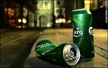
Suggested Questions and Discussion areas:

- What is meant by the term ‘merit good’?

- What is meant by the term ‘demerit good’?

- What is meant by the term ‘market failure’?

- Briefly explain why the UK Government funds the NHS.

- Why are the concepts of ‘scarcity’ and ‘opportunity cost’ important to the NHS?

- Should the cost of alcohol treatment be met by tax payers or by individuals?

- Should the Government bring in a 50p minimum price for alcohol?

- Should supermarkets be allowed to lower prices on alcohol in order to increase revenue?

- Do you think that people would drink less if they had to pay for treatment on the NHS?

- Should binge drinkers and patients admitted to hospital due to excessive drinking be made to pay £532 for their treatment (Evidence A)?

- What are the private and social costs of alcohol?

- What are the private and social benefits of alcohol?

- What strategies can the Government implement in order to reduce alcohol consumption in the UK?

- How does the UK tax rates on alcohol compare to other countries in Europe?

- What do you think the rate of tax should be in the UK?

- Why does the Government charge high levels of tax on alcohol?

- What do you think is the likely PED of alcohol?

- Should the 24 drinking laws be abolished in England and Wales?

- Evaluate the arguments for using taxation as a way to reduce consumption of alcohol.

- Should taxation be increased in the UK in order to fund more public services such as the NHS and Education?

