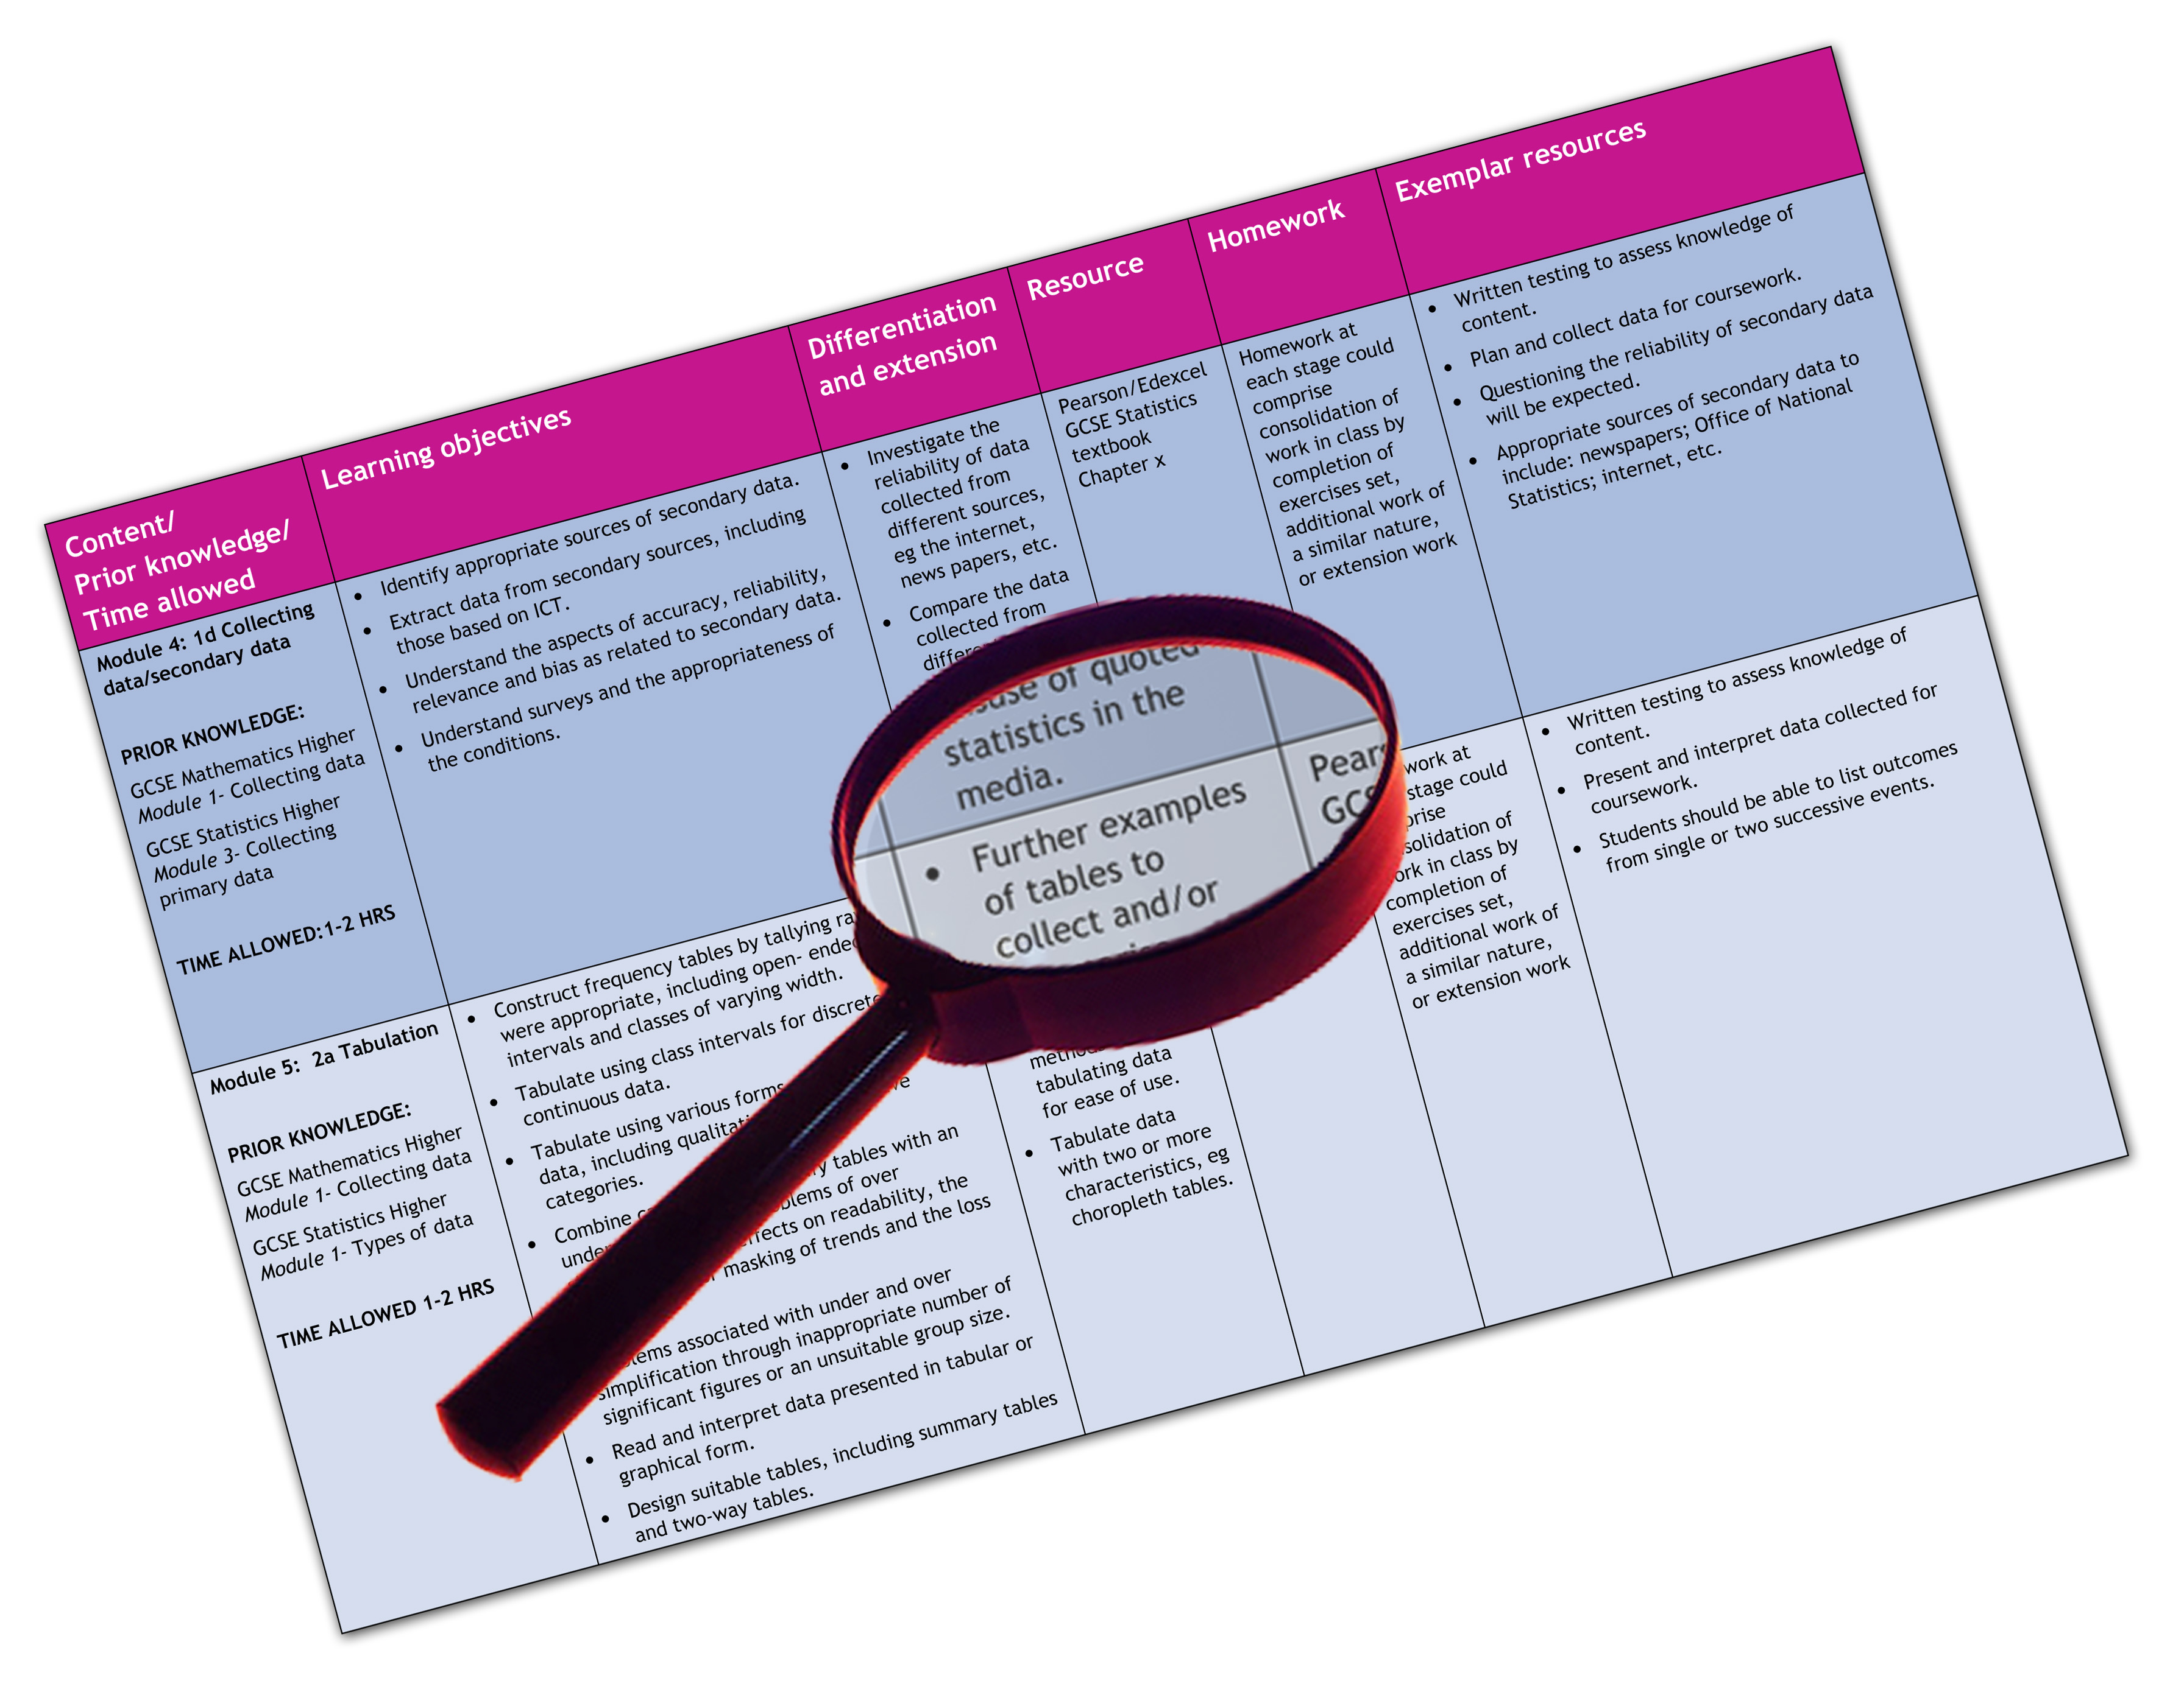


Edexcel GCE Drama and Theatre Studies (9DR01)
We are happy to provide this scheme of work for you to amend and adapt to suit your teaching purposes.

We hope you find this useful.
Editable scheme of work

Detailed help on resources

Week by week content coverage

Exemplar activities

Learning outcome

Units 1, 2, 3 and 4

GCE Drama & Theatre Studies
Edexcel scheme of work
This scheme of work covers Year 12 and Year 13. It assumes that:
- Unit 1 is taught by two teachers primarily in the Autumn term of Year 12. The second text is taught alongside the first, although this looks slightly different in the layout of the SOW. The Exploration Notes are completed towards the end of the unit under controlled conditions.
- Unit 2 is taught from January through till the date agreed with the visiting examiner to perform Sections A and B. The centre has enough students to warrant 2 visits (18) and has chosen to do Section B before Section A. There are to be 2 group performances for Section B with each group having 9 performance students. Section A is a mixture of monologues and duologues. The centre has chosen to limit the students to pieces from 3 texts only for Section A. They have chosen the text for Section B.
- Unit 3 commences in the Autumn term of Year 13. There are 12 students taught by 2 teachers. There are no design candidates and the performances are scheduled for the second week in December. The students are working in 3 groups of 4 candidates.
- The centre has chosen to study Lysistrata for Unit 4 sections A and B. This means that for Section C, they can choose to study and research the original performance conditions of a play written from either of the 2 remaining time periods - 1564-1720 or 1828-1914. In this case, they are going to see a Shakespeare play - ‘Romeo & Juliet’ at Stratford in March 2010.
- In summary, the text studied over the AS and A2 course are as follows: A Doll’s House, Metamorphosis, Blood Wedding, one from The House of Bernarda Alba, King Lear or All My Sons. Lysistrata and Romeo & Juliet.

Week | Content coverage/key questions | Learning outcomes | Exemplar activities | Exemplar resources
1 | Induction - Group games | - To encourage the group to get to know each other, to build up trust and create a collaborative work ethic | Getting to know you games. trust games e.g. fall and catch, blind leading. Name games. Ball games. | 100+ ideas for drama by Anna Scher
2 | Induction - make a video | - To encourage the group to work collaboratively on a slightly longer project (one week) with a definite outcome i.e. they have something to show  - To work within a given time frame - 1 minute and 5 minutes | In groups of approx. 5, create a 5 minute video advertising one of the following:  the school/college, the ideal 17 year old! ,the area you live in, Decide on an audience e.g. parents, students, new teachers.. | Discuss favourite advert and what makes it successful.  Ask group to record their favourite advert and to give a ONE MINUTE timed talk about it.
3 | Background to the play | - To begin to research the background of Henrik Ibsen  - To know enough about Ibsen’s life to connect it to major themes in the play  - Extension for G&T - Read any other play by Ibsen | Create a quiz for the rest of the group about Ibsen’s life. They must also be able to provide the answers !  H/W Read the whole play  How would women today react to being called the names that Torvald uses ? | Library, Internet.  Any resource books available in the department  Most useful book is the Michael Meyer book on Ibsen ISBN : 0140580034  plus Cambridge University Press ‘Ibsen - A Doll’s House’ Plays in production ISBN: 0-521-47866-9  Talk from librarian on plagiarism, use of bibliography/footnotes, acknowledgment of source materials etc.
4 | Focus on Social, Cultural, Historical, Political aspects of the play | - To use information acquired on Ibsen’s own life, knowledge of the time period - 1879- and an article on feminism to inform notes | The changing role of women - the suffragettes, feminism in the 1980s... Play Nora as a woman in a different time. What do we learn about the SCHP ? H/W submit 200 words on the SCHP work done this week | Text Book: AS Drama and Theatre Studies: The Essential Introduction for Edexcel ISBN: 978-0-415-43659-5
5 | Focus on use of language | - To understand the emotive power of certain words, linked with how they’re said. (vocal awareness)  - To select and use language effectively in performance | Choose 3 key sentences or phrases that are vital to the text. Explore ways of using language to alter the situation - emphasise words, mime it, shout it, underplay, be melodramatic.. Discuss major themes in the play - money, health, deceit, show how the language enhances these themes.  e.g. H/W submit 200 words on the use of language | Key quotes from the actual text  The language of love ?  Use a highlighter pen to stress/emphasise selected words  Show students a script extract with all stage directions removed
6 | Focus on Visual, Aural, Spatial elements | - To look at the technical aspects of putting a play on. What do you see/hear ?  - To develop greater knowledge of backstage jobs in the theatre | Working in groups, using LARGE paper, you have 30 (?) minutes to draw your set.  H/W submit 200 words on V, A, Sp. plus drawings  Actually plan the set in the studio using real objects and signs | The National Theatre website - technical departments  Diagrams of sets (scale models) as exemplars  Fourth Wall exercises
7 | Focus on Vocal Awareness | To understand the emotive power of certain words, linked with how they’re said. (vocal awareness)  To select and use language effectively in performance | Voice training exercises  Using terms of endearment, show how they can be supportive/patronising/insulting/significant  Select passages that show that Nora is likely/unlikely to leave Torvald by HOW things are said, not what is said. | Film a session this week to send to the moderator in May  ‘Voice and the Actor’ by Cicely Berry
8 | Focus on Non-verbal communication | To understand the importance of body language and proxemics,  To understand the significance of gesture, expression and action to convey meaning | Look at the scene between Nora & Dr Rank - show how their relationship alters depending on their gestures and proximity  Try and act out the tartantella - what do you learn from this dance ?H/W submit 200 words on non-v communication | Show the dance from the film version of the play (1973, with Claire Bloom as Nora)  This was filmed 36 years ago, can this be connected to SCHP, how was Nora portrayed then ?
9 | Focus on Characterisation | To understand about exposition and how we learn about a characters past life.  Look at Aristotle’s elements of drama. | Using the very start of the play, the arrival of Mrs Linde and then the arrival of Krogstad, go on a fact finding mission to show how information is imparted and implied.  H/W submit 200 words on characterisation | Look at the nature/nurture theory  What do we inherit ?  What do we do to adapt ?  Aristotle’s elements of Drama
10 | Focus on practitioners | Stanislavski workshops  Naturalism  To try ‘magic if’ exercises to highlight key moments in the plot and structure of the play | What if.. students to develop  Rehearse scenes with each character having a super objective  H/W submit 200 words on the application of Stanislavski | Chapter on units and objectives  ‘An Actor prepares’ by Stanislavski  ‘An actor’s work on a role’ by Stanislavski. Routledge October 2009  Video on method acting and Lee Strasbourg
11 | Focus on Interpretation | To understand the role of the Director and how they are responsible for the interpretation of the text.  To raise awareness of audience, intention and communication | Working in small groups, choose an extract from the text that can be shown in 2 different ways.  Perform and evaluate your own work and that of one other group.  H/W submit 200 words on interpretation | Check filmed session before completing work. Make another video to submit if necessary
12 |  | Re-visiting any areas that students are not sure about - consolidate learning during the first term | Free choice group work - students focus on any aspect of the text or the 8 elements, and share practical findings with the rest of the class for a final opportunity to be assessed on practical work | Final opportunity to film a session if necessary, otherwise pass completed DVD to technician to make a copy and put original in school safe with exams officer.
End of Autumn term/start of Spring term - Exploration Notes to be competed in controlled conditions
SOW for 2nd text taught by a different teacher but explored alongside the first text
 | Section B of Unit 2 worth 30% |  |  | Confirm date/s with examiner as soon as possible
1 & 2 | To prepare for the group performance, just before the Easter break. | To introduce students to the Section B text - Blood Wedding by Lorca | Read the play  Look at Lorca’s life to give context to the play  In week 2, the text needs cutting so that each of the 2 groups has their own unique version of it | Show how texts have been cut from previous series.  Stress the importance of not exceeding the time limit.  Less is more !
3 & 4 | Start rehearsals for Section B | Two groups of 9 are established  The play is cast with appropriate distribution of roles | Characters can be paired e.g. the Bride from group 1 can do character building exercises with the bride from group 2 etc.  The play should be blocked by the end of week 4 | Egg timers/electronic timers to be used regularly so that time limits are kept to
5 & 6 | Rehearsals to develop skills, in particular skills that relate to the assessment criteria | skills lessons - focus on movement, vocal qualities, characterisation & communication | Focussed rehearsals  Divide the play up into units/sections to make sense of rehearsals and good use of students time
7 | Half-term All lines to be learnt over half-term
8 | Full run-through | To have a full run-through of the text this week | Timed run-through
9 | Rehearsing | Rehearsing | Filmed run-through so students can watch with a more objective and critical eye | Decide on appropriate audience to invite
10& 11 | Technical requirements to be discussed, prepared and finalised | To continue to rehearse the play until it is ready for the exam | Rehearsals in front of an invited audience - younger classes if in school time | All paperwork sent to the examiner this week
12 | Production week | Practical exam to visiting examiner this week |  | Check DVD of exam and make a copy before sending to the examiner. Place the copy in school safe with exams officer.
Easter Holidays
1 &2 | Section A of Unit 2 worth 30% | To prepare for the monologue/duologue performances in 8 weeks time, just before study leave in May | Introduce the 3 texts that are to be used for Section A.  Students have one week to read them before expressing a preference for a text. In week 2, they are to work in 3 groups according to their choice of play. | King Lear - Shakespeare  The House of Bernarda Alba - Lorca  All My Sons - Miller
3 & 4 | Choosing extracts  Start rehearsals | To allow candidates a choice of text from 3 available, all connected by the theme of family relationships. | Choose suitable monologue/duologues. Justify choices in writing (250 words) To present justification to whole group.  Early start of rationales ? | Briefly watch monologues/duologues from previous year group.  How could they have been better ?  Write note in working logs for self-evaluation
5 & 6 | Rehearsing | To write Written Performance Concept/rationale - | Ensure that work is seen regularly particularly for monologue students, pair them together so they are supporting each other | To look at examples of annotated script and last years rationales-How could these have been better ?
7 | Rehearsals to a chosen audience. Technical requirements to be discussed, prepared and finalised | Skills lessons - focus on movement, vocal qualities, characterisation & communication | Film rehearsals so that students can see their own work with a more objective eye | Send materials to examiner for Section A  Decide on audience, in this case, just the examiner and the rest of the class
8 | Production week | To successfully complete Section A to the visiting examiner | Performances | Check DVD of exam and make a copy before sending to the examiner. Place the copy in school safe with exams officer.
End of AS course
When students return after June exams, choose from any of the following activities that could support the A2 year
Look at practitioners not studied yet, devise a project to take in to Primary feeder schools, arrange a visit to The Globe theatre
1 | Launch of Stimulus material for Unit 3 | - To discuss the stimulus materials and look at ways of developing them  - To encourage students to recognise the dramatic potential in materials | Students are presented with a stimulating range of materials/texts appropriate to the challenge of A2 work | The Magdalene Sisters (film)  The Magdalene Laundries - Factual information from wikipaedia etc  ‘Be my baby’ by Amanda Whittington  Adoption in China  Surrogacy  Newspaper article from the Guardian http://www.guardian.co.uk/lifeandstyle/2009/sep/19/catholic-church-sold-
2 | To ensure that students are familiar with the demands of the unit | To ensure that students creativity doesn’t detract from the requirements of the unit | Looking at the specification, the rules and rubric of the unit, particularly the SWED which is worth 50% of the available marks | A2 Drama and Theatre Studies: The Essential Introduction for Edexcel  ISBN: 978-0-415-43661-8
3 | Development of  stimulus materials into  3 x 20 minute plays that can each be classified as a ‘unique and original piece of theatre’. | Students feel supported as they work together collaboratively to devise their plays based from/on the range of stimulus materials provided | H/w 500 words on how research materials are being developed | Talk from librarian (with Y12) on plagiarism, use of bibliography, acknowledgment of source materials etc.
4 |  |  | H/w 500 words on how you are exploring & developing your role | The Frantic Assembly Book of Devising Theatre : ISBN: 978-0-415-46760-5
5 & 6 |  |  | H/w500 words on the form, structure & style of your piece
7 |  | - Play to be completed by the end of this week whether that means a script is produced or scenarios or just a series of sentences to structure the piece | H/w 500 words on what or who has influenced your piece
8 & 9 | Continue rehearsing final draft of play. | To begin to fine tune the play and check that it meets requirements | Is everyone equally involved?  Does the play communicate ?  Does it meet the time limits - groups of 4 = 20 minutes  Are students keeping notes that will contribute meaningfully to the SWED ?
10 |  | Preparing performance concept and programme to accompany DVD to be sent to the moderator | H/w 500 words on the SCHP context of your piece | Performance concepts from previous series (and programmes)
11 | Rehearsals to a chosen audience. Technical requirements to be discussed, prepared and finalised | - To perform the piece in its entirety to an audience (Year 10?) | Time performances to check that they meet the exam requirements.  Film a run-through early in the week so that students can watch it back - this will help with self-evaluation activities. | Keep the camera & tripod available at all times in the studio to encourage groups to film their rehearsals/run-throughs.
12 | Production Week | The plays are ready to be performed to an invited audience | Rehearsed performances are shown regularly throughout the week with sections evaluated
13 | Performance Week |  | H/w 500 words on how successfully your aims and intentions were communicated to your audience | Film a dress rehearsal as well as the final performance. Pass completed DVD to technician to make a copy and put original in school safe with exams officer.
14 | Evaluation of Performance | To complete final drafts of the SWED in lesson time, maximum 3,500 words | Final drafts need to be supervised. | Make sure that enough computers are available for students to complete their SWEDs in school. See if any ELO support is available for students who may need extra time. (Library?)
End of Autumn term/start of Spring term - SWED to be competed in controlled conditions
1 - 3 | January of Final year  Check study leave arrangements | Depending on study leave arrangements, either allow extra supervised time to complete SWEDs from Unit 3, or ask students to read both texts for the Unit 4 exam, in this case, Lysistrata for sections A & B and Romeo & Juliet for Section C. Students can sign out the DVD of Baz Luhrmanns Romeo & Juliet to watch during the study period. |  | Make sure sufficient copies of the official Edexcel texts are ordered in reprographics. Distribute them to students with their names on so any ’lost’ copies are purchased thereafter  Best done earlier in the year so students can read ahead
4 | Introduction to  Greek Theatre | To have a firm grasp of basic Greek theatre conventions by the end of the week | Working in 6 groups x 2 research the following elements to share with the group at the end of the week:  masks, Dionysus, Greek tragedy & comedy, Greek theatre buildings, Aristophanes, | library, Internet.  Any resource books available in the department
5 & 6 | Directing a scene from the play | To choose extracts from the play and plan how they could be directed | In groups of 3, each group is given a section of the play (4 extracts), they not only have to plan how they might direct this extract but do it for real with the remaining 9 students, a lesson each during week 6
6 | Developing a concept | Explain the need for a Director’s concept that is relevant, practical and personal | Students begin to annotate the actual text according to their concept to include production details, staging ideas, visual, aural ideas etc.
7 | Modern day parallels | To connect the play with real-life situations in society today | Focus on Social, Cultural, Historical, Political aspects of the play | Newspaper article from the BBC on Kenyan sex strike  http://news.bbc.co.uk/1/hi/world/africa/8025457.stm
8 | Half-term Students are to complete Section A and Section B timed essay questions and Re-visit their notes from the visit to The Globe theatre in the Summer. Research Elizabethan performance conditions
9 | To learn about the original performance conditions of the play | To understand about Elizabethan performance conditions particularly in 1594 | Watch ‘Shakespeare in Love’ | 1599’ A Year in the life of William Shakespeare’ by James Shapiro
10 | Prepare for theatre visit to Stratford to see ‘Romeo & Juliet. |  |  | Ask the library to prepare a book box/resources on Elizabethan performance conditions
11 | Evaluation of live performance seen | To make connections between the original performance of the play and the live production seen today | How did the Director interpret the play?  What design elements were used to interpret the play and make it relevant to a modern audience?  How did the live performance seen today compare with its original performance? | Live performance  Talkback session & workshop
12 | To use notes effectively to be able to access Section C of the exam paper | Timed essay questions this week of around 55 minutes | Do the planning for the first practice question as a whole group, then set 2 further questions that students do on their own  Ensure research notes are written up over the Easter holidays
1 | Start of 5 week revision period before students commence study leave  7 weeks until the exam | Lysistrata - methods of approaching the text | Rehearsal techniques  Design aspects  The role of actors and the director  characterisation  The Director’s copy and concept
2 | 6 weeks until the exam | Mock exam 56 Minutes on Section C only | Acting techniques such as vocal qualities, body language, proxemics  design elements - set, LFX, SFX, costume, make-up, special effects  audience reaction
3 | 5 weeks until the exam | Mock exam 110 minutes on Sections A & B only | Perform a rehearsed reading of Lysistrata to the year 12 students
4 | 4 weeks until the exam | Mock exam lasting 2 hours 30 minutes |  | Complete & sign paperwork - DTS11 to accompany Romeo & Juliet research notes to take into the exam
5 | 3 weeks until the exam | To go over any areas that were highlighted as weak in the mock exam | Short timed essays  Look at ways of breaking the questions down  Emphasis on Evaluating | Final check of notes and annotated scripts

