Alton Towers will never ‘Surrender’ details of latest huge rollercoaster

Adapted from Source: Staffordshire News, Tuesday 11 Nov 2009
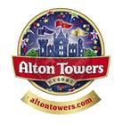
Alton Towers, the UK's most popular theme park resort and home to some jaw-dropping rides such Oblivion, is causing a stir amongst thrill-seeking enthusiasts. Its latest attraction, a product extension strategy codenamed Secret Weapon 6 (SW6), is a new rollercoaster scheduled for launch in March 2010.

The management at Alton Towers are refusing to disclose any details, but they have promised fans the ride will be a world first! The estimated £15 million attraction has caused much speculation that even the ride’s name is uncertain – die-hard fans have speculated “Surrender” as the most likely name for the rollercoaster. SW6 has been in design for 2 years and taken a team of 35 nine months to build working round the clock, to ensure it’s ready for launch in March.

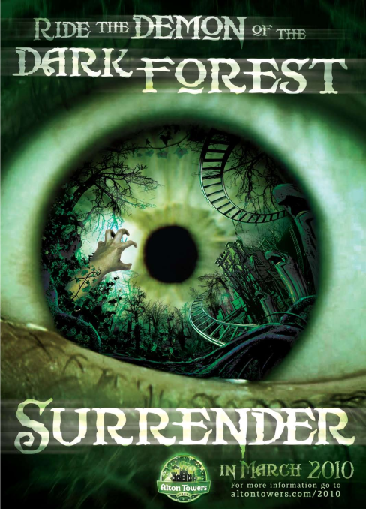
Mass marketing techniques using adverts promoting SW6 have appeared on www.altontowers.com and around the resort, enticing adrenaline-junkies to “ride the Demon of the Dark Forest”. This has spurred bloggers and tweeters to speculate a possible theme for the ride. The most popular being that a crypt in a mysterious forest has been disturbed, awakening a ghost. Other online rumours include:

- A track that gives the illusion it is invisible
- SW6 will beat the record for the greatest vertical drop in the world
- A track that moves vertically as you ride

Alton Towers has increased security staff at the building site, banning cameras and mobile phones, issuing non-disclosure agreements to staff and has even approached Google Earth to black out the building site to ensure its attraction remains top secret from rivals like Drayton Manor Park.

Morwenna Angove, Sales and Marketing Director at the Alton Towers Resort said: “In the build-up to previous rides, significant details were leaked and this time we are taking no chances. Our new attraction is totally unique and scarier than ever – it’s unlike anything the world has seen before. Fans do not have to wait too long to enjoy the ride, as they will be given the chance to ride SW6 early in 2010. I would suggest those who dare prepare themselves; they will be in for a ride they will never forget…”

Alton Towers is also set to boost its market position by its plans to source products sold in its shops locally and by taking into account environmental factors.

Unit 2A: Managing the Business of Alton Towers

Question  Number | Question
7. | Describe TWO reasons to explain why Alton Towers needs to make use of product extension strategies
 | Answer | Mark
 | Knowledge 2, Application 2  Product extension strategies are used to give a boost to sales revenue (1 mark) to arrest a decline in sales/maintain profits because customers can become tired of existing products (1 mark) or help the company to compete with its rivals (1 mark) by stirring up existing customer interest/new customers (1 mark)  Credit could also be given for references to Oblivion or competitors such as Drayton Manor Park | (Total 4)

Question  Number | Question
8. | Explain why mass marketing techniques might cause an increase in Alton Towers sales revenue
 | Answer | Mark
 | Knowledge 2, Application 1, Analysis 1  The value of sales revenue is determined by selling price X quantity sold (1 mark) therefore if a product is advertised it makes more people aware (1) so the quantity being bought and sold is falling sales/revenue will increase (1 mark)  In this case the number of visitors to AT should increase (1 mark)  Give credit for increases in secondary spending, e.g. on souvenirs for the new ride. | (Total 4)

Question  Number | Question
9. | The price elasticity of demand between 2007 and 2008 for Alton Towers range of products has been calculated to average -0.5.  Explain what this means
 | Answer | Mark
 | Knowledge 2, Application 1, Analysis 1  Price elasticity of demand measures the responsiveness of demand to changes in price (1 mark) it can be calculated by dividing the % change in quantity demanded by the % change in price (1 mark)  In this case if the value is 0.5 then it means that if the price of confectionery or souvenir key rings increases by say 20% then demand will have fallen by 10%  (1 mark) which means that PED is inelastic so consumers do not seem to respond much to price changes (1 mark) | (Total 4)

Question  Number | Question
10. | ‘Alton Towers is also set to boost its market position by…taking into account environmental factors’.  Analyse how social trends may affect the marketing mix for Alton Towers
 | Answer | Mark
 | Knowledge 1, Application 2, Analysis 3  Social trends are changes in fashion, tastes, preferences within a society as a whole (1) Marketing mix is described as product, price, place, promotion (1 mark)  In order to maintain custom/gain custom, Alton Towers needs to show a sensitivity to these trends (1) to continue to attract customers (1 mark)  Place – the products in the shop might be sourced in Staffordshire to reduce carbon footprint (1 mark)  Promotions may be done via the website to reduce paper usage (1 mark) Product may means using recycled packaging in their fast food restaurants (1 mark) | (Total 6)

Question Number | Question
11 | Assess the likely value of Branding to Alton Towers.  (8 marks)
 | Mark | Descriptor
4 | 7-8 | Evaluation must be present. Up to 2 further marks are available for providing arguments for and against the value of branding to Alton Towers, e.g. it assumes that branding is always positive…  A contextual conclusion should be provided to achieve the highest mark of 8 marks, e.g. Alton Towers do use significant branding across its portfolio of products from rides to merchandise because it provides value added based on years of experience which customers expect but also trust…
3 | 5-6 | Analysis must be present. DOES NOT HAVE TO BE IN CONTEXT. (Maximum 5 marks)  2 further marks are available for considering the reasons for Alton Towers makes use of branding e.g. souvenirs like teddy bear key rings with the Alton Towers logo are more likely to be valued by a visitor which will therefore boost sales
2 | 3-4 | Application must be present. Up to 2 further marks are available for contextualising the response by referring to Alton Towers, e.g. the souvenirs and rides need to display the logo or make use of the Alton Towers music common across the park
1 | 1-2 | Knowledge/understanding must be present. Up to 2 marks are available, e.g. for describing what is meant by branding, e.g. provide distinctive logo, lettering, image (of haunted house) to make recognizable to customers, etc

Question Number | Question
12 | Assess the likely value of the Boston Matrix to Alton Towers  (8 marks)
 | Mark | Descriptor
4 | 7-8 | Evaluation must be present. Up to 2 further marks are available for providing arguments for and against the value of the Boston Matrix to Alton Towers, e.g. it enables the product managers to determine which products to maintain and which to lose such as the suspension of the Corkscrew ride in 2008 which was clearly a dog product (used only when the queues for other more popular rides were too big)  A contextual conclusion should be provided to achieve the highest mark of 8 marks, e.g. Alton Towers is a profit making company which is accountable to its shareholders so any marketing strategy which helps support financial management should be used in conjunction with other methods such as quality assurance.
3 | 5-6 | Analysis must be present. DOES NOT HAVE TO BE IN CONTEXT. (Maximum 5 marks)  2 further marks are available for considering the reasons for Alton Towers using the Boston Matrix, e.g. to justify the introduction of a new ride – SW6 – (potential ‘Star’) to boost its market position against rivals like Drayton Manor
2 | 3-4 | Application must be present. Up to 2 further marks are available for contextualising the response by referring to Alton Towers, e.g. ‘cash cows’ might be the Cadbury Dairy Milk chocolate bars or Big Macs sold
1 | 1-2 | Knowledge/understanding must be present. Up to 2 marks are available, e.g. for describing what is meant by dog, cash cow, etc

Question Number | Answer |  | Mark
13 Recommend TWO ways that Alton Towers could price its products

NB Assessment for QWC will be attached to this question.
Level | Mark | Descriptor
4 | 7-12 | Evaluation must be present, i.e. the answer must include how a policy might benefit and adversely affect Alton Towers  NB For a mark of 9-12 TWO pricing policies need to be evaluated; for a mark of 7-8 ONE pricing policy must be evaluated.  QWC: To achieve a mark of 8-10 the candidate will use business terminology precisely and effectively/organises their answer to provide a coherent and fluent response/ good-excellent spelling, punctuation and grammar.
3 | 6 | Analysis must be present, i.e. in this case answers must explain why a particular pricing policy might affect the profits at Alton Towers, e.g. if the burgers are priced competitively then more customers are likely to buy than say bring a packed lunch but these prices may not cover the extra costs to Alton Towers caused by extra transport or storage  QWC: To achieve a mark of 6-7 the candidate will use business terminology quire well/style of writing is appropriate to the question/ reasonable to good spg.
2 | 3-5 | Application must be present, i.e. the answer must be contextualised, e.g. if Alton Towers uses psychological pricing, such as £9.99 for a souvenir teddy bear then customers may be ‘fooled’ to thinking that they have a bargain rather than paying £10.  QWC: To achieve a mark of 3-6 the candidate will use some business terms but the style of writing could be better / there will be some errors in spg / the legibility of the text could have been better in places.
1 | 1-2 | Up to 2 marks are available for simple responses such as ny stating pricing policies like skimming or cost-plus  QWC: To achieve a mark of 1-2 the candidate will have struggled to use business terminology or write legibly with frequent errors in spg and/or weak style and structure of writing.

