23 Variation and selection
Self-assessment questions 23.01

1 What are the two main causes of heritable variation?

2 Classify the following variations as either (i) caused entirely by genetic effects or
(ii) caused by a combination of genetic and environmental effects.

obesity, eye colour, tallness, ability to sing, maleness, masculinity, blood group,
natural hair colour; sickle-cell anaemia, agility

3 Alleles are genes which occupy corresponding positions on….. A ….. chromosomes. They control the same ….. B ….. but not necessarily in the same way.

4 (a) What new combinations of characteristics might arise in the offspring when a tall plant
with white flowers is crossed with a dwarf plant (of the same species) with red flowers?
(b) What selective advantage might either of the new varieties have?

5 The genotypes of two guinea pigs, for two characteristics are represented as AABB and aabb. These guinea pigs are mated, and their offspring eventually mate with each other.
(a) What genotypes could emerge in the second generation?
(b) Which of these would be phenotypically different (i.e. be different in appearance) from
the original pair?

6 Suppose that there are six pairs of alleles which control height and that each dominant allele adds 5cm to the stature. Suppose also that the average height of an adult (with equal numbers of recessive and dominant alleles) is 160cm
(a) What is (i) the tallest, (ii) the shortest person you would expect from this pattern?
(b) On this basis, what would be the minimum difference in height between any two people?
(c) Why is this minimum difference unlikely to be observed in reality?
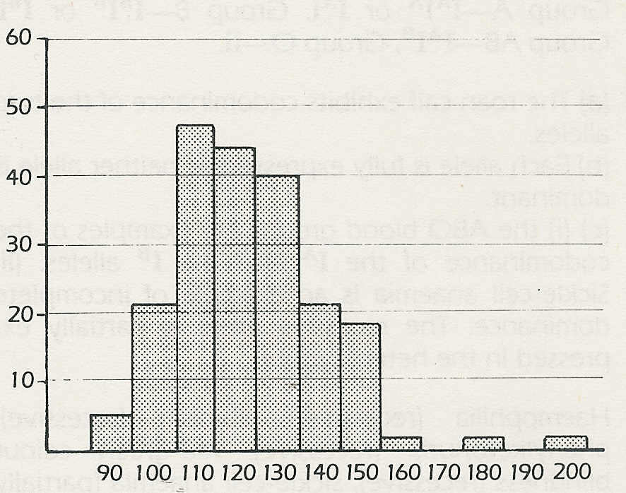
7 The histogram shows the range and
frequency of occurrence of particular blood
pressures (systolic) in a group of women in
% people
the 30-39 age group.
(a) On this evidence, could you say that
blood pressure is a discontinuous variable?
(b) Justify your answer.

© Curt Stern
blood pressure/ mmHg

8 Give two examples in each case of (a) continuous, (b) discontinuous variation in human
populations.

9 Which one of the following statements is the least accurate?
(a) Discontinuous variation results entirely from genetic differences.
(b) Continuous variation can result from genetic differences.
(c) Discontinuous variation cannot be altered by environmental effects.
(d) Continuous variation results from environmental effects.

Variation and selection (continued)
Self-assessment questions 23.02

10 Explain why identical twins will have the same genotype.

11 When ….. A ….. and ….. B ….. put forward the theory of Natural Selection in 1858
they observed that there are ….. C ….. between the individuals of a species. They also observed
that organisms produce more offspring than can possibly …. D …..to maturity. If the ….. E ….. are inherited and give the individuals an advantage over the other members of the species, they will live ….. F ….. and so leave more offspring with the same beneficial ….. G …..

12 A pair of mice has, on average, a litter of six babies. Assuming (i) that there are equal numbers of males and females in the litters, (ii) that the offspring breed freely amongst themselves, how many mice will there be after three generations?

13 (a) Give three examples of types of competition between members of an animal species in
the same population.
(b) In each case suggest a variation that might help an individual to compete more
effectively.

14 For a beneficial variation to have a selective advantage in the course of evolution, it must
be ….. A ….. by the offspring.

15 Evolution is thought to come about as a result of ….. A ….. which produce new
….. B ….. These gradually replace the original population as a result of …..C …..

16 Which of the following statements is most acceptable from an evolutionary point of view?
(a) Apes and humans have evolved from a common ancestor.
(b) Humans have evolved from apes.
(c) Certain apes have gradually evolved into humans.
(d) Apes and humans are related.

17 What characteristics might a breeder select for in (i) a cereal crop, (ii) a farm animal?

