17 The skeleton, muscles and movement
Self-assessment questions 17.01

1 Match the following biological names of bones to their everyday names,
Biological names: humerus, femur, sternum, tibia, clavicle, scapula, pelvis.
Everyday names: shoulder blade, shin bone, upper arm bone, hip girdle, collar bone,
breast bone, thigh bone.

2 Which organs are protected by (a) the skull, (b) the rib cage, (c) the vertebrae?

3 What is the function, other than protection, of the ribs?

4 Give one example in each case of (a) a fixed joint, (b) a ball and socket joint, (c) a hinge joint.

5 Where does cartilage occur in a joint and what it its function?.

6 Name one inorganic component of bone,

7 (a) Name three parts of the body where smooth (involuntary or unstriated) muscle may be
found.
(b) In any one of your examples, say what the smooth muscle does.

8 How does skeletal (striated) muscle differ from smooth (unstriated) muscle in its function?

9 Why does each skeletal muscle need an antagonistic partner?

10 Which bone forms the non-moving muscle attachment in (a) the hip joint, (b) the shoulder
joint, (c) the ankle joint?
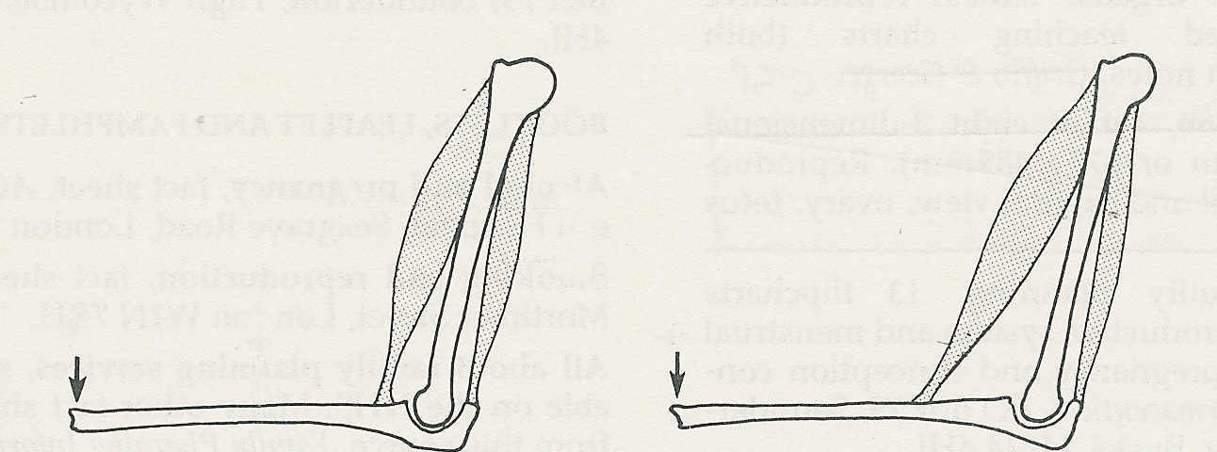
11

X
P

Q
Y
F
F

A
B

(a) Assuming that the bone X remains stationary, what will happen (i) when muscle P
contracts, (ii) when muscle Q contracts?
(b) Assuming muscle P is equally strong in each case, which one of A and B will produce
(i) the greater movement at F, (ii) the stronger force at F?

12 In a word, what process provides the energy for muscle contraction?

The skeleton, muscles and movement (continued)
Self-assessment questions 17.02

13 (a) What are the immediate effects of exercise on the functions of (i) the heart, (ii) the lungs,
(iii) the liver?
(b) How do these changes help to meet the needs of exercise?

14 State four long-term benefits of exercise.

15 Which one of the following is most likely to contribute to good health when you are 45?
(a) Active participation in sport when you were at school. .
(b) Walking to work every day.
(c) Playing golf every week-end.
(d) Playing squash three times a week.

