18 The senses
Self-assessment questions 18.01

1 Complete the sentence below using the three most appropriate words from the list.
A …..(A) ….. such as touch, is detected by a ….. (B) ….. and we may make a
….. (C) ….. . .
response, change, organ, stimulus, movement, receptor, effector

2 List four stimuli which can be detected by the skin.

3 By what means do we become aware of a stimulus?
F
G

4 Name the four taste sensations that we can distinguish.
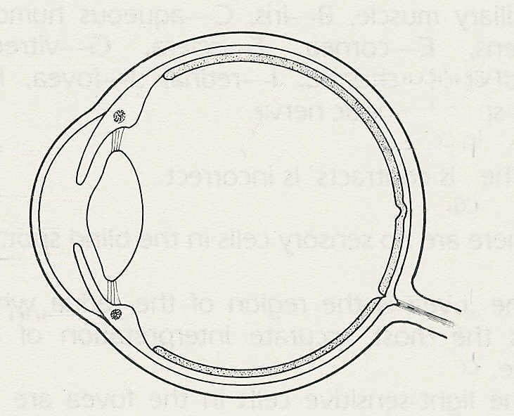
H
5 Give the names of the parts of the eye
E
labelled in the diagram.
I

6 Which one of the following statements is
incorrect?
When a bright light shines in the eye
D
J
(a) impulses travel in the optic nerve
K
(b) the radial fibres in the iris contract.
C
(c) the retina responds
(d) the pupil becomes smaller.
B
A
L
7 What is the cause of the blind spot in the
field of vision?
(a) There are no nerves in the blind spot.
(b) There are only cones in the blind spot.
(c) There are no sensory cells in the blind spot.
(d) The image is not formed on the blind spot.

8 (a) Which region of the retina gives the most accurate interpretation of the image?
(b) What type of light-sensitive cell is present in this region?

9 Which parts of the eye refract ('bend') the light in such a way as to form an image on the retina?

10 (a) What do you understand by the term 'accommodation'?
(b) What part does the lens play in this process?

11 Which is the correct statement?
To focus a distant object
(a) the ciliary muscle contracts and the lens gets thicker
(b) the ciliary muscle relaxes and the lens gets thinner
(c) the ciliary muscle contracts and the lens gets thinner
(d) the ciliary muscle relaxes and the lens gets thicker.

12 What type of colour blindness is most common in men?

13 What kind of eye defect can give rise to short-sightedness?

14 What type of spectacle lens can help correct long-sightedness?

