29 Populations
Self-assessment questions 29.01
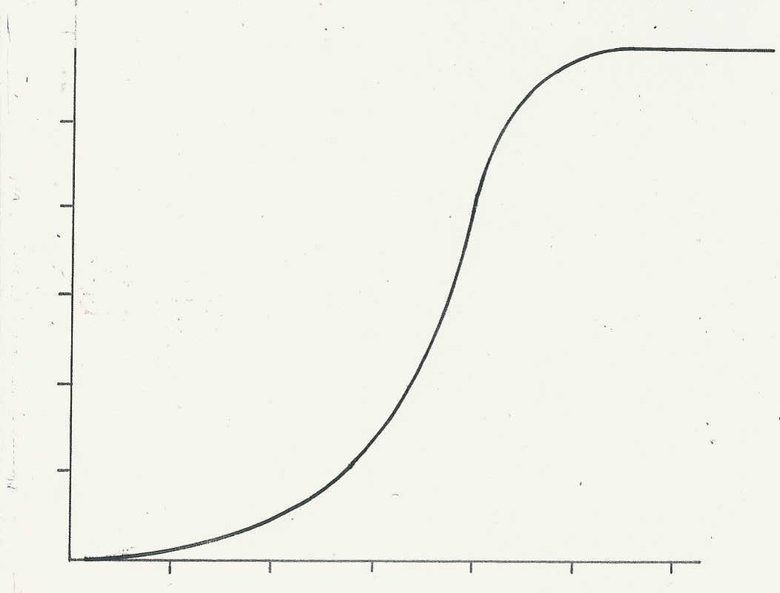
k
i
1 The graph represents a sigmoid growth curve
h
for a population of micro-organisms.
g
(a) Select the sequence of letters on the curve
population size
which best represents (i) the exponential
f
phase of growth, (ii) the stationary phase and
e
(iii) the lag phase.
(b) What is taking place during the exponential
d
phase?
c
2 What are likely to be the limiting factors in
b
a population of (a) green plants, (b) birds?
a

time

3 What is meant by the expression ‘infant mortality’?

4 What is meant by a ‘fertility rate of 3’?

5 Each of the following events could result in population growth, but only if certain other conditions are fulfilled. In each case, suggest what these conditions are.
(a) Birth rate increases.
(b) Death rate decreases.
(c) More people live to reproductive age.
(d) Infant mortality decreases.
(e) Life expectancy increases.

6 The table shows birth rates, death rates and infant mortality for four African countries some years ago. Which country would you expect to show (a) the greatest, (b) the smallest population increase by now, assuming no wars or famines?

Country | Rates per 1000 population
Country | Birth rate | Death rate | Infant mortality
Tanzania  Gabon  Ethiopia  Kenya | 46  33  50  53 | 16  22  25  14 | 125  178  162  80

7 If 65 year-old women in Britain have a life expectancy of 13 years, what will be their
average age at death?

8 State the changes in society which could contribute to a falling death rate.

9 State three conditions in a society which could contribute to a reduction in the birth rate.

10 How would an increase in the fertility rate affect the age structure of a population?
29 Populations - continued
Self-assessment questions 29.02

11 The bar charts show the numbers of people of different ages in two countries.
(a) Describe the age structure of the population in each case.
(b) Comment on the death rates in the two countries.
(c) Which of the two charts is characteristic of an industrialised country?

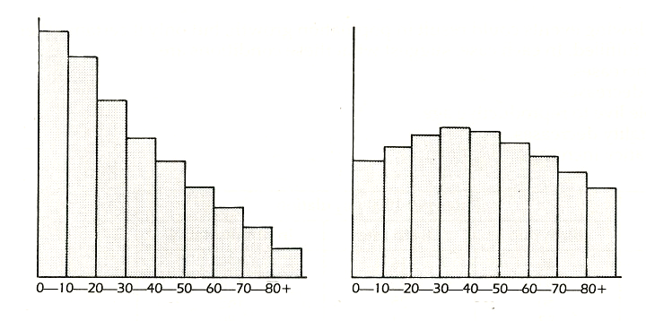
numbers of people
numbers of people
age
age
A
B

