6 Plant structure and function
Self-assessment questions 6.01
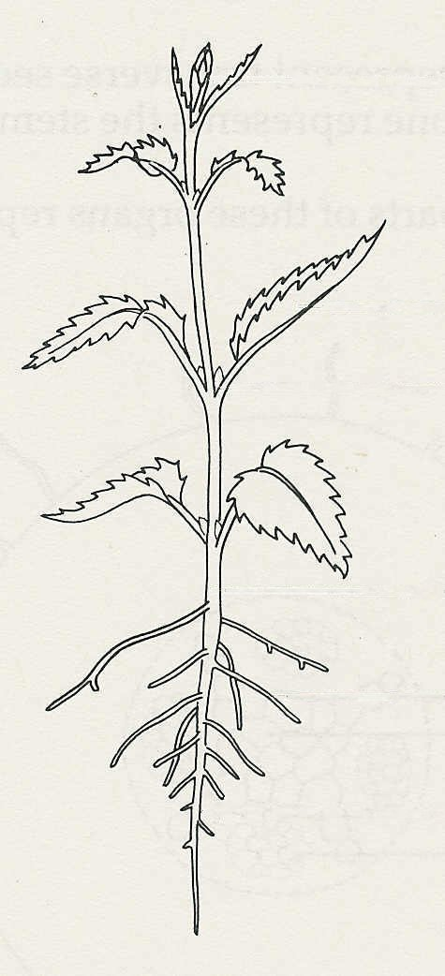
1 Name the parts of the plant shown in the drawing.
A

2 Match the structures stem, leaf, root,
terminal bud, lateral bud to the following
functions:
B
(a) produces carbohydrates
(b) carries water to leaves
C
(c) absorbs sunlight
(d) continues growth in height
(e) absorbs mineral salts
(f) makes branches
D
(g) anchors plant in soil
(h) conducts food to roots
E
(i) evaporates water
(j) produces new leaves
(k) spaces out leaves
F
(l) produces flowers
(m) absorbs carbon dioxide
(n) absorbs water.

3 The drawing represents a vertical section through a leaf x 200
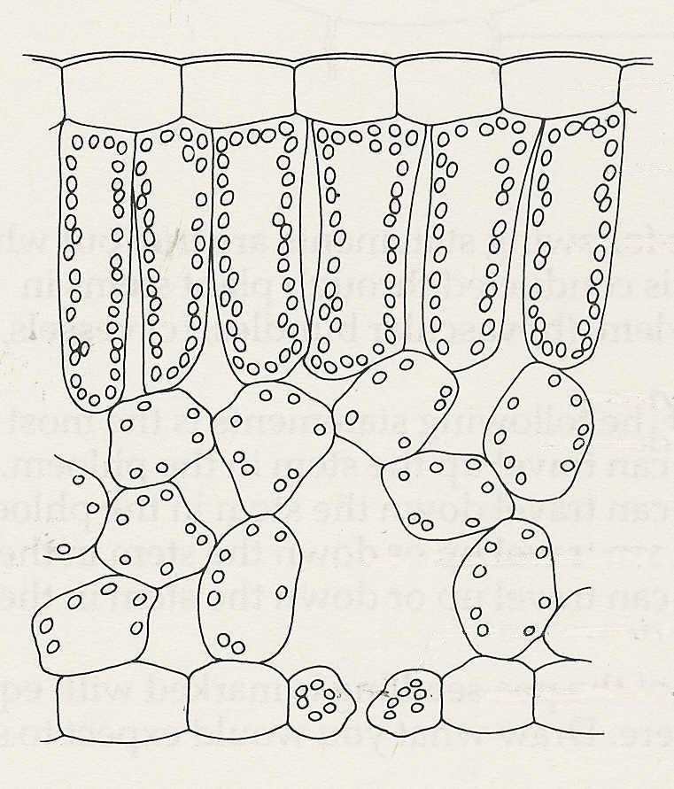
(a) Name the parts indicated by the letters
A - E.
A
(b) What differences can you see between
the palisade cells and the spongy mesophyll cells
B
(c) What is the function of C?
palisade
cell
(d) (i) Name the features represented in the
diagram, which are thought to adapt the
leaf to its function in photosynthesis.
spongy
mesophyll
cell
(ii) Say how these features help to
promote this process.
(e) State three other structural features, not
shown in the drawing, which are thought
C
to be adaptations to the process of photo-
D
synthesis in most leaves.
Explain briefly how these features
E
contribute to the efficiency of photosynthesis.

4 Which of the following are most likely to be true? When the stomata are open, the leaf is
(a) absorbing oxygen (d) giving off carbon dioxide
(b) giving off water vapour (e) giving off oxygen
(c) absorbing carbon dioxide
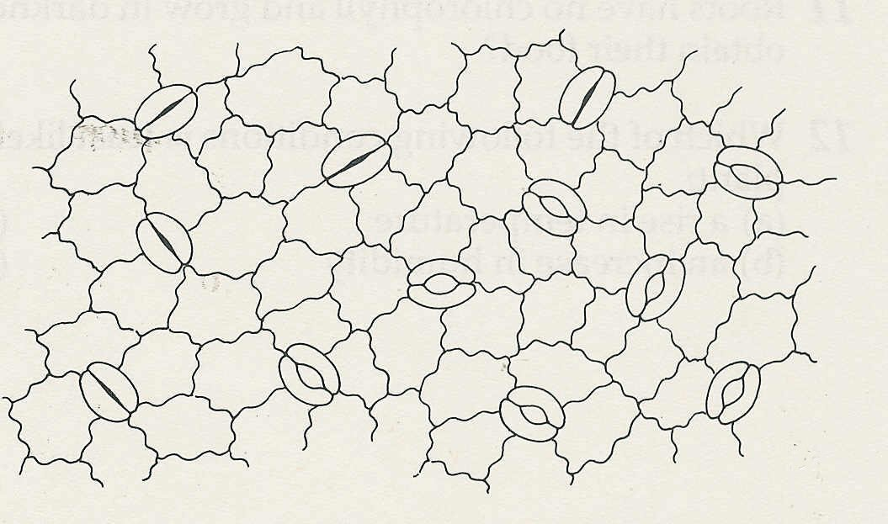

5 (a) How many stomata are shown in this
drawing of leaf epidermis?
(b) How many of the stomata are open?
0.1 mm
(c) How many are likely to be open at
night?
(d) What is the magnification of the
drawing?
Plant structure and function (continued)
Self-assessment questions 6.02

6 (a) What process is responsible for the movement of carbon dioxide into a leaf?
(b) In what conditions might the same process cause oxygen to enter a leaf?

7 The diagrams represent transverse sections through a root and a stem.
(a) Say which one represents the stem and which one represents the root, giving your
reasons.
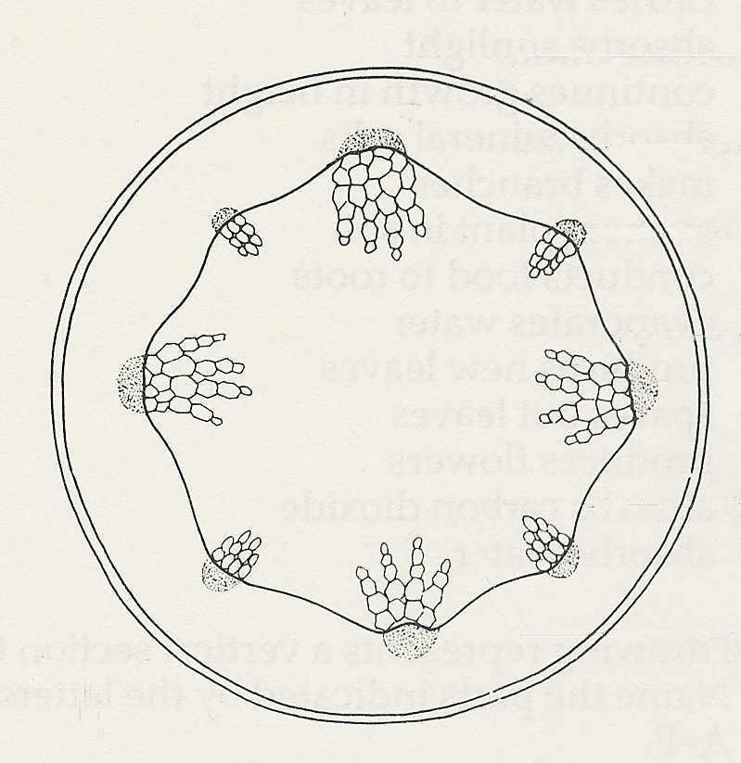
(b) Name the parts of these organs represented by the letters A-J.
E
F
G
H
I
J
A
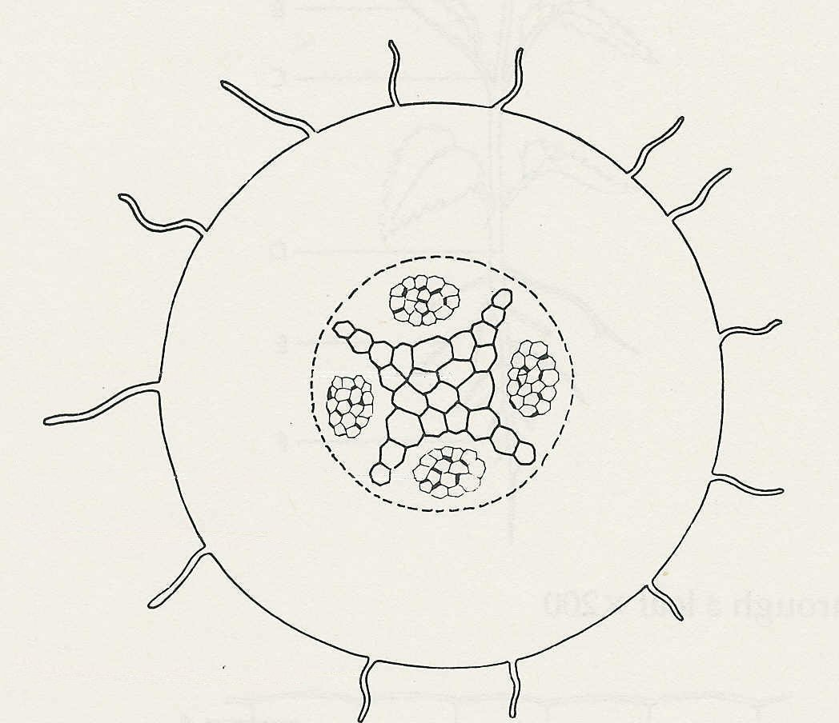

B

C

D
Figure 1
Figure 2

