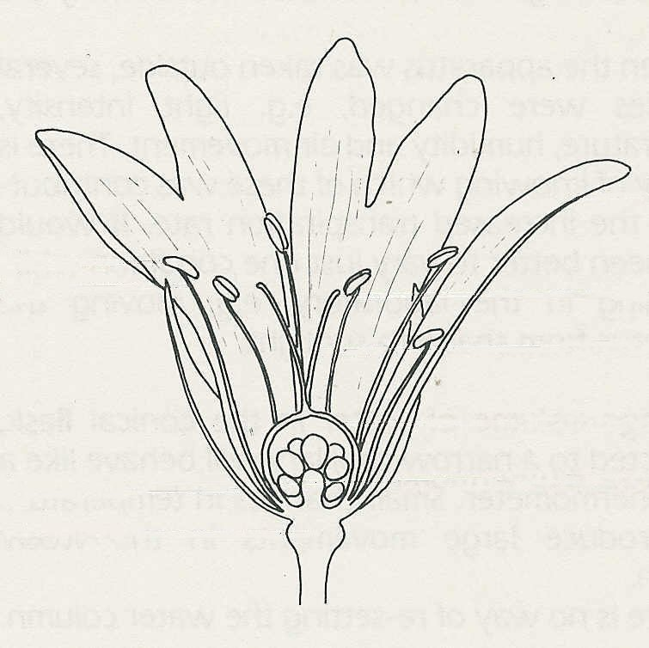
8 Reproduction in flowering plants
A
B
C
D
E
F
G
H
I
J
Self-assessment questions 8.01

1 Which is the most accurate statement?
The principal role of a flower in the life
cycle of a plant is:
(a) attracting insects
(b) producing seeds
(c) producing pollen
(d) producing nectar

2 Name the parts A-J shown on this drawing
of a half-flower of a Stitchwort.

3 What is (a) the male gamete, and (b) the
female gamete in a flowering plant?

4 Complete the following paragraph selecting words from the list below. Pollination is the transfer of ……. from the …….. to the ……. in a flower. In cross-pollination, the ……. from a flower on one …….is transferred to the …….of another ……. of the same species.

anthers, ovule, stigma, plant, flower, pollen, ovary, petal, style, receptacle, stamens

5 Complete the following sentences:
In a flowering plant fertilisation occurs when the ……..of the ……. fuses with the …….of
the ……… . After fertilisation , the ……. becomes the ……. and the ……. becomes the ……. .

6 Which of the following statements is correct? In flowering plants:
(a) pollination can take place without fertilisation
(b) fertilisation can take place without pollination
(c) pollination and fertilisation are the same
(d) pollination and fertilisation must occur at the same time

7 Some species of plant are strongly adapted to pollination by certain insects. Which of the following characteristics would you regard as adaptations to pollination by bees:
(a) white or coloured petals (f) small green petals
(b) light, smooth pollen grains (g) production of nectar
(c) spiky or sticky pollen grains (h) production of pollen
(d) anthers and stigma inside the flower (i) production of scent?
(e) anthers and stigma protruding from the flower
pollen grain
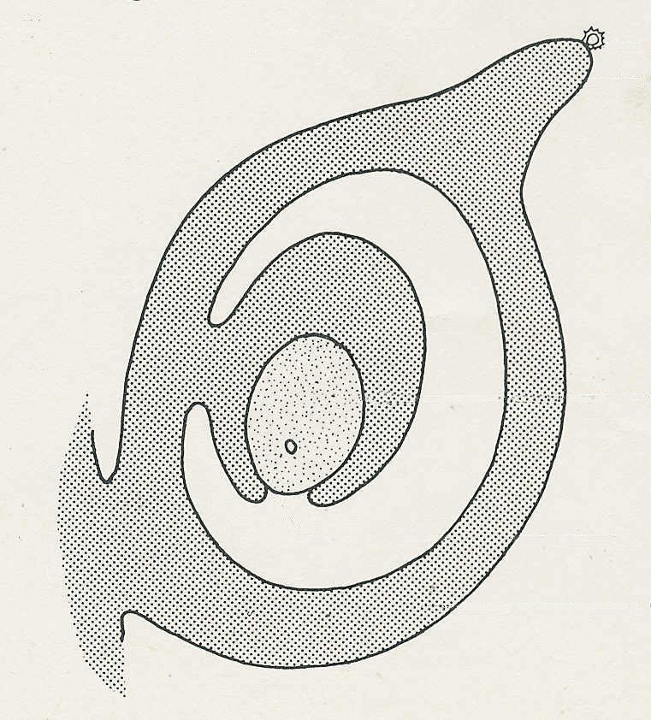
8 A bee visits several flowers in succession on
stigma
a single willow herb plant. In doing so, the
bee transfers pollen from the younger flowers,
near the top of the inflorescence (group of
flowers) to the older flowers near
the base of the inflorescence. Is this an
ovule
example of self-pollination or cross-pollination?

9 Complete the drawing to show what has to
micropyle
happen before fertilisation can occur
ovary

Reproduction in flowering plants (continued)
Self-assessment questions 8.02

10 The drawings show seeds or fruits of different plants.
(a) From the appearance of the structures, make a guess at how each one is dispersed giving
reasons for your answers.
(b) What are the advantages to a plant of an effective method of seed dispersal?

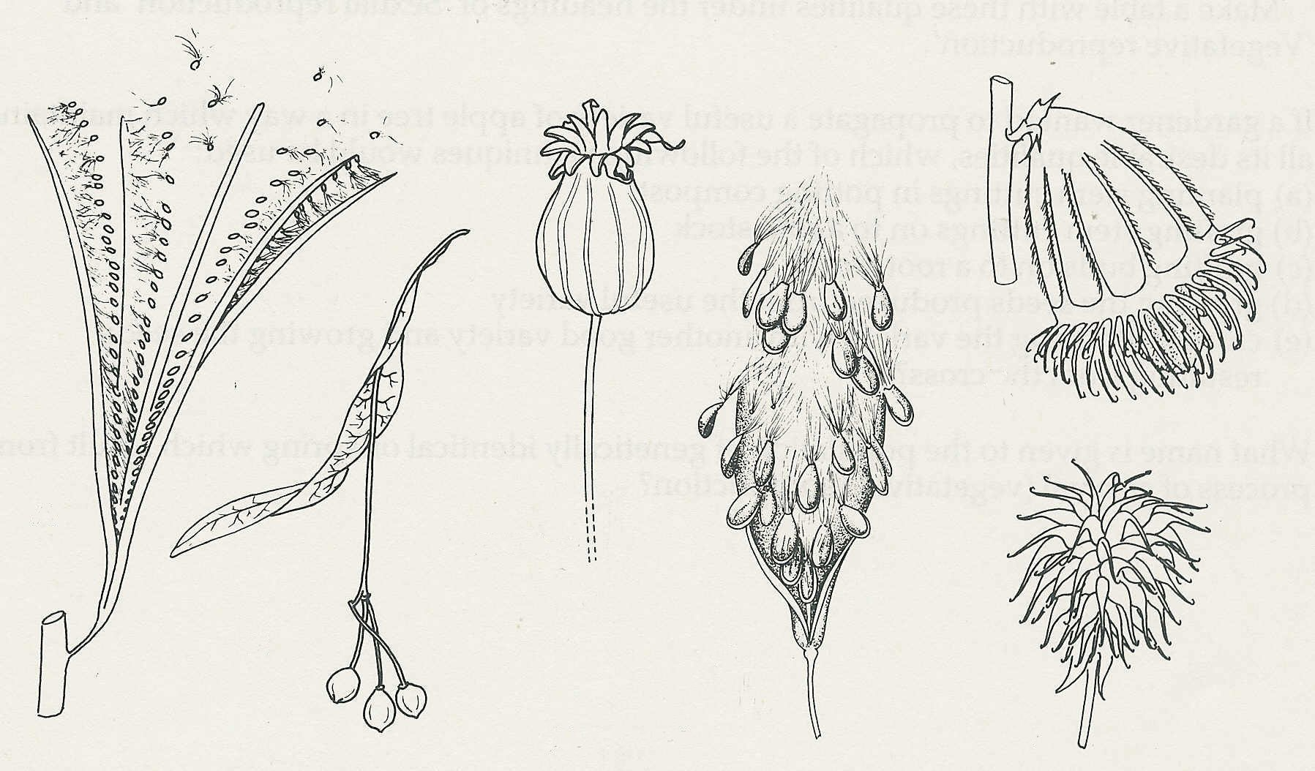
E

A

B
C

D
F

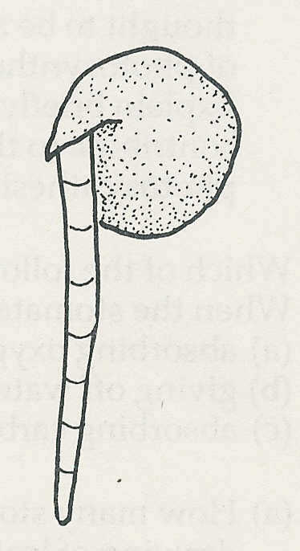
11 The root of the pea seedling is marked with equally spaced lines
as shown here. Draw what you would expect to see in two days' time if the
root
(a) grew only from the tip (c) grew only at the top
(b) grew uniformly along its length (d) did not grow.

12 (a) What conditions do most seeds need in order to begin germination?
(b) What other condition do the seedlings need to continue growth to mature
plants?

13 How would you design, in principle, an experiment to test the hypothesis that a certain
variety of lettuce seed needed daylight in order to germinate?
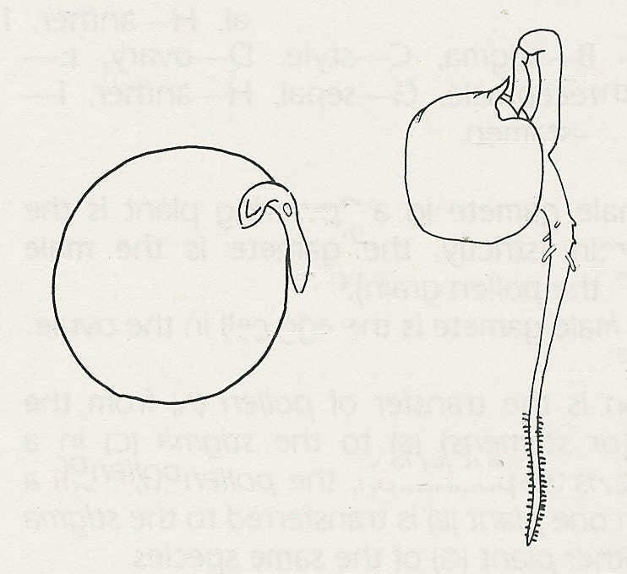
D
14 Figure 1 represents a pea seed split open to
A
E
show its structure. Name the parts A-C
and state the function of each.
Figure 2 represents a pea seedling-5 days
after germination. Name the parts D-H.
B
F
15 The early stages of germination take place
in the soil where there is little or no light for
G
photosynthesis. How does the seedling obtain
C
Figure 1
Figure 2
materials for its growth and energy during
needs during this time?
H

Self-assessment questions 8.03
Reproduction in flowering plants (continued)

16 You are asked to set up an experiment to investigate the effect of temperature on the rate of germination. You place ten soaked peas in each of three flower pots containing moist sand. One pot is placed in a refrigerator at 4°C, one is placed in a cupboard at room temperature (about18°C) and the third is placed in an incubator at 25°C. You leave them for a week, checking each day that the sand is kept moist.
(a) How would you judge the results?
(b) Why was the pot, at room temperature, kept in a cupboard rather than on the
laboratory bench?

17 Starch is one of the most common storage product in seeds. What happens to the starch
before it can be used by the germinating seed?
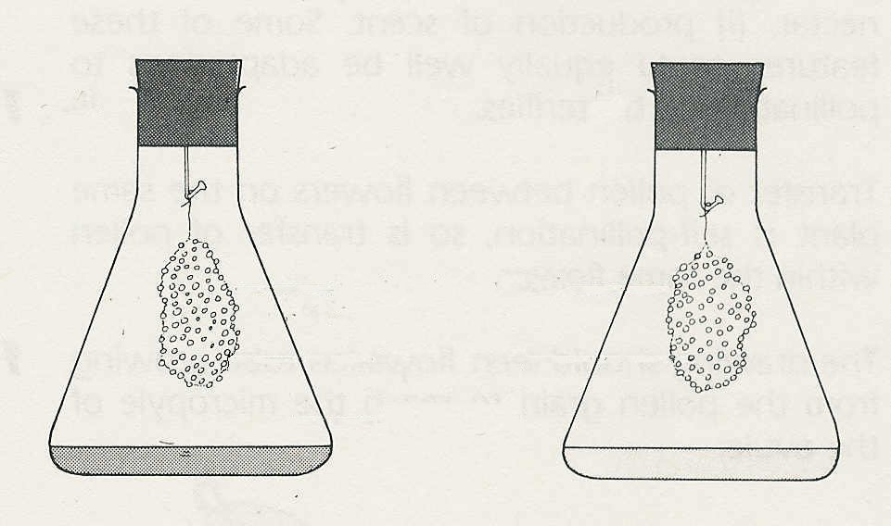
A
B
18 The diagram represent an experiment to
test the hypothesis that seeds need oxygen
wet cotton wool
in order to germinate.
(a) What is the liquid in A and what does it do?
cress seeds
(b) What is the liquid in B and what does it do?
(c) Which of the two flasks represents the control
no oxygen
and what is its purpose?
(d) What results would you expect
(i) if oxygen is necessary for germination
(ii) if oxygen is not necessary for germination?

19 What differences would you expect to see between pea seedlings grown for 10 days in total darkness and pea seedlings grown in the light for the same period of time?

26

