25 Interdependence of living organisms
Self-assessment questions 25.01

1 Classify the following animals as either carnivores or herbivores.
cow, rabbit, dog, shark, sheep, deer, lion, eagle, giraffe, seal, grass snake, horse

2 Classify the following as producers, primary consumers or secondary consumers.
caterpillar, falcon, mouse, tree, phytoplankton, pike, cat, grass, locust, goat, otter, wheat

3 The diagram represents a food web that might occur on a rocky seashore.
octopus
gull

crabs, prawns
goby
blenny
starfish
dog whelk

marine worms

shrimps
acorn barnacles,
limpets
mussels
periwinkles,
top shells

animal
carrion
microscopic green algae
seaweed

© P.W. Freeland
School Science Review

(a) Pick out a food chain that includes shrimps and ends with gulls.
(b) Which are the producers?
(c) Name a primary, secondary and tertiary consumer in the food web.
(d) What might happen to the food web if all the mussels were killed by a pollutant?

4 A meal consists of grilled trout, potatoes and mushrooms. Explain how each item is ultimately the product of photosynthesis.

5 On average, what percentage of the sun's energy, which reaches the surface of the Earth, is used for photosynthesis?
(a) 100% (b) 10% (c) 1% (d) 0.1 %

6 On average, what percentage of the food given to cattle is converted to flesh and bone?
(a) 100% (b) 10% (c) 1 % (d) 0.1 %

7 Choose the most appropriate words from the list below to complete the following
paragraph.
In a food chain, …… passes from one …… to another. The ……of the …… is always less than that of the ……because most of the food eaten by the …… is used to produce ……rather than new growth.
biomass, sunlight, trophic level, photosynthesis, producers, energy, consumers, decomposers
Interdependence of living organisms (continued)
Self-assessment questions 25.02

8 Which two major groups of organisms make up the bulk of the decomposers?

9 The diagram represents part of a simplified
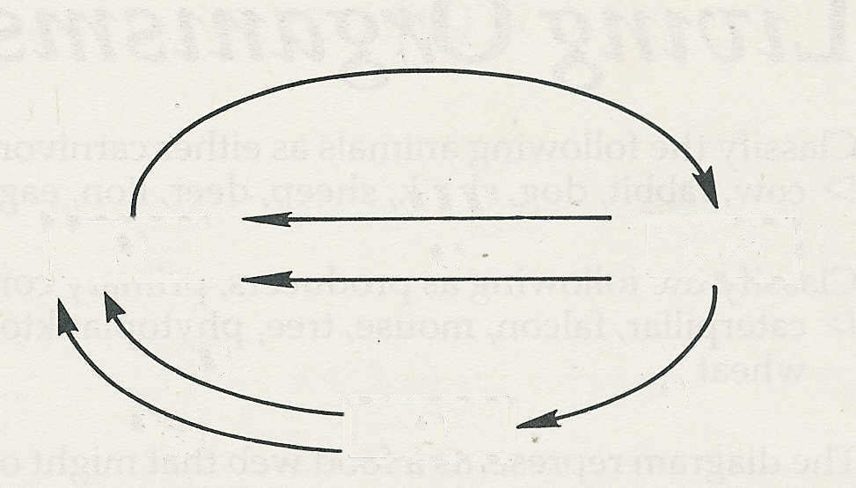
(d)
carbon cycle. Write the name of the
organisms, substances or processes
represented by the letters (a)-(f).
decay
(c)
plants
10 What processes (a) remove and (b) add to
the carbon dioxide in the air?
(e)
(b)
(a)
(f)
decay

11 What part do (a) nitrifying, (b) nitrogen-fixing and (c) denitrifying bacteria play in the nitrogen cycle?
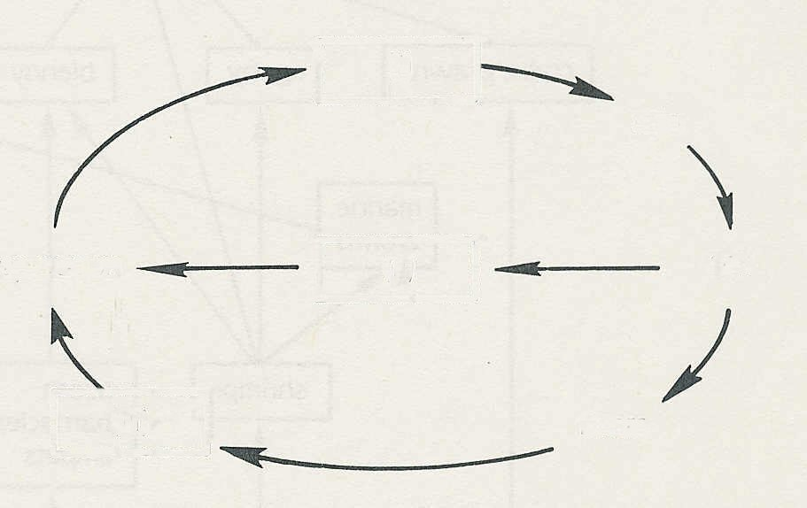
(i)
(ii)
(iii)
rain
soil
rivers
evaporation
12 What processes remove nitrates from the soil?

13 The diagram represents a simplified water
cycle.
(a) Say what might be represented
by (i) - (iii).
(b) At which three points in the cycle are
humans most likely to interfere?

14 (a) In what ways do farmers try to improve the quality of (i) their soil, (ii) their crop plants?
(b) What other steps do farmers take to maximise the yield from their crops?

