Exercises and discussion E7.01
Section 7 - Health and Disease - Exercises and discussion

1 The drawings represent a bacterium, a protozoan and a plant cell (not to scale). Say which
is which and give reasons for your decision. (A)
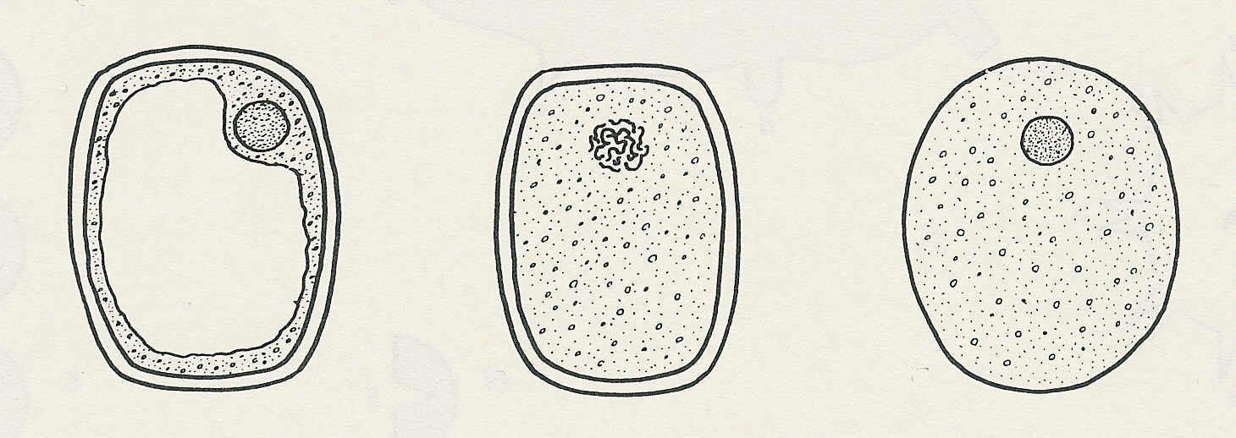

A
B
C

2 Rewrite the following list in order of size starting with the smallest.
red blood cell, virus, protein molecule, bacterium (R)

3 Which of the following is produced by the body in response to bacterial infection?
(a) antibiotics (c) antigens
(b) antibodies (d) antiseptics. (R)

4 Malaria is transmitted by
(a) droplet infection (c) contaminated water
(b) mosquitoes (d) houseflies (R)

5 Phenylketonuria is caused by
(a) a gene deficiency (c) a blood disorder
(b) a dietary deficiency (d) an allergy (R)

6 A microbiologist describes a new type of bacterium as follows:
It appears oval, about 5 µm long and 1.5 µm at its widest point. It has a cell membrane about
0.01 µm thick, surrounding its cytoplasm. Outside the cell membrane there is a cell wall
0.03 µm thick, surrounded by a layer of slime about 0.1 µm thick. Projecting from the
surface of the bacterium are several hundred fimbriae (fine cytoplasmic threads) about
l µm long, uniformly distributed and having their origin in the cytoplasm. Special stains show
a region of DNA about 0.6 µm across, near the centre of the bacterial cytoplasm but
with no membrane round it.

Use a whole A4 sheet of paper to make a labelled drawing of this bacterium, roughly to
scale (where possible).
What is the magnification of your drawing? (1 mm = 0.001 µm) (A)

7 Draw up a dichotomous key to help identify the different species of bacteria shown in the
drawing. (A)
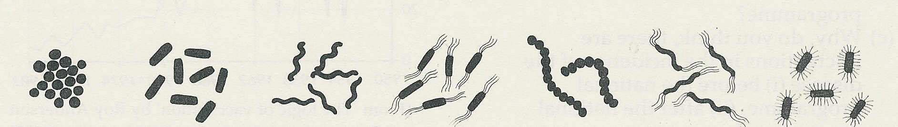

A
B
C
D
E
F
G

Section 7 - Health and Disease - Exercises and discussion (continued)
Exercises and discussion E7.02

8 Diagram A represents a virus. The regions a represent molecules in its outer membrane
which act as antigens.
Diagram B represents part of a human cell. Regions c-f represent molecules which act
as receptors for virus antigens.
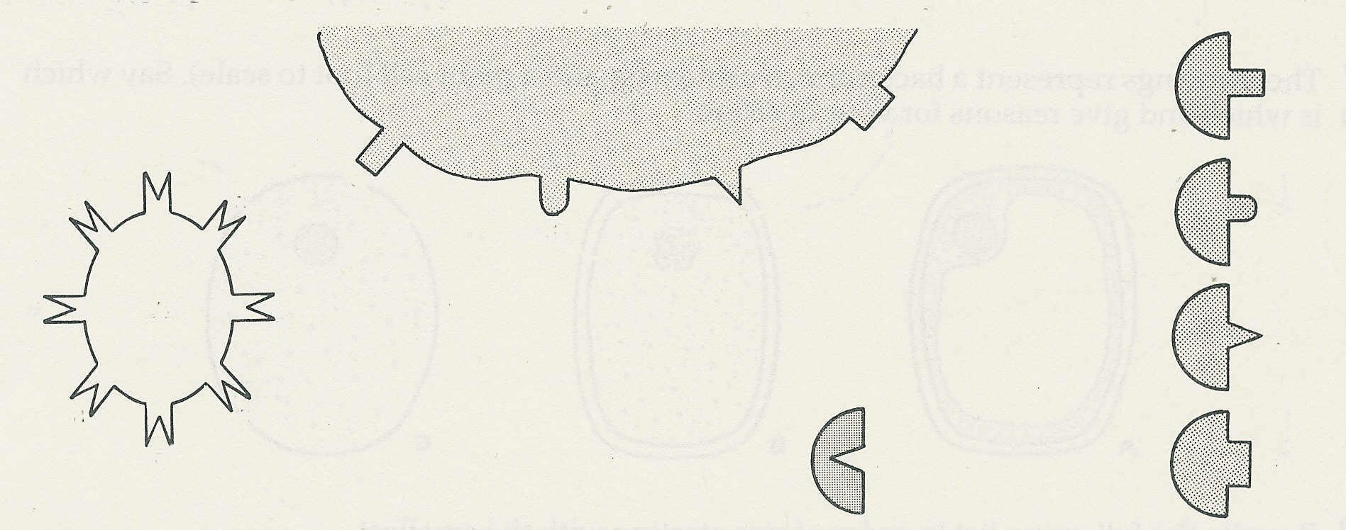

B
1
a
a
a
c
f
2
d
e
A
a
a
3

a
a
a
4
5

Before the virus can infect the cell, its antigen must combine with one of the receptors.
(a) With which of the receptors is the virus most likely to combine?
(b) Diagrams 1-4 represent the molecular structure of some anti-viral antibodies. Which of
these is most likely to combat an infection by virus A?
(c) In what way might substance 5 help to prevent infection by the virus?
(d) Give reasons for your answers to (a), (b) and (c). (A)
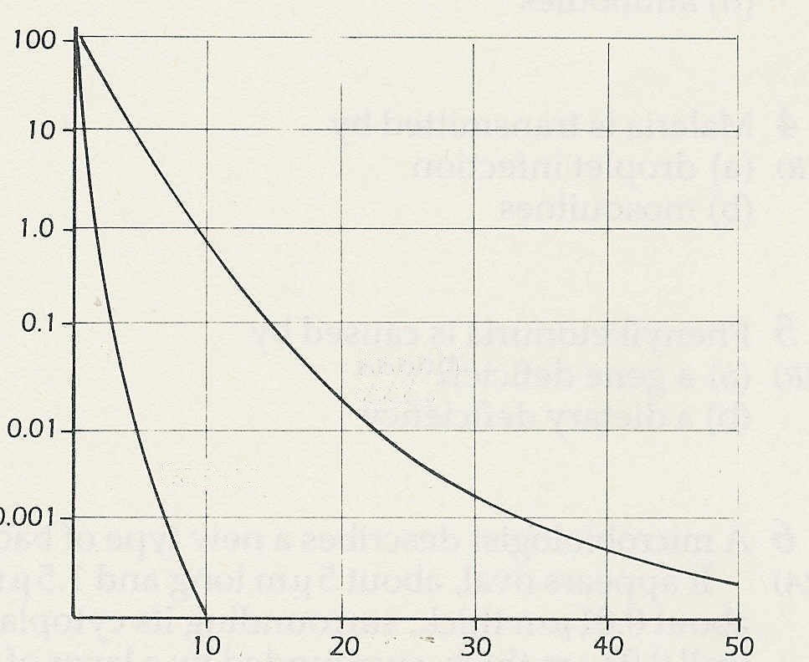
9 The graph shows the survival of bacteria
and their spores when exposed to boiling
water for increasing periods of time.
(a) What percentage of bacteria survive
after 5 minutes boiling?
% survivors
(b) What percentage of bacterial spores
bacterial
spores
survive after 30 minutes boiling?
(c) From this evidence, why is boiling not
bacteria
the best method of sterilisation?
(d) Name or describe a better method. (I)
© Passmore and Robson

10 The graph shows the number of notified
time/ minutes
cases of measles (per 10,000 people) in
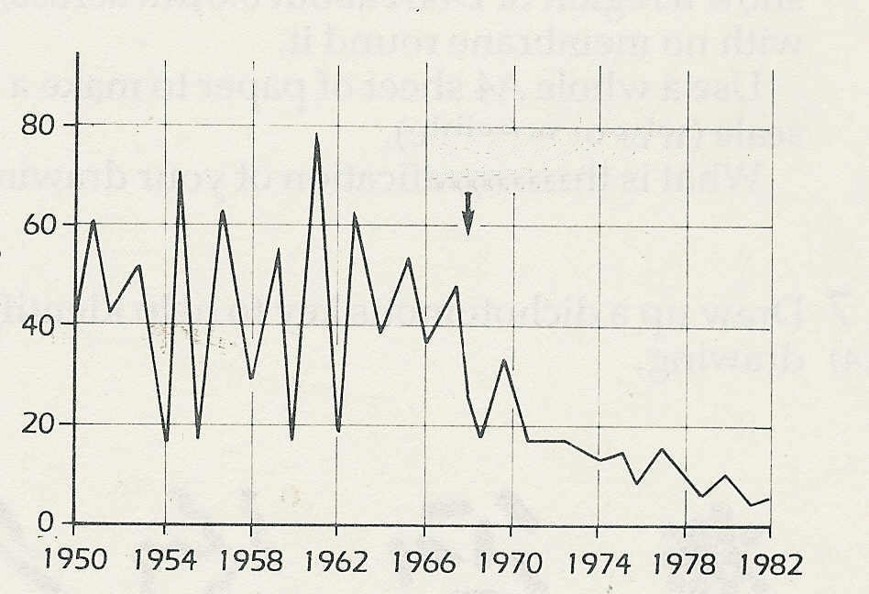
England and Wales between 1950 and 1982.
(a) What was the maximum number of
vaccination started nationally
cases (i) before vaccination started
nationally, (ii) after the national
cases per year
vaccination programme?
(b) Suggest two possible reasons why the
incidence of the disease continued to
fall after the introduction of the
programme.
(c) Why, do you think, there are
fluctuations in the incidence of the disease
(i) before the national programme, (ii) after
© NEW SCIENTIST
the national programme? (I)

Section 7 - Health and Disease - Exercises and discussion (continued)
Exercises and discussion E7.02

11 To try and find an effective and economical strength for a commercial disinfectant, a dilution is made and tested against some bacterial colonies.
1 cm³ of disinfectant is diluted with 9 cm³ of water in tube 1; so giving a 10% solution. 1 cm³ of this solution is diluted with 9 cm³ water in tube 2. The process is repeated for tubes 3-5.
5 cm³ solution from each tube was placed on separate agar plates containing equally dense colonies of bacteria. The figure below shows the method and the result.
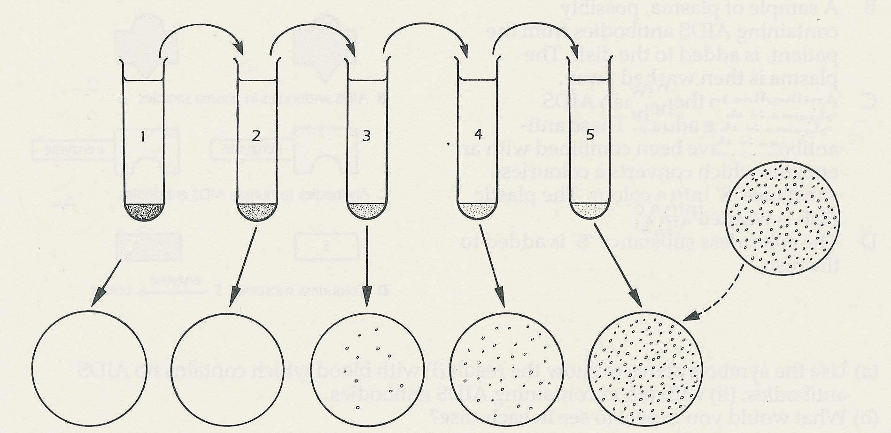
9 cm³
water

1cm³
9 cm³
water
five identical agar
plates with bacterial colonies

1 cm³
disinfectant
1 cm³ from
tube 4

result after 24 hours

(a) Which tube contained the most economical concentration that was effective against the
bacteria?
(b) What is the concentration of disinfectant in this tube?
(c) If this is the most economical concentration, why don't the manufacturers sell the
disinfectant in this form? (I)

12 Disasters such as floods and earthquakes are often followed by epidemics of intestinal
diseases such as cholera, typhoid and dysentery. Why do you think this happens? (A)
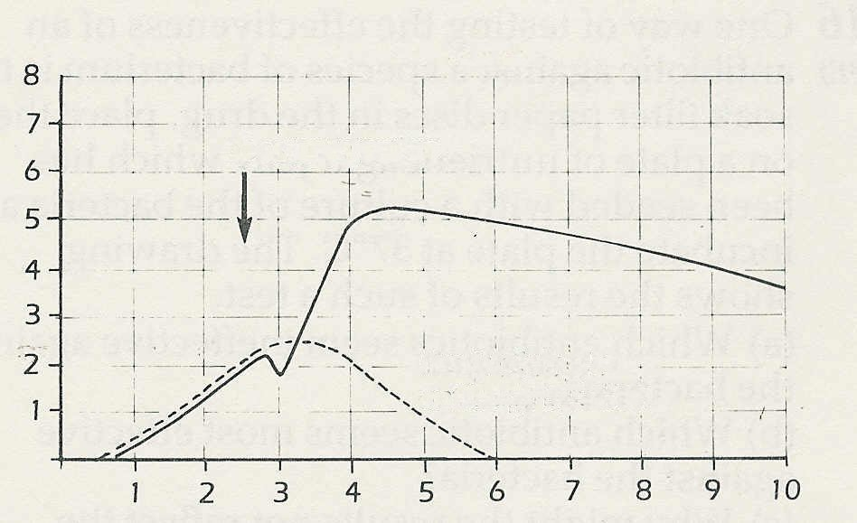
antibody level/ arbitrary units
weeks
booster injection
result of single antibody injection
13 The graph shows the level of antibody in
the blood after receiving the first and second
(booster) injection of a vaccine.
(a) What is the maximum antibody level
(i) after the first injection, (ii) after the
booster injection?
(b) What are the effects of the booster injection?
(c) How long does it take for the antibody
level to reach its maximum after the
booster injection?
(d) Why, do you think, does the level of
antibody fall slightly immediately after
the booster injection? (I)
© Passmore and Robson

Exercises and discussion E7.04
Section 7 - Health and Disease - Exercises and discussion (continued)

14 One method of testing whether a person has antibodies to the HIV virus in his or her
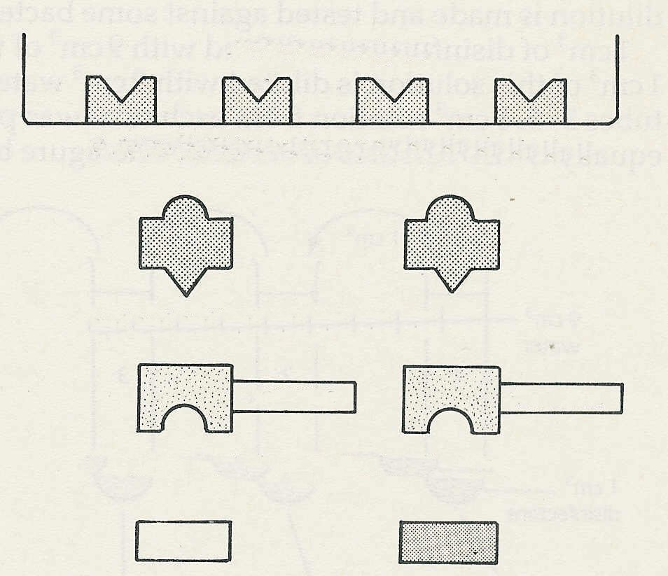
blood is carried out as follows:
HIV virus antigens
A HIV virus particles are broken up and
made to stick to the bottom of a plastic dish.
A Virus particles broken up and stuck to plastic
The particles will carry the virus antigens.
B A sample of plasma, possibly containing
HIV antibodies from the patient, is added
to the dish. The plasma is then washed away.
B HIV antibodies in plasma samples
C Antibodies to the human HIV antibodies
enzyme
enzyme
are added. These antibodies have been combined
with an enzyme which converts a colourless
C Antibodies to HIV antibodies
substance 'S' into a colour. The plastic dish is
washed again.
D The colourless substance 'S' is added to the dish. (I)
D colourless substance S + enzyme colour colour

(a) Use the symbols above to show the result (i) with blood which contains no HIV
antibodies, (ii) with blood containing HIV antibodies.
(b) What would you expect to see in each case?

15 An insurance office has a staff of 300. One Tuesday, 45 people are absent with sickness and diarrhoea which, investigations show, was caused by Salmonella typhimurium.
The investigation found that 230 people on the staff, including 40 of the affected people, had taken lunch in the office canteen on Monday. The choices had been meat and potato
pie (100 servings), chicken curry with rice (80 servings) or pizza and chips (50 servings).
38 of the affected people had chosen the chicken.
40 of the affected people had been amongst 60 who had attended an office party on the Monday night.
(a) What evidence supports the possibility that the salmonella outbreak was caused by the
chicken curry?
(b) What is the evidence against this possibility?
(c) What further investigations would be necessary to find out the cause of the outbreak? (A/I)
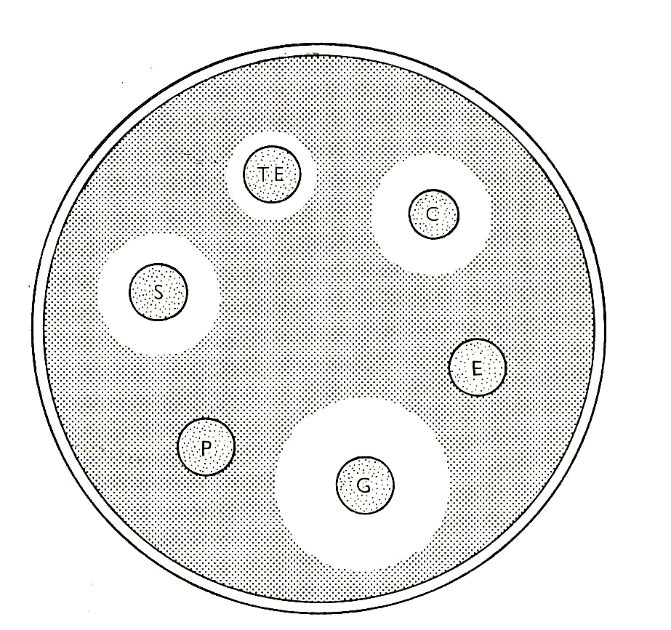

16 One way of testing the effectiveness of an antibiotic
against a species of bacterium is to soak filter paper
discs in the drug, place them on a plate of nutrient agar
jelly which has been seeded with a culture of the bacteria
and incubate the plate at 37°C. The drawing shows the
results of such a test.
(a) Which antibiotics seem ineffective against
the bacteria?
(b) Which antibiotic seems most effective
against the bacteria?
(c) Why might the results not reflect the effectiveness
of the drug in the body?
(d) How would you design an experiment to find
C - chloamphenicol E - erythromycin
TE - tetracycline S - streptomycin
G - sulphurazole P - penicillin
whether increasing concentrations of penicillin
might be effective against the bacteria? (I/E)
© John Humphries

Exercises and discussion E7.05
Section 7 - Health and Disease - Exercises and discussion (continued)
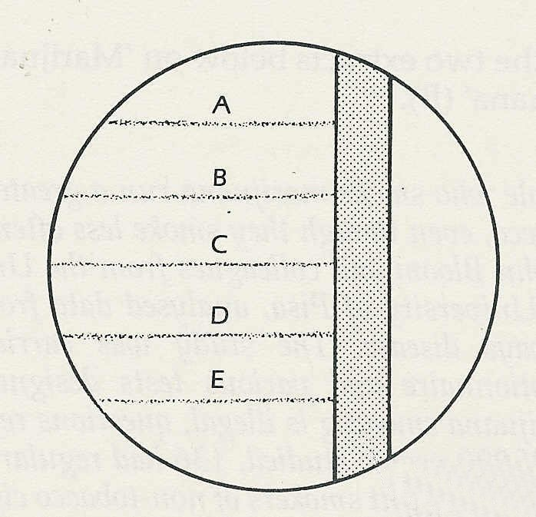

17 The experiment in question 16 compares the
effectiveness of different antibiotics against the
same species of bacterium. The experiment in the
diagram on the right tests the effectiveness of one,
antibiotic against different species of bacteria.
The lines A-E represent streaks made on the agar
with five different bacterial species.
(a) Draw what you would expect to see, after
24 hours incubation, if the antibiotic is
effective against species C and E but not
against the others.
(b) How might the choice of nutrient in the agar
trough cut in agar and filled with antibiotic solution
affect the result? (A/E)

18 A student who has had a bad cough decides to see if his symptoms are caused by a
pathogenic bacterium. He obtains a sterile petri dish with sterile agar containing a suitable nutrient. He removes the lid, coughs over the agar, replaces the lid and incubates the dish
for 24 hours at 37°C.
After this time, he removes the lid, counts the colonies of bacteria and washes the
contents of the dish down the sink.
(a) Explain why the student's procedure is dangerous for him and his classmates.
(b) This experiment should not be carried out in school but, if carried out in a pathology
laboratory, could be made much safer. Suggest at least two safety measures that could
be taken.
(c) Apart from the safety aspects, in what ways is the experiment badly designed? (E)

