Section 5 Organisms and their environment - Exercises and discussion
Exercises and discussion E5.01

1 When an animal eats a plant, about how much of the food value of the plant is used for energy for the animal's living processes and does not contribute to its growth?
(a) 1%, (b) 50%, (c) 75%, (d) 90%. (R)

2 What are the steps in the transfer of energy from sunlight to humans via butter?
(R)
3 The diagram represents the water cycle.
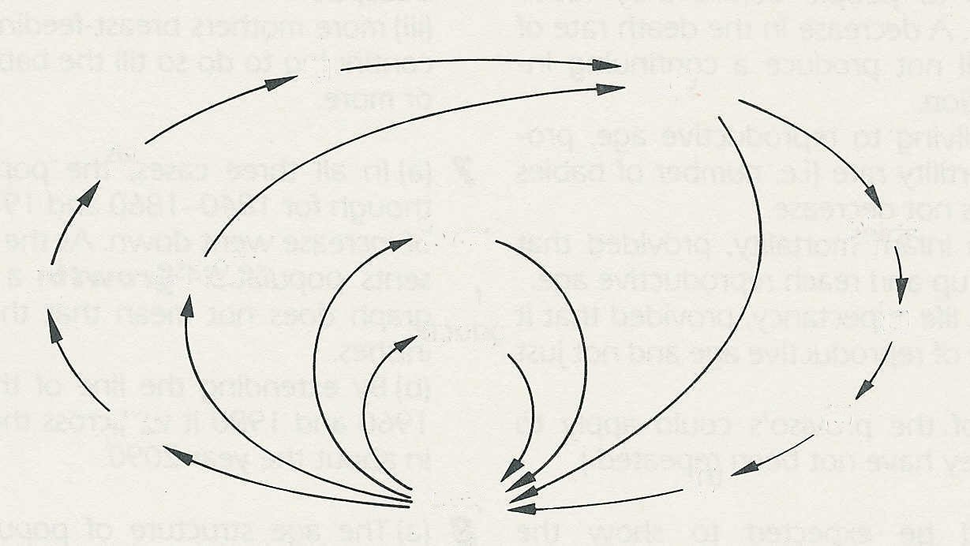
(c)
soil
(b)

plants
town
irrigation
(a)
factory
(d)

sea
(e)

river
(f)

(a) Fill in the missing stages by selecting words from the following:
evaporation, transpiration, rain, clouds (the same word may be used more than once)
(b) At what points in the cycle could the water become polluted?
(c) In each case, say what might cause the pollution. (R)

4 The table shows the result of a survey of
 | Butterflies in equal areas of headland
Species | Sprayed | Unsprayed
Brimstone  Holly blue  Large white  Peacock  Ringlet  Small white | 10  13  38  19  23  14 | 52  29  56  39  52  19
some of the butterflies in the headlands
(edges of fields) which were sprayed with
pesticides or left unsprayed.
(a) Present the results in the form of a bar
chart.
(b) What effect does spraying seem to
have on (i) the total number of
butterflies, (ii) the diversity (i.e. the
number of different species)?
(c) Which species seem (i) most affected © Dr. N. Sotherton
(ii) least affected by spraying?
(d) If the sprays include (i) herbicides or (ii) insecticides, in what ways could they affect the
butterfly population? (I/A)

Section 5 Exercises and discussion (continued)
Exercises and discussion E5.02

5 The diagram shows part of a food web starting in an apple tree and ending in a kestrel.

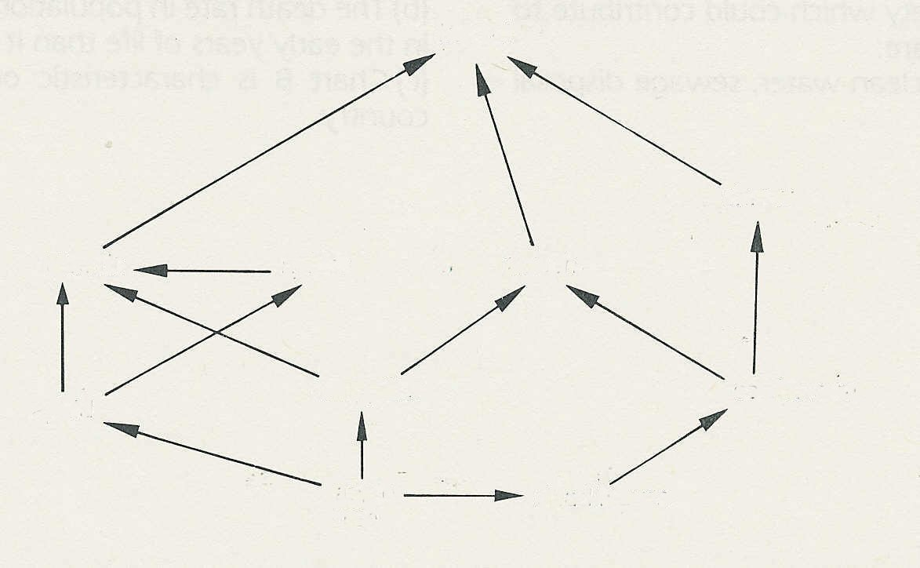
kestrel

shrew
blue tit
spider
thrush

earthworm
caterpillar
aphid

dead leaves
apple
tree

(a) Pick out one food chain which connects the apple tree to the kestrel.
(b) What might be (i) the immediate effect, (ii) the long-term effect of spraying the apple
tree with insecticide?
(c) Name one primary and one secondary consumer.
(d) What might happen to this food web if the population of kestrels was reduced? (R/A)

6 The table shows the use of non-biodegradable detergents (in thousands of tonnes) in
Britain over a 6 year period.
(a) Complete the table by calculating the total
Year | Domestic | Industrial | Total
1  2  3  4  5  6 | 10.5  14.0  29.0  34.0  34.1  37.5 | 2.5  3.8  6.0  6.5  6.9  7.4
consumption for each year.
(b) Plot the three sets of figures on a graph,
labelling each line clearly. Put the years
on the horizontal axis.
(c) Which of the two classes of user made the
greater contribution to detergent pollution of
rivers in this period?
(d) Between what years did detergent use increase © L.B.Wood
most rapidly? (I)

Section 5 Exercises and discussion (continued)
Exercises and discussion E5.03

7 The table shows the annual catches of three species of fish over a period of 8 years.

 | Catches (thousands of tonnes)
 | Yr 1 | Yr 2 | Yr 3 | Yr 4 | Yr 5 | Yr 6 | Yr 7 | Yr 8
Atlantic herring  Atlantic cod  Salmon | 3735  1462  236 | 14711199  185 | 1132  793  193 | 1078  639  268 | 855  530  208 | 708  469  254 | 644  488  188 | 682  561  264

(a) Plot these figures on a graph with the years on the horizontal axis. Label each line with the
name of the fish.
(b) What has been the trend in catch size of each of these species since year 1? Suggest
possible reasons for these trends. '
(c) Which species seems to have been (i) most severely, (ii) least severely affected? (I)

8 What is the connection between recycling waste paper and the preservation of moorlands as wildlife habitats?

9 The level of pollutants that sewage works and industries are allowed to discharge into rivers is called the ‘consent value'. A small sewage works might have a consent value of 30:20. This means that the effluent should contain no more than 30 mg/l suspended solids (SS) and
20mg/l biological oxygen demand (BOD). The table shows SS and BOD values in nine samples taken over a period of 9 months at a small sewage works. (A/I)

(a) On what dates were the consent
Sample date | SS | BOD
March 26th  April 8th  June 4th  June 30th  September 18th  September 24th  November 3rd  December 2nd  December 6th | 17.0  32.0  163.0  24.0  31.5  11.0  23.5  58.0  29.0 | 13.5  24.0  47.7  9.8  13.0  6.4  14.0  18.0  11.0
values exceeded?
(b) What proportion of the samples
exceeded the consent values?
(c) What are the likely consequences to
the river of these failures to meet the
consent values?

© Dennis Moss

Section 5 Exercises and discussion (continued)
Exercises and discussion E5.04
10 The graph shows the catch of three species of whale in the Southern Ocean between 1940 and 1980. (Whale hunting was interrupted by World War from 1939 - 45 and is currently partially banned). The weights of these three species are
Blue whale 90-144 tonnes Sei whale 14-17 tonnes Minke whale 6-8 tonnes
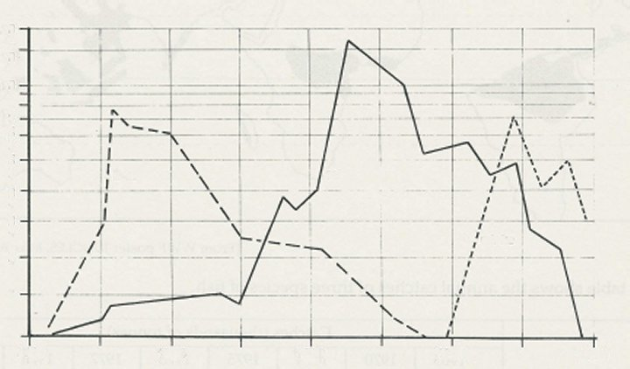
20
15
10
catch/ thousands
7

sei
6
5
4
blue
3
2
minke
1

1940
1950
1960
1970
1980
© Greenpeace

Note: The vertical axis has a logarithmic scale, so the divisions are not equal.
(a) What was the catch (approximately) of Sei whales (i) in 1965, (ii) in 1975?
(b) What happened to the catches of all three species during the last 5 years in which they
were hunted?
(c) Compare the weights of the three species and then suggest why the maximum catches of each
species are 10-20 years apart and in that order. (I)

11 The table shows the average composition of
 | kg per household
Dust and cinders  Paper and cardboard  Glass  Metals  Food and garden  waste  Cloth and clothing  Plastics  Other materals | 1.6  10.0  4.0  2.8  15.2  1.2  2.0  3.2
domestic waste per month.
(a) Construct a bar chart (or pie chart) to
display these figures.
(b) Which of these waste materials could be
(i) recycled, (ii) used in some other way?
(A/R)

Section 5 Exercises and discussion - continued
Exercises and discussion E5.05
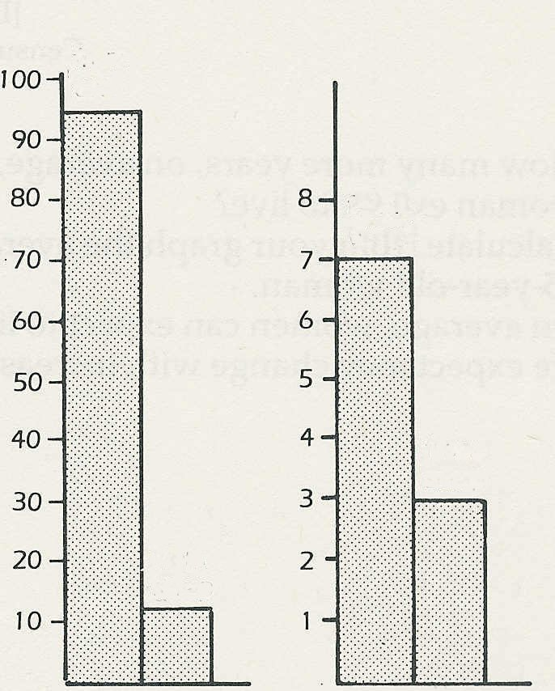
energy/ thousands of kWh
from
ore
from scrap
from
wood
from
scrap
aluminium
paper

12 The charts show the energy needed to
make aluminium and paper from raw
materials or recycled materials
From the charts:
(a) calculate how much energy can be
saved, in each case, by recycling
(b) express these figures as a percentage
from scrap
of the energy needed to make the
products from raw materials. (I)
from scrap

(Note; kWh = kilowatt hour)

© The Tidy Britain Group

13 Read the following extract which is taken from a leaflet on 'Recycling'.
Every year over 6 billion glass bottles and jars are used in Britain, the equivalent of 7
containers a week per household. The container industry accounts for 66% of all the glass
used but only about 30% of the raw material comes from 'foreign cullet' - that is broken glass
obtained as post-consumer waste. An additional 19% is 'factory cullet' or waste arising from
the manufacturing process. This means that a large proportion of glass is produced from raw
materials.
Whilst the main components of glass - sand, limestone and soda ash - are relatively cheap
and plentiful, their quarrying leads to a significant environmental impact. Re-using glass
therefore makes sense on both environmental and energy grounds. Every tonne of 'cullet'
(broken glass) used saves 30 gallons of oil and replaces 1.2 tonnes of raw materials.

(a) What is ‘cullet’?
(b) What percentage of the materials for making glass come from recycled glass?
(c) What substances are used to make glass?
(d) If these substances are cheap and plentiful what are the advantages of using waste glass?
(C)

