Section 4 Genetics and variation - exercises and discussion
Exercises and discussion E4.01
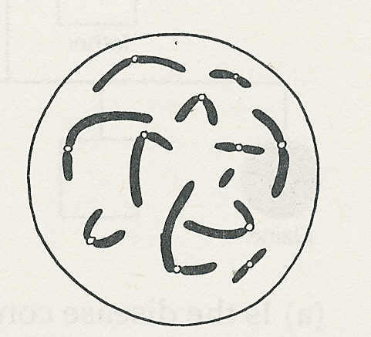
1 The drawing shows the chromosomes in the nucleus of an
epithelial cell of a mammal
(a) What is the diploid number of chromosomes in this species?
(b) What would be the haploid number.
(c) Label the chromosome which you think is the Y chromosome.
(d) Explain why you selected that one. (R/A)

2 The sequence of drawings below shows stages of meiosis, but an important intermediate
stage has been omitted. Complete drawing B to show what happens at this stage. (R/A)
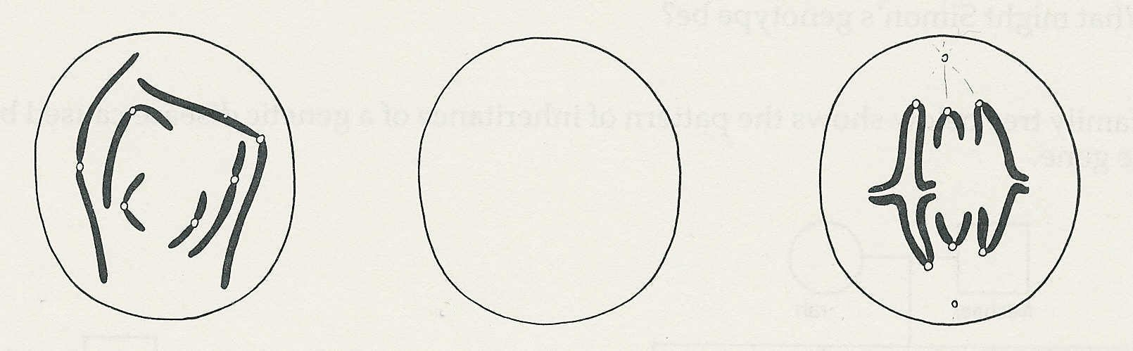

A
B
C

3 In animals, which cells which are produced as a result of meiosis ?
(a) zygotes (b) epithelial cells (c) blood cells (d) gametes (R)

4 A liver cell in a mouse contains 40 chromosomes.
(a) How many of these are derived from the male parent?
(b) How many chromosomes will there be in a nerve cell?
(c) How many chromosomes will a sperm cell have? (A)

5 It is possible to find out whether a black rabbit is homozygous (BB) or heterozygous (Bb) for coat colour by mating it with a homozygous recessive white rabbit (bb). What would be the expected results of such a cross if the black rabbit was (i) homozygous, (ii) heterozygous? (A)

6 The offspring from crossing two normal fruit flies consisted of 46 normal (grey-bodied)
flies and 14 ebony (black-bodied) flies.
(a) What is the approximate ratio of grey-bodied to ebony-bodied flies?
(b) Which of the two characteristics is controlled by a recessive allele?
(c) What can you deduce about the genotypes of the parent flies? (A/I)

7 In a marriage between two 'normal’ people’, the first child has phenylketonuria (PKU);
(This is an inherited disorder controlled by a recessive allele.)
(a) What does this indicate about the genotypes of the parents?
(b) What are the chances that their second child will have PKU? (A)

Genetics and variation- exercises and discussion (continued)
Exercises and discussion E4.02

8 (a) A man of blood group A marries a woman of blood group O. What blood groups might
their children have?
(b) A woman of blood group AB claims that a certain man was the father of her child.
Answer each of the following questions and give reasons for your answers.
(i) Blood tests show the man to be group O and the child to be group A. Is it possible
that the man is the father?
(ii) Do the tests prove that the man is the father?
(iii) If the child had been group AB, could the man be the father? (A)

9 The family tree below shows the pattern of inheritance of a genetic disorder.
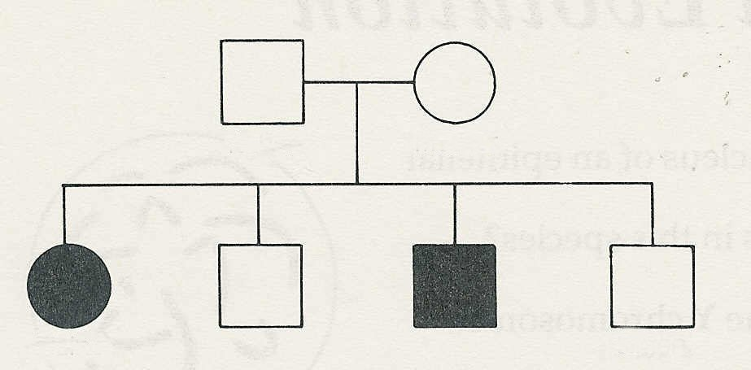
father
mother
Elaine
Simon
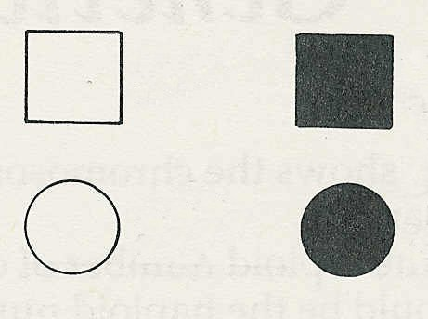

normal
male
affected
male

normal
female
affected female

KEY

(a) Is the disease controlled by a dominant or recessive allele (N or n)?
(b) How do you know?
(c) Why is it unlikely that the disease is sex-linked?
(d) What must be the genotypes of (i) Elaine, (ii) her parents?
(e) What might Simon's genotype be? (I/A)

10 The family tree below shows the pattern of inheritance of a genetic disease caused by a
single gene.
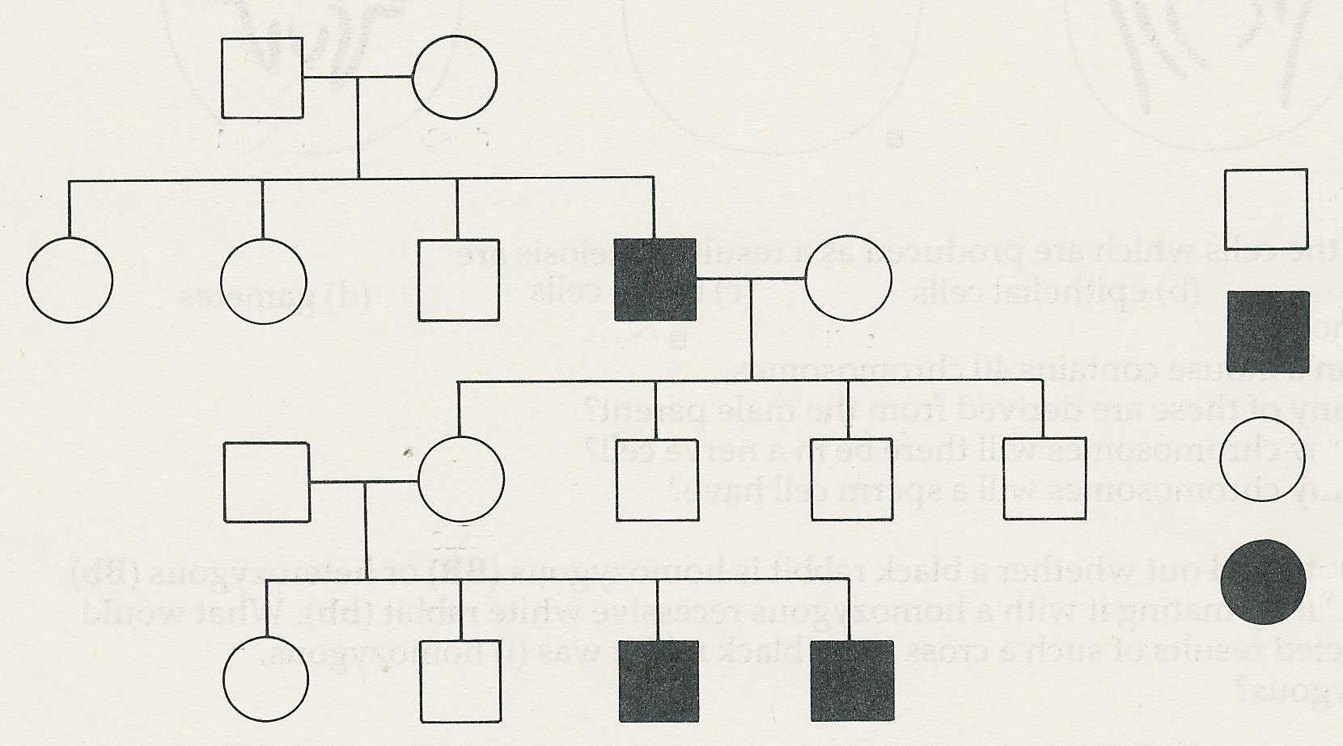

Michael
Sarah
normal
male

affected
male
James
Kate

normal
female

Susan
affected female

(a) What features of the pedigree suggest that the disease is sex linked?
(b) Assuming sex-linkage is involved, what are the genotypes of, Sarah, Michael, James
and Susan? (Use X and Y for the sex chromosomes and N or n for the relevant alleles)
(c) What might Kate's genotype be? (I/A)
Exercises and discussion E4.03

Genetics and variation - exercises and discussion (continued)

11 A horticulturist is investigating the range of heights of a plant species. She measured the
height of 20 plants in a population. Her results, in millimetres, are given below.

125 160 119 167
152 117 120 125
161 127 159 161
128 158 128 163
158 120 161 124

(a) Group these plants into height categories differing by 5mm. e.g. 115-119, 120-124, 125-
129 etc. Count the number of plants in each category and p1ot a histogram of your results.
(b) Discuss, whether height is a continuous or discontinuous variation in this species.
(c) How might you test your conclusion? (I)

12 It is observed that plants growing in a valley are taller, with larger leaves than plants of the same species growing on an exposed mountain side. Suggest an experiment to determine
whether the difference is caused by genetics or the environment. State the results you would expect in either case. (E)

13 In principle, how would you attempt to produce a true-breeding variety of long-backed
disease-resistant pig, from a short-backed, disease-resistant pig and a long-backed, disease-prone pig? (E)

14 Put the following in the correct order for evolution by natural selection to occur.
(a) Some varieties are better able to compete against their fellows (i.e. are better adapted).
(b) Organisms produce more offspring than can survive to maturity.
(c) Individuals within a species vary.
(d) The better adapted varieties gradually replace the original population.
(e) The better adapted varieties pass their beneficial genes to their offspring.
(f) If conditions become harsh, the well adapted varieties survive at the expense of the
others.
(g) There is competition, between members of the species for food, mates and shelter. (A)

Exercises and discussion E4.04
Genetics and variation - exercises and discussion (continued)

15 Read the following extract ‘Genetic disease diagnosed in a 10-week foetus’ and answer the
questions which follow.

Sufferers of beta thalassaemia have defective haemoglobin the protein of red blood cells that
is responsible for transporting oxygen around the body. It mainly affects people of
Mediterranean Oriental origins. It is characterised by severe anaemia and patients require
frequent blood transfusions. The disease is caused by a defect in the gene coding for beta-
globin, one of the sub units of the haemoglobin molecule. When this defective gene is inherited
from both parents (homozygous) the disease is called thalassaemia major, and sufferers rarely
used to live beyond their teens. Sickle cell disease is due to a different defect in the same gene.
At present, beta thalassaemia and sickle cell disease are diagnosed prenatally by a technique
known as fetoscopy. This involves taking a sample of fetal blood (usually from the umbilical
cord) by passing a fine needle into the uterus. Analysis of haemoglobin from fetal blood cells
will tell whether or not the child is affected. The drawback with fetoscopy is that it can be
carried out only at about the eighteenth week of pregnancy, when termination, if necessary
and desired, is a much more distressing experience for all concerned. The advantage with the
new technique, is that the defect can be spotted in the DNA of the fetus; there is no need to
wait until a blood sample can be obtained.
When an embryo implants in the wall of the uterus, it is surrounded by a layer of cells,
called the trophoblast. These cells go on to form the placenta, and contain fetal, rather than
maternal DNA. The UCH group devised a means of obtaining these cells, by applying gentle
suction through a thin tube which is passed through the cervix (transcervical aspiration).
© NEW SCIENTIST

(a) Which group of people is most at risk of having thalassaemia?
(b) (i) What is its cause, (ii) what are its symptoms and (iii) what is the treatment?
(c) (i) Is thalassaemia caused by a dominant or a recessive gene? (ii) How do you know?
(d) What is 'fetoscopy'?
(e) Apart from potential damage to the fetus what is the disadvantage of fetoscopy?
(f) (i) What tissue does the new technique use for diagnosis? (ii) How is this tissue obtained?
(iii) What are the advantages of this technique over fetoscopy? (C)

