Personal health - exercises and discussion
Exercises and discussion E3.33

1 Robert and Jane go to a wedding reception. They are met with a glass of sparkling wine. During the meal, Robert drinks two glasses of wine while Jane has one glass. At the disco which follows, Robert drinks two pints of beer and Jane has another glass of wine.
(a) How many units of alcohol did they each consume?
(b) Assuming that it takes one hour for the body to metabolise one unit of alcohol,
approximately how long will it be before the alcohol level in their bloodstream falls to zero?
(c) Who should drive home? (A)

2 The following table gives ratings for the effects of different activities for their contribution to fitness.
Badminton  Football  Jogging  Squash  Swimming (hard)  Walking (briskly)  Weight-lifting | Stamina | Suppleness | Strength
 | o o  o o o  o o o o  o o o  o o o o  o o  o | o o o  o o o  o o  o o o  o o o o  o  o | o o  o o o  o o  o o  o o o o  o  o o o o

o no real effect o o o very good effect
o o beneficial effect o o o o excellent effect © Health Education Authority

(a) Which of these activities has the best all-round effect on fitness?
(b) Which of these activities has least effect on fitness?
(c) Which of the activities affects only one aspect of fitness? (I)

3 There is evidence that the risk of having a baby with spina bifida (a congenital
malformation of the spinal cord) can be greatly reduced If the mothers at risk take extra
vitamins (especially folic acid) before and during pregnancy.
In scientific trials, 2000 women known to be at risk were divided, at random, into four groups. One group was to receive extra folic acid, while the other groups were to take different combinations of vitamins and minerals. The women would not be told which treatment they were receiving,
(a) How, do you think, is it possible to decide which women are at risk?
(b) Suggest a reason why the women were not told which treatment they were receiving.
(c) The trial has been condemned by some doctors and pharmacologists as unethical.
Suggest some points for and against conducting trials of this kind. (E)

4 The following table gives the percentage of sugar in various foodstuffs:

Fruit gums 43 Ribena (diluted 1:5) 12 Shredded wheat 0.4
Weetabix 6 Lucozade 9 Grapefruit juIce (unsweetened) 8
Coca Cola 10 Chocolates 66 Chewing gum 74
Peppermints 100 Sugar puffs 56 Rice crispies 9

(a) Sort these foods out under the headings, 'Sweets'; 'Soft drinks' and 'Breakfast cereals'
(b) Plot bar charts of their sugar concentration.
(c) In each category, say which item is least likely to cause tooth decay. (A)

Exercises and discussion E3.34
Personal health - exercises and discussion (continued)

5 A single joint of marijuana is as dangerous as five tobacco cigarettes, researchers from the
University of California at Los Angeles report today in the New England Journal of Medicine.
The research, conducted over the past five years on 15 male volunteers, found that five times
the amount of carbon monoxide enters the blood stream immediately after smoking a
marijuana cigarette as after smoking a tobacco cigarette. Increased levels of carbon monoxide
in the blood reduce the amount of oxygen available to tissues and have been linked to
coronary artery disease.
Marijuana smokers inhale three times as much tar and retain a third more of the inhaled air in
the lung and respiratory tract than cigarette smokers.
© NEW SCIENTIST
(a) How many people were studied in the trial?
(b) What harmful effects of marijuana were revealed by the trial?
(c) What effect does carbon monoxide have?
(d) Why, do you think, is it more difficult to conduct large-scale trials and collect evidence
for the effects of marijuana smoking than for tobacco smoking? (C)

6 The graph below shows the incidence of dental decay and tooth mottling (fluorosis) in children, at increasing concentrations of fluoride in drinking water. High fluoride concentrations can give rise to a discolouration of the teeth known as mottling (or fluorosis). The broken horizontal line shows the degree of mottling which is just visible to then naked eye.
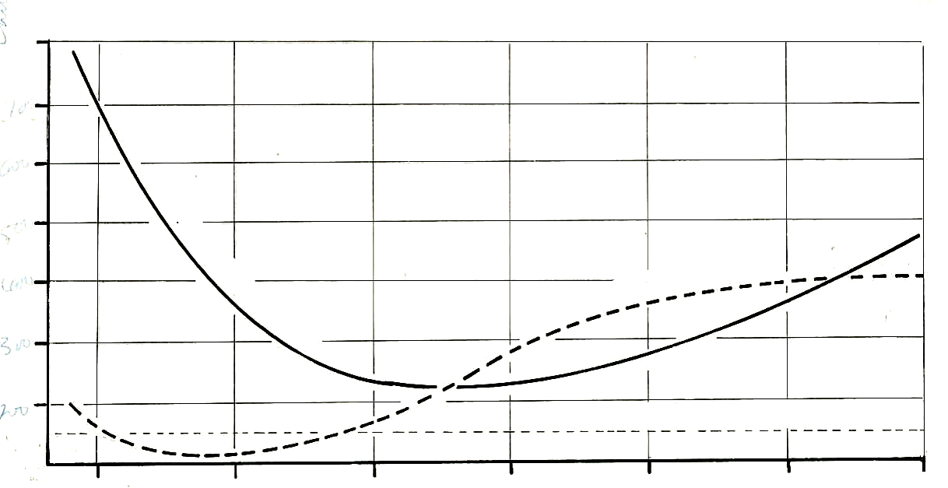
700
decayed permanent teeth per 100 children
600
decay
500
mottling
400
300

200
threshold of visible mottling

1
2
3
4
5
6
0.1
fluoride levels in water parts/ per million

© J. Besford, ‘Good mouthkeeping' (OUP)

What is the best concentration of fluoride to reduce tooth decay without giving rise to
visible mottling? Justify your answer. (I)

